Slide Tool Command Line Examples

py worship.py -d 2026-07-12 -s sunday
Creates a set of blank worship specs (JSON files) for the date July 12, 2026, using the schedule specified in the /schedules/sunday.json file.
That schedule file defines two services for that date, as shown below.
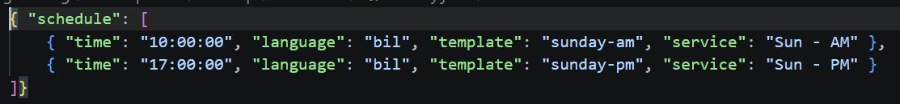
The command creates one folder for the given date: /specs/worship/2026/07/12
And then one subfolder for each service:
/specs/worship/2026/07/12/1000
/specs/worship/2026/07/12/1700
Inside each folder is a set of four JSON files for the corresponding service:
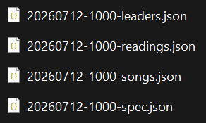

py worship.py -d 2026-07-12 -t 10:00:00 -r
Queries an API on embryhills.church to fetch the scripture reading passage for July 12, 2026, for the 10:00:00 service (-r == reading).
Displays the resulting output, which is also written into the corresponding JSON file (20260712-1000-readings.json)

py worship.py -d 2026-07-12 -t 10:00:00 -l
Queries an API on embryhills.church to fetch the worship leader passage for July 12, 2026, for the 10:00:00 service (-l == leaders).
The result is written into the corresponding JSON file (20260712-1000-leaders.json).
This command is currently broken because the script running on the embryhills.church server relies on my embryhills.com login to scrape the duty roster data. We need to replace that login with one from a current deacon. (The same script supplies directory information to the Photo Directory that runs in the foyer.)
The worship leader information has been scaled back, as EH too frequently cannot insure everything is done decently and in order
So the only positions that we populate are Song Leader, Lord’s Supper, and Preach. The script will populate the whole lineup, so one must remove those from the JSON to suppress them. Otherwise, I could tweak the script to only pull over the three that we care about. Well, really just two, because our preaching schedulers do not populate Congregate with their schedule, so the Preach field is always blank. Grantham tried to keep up with that on a monthly basis, but Cornett does not bother. One must add a name for “Preach” from the bulletin or the preaching schedule, whichever you trust more.
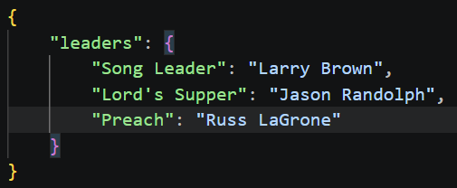

Prepping the JSON
The remaining JSON content for a service must (currently) be supplied by editing the files directly. The vision was that a future web-based UI could generate or modify these in a more user-friendly manner. But until then, here is the process:
Finalize the “-readings” JSON:
The scripture reading passages are populated by the -r command above – but can be overridden (or even initially supplied) in this file.
The “ls-1” section applies to the Lord’s Supper. The “reading” value must be supplied as a number. The number refers to the slide number in the /assets/readings-supper.pptx file (note: the first slide is number zero). More about the readings later.
One could optionally add a “background” element to this section with the name of a subfolder in the /assets/background folder to override the default background.
The “sermon-1” section provides the sermon title for the welcome slide. In most cases, the title is announced in the bulletin, but one might need to consult other sources, especially when preachers tweak the lesson at the last minute. These days, VS Code (which I used to edit the JSON) is smart enough to auto-populate the Spanish translation (I rarely have advance time to have Brigham provide an approved translation).
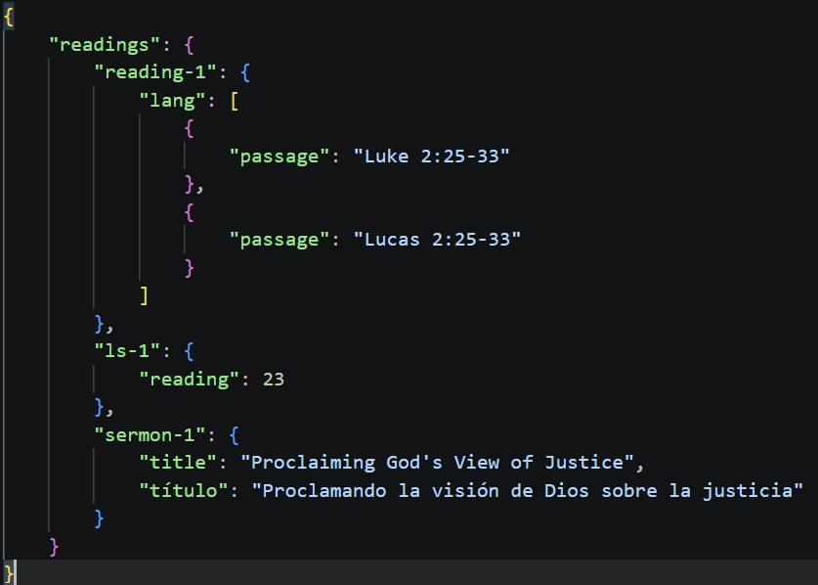
Populate the songs in the “-songs” JSON file:
The initial JSON will have “blank” entries for the songs needed for the template for the service (five in this Sunday morning example).
Blank JSON on the left, then after editing with the book and song numbers. If there are no exceptions to verses and choruses, you can just leave those blank.
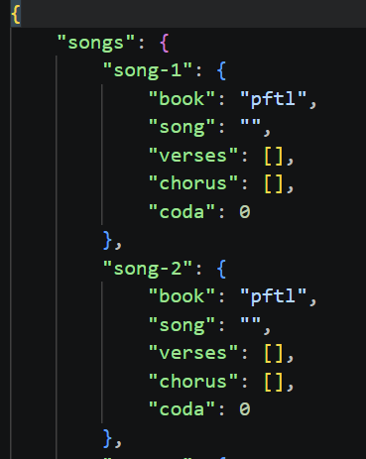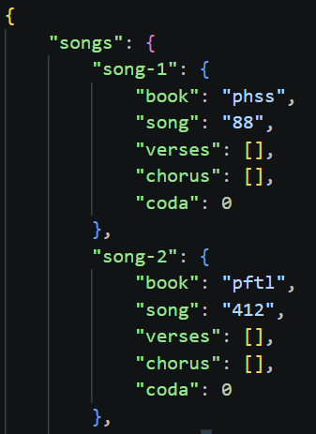
Any verse exceptions are captured here:
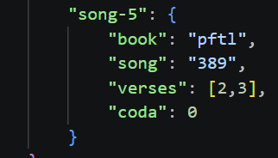

py worship.py -d 2026-07-12 -t 10:00:00 -j
Using all the JSON files we have prepared, this command with the -j (for JSON) option generates a consolidate JSON file in /worship/2026 that can be used as the input recipe for the slide compiler itself.
In this example, the file is /worship/2026/20260712-1000.json.

py slides.py -w worship\2026\20260712.json
Using all the JSON recipe we created with the previous command with the worship.py script, this command using the slides.py script uses that recipe to generate the slide deck, which should include everything but the sermon.
The output file is named /worship/2026/20260712-1000.pptx.

Commands for Importing Songs
py slides.py -s 219
The /ehsf tree has all the PFTL (red book) songs in their original Paperless Hymnal PowerPoint format in /ehsf/pftl/ppt. The Python library for manipulating PowerPoint slides, however, requires PPTX format. So we have systematically converted all the PFTL PPT files into PPTX format, and those are in /ehsf/pftl/pptx.
This command, given a song number (-s), will open the corresponding PPTX file and extract all the song metadata and music, and place them into PNG and JSON files in /ehsf/pftl/219 (each song has its own directory).
Likewise, the database for Psalms, Hymns, and Spiritual Songs book lives in /ehsf/phss. Before the 10/2025 hard disk crash, we had a /ehsf/phss/pptx folder with all the songs exported into PowerPoint. I believe Danny did that exercise. Since the crash, I have been exporting PHSS songs as needed from Sumphonia’s “Slide Maker” tool. Once a song number has been exported from that tool in the pptx folder, you can use this command with the “-b phss” option to import that PHSS song into the EHSF database.
There is a “-b eh” for Embry Hills custom songs, but that is a whole other discussion.

py slides.py -s 219 –esp-eng
Once a song (from any of the three book types: pftl, phss, eh) has been successfully imported into EHSF, this command attempts to “stretch” the music in preparation for adding a Spanish translation. (Note the two dashes in front of esp-eng).
This command creates the folder structure needed for the Spanish version of the song:
/ehsf/esp/pftl/219
/ehsf/esp/pftl/bil/219
The stretched slides are saved in /ehsf/esp/pftl/eng/pftl-219-eng.pptx.
One must inspect the pftl-219-eng.pptx file to check for a successful stretch. If there are weird results, there are parameters that one can tweak by creating a pftl-219-hints.json file in the eng directory. A discussion of those hints is beyond the scope of this document, but will be covered elsewhere.
Once a successful stretch is completed, one sends the -eng.pptx file to the Translation Team (aka, Brigham) for processing. Currently, I have a folder on my OneDrive called “bil-exchange” where I deposit freshly stretched -eng.pptx files, rename them to -bil.pptx files, and notify Brigham, who will insert the Spanish lyrics as text boxes in the PPTX file.
From time to time, Brigham may update the translation of existing translated songs and put the update in that bil-exchange folder. That folder always contains the latest & greatest versions of the translations.

Using PowerPoint to export the bilingual slides to PNGs
After Brigham completes his task of adding Spanish lyrics into a -bil.pptx file, and puts it into the bil-exchange folder, and sends notification that the song is ready, one must import that PPTX into the esp database.
The first step in that process is to export the slides from PPTX to a set of PNG files.
The first step of that process is to copy the -bil.pptx file from the bil-exchange back into the main ehsf tree (which is where the Python expects to find the files):
/ehsf/esp/[book]/bil, where book == pftl in this case.
Before opening the file, one be certain to have another file open first:
/assets/template-spanish.pptm
After opening that template file, open the /ehsf/esp/pftl/pftl-219.bil.pptx file.
Then choose the “Macros” button and use the “Macro in” drop-down in the dialog box to choose the template-spanish.pptm file as the source of the macro:
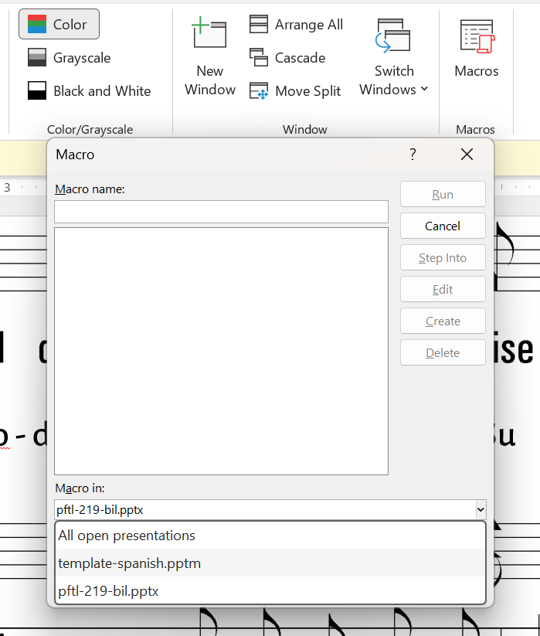

Then select the “ExtractImagesFromPres” macro and Run it:

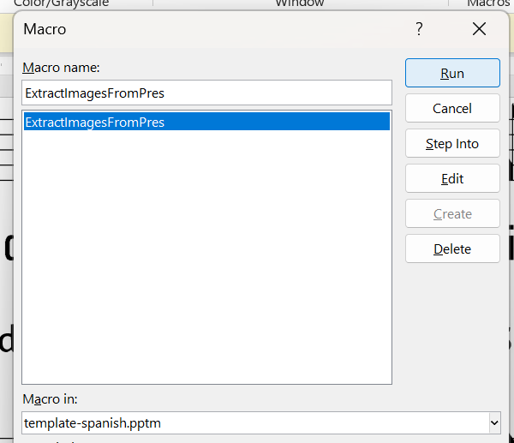

The macro will then export each music slide (with Spanish subtitles) as a PNG file in the appropriate directory inside /ehsf/esp. The macro expects some metadata inside the “Notes” of each slide to work properly. The Python embeds that metadata when generating the -eng.pptx file, and Brigham knows not to modify it in any way. The metadata helps the script choose the correct output resolution and filename for the PNG files that it generates.

py slides.py -s 219 –esp-bil
This final command takes the raw PNGs exported from PowerPoint above and preps them for use by the slide compiler (determining the extents and scaling parameters of the music and so forth, cropping the PNGs as needed).
The song is now available to be used in bilingual worship decks.

