The TCP/IP Five-layer Network and how it works

I think it’s fair to say, that technology has become a vital part of our daily lives, yet most people today, couldn’t explain to you the basic as to how it all works and why protocols are so important. Before this class, I too wouldn’t have been able to explain as much as I know now. So, with that being said, please keep in mind that I am still learning, so I welcome any correction needed.

Networks can be as simple as 100 computers, connected to one business server, a router, couple of switches and a printer. Or you can put together a large network, that consist of many domain servers, connected from different location, hundreds of users, few routers connected to subnets, and large switches connected to many things. But, for the purpose of this paper, I’m going to keep it simple and explain how 2 computers, transfer data using the TCP/IP Five-Layer Network Model. When I’m done explaining you should have a basic understanding as to how networking works.

First let’s start with the “Physical Layer 1.”

To me the Physical Layer 1, is quite important, because without the physical hardware the OSI (Open Systems Interconnect) doesn’t work. The Physical Layer, interconnects all computers.

**Physical layer consists of**

* Copper cabling known as Cat6 or category 6 cable. Preferably twisted pair, to protect your network from electromagnetic interferences or crosstalk.
* Desktop computer (Node) with a built in NIC (Network Interface Card) Every network card comes with its own unique identifier known as a MAC Address (Media Access control address)
* Router, which is a physical device but its job is needed on the Network Layer 3.
* Local Host Server, also known as a domain controller, which is basically a faster processing computer (Node) using software to manage the network.
* Switch, which is a physical device but its job is needed on the Data Link Layer 2.

To be frank, more physical devices could be added to the list, but for sake of this assignment, what I have listed above is what you would need to set up a simple network for the physical layer 1.

Ok, so now that we have all of the equipment needed to get started let’s plug our physical devices, connect the Cat6 cabling and see how this all works using the OSI TCP/IP Five-Layer Network Model.

In this example I’m using two computers, (Computer A and Computer B) a router, and two domain servers. Server A and Server B, will be on their own network.

The networks will be split into two sections, yet they will be connected via one router.

**Network side A**

*Network server A*: will have a IP address of 10.1.1.0/24

*Computer A*: will have an IP address of 10.1.1.100 with an Ephemeral socket/port of 50000. Which is 10.1.1.100:50000

*Router A:* will have a gateway IP address of 10.1.1.1

**Network side B**

*Network Server B*: will have an IP address of 192.168.1.0/24

*Computer B*: will have and IP address of 198.168.1.100 with a socket/port of 80. Which is 198.168.0.100:80

*Router B side*: will have a gateway IP address of 192.168.0.1

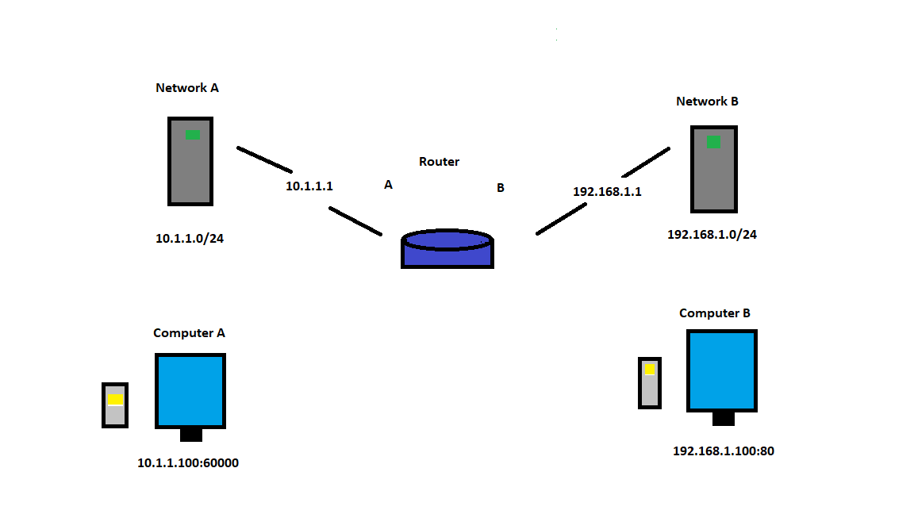

Let’s say that the end user A, on Computer A, needs to order more office supplies from a supply store, which is hosted on Network B, managed by ender user B, from Computer B. Several protocols need to take place before this transaction can take place or complete.

Let’s start with Computer A

* On the **physical layer 1**- before any data can be sent, all of the physical devices in the picture above, including the cabling are needed to begin.

Once every device is plugged in and data is ready to be sent, the next step on how computer A, talks to Computer B, is by using the Data Link Layer.

**Data link layer 2**- relies on the Ethernet protocol. Ethernet protocol is how data is transmitted over a WAN or LAN network. So, if Computer A, needs to purchase a product from computer B, both sides are going to need Ethernet devices that can transfer data at fast speeds. Such items are the Network Interface Card, that comes installed on both Computer A and Computer B. A switch, CAT6 cabling, or fiber optic cable and a gateway router. Ethernet also uses MAC address to ensure that the data it sends has both an address for the source and destination.

When Computer A, makes a request to visit [www.officesupplies.com](http://www.officesupplies.com), an outbound data packet is needed to be made. Because [www.officesupplies.com](http://www.officesupplies.com) is not on Network A, Computer A, will need to send any data to its local gateway. So, Computer A, sends out an **ARP** (**Address Resolution Protocol**) request to discover who the gateway router is. ***An ARP Request is a broadcast of FF.FF.FF.FF.FF.FF****.* The router then receives the broadcast from computer A, in return sends computer A, its MAC address. Now that computer A and the router know about each other via IP address and MAC address, the outbound data packet can now be constructed.

An outbound data packet is a **TCP Segment**, **IP Datagram** and an **Ethernet frame** encapsulated into one. But on the Data Link Layer, an Ethernet frame is the only protocols being used. An Ethernet Frame consist of the source MAC address, destination MAC address, and the payload. An Ethernet frame is the last part of the outbound data packet.

When Computer A, makes a request to visit [www.officesupplies.com](http://www.officesupplies.com), **The Transport layer 4,** is needed first to begin with creating a **TCP Segment**.

**Transport Layer** 4- is responsible for multiplexing and Demultiplexing traffic through ports.

When Computer A, makes a request to visit [www.officesupplies.com](http://www.officesupplies.com), Computer A, knows that it’s being asked to the web browser (www.officesupplies.com) to make an outbound TCP connection, so computer A, is going to need an outbound TCP port. Computer A’s, operating system sees the TCP connection and creates an Ephemeral connection of 60000, known as a socket number. and connects the web browser ([www.officesupplies.com](http://www.officesupplies.com)) to this port.

* Ephemeral port, is any number between 49152 and 65535.
* Ephemeral port is a short-lived endpoint that is created by the operating system.

Once the operating system has opened up a short-lived ephemeral socket, for the web browser [www.officesupplies.com](http://www.officesupplies.com), Network A, can now start putting together a TCP Segment

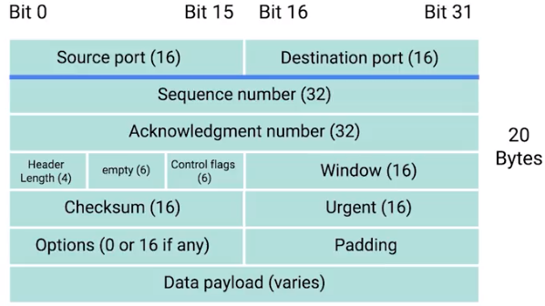

After all of the fields have been filled in by Network A, The TCP Segment can now be passed onto The **Networking Layer 3.**

**Networking Layer 3-**  Allows different networks to communicate with each other through devices known as routers and assigned IP addresses. The **IP datagram** is created on this layer

* An IP address is a 32-bit number, which contain a Network ID and a Host ID. An IP address is given to every device on the Network A, using DHCP (Dynamic Host Configuration Protocol)

Once the TCP Segment has been created, an IP Datagram is created by Network A, by imputing all of the information needed from the photo below.

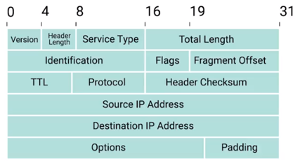

Once the IP Datagram has been created, the TCP Segment is inserted as the payload for the IP Datagram. Now that an IP Datagram has been made, Computer A needs to get this information to its gateway router. So, the last step is to create an Ethernet frame. An Ethernet frame is constructed by the fields in the photo below.

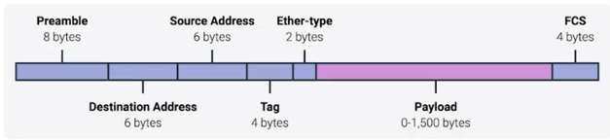

Once the Ethernet frame has been created the IP Datagram is inserted into the data payload of the Ethernet frame, so the data packet can be sent across the **Physical Layer 1**.

The Ethernet packet is then passed onto Network A, that then passes the information to its router.

**Quick note about Routers:** Router is a networking device that forwards traffic to other routers or its destination address. Routers are used on the **Networking Layer 3**.

* A router receives a packet of data on one of its interfaces.
* The router examines the destination IP of this packet.
* The router then looks up the destination network of this IP in t its routing table.
* The router forwards that out through the interface that’s closet to the remote network. As determined by the additional info within the routing table.

The router takes the Ethernet frame and calculates a checksum against the data packet. After the router sees that all of the data is correct it looks at the destination IP address of the IP datagram and determines the fastest route to Computer B (172.16.1.100:80

* The Ethernet Datagram is send to Network A, that then passes on the information to Computer B (www.officesupplies .com)

Once Computer B, receives the Ethernet frame it reads all of the information and immediately knows that the frame is intended for itself.

* It then strips away the Ethernet frame, leaving it with the IP Datagram. Computer B, then runs a checksum against the IP Datagram to ensure everything checks out.
* Once the IP Datagram checks out. It then strips away the IP Datagram leaving it with the TCP Segment. Computer B, then runs a checksum again the TCP Segment to ensure everything checks out.

After Computer B, has dissected the Ethernet frame down to TCP Segment, The Three-Way Handshake is the last process for the TCP connection can be established.

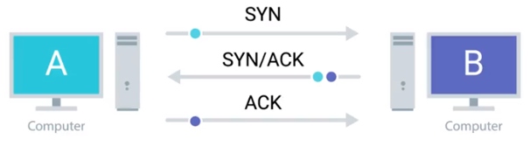

Computer A, (**IP address of 10.1.1.100:80 on Network A, with a DNS of 10.1.1.0/24**) with an Ephemeral socket of 60000, has now established a TCP connection with Computer B via port 80 (**with and IP of 192.168.1.100:80 on Network B with a DNS of 192.168.1.0/24**)

* Computer A, is now free to send whatever data it wants.

Since both sides have sent the SYN/ACK to each other, the TCP connection is ready to operate at full duplex.

To sum things up. The OSI five-layer model, has a lot of protocols that need to be carried in order for the networking to work. Sending an email or searching the web, requires these five-layers and all of the protocols that come with it.

This paper was pretty tough for me. I tried to be clear, hopefully after having read this you have a basic understanding on how the OSI Five-Layer works.

P.S

I didn’t mention the Application Layer 5, because the Application layers is just list of protocols carried out between the Networking layer, and Transport layer. If I’m wrong feel free to correct me.

**Application Layer 5-**  provides many services, including:

* Simple Mail Transfer Protocol
* File transfer
* Web surfing
* Web chat
* Email clients
* Network data sharing
* Virtual terminals
* Various file and data operations