Brandon Tomich

CPSC 362

Professor: Marc Velasco

Chatbot Readme

1. To get everything up and running you will need the following
   1. Visual Studio 2019 community (Its free)
   2. The Bot framework emulator (also free)
      1. Download link: <https://github.com/Microsoft/BotFramework-Emulator/releases/tag/v4.5.2>
   3. Must install the NuGet package “Microsoft.bot.dialogs” this holds the library that allows the dialog functionality. Also the code wont run without it as it’s a dependency.
2. Once everything is downloaded and the project is compiles you can click the green play button on the top bar in Visual Studio.
3. Once Visual Studio is open a web browser will pop up as seen below

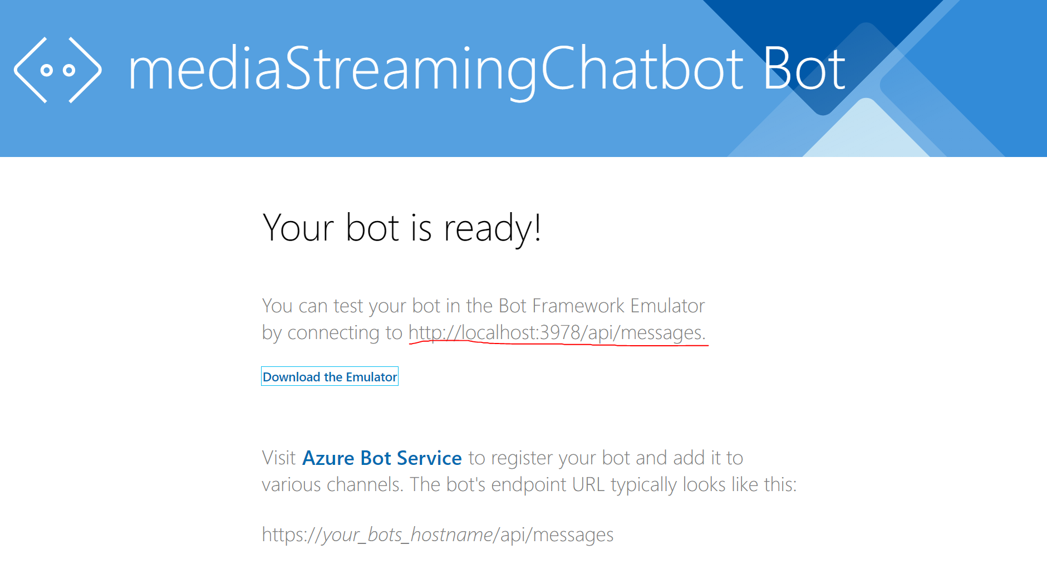

1. Take note of the endpoint underlined in red

**Next page**

1. Next open the bot emulator as seen below

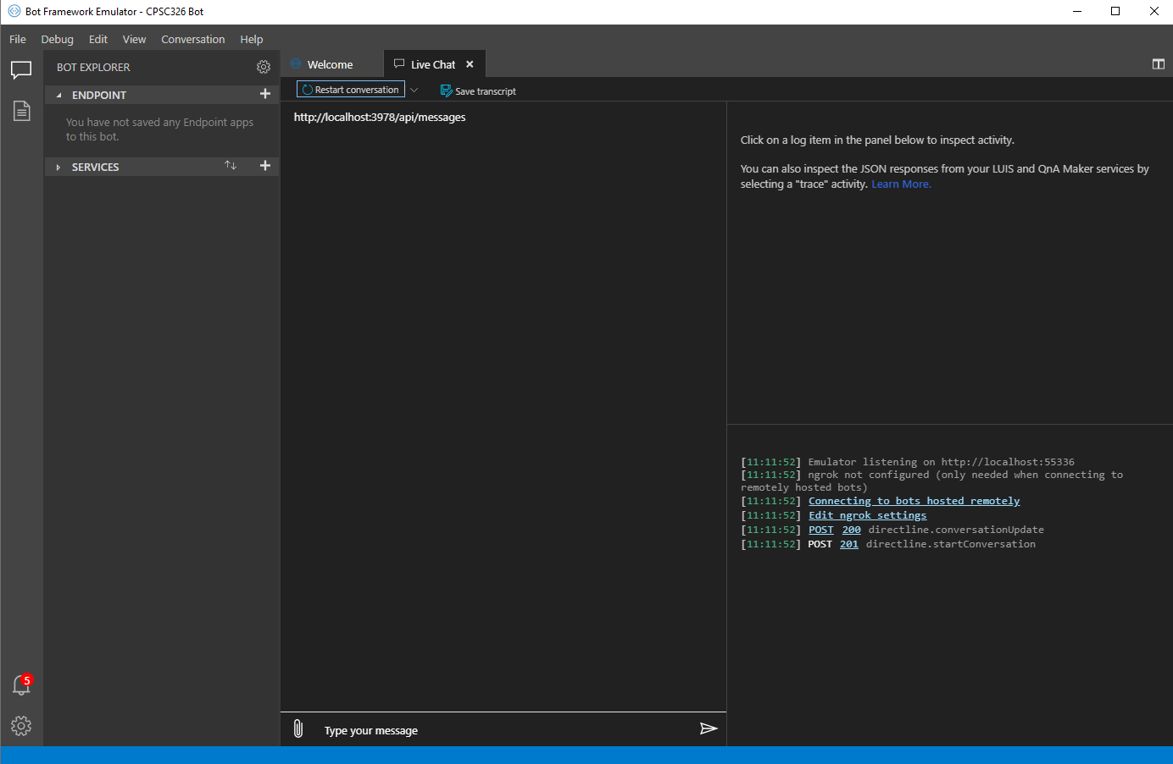

1. Next click the plus button circled below and paste the endpoint in the textbox with the red arrow.

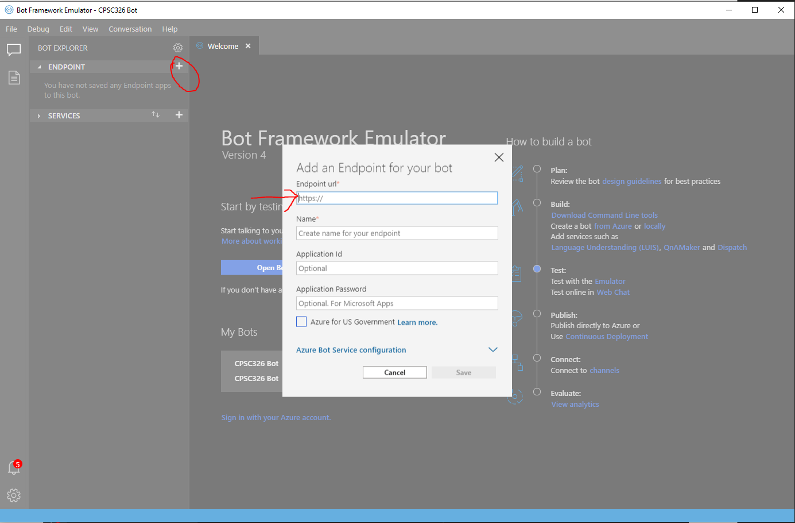

1. Next make a name and click save.
2. Then, under the tab that says endpoint click on the new name you created.
3. Finally, you can begin interacting with the chatbot by typing “hello”

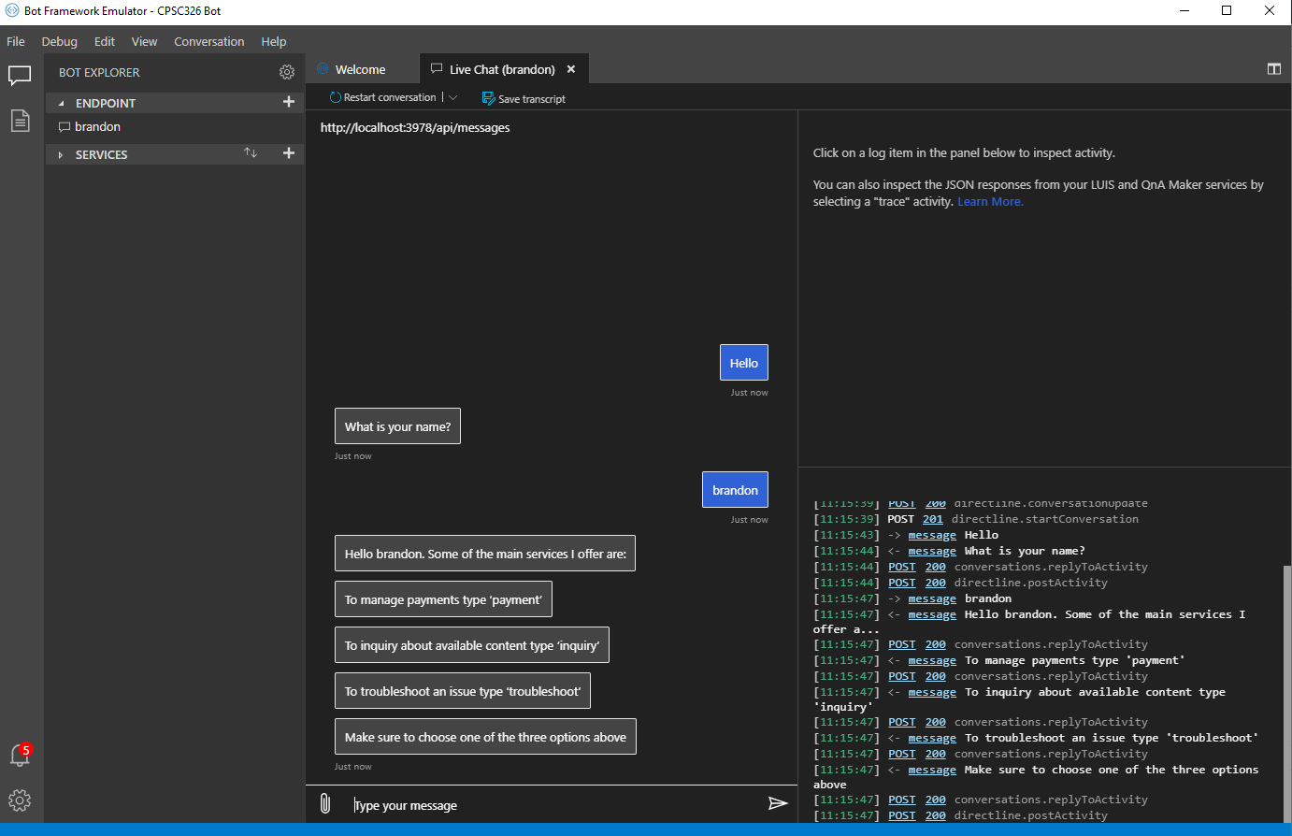

1. The chatbot is capable of all the functionality required for this project. To see each of the three main options you can type them as the chatbot asks for above.

******************TEST CASES******************

**Test cases are listed as screenshots in order as displayed on the assignment 4 handout**

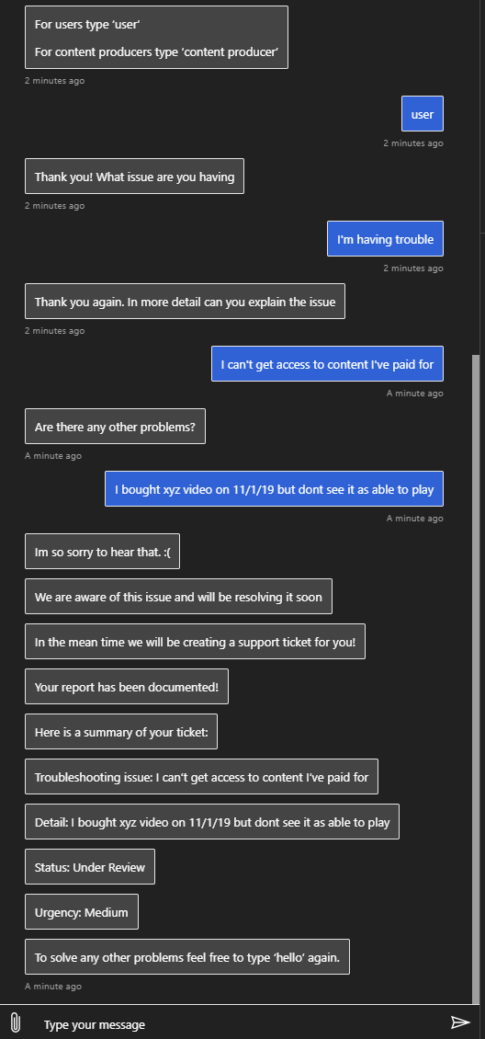

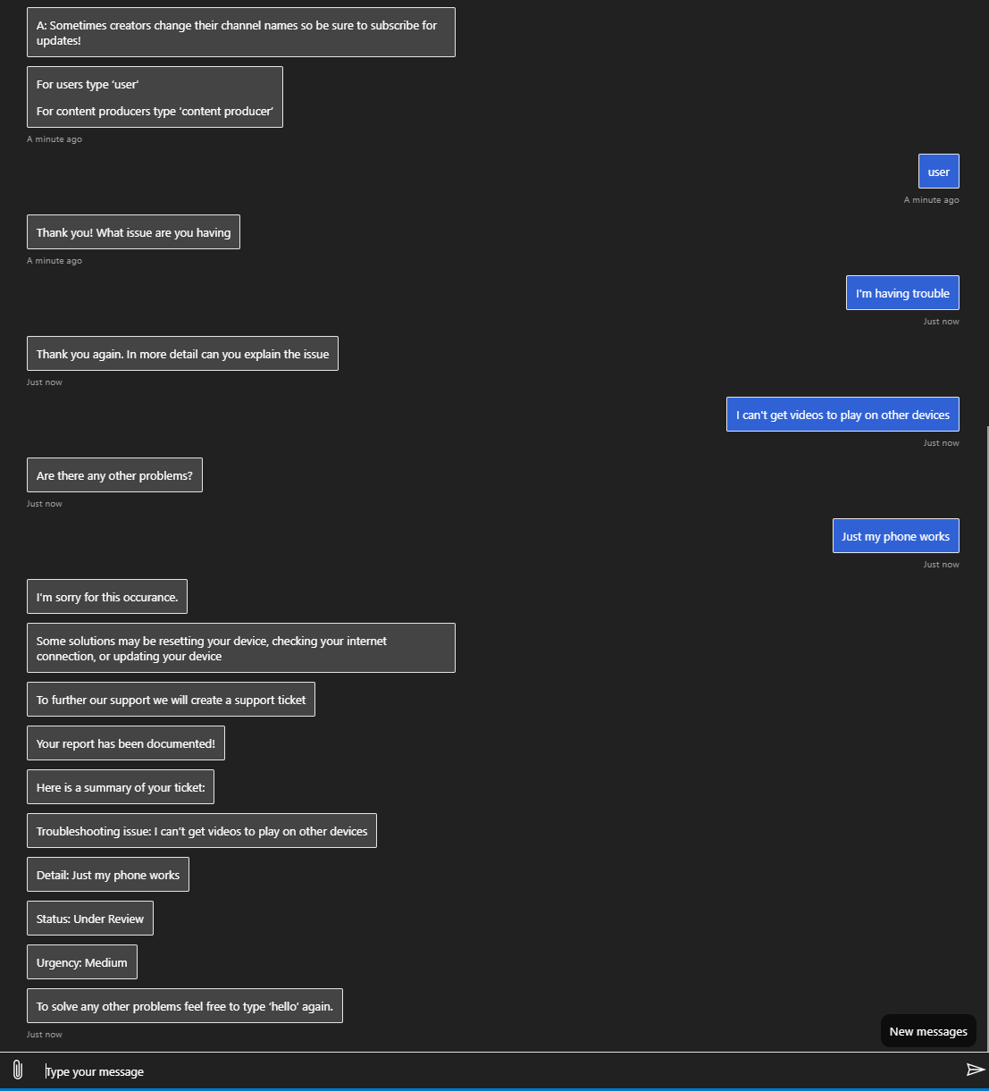

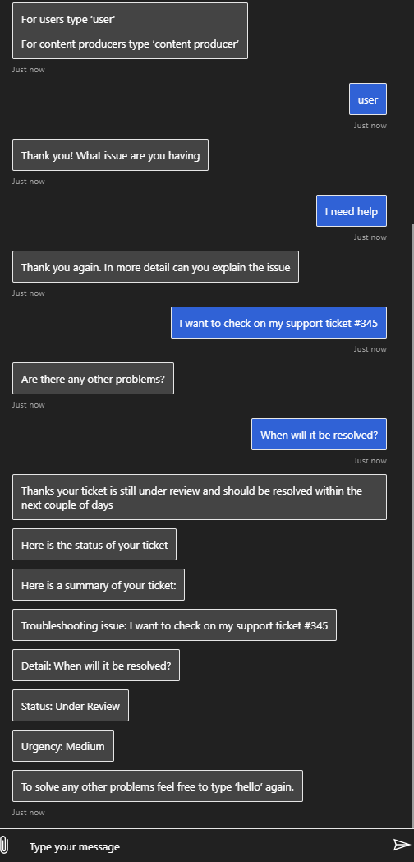

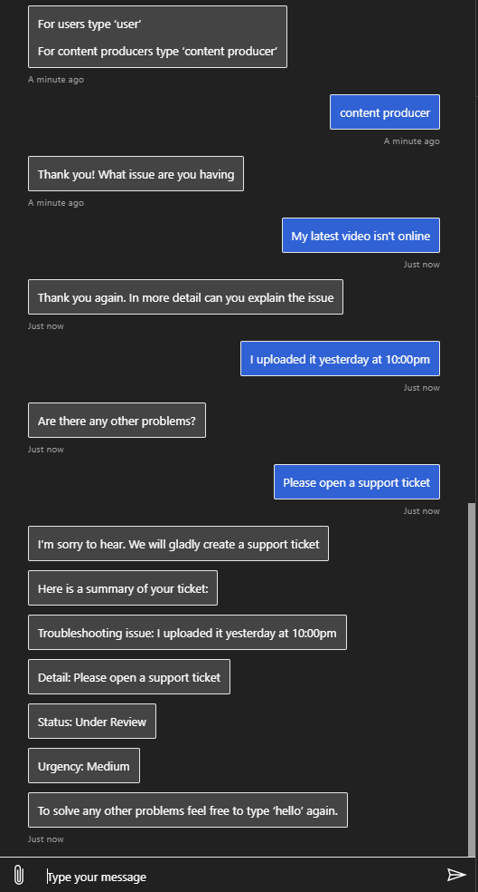

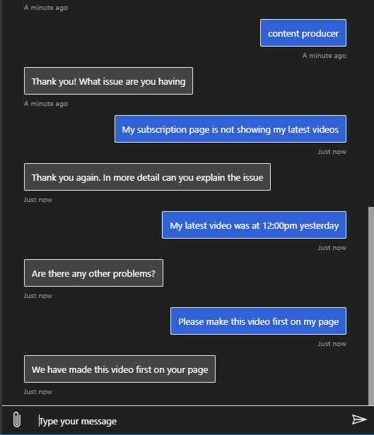

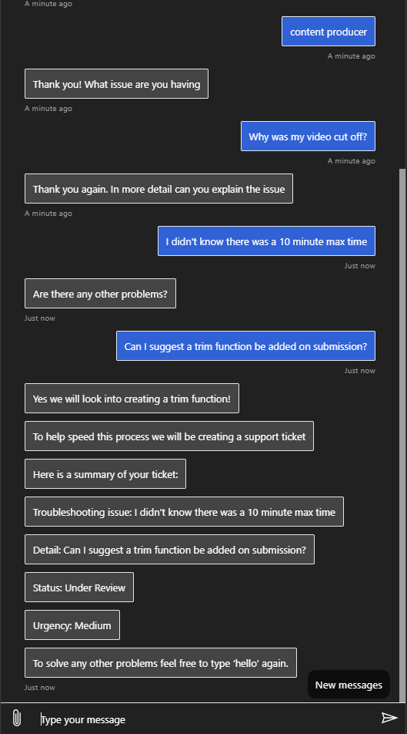

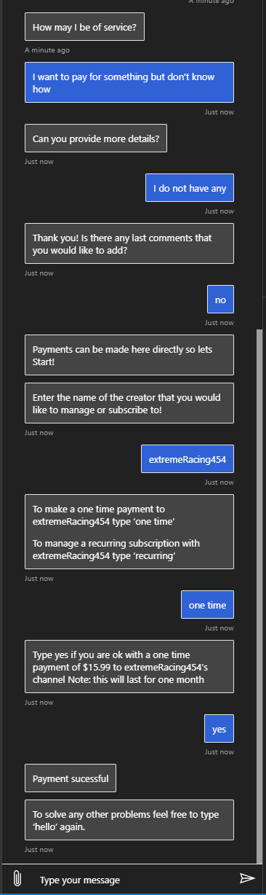

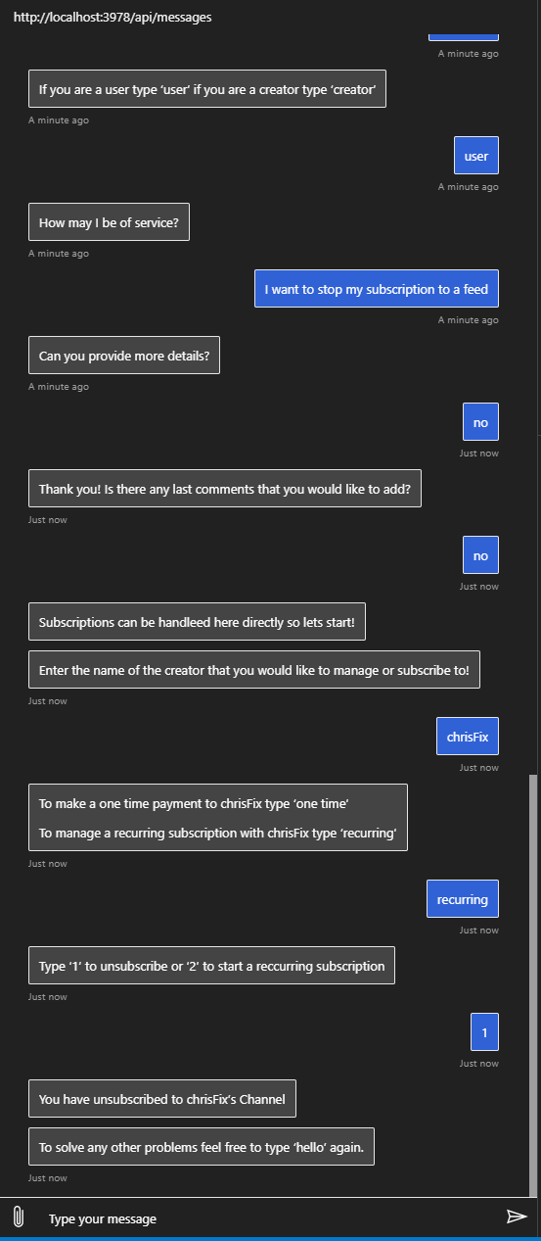

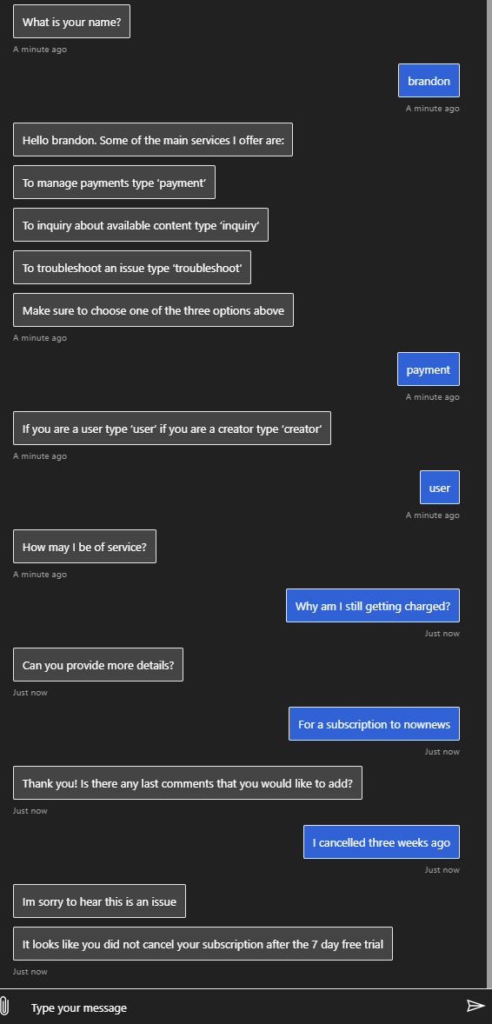

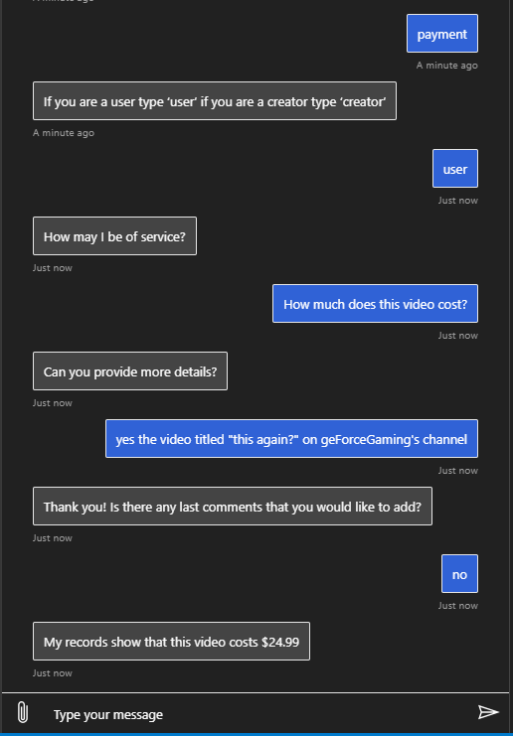

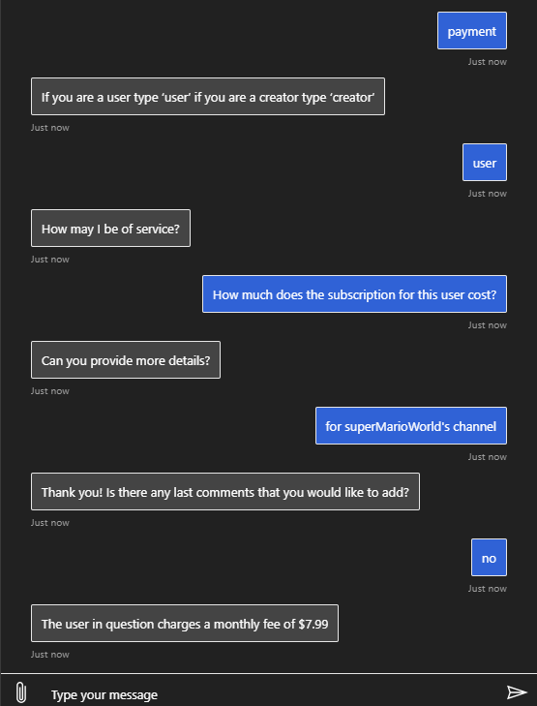

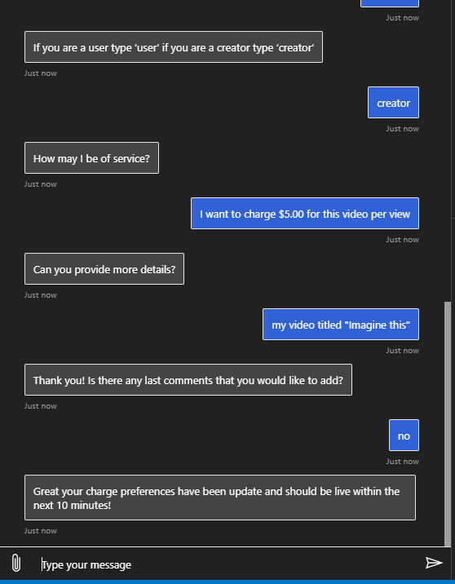

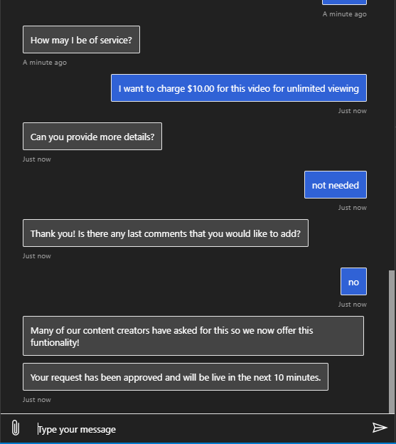

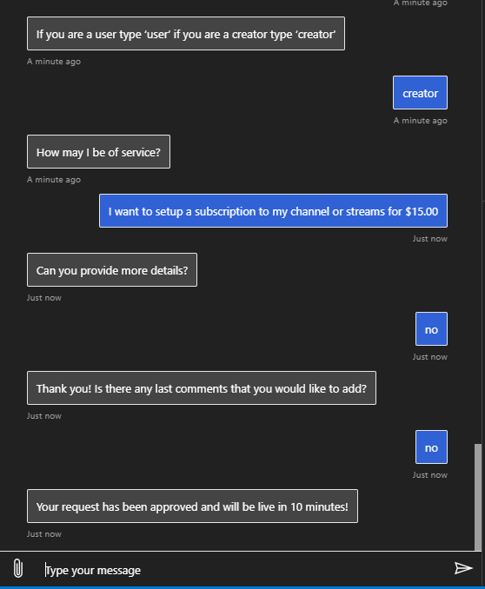

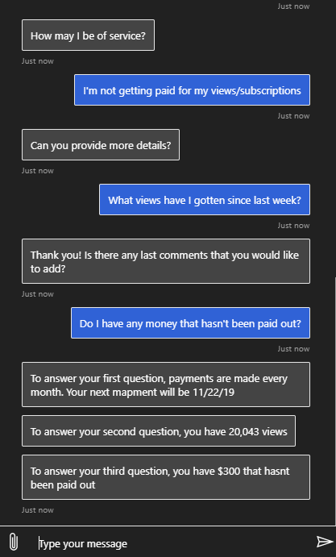

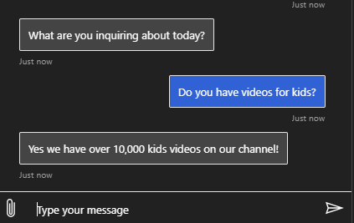

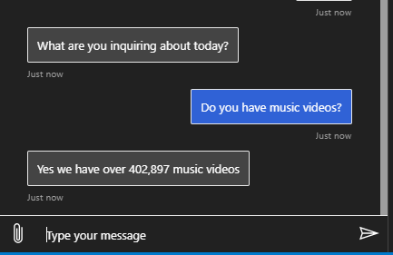

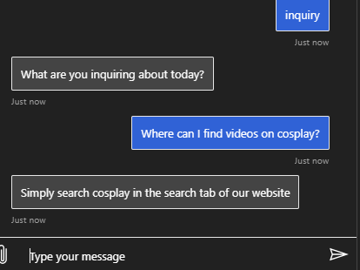

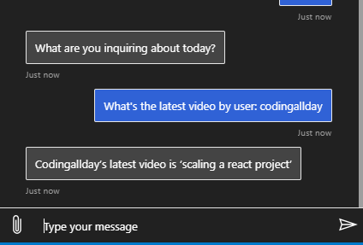

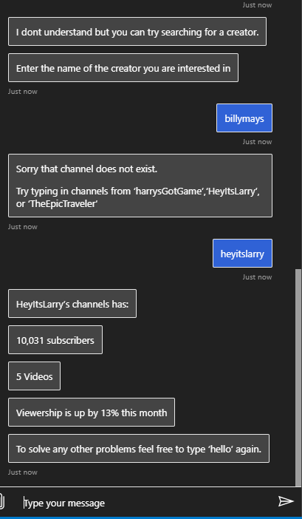

*******END OF README*******