Title

# Heading 1

## Heading 2

### Heading 3

#### This is header4 text to get centered text for the text.

##### Heading 5

##### This is header5 to get small text for the Acknowledgements.

THE STYLES FOUND IN THIS DOCUMENT WILL BE USED TO GENERATE THE CES PROJECT REPORTS DO NOT DELETE!!

This is an R Markdown document. Markdown is a simple formatting syntax for authoring HTML, PDF, and MS Word documents. For more details on using R Markdown see <http://rmarkdown.rstudio.com>.

When you click the Knit button a document will be generated that includes both content as well as the output of any embedded R code chunks within the document. You can embed an R code chunk like this:

summary(cars)

## speed dist   
## Min. : 4.0 Min. : 2.00   
## 1st Qu.:12.0 1st Qu.: 26.00   
## Median :15.0 Median : 36.00   
## Mean :15.4 Mean : 42.98   
## 3rd Qu.:19.0 3rd Qu.: 56.00   
## Max. :25.0 Max. :120.00

You can also embed plots, for example:

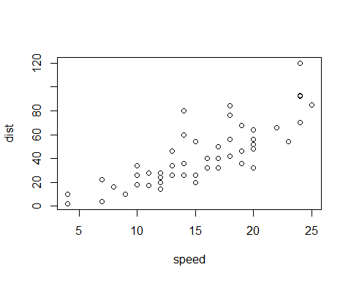

Note that the echo = FALSE parameter was added to the code chunk to prevent printing of the R code that generated the plot.