**Here are a few screen shots of the variations of code tried using the SCM Tortoise SVN.**

*Note:*

*This is only displaying 3 versions of the dress room class; however, well over 15 versions were tested until the final produced the closest results to meeting the requirements. The results for the final product are shared below the Tortoise SVN screenshots shown here on pages 7, 8, and 9.*

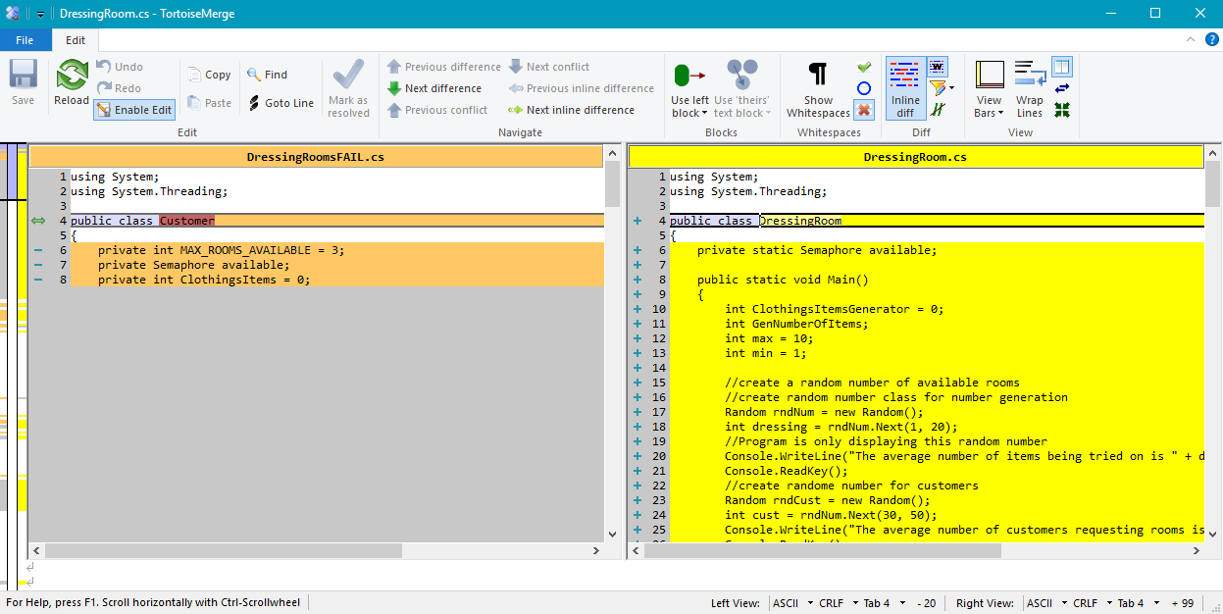

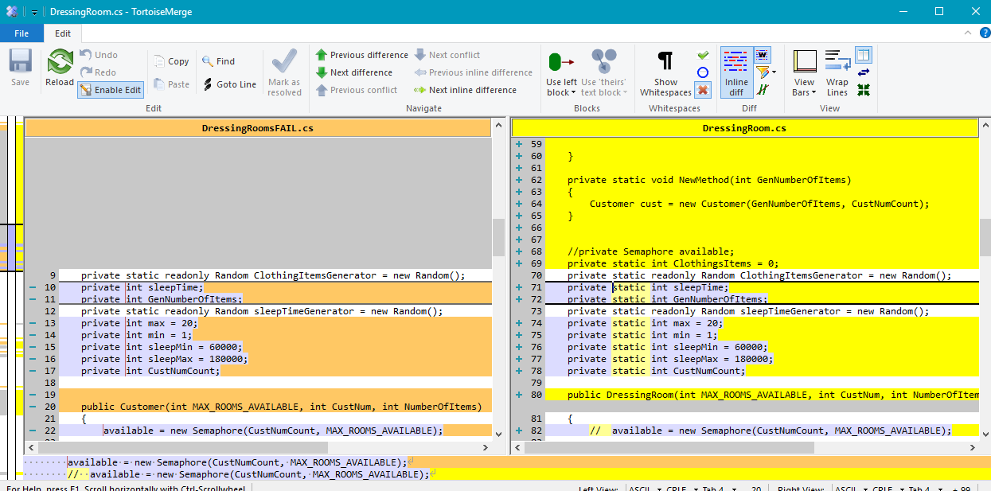

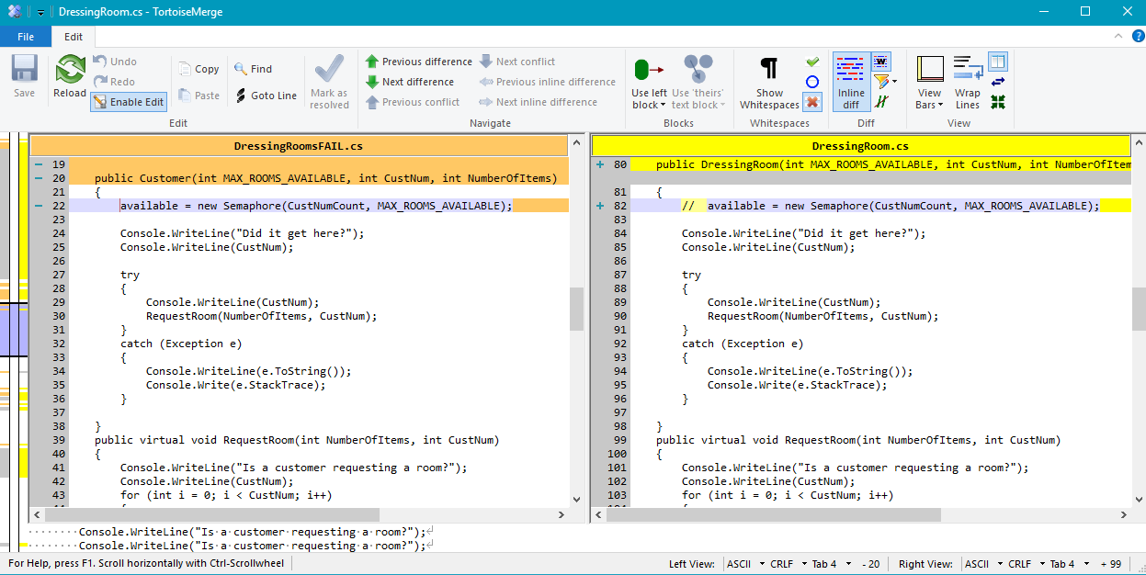

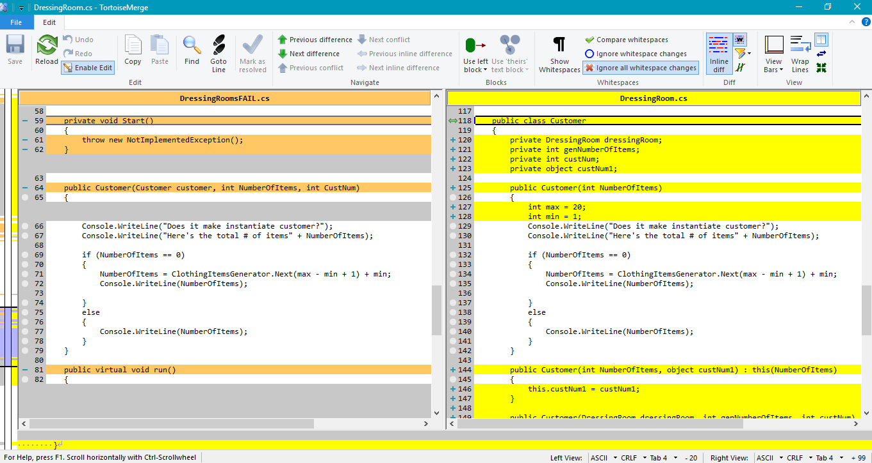

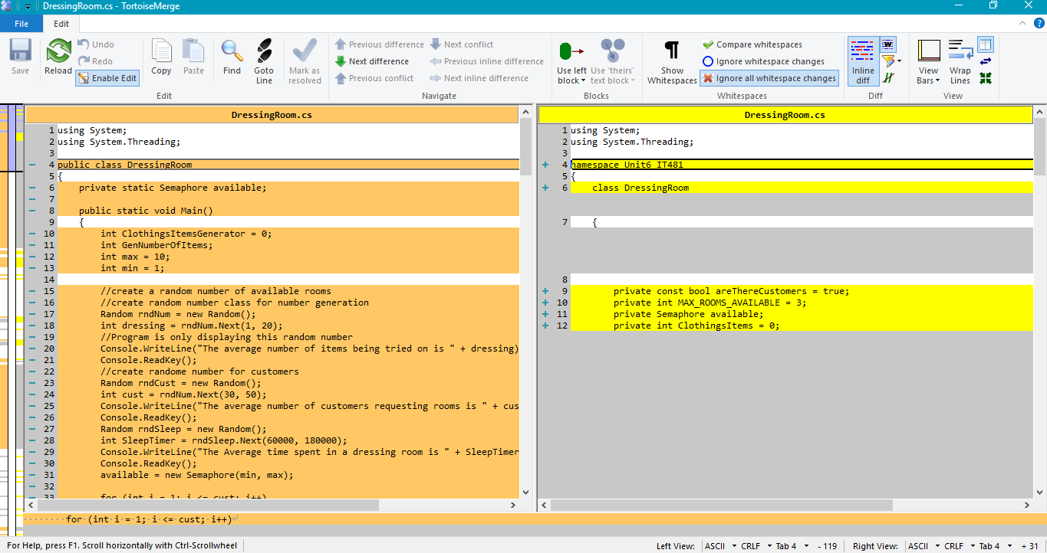

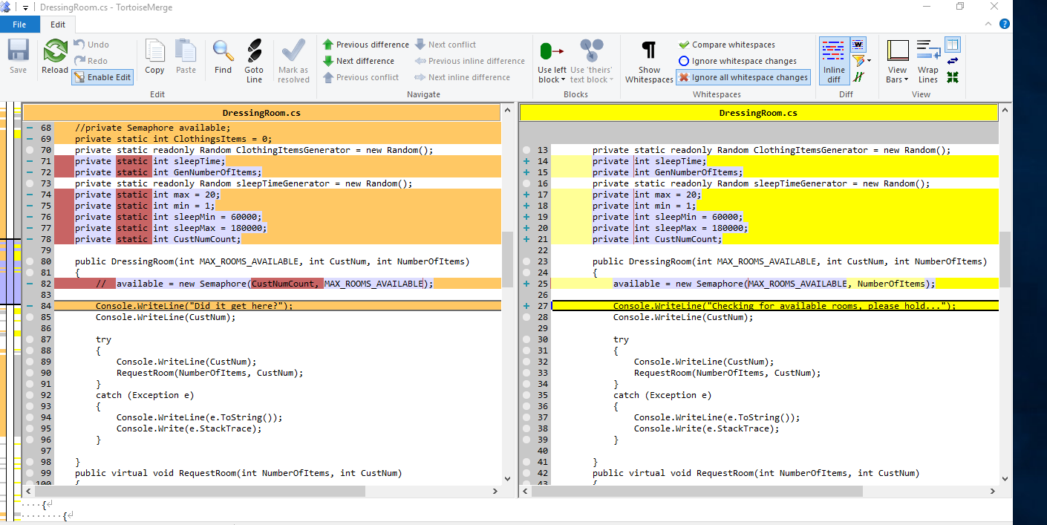

**Results for 3 Scenarios testing 9 customers, 21 customers, then 31 customers.**

9 customers 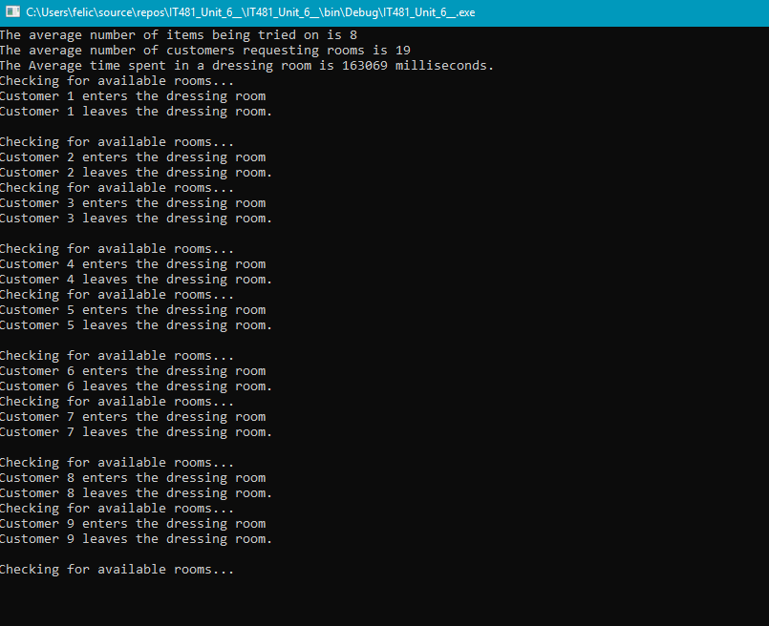

21 customers

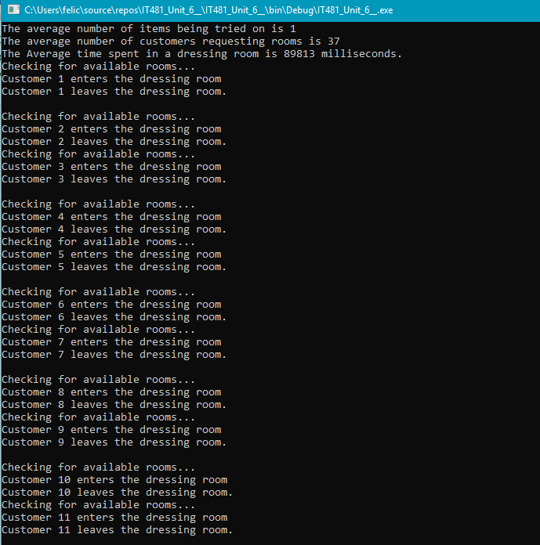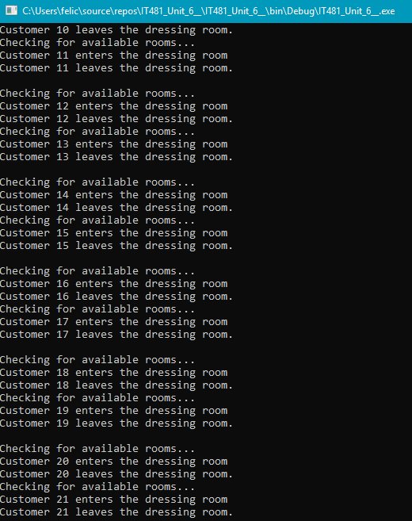

31 Customers

