Brandon Phillips

Project State

1. Describe any problems encountered in your implementation for this project.
   1. In this project, I had issues with segmentation faults that generally originated because I was accessing my elements at 0. I also ran into a bracket issues inside of my Dijkstra’s implementation where my code was running the wrong if else statement and never entering the DecreaseKey() loop. I also had an issue where I had a typo in my makefile executable.
2. Describe any known bugs and/or incomplete query implementation for this project.
   1. The code now currently compiles and other than some failed test cases, there should be little to no bugs in my code. The only known bugs are regarding the test cases.
3. While this project is to be complete individually, describe any significant interactions with anyone (peers or otherwise) that may have occurred.
   1. The most significant interaction that I had between others were with your code and watching the videos.
4. Cite any external books, and/or websites used or referenced.
   1. The only external source I had used was your examples of code and I was able to manipulate it to create my own. I used a portion of the book to verify pseudocode.
5. 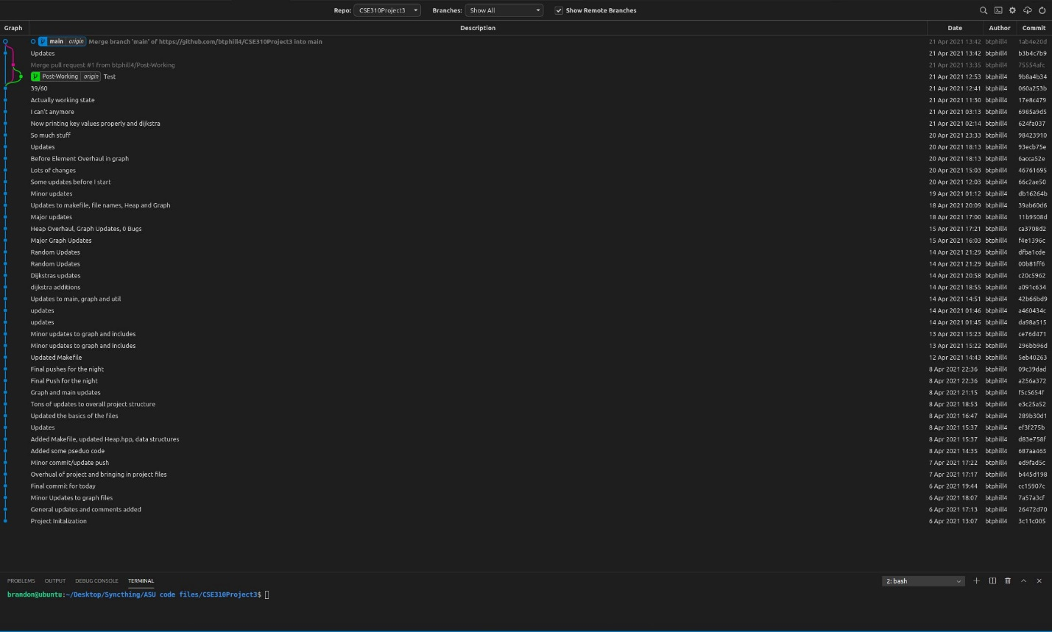A screen shot from your version control system showing commits over the development period of this project