Bench to Rafters
Peak OVR by difficulty and mode: how wide the spread is
18,000 simulated careers · 31 October 2026 · after round 25

Summary
Difficulty | Mean peak OVR  (random / smart) | Standard deviation  (random / smart) | Reached the NBA  (random / smart) | Round 8 report  (mean / SD, smart)
Regular guy | 69.73 / 73.73 | 12.61 / 11.83 | 68.7% / 76.1% | 75.74 / 17.83
Reality hits hard | 63.01 / 66.76 | 9.38 / 8.70 | 45.5% / 52.5% | 50.64 / 8.69
Shoot for the stars | 91.18 / 93.27 | 3.86 / 3.50 | 100.0% / 100.0% | 96.07 / 3.51

- Regular guy: an average peak of 73.73 for the smart player and 69.73 for random choices, with a standard deviation of 11.83 and 12.61. In round 8 it was about 18 (17.83 and 18.70): the spread is 33.7% narrower for the smart player and 32.6% for random choices, so more careers sit near the middle and the very top is rarer (2.1% of smart careers reach 97, against 17 in 100 then).
- Reality hits hard: an average of 66.76 (smart) and 63.01 (random), spread 8.70 and 9.38; 52.5% of smart careers play an NBA game.
- Shoot for the stars: an average of 93.27 (smart) and 91.18 (random), the tightest spread (3.50 and 3.86): potential is drawn in a narrow band from 85 up, a floor keeps every career on course for 80 by 22, and the 99 ceiling caps the top (15.5% of smart careers reach 97).
- Choices: smart play is worth 4.00 OVR on average in Regular guy, 3.75 in Reality and 2.09 in Stars; most of the spread is set before the first game (potential and starting OVR explain 79.2% of the variance in Regular guy).
- Modes: on the same careers in Regular guy, Fast break peaks −4.20 OVR (±0.15) and Sim mode −4.10 OVR (±0.15) against normal play: the 1.3 times faster growth does not make up for the training groups, the shop and the national team that the quick pace skips. In return Fast break takes 5.43 clicks a season and Sim mode 2.67, against 13.33.
- Sample size: 2,000 careers per difficulty and play style (20 times round 8’s 100), so a smart Regular guy mean is now known to about ±0.52 OVR (95%) instead of about ±3.49.
- Scouting: the starting OVR at 14 says little about the peak (each point ahead of the usual 14-year-old adds 0.28 to the expected peak in Regular guy), so the round 25 scouting report projects a freshman from these fits instead of the old 1.2 a point, which sent a 65 OVR freshman in Shoot for the stars past 99.

How the test was run
- The careers: each was played by the game engine from age 14 to retirement with the balance harness’s automated players: “random choices” picks any available option; “smart choices” focuses the two key stats for the position, picks plans by mood and age, takes the best-fitting offers and answers press conferences humbly. Mini-games were played casually (one claim a season when one is open), as in the balance checks. Postseasons were simulated.
- The seeds: every difficulty used the same 2,000 starting seeds (600000 to 601999), so the difficulties differ only by their rules. Fast break and Sim mode used the first 1,000 of them with the smart player, so each compares with normal play career by career.
- Fast break and Sim mode: turned on from the first day. Fast break plays one training group a season, skips the shop and the national team, and grows a player 1.3 times faster to make up for it (it does not fully, see below); Sim mode is fast break plus the routine calls made for him (the season plan, the summer, call-ups, press conferences).
- Not simulated: Master mode (it only hides recommendations), Simple text and Guide mode (they change the screen, not the game), and Built in a lab (now a mini-game, not a career difficulty).
- Statistics: the standard deviation is the sample standard deviation; its own standard error is SD ÷ √(2(n − 1)); brackets after a count are 95% confidence intervals (Wilson score); “±” after a mode difference is its standard error from the paired careers.
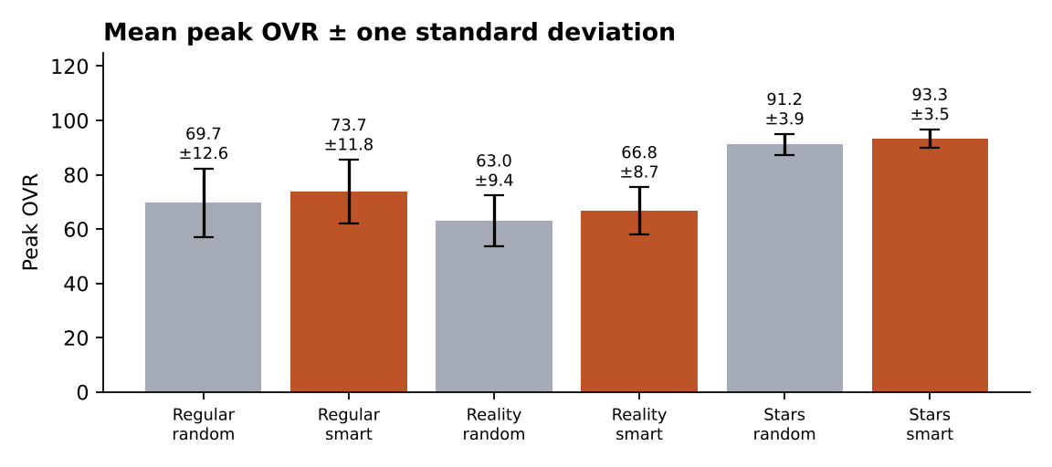
Mean peak OVR with one standard deviation either side, for each difficulty and play style (2,000 careers each).

Starting OVR (the same draw in every difficulty)
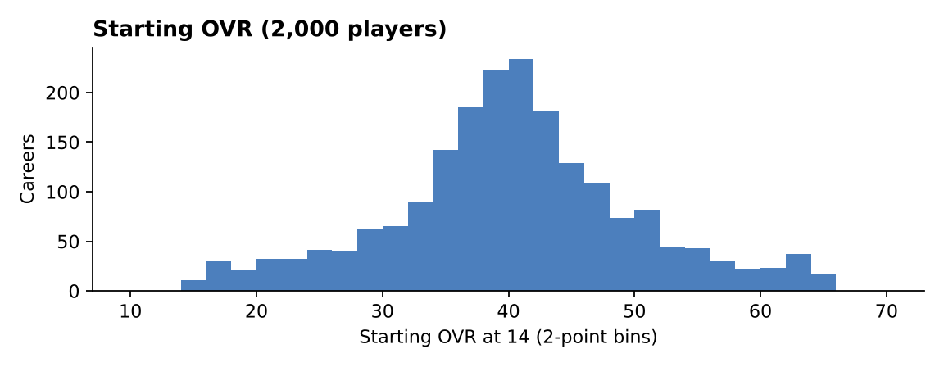
Starting OVR at 14 of 2,000 players.
- Mean 40.28, standard deviation 9.79: 970 of 2,000 players (48.5%) start within 5 of 40, 62 at 20 or below and 77 at 60 or above.

Regular guy
The default game: most careers peak in the 60s and 70s; the NBA is common and stardom is earned.
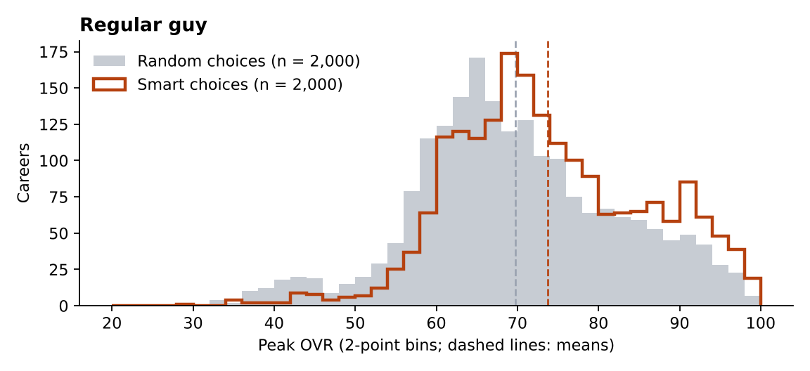
Peak OVR of 2,000 careers per play style in Regular guy.
Peak OVR | Random choices | Smart choices
Mean (95% interval) | 69.73 (69.18–70.29) | 73.73 (73.22–74.25)
Standard deviation (± its SE) | 12.61 (±0.20) | 11.83 (±0.19)
Median | 68.55 | 72.07
Middle half (25th–75th percentile) | 61.7–78.0 | 65.3–82.3
5th / 95th percentile | 49.1 / 92.0 | 57.3 / 94.4
Lowest / highest | 32.2 / 99.0 | 28.1 / 99.0
Skewness | 0.02 | 0.07
Below 50 | 109 (5.5%; 4.5–6.5%) | 38 (1.9%; 1.4–2.6%)
70 or higher | 905 (45.3%; 43.1–47.4%) | 1,164 (58.2%; 56.0–60.3%)
80 or higher (All-Star level) | 434 (21.7%; 19.9–23.6%) | 573 (28.6%; 26.7–30.7%)
90 or higher | 149 (7.5%; 6.4–8.7%) | 252 (12.6%; 11.2–14.1%)
95 or higher (MVP level) | 48 (2.4%; 1.8–3.2%) | 84 (4.2%; 3.4–5.2%)
97 or higher | 20 (1.0%; 0.6–1.5%) | 42 (2.1%; 1.6–2.8%)
Played in the NBA | 1,374 (68.7%; 66.6–70.7%) | 1,522 (76.1%; 74.2–77.9%)
At least one All-Star | 572 (28.6%; 26.7–30.6%) | 713 (35.6%; 33.6–37.8%)
At least one All-NBA | 423 (21.1%; 19.4–23.0%) | 465 (23.3%; 21.5–25.2%)
At least one MVP | 127 (6.3%; 5.4–7.5%) | 236 (11.8%; 10.5–13.3%)
At least one title | 256 (12.8%; 11.4–14.3%) | 720 (36.0%; 33.9–38.1%)
Hall of Fame | 147 (7.3%; 6.3–8.6%) | 267 (13.3%; 11.9–14.9%)
NBA seasons (those who made it) | 8.37 | 11.45
Median retirement age | 33.0 | 32.0
Career index (mean) | 26.63 | 42.49
Clicks a season | 12.97 | 13.33

Counts are out of 2,000 careers; brackets are 95% confidence intervals.
- Smart play adds 4.00 OVR on average; the two standard deviations are 12.61 and 11.83.
- Against round 8 (100 careers each): the smart mean was 75.74 with a standard deviation of 17.83; now 73.73 and 11.83. Random: 68.96 and 18.70 then, 69.73 and 12.61 now.
- Set at the start: potential correlates with peak OVR at r = 0.88 (smart) and starting OVR at r = 0.18; together they explain 79.2% of the variance (random: 73.1%). The rest comes from the career: choices, events, injuries, minutes and luck.

Reality hits hard
Potential is drawn far lower, growth is 10% slower and injuries 30% likelier. The league is unchanged, so reaching it is the hard part.
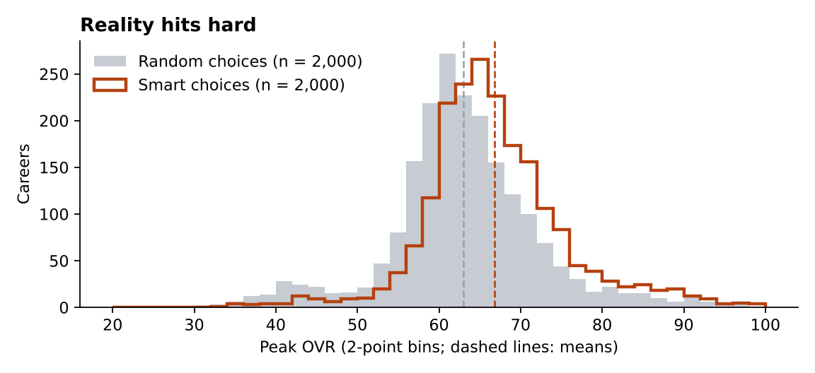
Peak OVR of 2,000 careers per play style in Reality hits hard.
Peak OVR | Random choices | Smart choices
Mean (95% interval) | 63.01 (62.60–63.42) | 66.76 (66.38–67.15)
Standard deviation (± its SE) | 9.38 (±0.15) | 8.70 (±0.14)
Median | 62.57 | 65.81
Middle half (25th–75th percentile) | 58.5–67.6 | 61.8–70.8
5th / 95th percentile | 45.3 / 79.3 | 55.4 / 83.6
Lowest / highest | 31.8 / 98.4 | 33.8 / 98.5
Skewness | 0.12 | 0.39
Below 50 | 142 (7.1%; 6.1–8.3%) | 52 (2.6%; 2.0–3.4%)
70 or higher | 354 (17.7%; 16.1–19.4%) | 575 (28.8%; 26.8–30.8%)
80 or higher (All-Star level) | 94 (4.7%; 3.9–5.7%) | 146 (7.3%; 6.2–8.5%)
90 or higher | 26 (1.3%; 0.9–1.9%) | 34 (1.7%; 1.2–2.4%)
95 or higher (MVP level) | 8 (0.4%; 0.2–0.8%) | 12 (0.6%; 0.3–1.0%)
97 or higher | 1 (0.1%; 0.0–0.3%) | 6 (0.3%; 0.1–0.7%)
Played in the NBA | 909 (45.5%; 43.3–47.6%) | 1,050 (52.5%; 50.3–54.7%)
At least one All-Star | 150 (7.5%; 6.4–8.7%) | 232 (11.6%; 10.3–13.1%)
At least one All-NBA | 86 (4.3%; 3.5–5.3%) | 111 (5.5%; 4.6–6.6%)
At least one MVP | 23 (1.1%; 0.8–1.7%) | 42 (2.1%; 1.6–2.8%)
At least one title | 152 (7.6%; 6.5–8.8%) | 413 (20.6%; 18.9–22.5%)
Hall of Fame | 29 (1.4%; 1.0–2.1%) | 51 (2.5%; 1.9–3.3%)
NBA seasons (those who made it) | 5.82 | 8.71
Median retirement age | 33.0 | 32.0
Career index (mean) | 8.42 | 15.31
Clicks a season | 12.86 | 13.26

Counts are out of 2,000 careers; brackets are 95% confidence intervals.
- Smart play adds 3.75 OVR on average; the two standard deviations are 9.38 and 8.70.
- Against round 8 (100 careers each): the smart mean was 50.64 with a standard deviation of 8.69; now 66.76 and 8.70. Random: 47.27 and 9.55 then, 63.01 and 9.38 now.
- Set at the start: potential correlates with peak OVR at r = 0.78 (smart) and starting OVR at r = 0.28; together they explain 65.8% of the variance (random: 63.5%). The rest comes from the career: choices, events, injuries, minutes and luck.

Shoot for the stars
Potential starts at 85, growth is 20% faster and injuries 40% rarer; a floor keeps the player on a straight line to OVR 80 by age 22.
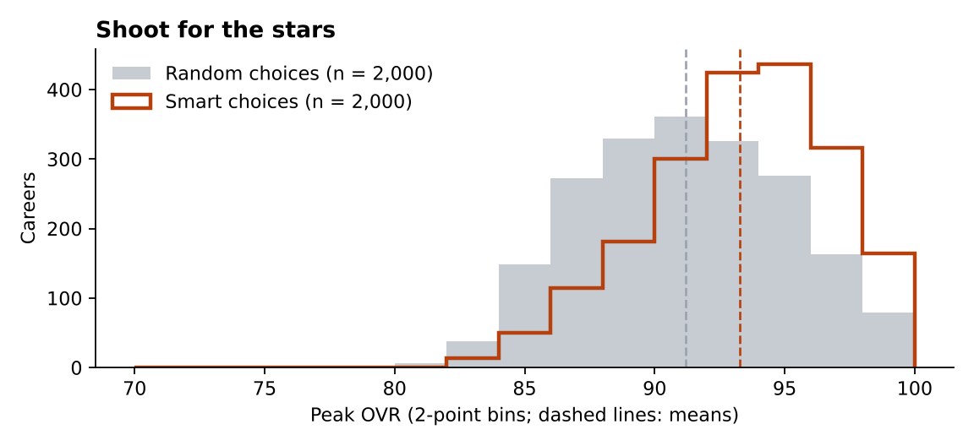
Peak OVR of 2,000 careers per play style in Shoot for the stars.
Peak OVR | Random choices | Smart choices
Mean (95% interval) | 91.18 (91.01–91.35) | 93.27 (93.12–93.42)
Standard deviation (± its SE) | 3.86 (±0.06) | 3.50 (±0.06)
Median | 91.09 | 93.66
Middle half (25th–75th percentile) | 88.2–94.1 | 91.0–95.9
5th / 95th percentile | 85.1 / 97.6 | 86.8 / 98.5
Lowest / highest | 80.9 / 99.0 | 83.0 / 99.0
Skewness | 0.02 | -0.49
Below 50 | 0 (0.0%; 0.0–0.2%) | 0 (0.0%; 0.0–0.2%)
70 or higher | 2,000 (100.0%; 99.8–100.0%) | 2,000 (100.0%; 99.8–100.0%)
80 or higher (All-Star level) | 2,000 (100.0%; 99.8–100.0%) | 2,000 (100.0%; 99.8–100.0%)
90 or higher | 1,205 (60.3%; 58.1–62.4%) | 1,641 (82.0%; 80.3–83.7%)
95 or higher (MVP level) | 375 (18.8%; 17.1–20.5%) | 675 (33.8%; 31.7–35.9%)
97 or higher | 153 (7.7%; 6.6–8.9%) | 310 (15.5%; 14.0–17.2%)
Played in the NBA | 2,000 (100.0%; 99.8–100.0%) | 2,000 (100.0%; 99.8–100.0%)
At least one All-Star | 2,000 (100.0%; 99.8–100.0%) | 1,998 (99.9%; 99.6–100.0%)
At least one All-NBA | 1,963 (98.2%; 97.5–98.7%) | 1,959 (98.0%; 97.2–98.5%)
At least one MVP | 1,087 (54.4%; 52.2–56.5%) | 1,646 (82.3%; 80.6–83.9%)
At least one title | 1,018 (50.9%; 48.7–53.1%) | 1,922 (96.1%; 95.2–96.9%)
Hall of Fame | 1,178 (58.9%; 56.7–61.0%) | 1,689 (84.5%; 82.8–86.0%)
NBA seasons (those who made it) | 13.49 | 14.49
Median retirement age | 34.0 | 32.0
Career index (mean) | 128.72 | 196.44
Clicks a season | 13.44 | 13.68

Counts are out of 2,000 careers; brackets are 95% confidence intervals.
- Smart play adds 2.09 OVR on average; the two standard deviations are 3.86 and 3.50.
- Against round 8 (100 careers each): the smart mean was 96.07 with a standard deviation of 3.51; now 93.27 and 3.50. Random: 92.57 and 4.73 then, 91.18 and 3.86 now.
- Set at the start: potential correlates with peak OVR at r = 0.54 (smart) and starting OVR at r = -0.07; together they explain 30.3% of the variance (random: 32.2%). The rest comes from the career: choices, events, injuries, minutes and luck.

Fast break and Sim mode
Each difficulty with the smart player, normal play against Fast break and Sim mode on the same 1,000 careers. The differences are paired (the same seed played three ways), with their standard errors.

Regular guy
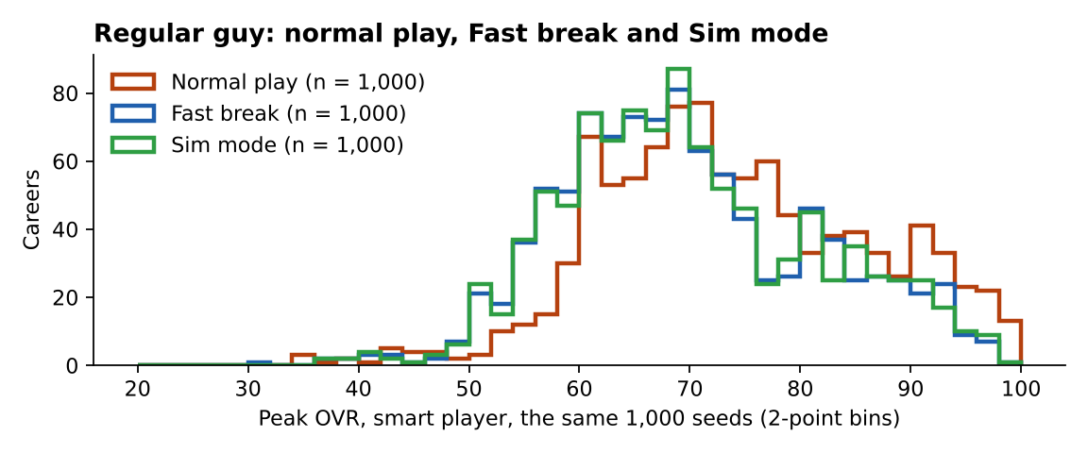
Regular guy: peak OVR in normal play, Fast break and Sim mode, the same 1,000 careers.
Smart player, same 1,000 careers | Normal play | Fast break | Sim mode
Mean peak OVR | 73.95 | 69.75  −4.20 (±0.15) | 69.85  −4.10 (±0.15)
Standard deviation | 12.10 | 11.64 | 11.59
Played in the NBA | 75.6% | 70.3%  −5.30 pts (±0.97) | 70.7%  −4.90 pts (±0.97)
At least one All-Star | 36.6% | 24.5%  −12.10 pts (±1.17) | 25.2%  −11.40 pts (±1.16)
At least one MVP | 12.6% | 6.0%  −6.60 pts (±0.83) | 6.1%  −6.50 pts (±0.84)
At least one title | 37.0% | 23.3%  −13.70 pts (±1.59) | 21.7%  −15.30 pts (±1.57)
Hall of Fame | 13.5% | 7.1%  −6.40 pts (±0.81) | 7.6%  −5.90 pts (±0.78)
Clicks a season | 13.33 | 5.43  −7.90 (±0.02) | 2.67  −10.66 (±0.02)

Reality hits hard
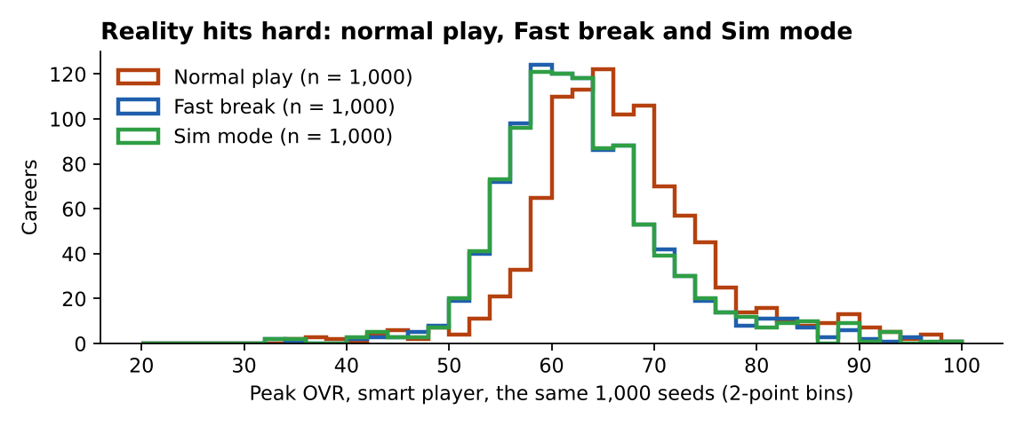
Reality hits hard: peak OVR in normal play, Fast break and Sim mode, the same 1,000 careers.
Smart player, same 1,000 careers | Normal play | Fast break | Sim mode
Mean peak OVR | 66.78 | 63.07  −3.71 (±0.17) | 63.06  −3.72 (±0.17)
Standard deviation | 8.81 | 8.14 | 8.34
Played in the NBA | 53.8% | 43.7%  −10.10 pts (±1.39) | 43.7%  −10.10 pts (±1.39)
At least one All-Star | 11.3% | 5.7%  −5.60 pts (±0.87) | 6.2%  −5.10 pts (±0.85)
At least one MVP | 2.5% | 0.8%  −1.70 pts (±0.41) | 1.2%  −1.30 pts (±0.39)
At least one title | 21.5% | 13.0%  −8.50 pts (±1.38) | 13.6%  −7.90 pts (±1.39)
Hall of Fame | 3.2% | 1.1%  −2.10 pts (±0.45) | 1.3%  −1.90 pts (±0.45)
Clicks a season | 13.26 | 5.45  −7.80 (±0.02) | 2.70  −10.56 (±0.02)

Shoot for the stars
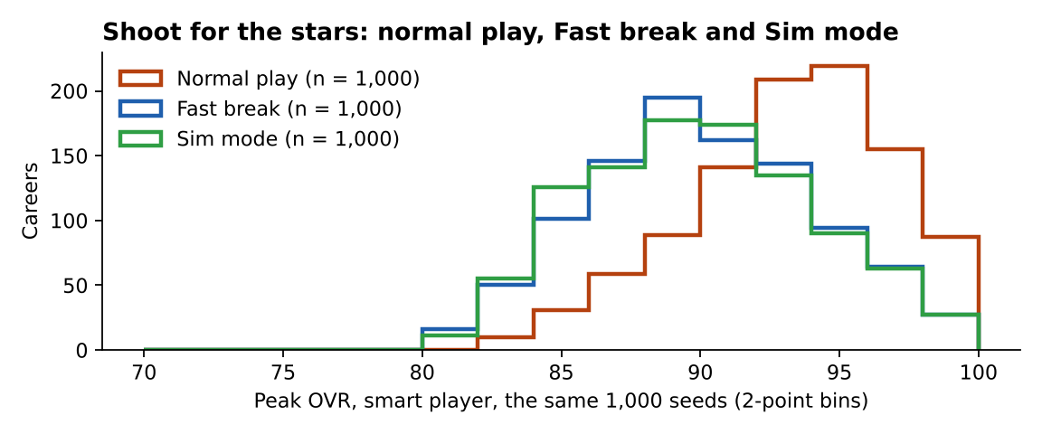
Shoot for the stars: peak OVR in normal play, Fast break and Sim mode, the same 1,000 careers.
Smart player, same 1,000 careers | Normal play | Fast break | Sim mode
Mean peak OVR | 93.22 | 90.07  −3.15 (±0.09) | 89.94  −3.28 (±0.09)
Standard deviation | 3.61 | 4.26 | 4.30
Played in the NBA | 100.0% | 99.9%  −0.10 pts (±0.10) | 99.9%  −0.10 pts (±0.10)
At least one All-Star | 99.9% | 97.8%  −2.10 pts (±0.45) | 98.1%  −1.80 pts (±0.42)
At least one MVP | 81.3% | 51.9%  −29.40 pts (±1.50) | 51.7%  −29.60 pts (±1.48)
At least one title | 95.3% | 89.7%  −5.60 pts (±1.14) | 89.8%  −5.50 pts (±1.15)
Hall of Fame | 83.3% | 58.8%  −24.50 pts (±1.47) | 57.8%  −25.50 pts (±1.49)
Clicks a season | 13.68 | 5.37  −8.31 (±0.01) | 2.66  −11.02 (±0.01)

In each cell under a mode: the rate in that mode, then its paired difference from normal play (± standard error).

What the modes cost
- Fast break and Sim mode land within 0.10 OVR of each other in Regular guy (0.01 in Reality, 0.13 in Stars): the calls Sim mode makes for him cost almost nothing next to what the quick pace itself skips.
- Both cost about 4.2 OVR in Regular guy, 3.7 in Reality and 3.2 in Stars. In Stars that is the difference between MVP level and not: 81.3% of normal careers win an MVP against 51.9% in Fast break.
- Clicks: normal play takes 13.33 a season in Regular guy, Fast break 5.43 and Sim mode 2.67.
- If the modes should keep pace with normal play, the Fast break growth factor (1.3) is the dial; that is the owner’s call, and nothing was changed for this report.

What the starting OVR says (the scouting report)
Before age 16 the scouts have no range on a player, so the scouting report projects his peak from his OVR as a freshman. These 12,000 careers (both play styles, normal play) show how much that OVR actually says:
Difficulty | Expected peak at a typical start (44.5) | Added per point of starting OVR | Spread around the line (SD) | Correlation r
Regular guy | 72.92153 | 0.2790611 | 12.08279 | 0.22056
Reality hits hard | 66.15788 | 0.2971412 | 8.767987 | 0.315271
Shoot for the stars | 92.09244 | -0.03057654 | 3.814488 | -0.078093

Starting OVR at 14 | Regular guy: mean peak (n) | Reality hits hard: mean peak (n) | Shoot for the stars: mean peak (n)
30–39 | 70.57 (1,418) | 63.58 (1,418) | 92.21 (1,436)
40–49 | 73.28 (1,456) | 66.11 (1,449) | 92.12 (1,448)
50–59 | 74.96 (438) | 68.69 (439) | 91.99 (430)
60–69 | 76.36 (151) | 71.74 (149) | 91.33 (147)

- A freshman 10 points ahead of the usual start can expect only about 2.8 more at his peak in Regular guy and 3.0 in Reality; in Shoot for the stars the starting OVR makes no difference at all (-0.03058 a point).
- The old projection added 1.2 a point. A 65 OVR freshman in Shoot for the stars was projected at 101–99, every milestone showed a tick, and the projection could pass 99.
- Round 25 projects from these fits instead (expected peak, the added amount a point and the spread for each difficulty), caps the projection at 99, and shows a tick only for a milestone already reached. The same 65 OVR freshman now projects at about 92.1 ± 3.8 in Shoot for the stars and 78.6 ± 12.1 in Regular guy.

Appendix: unrounded values
- standard, random: n 2000; mean 69.73371; standard deviation 12.61081; standard error 0.2819864; median 68.55186; skewness 0.0193385; variance explained at the start 0.7307735.
- standard, smart: n 2000; mean 73.73404; standard deviation 11.83034; standard error 0.2645344; median 72.07389; skewness 0.0692887; variance explained at the start 0.7924696.
- standard, smart, fast: n 1000; mean 69.75393; standard deviation 11.6359; paired difference -4.200015 (standard error 0.1497598); clicks a season 5.429585.
- standard, smart, sim: n 1000; mean 69.851; standard deviation 11.58956; paired difference -4.102948 (standard error 0.1528259); clicks a season 2.666061.
- reality, random: n 2000; mean 63.00954; standard deviation 9.384394; standard error 0.2098414; median 62.56503; skewness 0.1181089; variance explained at the start 0.6349154.
- reality, smart: n 2000; mean 66.76408; standard deviation 8.697618; standard error 0.1944847; median 65.81123; skewness 0.3890288; variance explained at the start 0.6576445.
- reality, smart, fast: n 1000; mean 63.06972; standard deviation 8.143489; paired difference -3.711891 (standard error 0.1702391); clicks a season 5.453147.
- reality, smart, sim: n 1000; mean 63.06029; standard deviation 8.343157; paired difference -3.721318 (standard error 0.1680347); clicks a season 2.697405.
- stars, random: n 2000; mean 91.17862; standard deviation 3.857408; standard error 0.08625428; median 91.09191; skewness 0.01975256; variance explained at the start 0.32211.
- stars, smart: n 2000; mean 93.26921; standard deviation 3.495792; standard error 0.07816829; median 93.66305; skewness -0.4876759; variance explained at the start 0.3030039.
- stars, smart, fast: n 1000; mean 90.07269; standard deviation 4.264686; paired difference -3.152082 (standard error 0.08926292); clicks a season 5.369744.
- stars, smart, sim: n 1000; mean 89.94278; standard deviation 4.30161; paired difference -3.281995 (standard error 0.08971689); clicks a season 2.659513.
- standard, scouting fit (random and smart, n 4000): peak = 72.92153 + 0.2790611 × (starting OVR − 44.5); residual standard deviation 12.08279; r 0.2205605.
- reality, scouting fit (random and smart, n 4000): peak = 66.15788 + 0.2971412 × (starting OVR − 44.5); residual standard deviation 8.767987; r 0.3152712.
- stars, scouting fit (random and smart, n 4000): peak = 92.09244 + -0.03057654 × (starting OVR − 44.5); residual standard deviation 3.814488; r -0.07809297.

