Bench to Rafters: peak OVR by difficulty mode
100 simulated careers per mode and play style (600 in total) · 28 October 2026

Summary
Mode | Average peak (random / smart) | Reached the NBA
Standard | 69.0 / 75.7 | 64% / 74%
Reality hits hard | 47.3 / 50.6 | 7% / 5%
Shoot for the stars | 92.6 / 96.1 | 100% / 100%
- Standard: the average sits in the low 70s as asked (69.0 and 75.7 here; 68.5 and 74.1 over 2,000 careers each). The spread is wider than before (standard deviation about 18), so the high end is easier to reach: 17 in 100 smart careers and 8 in 100 random ones peaked at 97 or higher.
- Reality hits hard: only 7 and 5 of 100 careers played a single NBA game, and none reached 80. Most peak in the 40s and 50s.
- Shoot for the stars: every career reached 80 (the lowest peak was 83.3), and 27 (random) and 58 (smart) of 100 peaked at 97 or higher.
- Starting OVR: out of 600 players, 24 started at 20 or below and 18 at 60 or above (about 1 in 25 and 1 in 33), and 307 (51%) started within 5 of 40.

How the test was run
Each career was played from age 14 to retirement by the game engine, using the balance harness's automated players: "random choices" picks any available option; "smart choices" focuses the two key stats for the position, picks plans by morale and age, and takes the best-fitting offers. Every mode used the same 100 starting seeds (600000–600099), so the modes differ only by their rules. Postseasons were simulated.
What changed since the last report: starting OVR is now drawn around 40 (a double-exponential, or Laplace, shape: dense in the middle, with rare extremes at 20 and 60); a hidden growth rate decides how fast each player turns work into improvement, shifts his prime and fades after 27; the growth curve slows through the twenties and stops between 30 and 34; benched teenagers now develop in practice; and Standard's potential distribution was raised and widened.
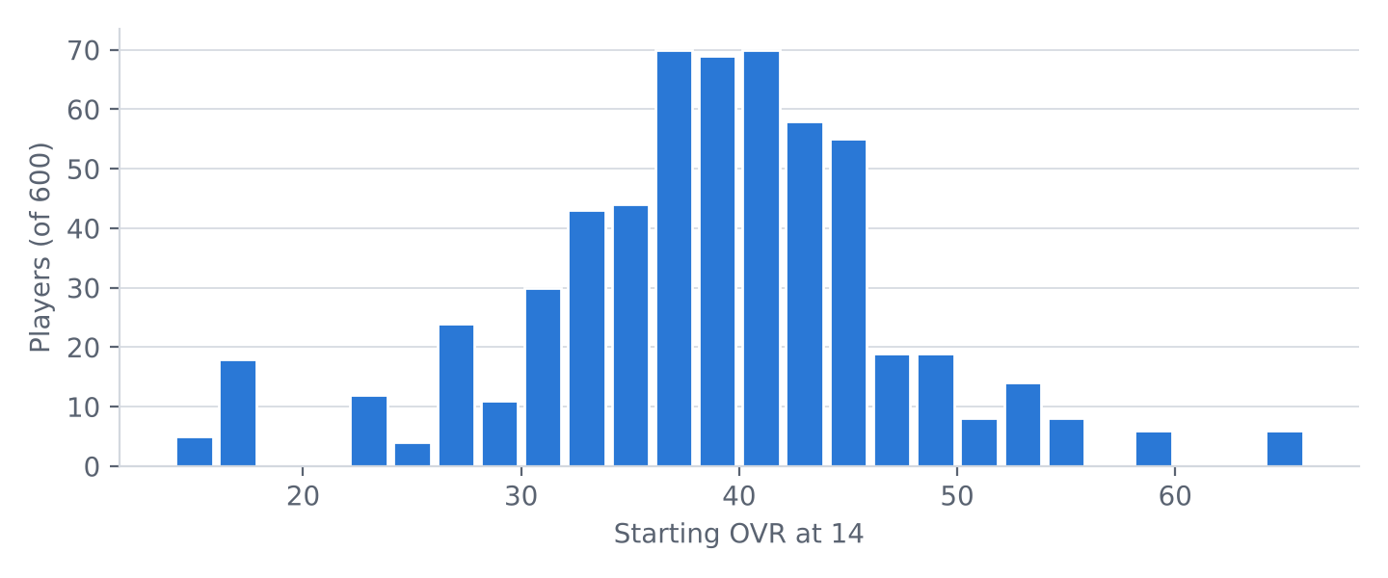
Starting OVR of all 600 players (the starting draw is the same in every mode), in 2-point bins.

Standard
The default game. Target: an average peak in the low 70s, spread out so the high end is reachable.
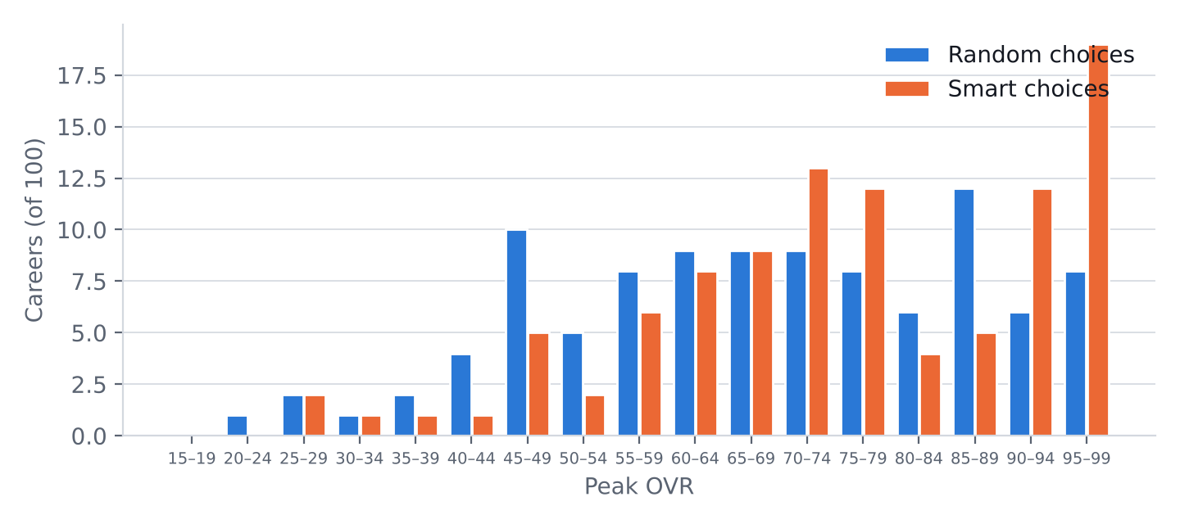
Peak OVR of 100 careers per play style in Standard, in 5-point bins (each bin includes its lower bound).
Peak OVR | Random choices | Smart choices
Mean | 68.96 | 75.74
Standard deviation | 18.70 | 17.83
Median | 69.58 | 75.83
5th / 95th percentile | 38.0 / 99.0 | 46.1 / 99.0
Lowest / highest | 24.6 / 99.0 | 29.4 / 99.0
Below 52.5 | 23 (16–32%) | 11 (6–19%)
80 or higher | 32 (24–42%) | 40 (31–50%)
90 or higher | 14 (9–22%) | 31 (23–41%)
97 or higher | 8 (4–15%) | 17 (11–26%)
Played in the NBA | 64 | 74
At least one All-Star | 37 | 46
At least one MVP | 13 | 20
Hall of Fame | 26 | 31
Counts are out of 100 careers. Brackets: 95% confidence interval (Wilson score); with 100 careers these intervals are wide.
- The two play styles are about 6.8 OVR apart on average: choices matter, but potential and the hidden growth rate matter more.
- With 100 careers the average is only known to about ±3.6 OVR (95%); the 2,000-career harness figures (68.48 and 74.12) are the reliable ones.

Reality hits hard
Potential is drawn far lower (median about 50), growth is 8% slower and injuries 30% likelier. The league around the player is unchanged, so reaching it is the hard part.
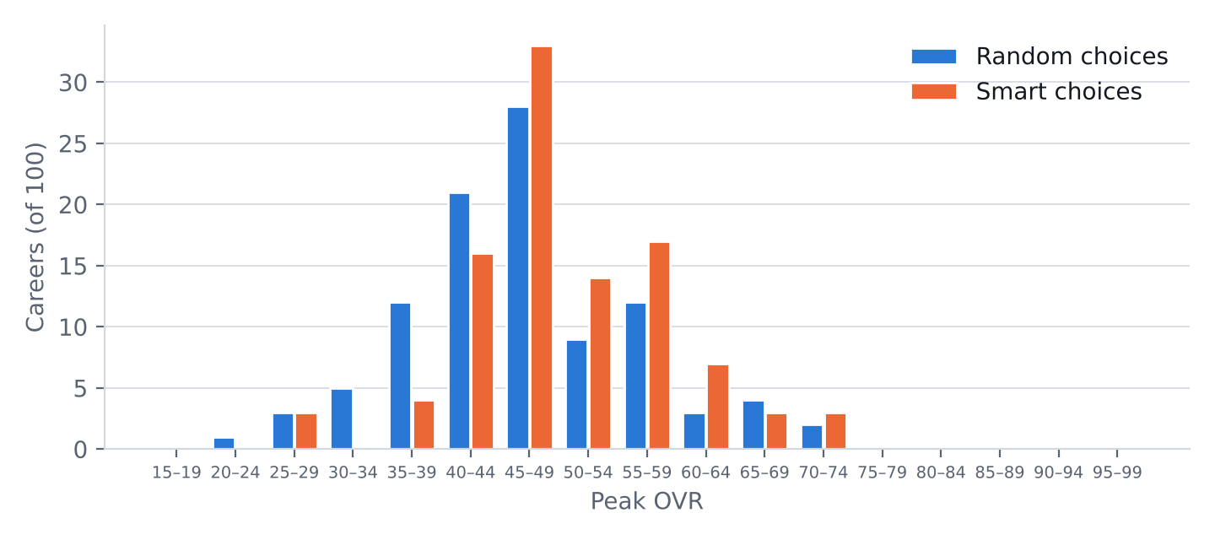
Peak OVR of 100 careers per play style in Reality hits hard, in 5-point bins (each bin includes its lower bound).
Peak OVR | Random choices | Smart choices
Mean | 47.27 | 50.64
Standard deviation | 9.55 | 8.69
Median | 46.49 | 48.94
5th / 95th percentile | 32.5 / 65.3 | 37.3 / 65.7
Lowest / highest | 24.0 / 70.6 | 28.3 / 73.3
Below 52.5 | 73 (64–81%) | 61 (51–70%)
80 or higher | 0 (0–4%) | 0 (0–4%)
90 or higher | 0 (0–4%) | 0 (0–4%)
97 or higher | 0 (0–4%) | 0 (0–4%)
Played in the NBA | 7 | 5
At least one All-Star | 0 | 0
At least one MVP | 0 | 0
Hall of Fame | 0 | 0
Counts are out of 100 careers. Brackets: 95% confidence interval (Wilson score); with 100 careers these intervals are wide.
- Random and smart play reached the NBA 7 and 5 times; at these small numbers the difference is noise.
- In real life the odds are far longer (a fraction of a percent of high school players), but a few percent keeps the dream possible in a game.

Shoot for the stars
Potential starts at 88, growth is 35% faster and injuries 40% rarer. A safety floor keeps the player on a straight path from his start to OVR 80 by age 22, so 80 is guaranteed for any career that lasts that long.
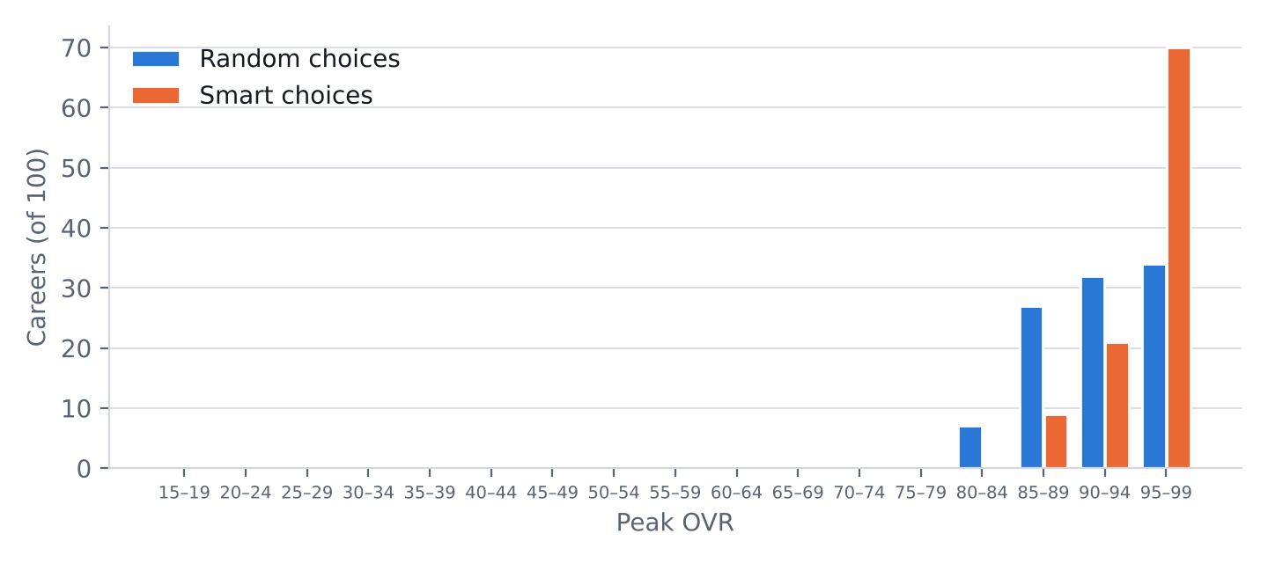
Peak OVR of 100 careers per play style in Shoot for the stars, in 5-point bins (each bin includes its lower bound).
Peak OVR | Random choices | Smart choices
Mean | 92.57 | 96.07
Standard deviation | 4.73 | 3.51
Median | 93.20 | 97.32
5th / 95th percentile | 84.7 / 99.0 | 88.2 / 99.0
Lowest / highest | 83.3 / 99.0 | 86.1 / 99.0
Below 52.5 | 0 (0–4%) | 0 (0–4%)
80 or higher | 100 (96–100%) | 100 (96–100%)
90 or higher | 66 (56–75%) | 91 (84–95%)
97 or higher | 27 (19–36%) | 58 (48–67%)
Played in the NBA | 100 | 100
At least one All-Star | 100 | 100
At least one MVP | 52 | 72
Hall of Fame | 99 | 97
Counts are out of 100 careers. Brackets: 95% confidence interval (Wilson score); with 100 careers these intervals are wide.
- A player who retires before 22 can still finish below 80; no career in this test did.
- MVP is common here (52 and 72 of 100), because the rest of the league is unchanged.

Appendix: unrounded values
standard: mean 68.95651 (random), 75.73789 (smart); sd 18.69921, 17.83079. reality: mean 47.26803 (random), 50.63656 (smart); sd 9.551783, 8.686517. stars: mean 92.56623 (random), 96.06684 (smart); sd 4.733569, 3.513544.

