Bench to Rafters: peak OVR distribution
Preliminary balance test, 100 simulated careers per play style (with a 1,000-career check) · 28 October 2026

Summary
- Average peak OVR: 67.4 with random choices and 70.4 with smart choices in the 100-career test. Over 1,000 careers the averages are 65.4 and 69.1, so both sit inside the 65–70 target.
- The 100-career test ran a little high: its 100 players happened to draw above-average potential (69.26 against 67.79 over 1,000 careers), which explains most of the difference.
- Low end (peak below 52.5): 8 in 100 for both styles in the test; over 1,000 careers, 15.0% with random choices and 8.0% with smart choices. The target was 1 in 20 (5%).
- High end (peak 97 or higher): 1 in 100 (random) and 3 in 100 (smart) in the test; over 1,000 careers, 1.5% and 4.9%. Smart play meets the 1-in-20 target; random play reaches it about one third as often.
- Main finding: the tails depend mostly on how well the career is played. With good choices both ends are close to target; with random choices the low end is about three times too common and the top is rare.

How the test was run
Each career was played from age 14 to retirement by the game engine itself, using the same automated players as the balance harness. "Random choices" picks any available option. "Smart choices" focuses the two most important stats for the position, picks plans by morale and age, takes the best-fitting offers and buys training. Both styles played the same 100 starting seeds (500000–500099), so differences between them come from the choices, not from luck in the draw. Postseasons were simulated. The 1,000-career check used seeds 500000–500999.
Peak OVR is the highest OVR a player reached at any point in his career. On the game's scale, 80 is an All-Star, 85 All-NBA, 90 All-NBA 1st team, 95 an MVP and 97 the all-time greats.

Distribution
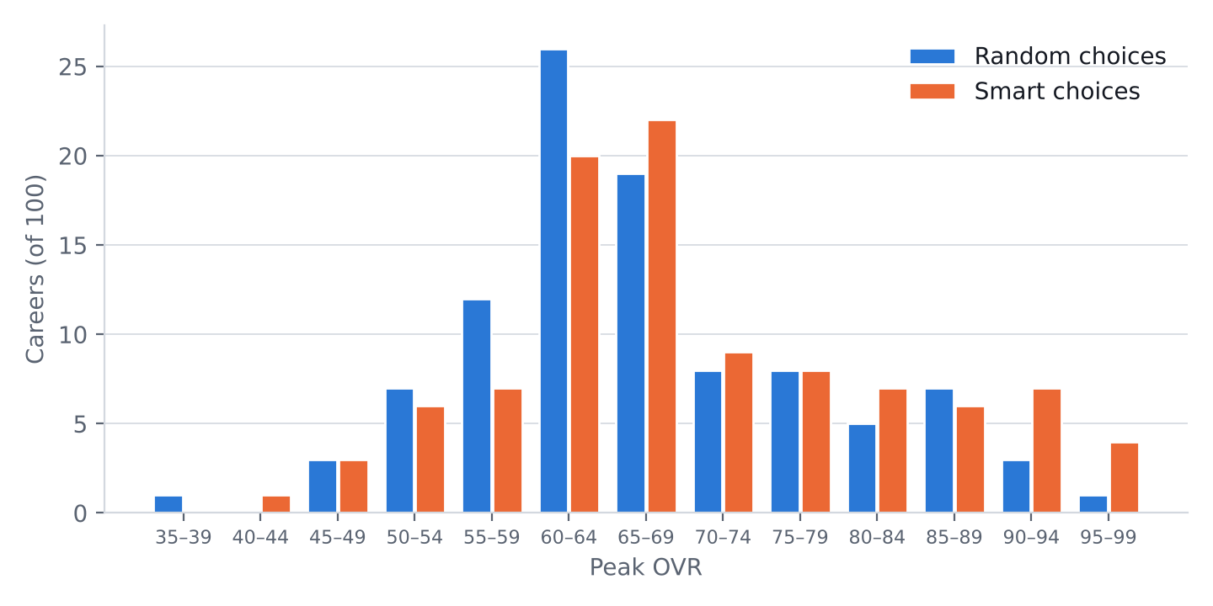
Figure 1. Peak OVR of 100 careers per play style, in 5-point bins (each bin includes its lower bound and runs up to, but not including, the next).
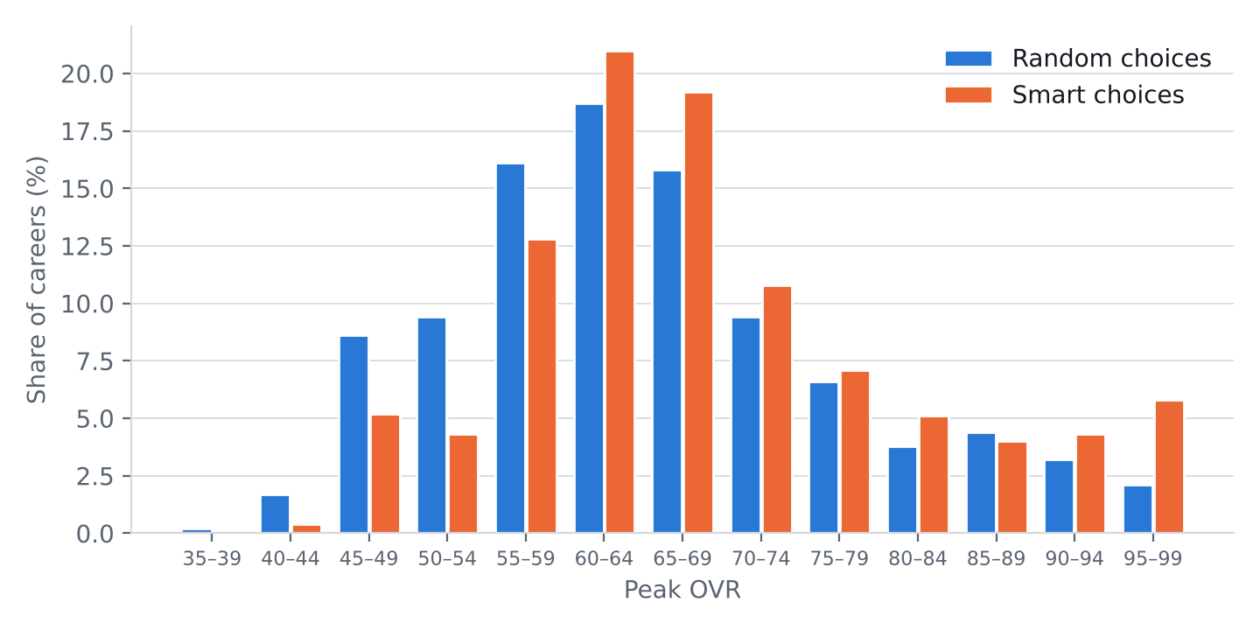
Figure 2. The same chart for 1,000 careers per play style, as a share of careers. The shape is clearer: a peak in the low-to-mid 60s and a long tail to the right.

Summary statistics
Peak OVR | Random, 100 | Smart, 100 | Random, 1,000 | Smart, 1,000
Mean | 67.39 | 70.39 | 65.41 | 69.10
Standard deviation | 11.61 | 13.06 | 12.50 | 12.90
Standard error of the mean | 1.16 | 1.31 | 0.40 | 0.41
Median | 65.30 | 67.57 | 63.67 | 66.35
5th percentile | 50.67 | 50.82 | 47.57 | 49.83
95th percentile | 88.62 | 93.86 | 90.11 | 95.82
Lowest | 39.96 | 43.97 | 39.75 | 40.65
Highest | 97.49 | 99.00 | 99.00 | 99.00
Table 1. The median is below the mean in every column: the distribution is skewed to the right (a few stars pull the average up).

How often the ends appear
Peak OVR | Random, 100 | Smart, 100 | Random, 1,000 | Smart, 1,000
Below 52.5 (target 5%) | 8 (4.1–15.0%) | 8 (4.1–15.0%) | 15.0% | 8.0%
80 or higher (All-Star level) | 16 (10.1–24.4%) | 24 (16.7–33.2%) | 13.5% | 19.2%
90 or higher | 4 (1.6–9.8%) | 11 (6.3–18.6%) | 5.3% | 10.1%
95 or higher | 1 (0.2–5.4%) | 4 (1.6–9.8%) | 2.1% | 5.8%
97 or higher (target 5%) | 1 (0.2–5.4%) | 3 (1.0–8.5%) | 1.5% | 4.9%
Table 2. For the 100-career test: number of careers, with a 95% confidence interval (Wilson score) in brackets. With only 100 careers the interval for a rare outcome is wide: an observed 3% is consistent with anything from 1% to 8.5%.

Career outcomes
Outcome | Random, 100 | Smart, 100 | Random, 1,000 | Smart, 1,000
Played in the NBA | 63 | 66 | 56.7% | 62.3%
At least one All-Star | 21 | 28 | 18.7% | 21.7%
At least one All-NBA | 16 | 19 | 14.2% | 16.4%
At least one MVP | 3 | 5 | 4.5% | 6.0%
At least one NBA title | 12 | 21 | 11.1% | 21.6%
Hall of Fame | 14 | 18 | 11.0% | 14.7%

Starting OVR
Starting OVR at 14 now varies: over 1,000 careers it averaged 44.77 with a standard deviation of 4.85, from 30.4 to 58.9. Its correlation with peak OVR is 0.48 (random) and 0.45 (smart): a head start helps, but potential and choices matter more.

Reading the results
- Potential versus what players reach. In the potential distribution itself, 5.1% of players can reach 99 and 3.8% have a ceiling under 52. Smart play realizes this almost exactly (4.9% peak at 97+). Random play wastes much of it: only 1.5% reach 97+, while 15.0% stay below 52.5.
- Sampling error. With 100 careers the average is only known to within about ±2.3 OVR (95%), and a 5% rate cannot be told apart from 2% or 10%. Use the 100-career test to spot large problems, and 1,000 careers before committing a balance change.
- Choices matter by about 3.7 OVR on average (65.41 against 69.10), and much more at the top (5.3% against 10.1% reach 90+).

Balance options (your call)
These are options, not changes: nothing below has been applied. Each would be re-tested with 1,000 careers per play style before going in.
- A. Leave it. With good choices both ends already hit the 1-in-20 targets, and the low end for random play is the cost of poor decisions.
- B. Thin the low end. Raise the lowest possible potential from 47 to 52. About 3.8% of players are drawn below 52, so this would lift that group only. Expected direction: fewer careers under 52.5 for both play styles, almost no change at the top.
- C. Make random play less punishing. Soften what bad plan, offer and shop choices cost, which narrows the 3.7 OVR gap. Both tails move toward the smart-play numbers, but choices would matter less.
- D. A fatter top for everyone. Widen the potential spread (sigma 0.60 to about 0.64). More 97+ careers for random play, but also more low ones, so it would need to be paired with B.
My suggestion is B, keeping the top as it is. It hits the low-end target without changing how much good decisions are worth.

Also checked in this update
- Career comparison model. Trained on 100 all-time greats, the rank model reaches a Spearman correlation of 0.868 with the real order on its own data, and 0.842 in leave-one-out testing (each player ranked by a model that never saw him). Its median miss in leave-one-out testing is 8.5 places, so treat a projected rank as a range of roughly ±10.
- Defensive Player of the Year. Defensive specialists were winning it 5–13 times. After the fix (ratings above 85 count for less, and past wins make the next harder), the most any career won in 250 defensive careers was 4, the real-life record.

Appendix: unrounded values
Mean peak OVR: random 100 = 67.39424, smart 100 = 70.39236, random 1,000 = 65.40666, smart 1,000 = 69.09554. Standard deviations: 11.61216, 13.05921, 12.49856, 12.89982. Start-to-peak correlations: 0.3239749, 0.3026720, 0.4769896, 0.4508120. Potential tail shares (lognormal, base 45, mu 3.01, sigma 0.6): P(potential < 52) = 0.03807, P(potential ≥ 99) = 0.05138.

