# Dev Test Project

1. Write a function to sort an array that mixes numbers and character so that the number will be sorted from small to big, then the string from A to z, then the special characters.

Input:

let arr = ["ax", "mof", "4", "63", "42", "3", "10", "[", "23", "adidas", "ba", ")", "ABC"];

Output:

["3", "4", "10", "23", "42", "63", "ABC", "adidas", "ax", "ba", "mof", ")", "["]

2. Please create a web application that allows users to share youtube videos.

Once you have completed the application, please deploy it to the cloud.

**Required Features:**

* **Register**: As a new user, I want to create an account and sign in by entering the **username** and **password** for the first time. (Picture 1)
* **Login**: As a registered user, I want to sign in by entering the username and password. (Picture 1)
* **Share movie**: As a signed in user, I want to share a youtube movie by clicking “Share a movie” button (Picture 2) and filling the share form (Picture 3).
* **See movie list**: As a visitor, I want to see a list of all shared movies. (Picture 1) (no need to display the number of up/down votes)

**Technology requirements:**

* NodeJS
* MongoDB
* Angular 8 or VueJS

**Technical requirements:**

* Use Git and commit often
* Have integration test
* Have unit test

**Picture 1 - Home page**

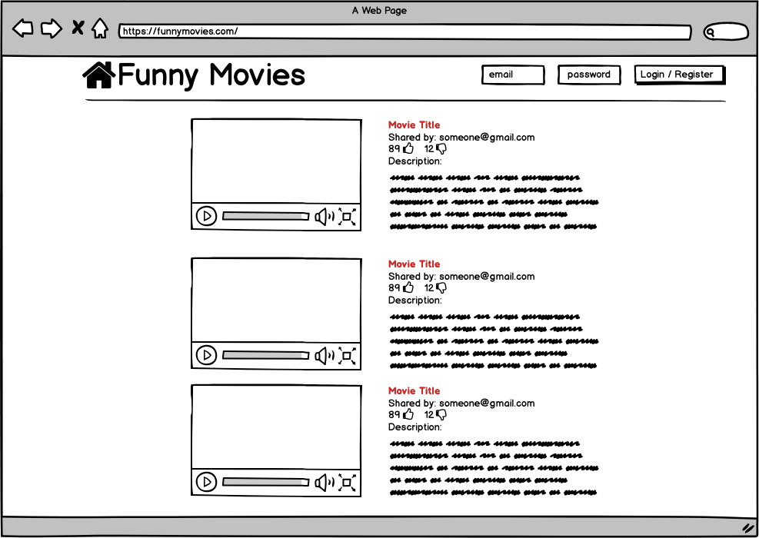

**Picture 2 - Home page signed in**

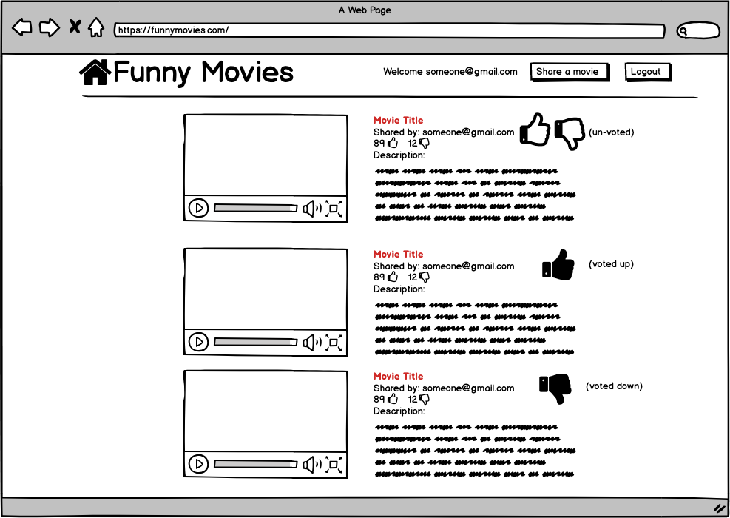

**Picture 3 - Share page**

