Mini Debugger for Oberon System 3

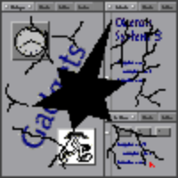

Debug is a small utility, which is helpfull in situations, where the normal Oberon debugging tools as the system log and trap viewers do not work. The debug application has three windows.

- The Console window displays the output written using the module Console.
- When an exception occurs a short description of the exception (e.g. Access Violation) is written to the Exception window. To continue execution of Oberon after an exception choose the Continue entry in the Action menu. To pass the exception to Oberon choose the Exception entry. To display the trap viewer befor continuing execution of Oberon select the Show Trap entry.
- In the System window all information on the state of Oberon is displayed. To see the list of loaded modules choose the Show Modules entry of the Action menu. To see the state of a module choose the Module State entry. To see a stack dump choose the Show Stack entry and enter the thread number. To see a list of all Oberon threads choose the Show Threads entry.

To start the debugging select the Start entry in the File menu.

Emil Zeller, Zürich 20.1.97

