OpenCV Assignment 2: Segmentation Problem

Prepared by
Bradley Trowbridge

Computer Vision
March 22, 2017
Table of Contents
Table of Contents 1
1. Figures 2
2. Overview 3
2.1 Task Description 3
3. Research 4
3.1 Pre Project Overview 4
3.2 Examples and Resources 4
4. My Implementation 6
4.1 Intro 6
4.2 How I implemented. 6
4.3 Results 6
References 7

Figures
Figure 1 from [1] : the resulting marker image (left) and the segment detection (right) 4
Figure 2 from [2]: Final result of watershed segmentation. the image shows overlapping cards. 5
Figure 3: Before (left) and after (right) of [3] mean shift filtering 5
Figure 4: The final output with originao photo (top left) blurred version of the photo (bottom left) and final output window with track bars (right) 6

Overview

Task Description

- Select your input data from Input Data Folder.
- You are required to “cut out” the main subjects such as sky, ground, or a person.
- The given experimental data are rectified stereo pairs. Thus, you can consider using depth information (OpenCV provides several stereo matchers). This is just a suggestion – you can also decide to do your segmentation without depth information.
- Code for a mean shift segmentation is provided. Alternatively, you can use any other image segmentation method of your choice.
- (Optional) For robustness consideration (i.e. accuracy across different input data), discuss the possible use of one (constant) setof parameters for all your selected input data.

Research

Pre Project Overview
From my searching’s I noticed that there weren’t too many ubiquitous solutions for segmentation. Most of them came from several external projects that had been developing their unique framework for segmentation. Most of the OpenCV solutions utilized the watershed and mean shift segmentation. It was difficult to find C++ for most of these as Python has a much more prominent online presence for OpenCV.

Examples and Resources

Image Segmentation with Watershed Algorithm
In [1] OpenCV goes over a method of implementing the watershed segmentation in Python. They use the method to identify circular coin objects that are closer together and touching. First, they use OTSU binarization in order to estimate the number of coins on the screen. Then, they apply some morphological opening utilizing a ones kernel in order to remove some of the noise in between the coins. Then, they dilate and apply a threshold in order to bring the foreground coins away from the background using a distance transform. At this stage, markers are applied to designate individual segments.

This was their output:
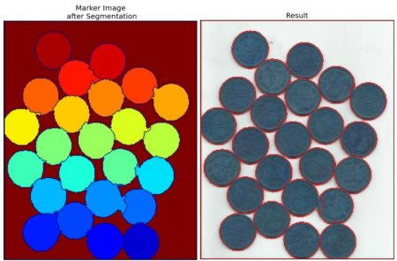
Figure 1 from [1] : the resulting marker image (left) and the segment detection (right)

This was an interesting example but not as helpful for many of the input data since they did not have a plain background to contrast from. The noise reduction used in this example would not help the same.

Image Segmentation with Distance Transform and Watershed Algorithm
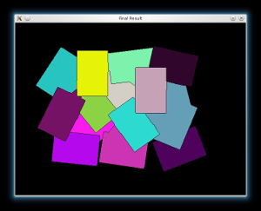
In this OpenCV example [2] does a similar process however with overlapping cards and they take advantage of the white background by blacking it out. In comparison to our data set these are still relatively undetailed objects. Also it doesn’t help that it is also in Python.
Figure 2 from [2]: Final result of watershed segmentation. the image shows overlapping cards.

Mean Shift Segmentation using OPENCV
This example had the cleanest output and was most diverse in its utility as far as working with different datasets. I stumbled onto [3] on github. In this code, the programmer is using a different version of OpenCV so much of the implementation of mean shift filtering and segmentation is on his own however he still leverages much of the OpenCV library for data types and transformations.

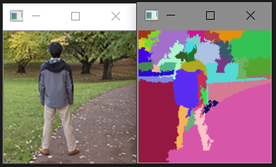
This is his output.
Figure 3: Before (left) and after (right) of [3] mean shift filtering

My Implementation

Intro
After all the research I have done I believed that Mean shift filtering would be the most useful out of any case that I have seen thus far. I also found OpenCV’s implementation of pyramid mean shift filtering which can also be used to implement mean shift segmentation.

How I implemented.
As I have said, I used OpenCV’s pyrMeanShiftFiltering() to filter the color data and blend the mean colors from the picture to allow easier identification of segments. Then I use a method for filling in segments with color to Identify them. I wrapped all this within a class MeanShiftFiltering with static members that are attached to track bar GUI items that can toggle the parameters of the mean shift filtering in order to optimize the segmentation being performed. These parameters are the radius of proximity for calculating the mean, the radius of color, and the pyramid level for filtering. These taskbars trigger a callback function from the MeanShiftFiltering class.

Results
In comparison to the case stated in 2.3 my implementation is very rough around the edges quite literally. My implementation can find the segments but the means of the edges of the segments are yielding a massive amount of segments that are given random colors.
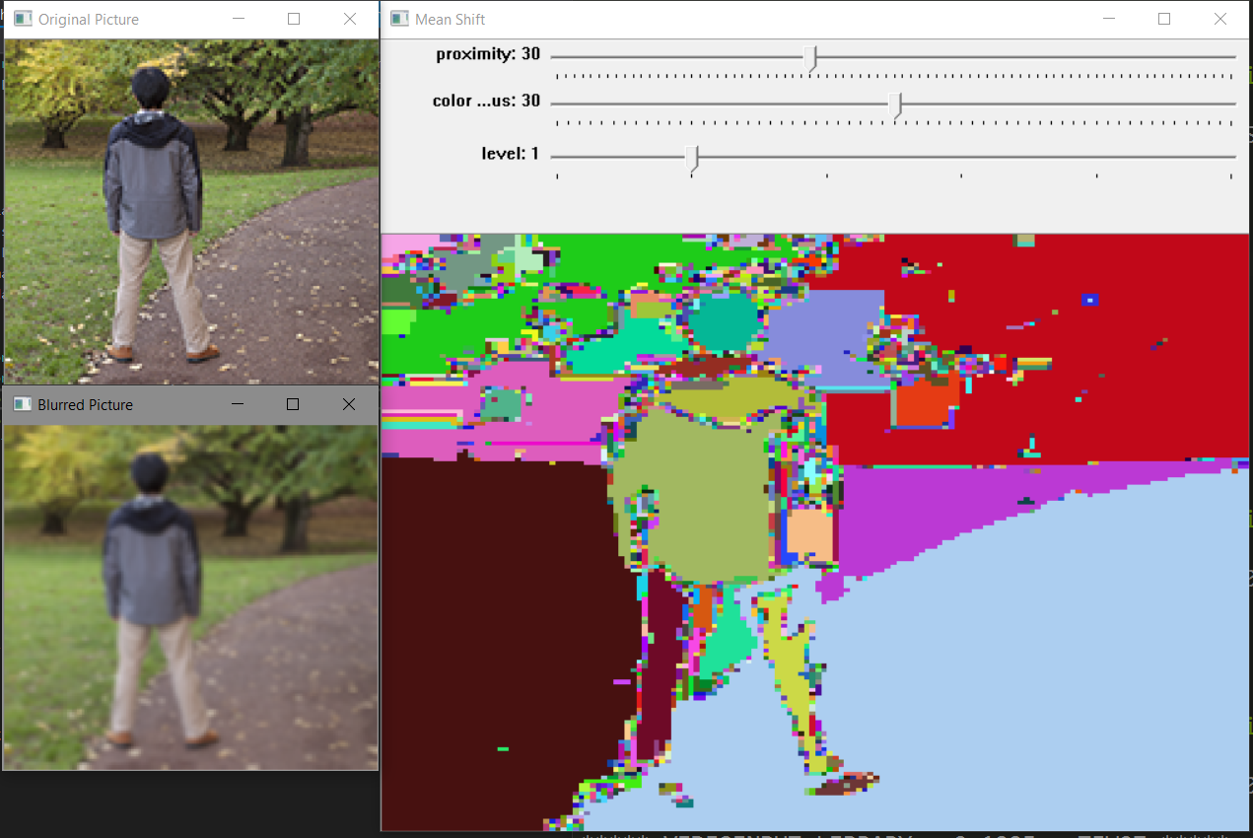
Figure 4: The final output with originao photo (top left) blurred version of the photo (bottom left) and final output window with track bars (right)
References

[1] [ http://docs.opencv.org/3.2.0/d3/db4/tutorial_py_watershed.html]
[2] [http://docs.opencv.org/trunk/d2/dbd/tutorial_distance_transform.html]
[3] [https://github.com/qiankanglai/opencv.meanshift]

