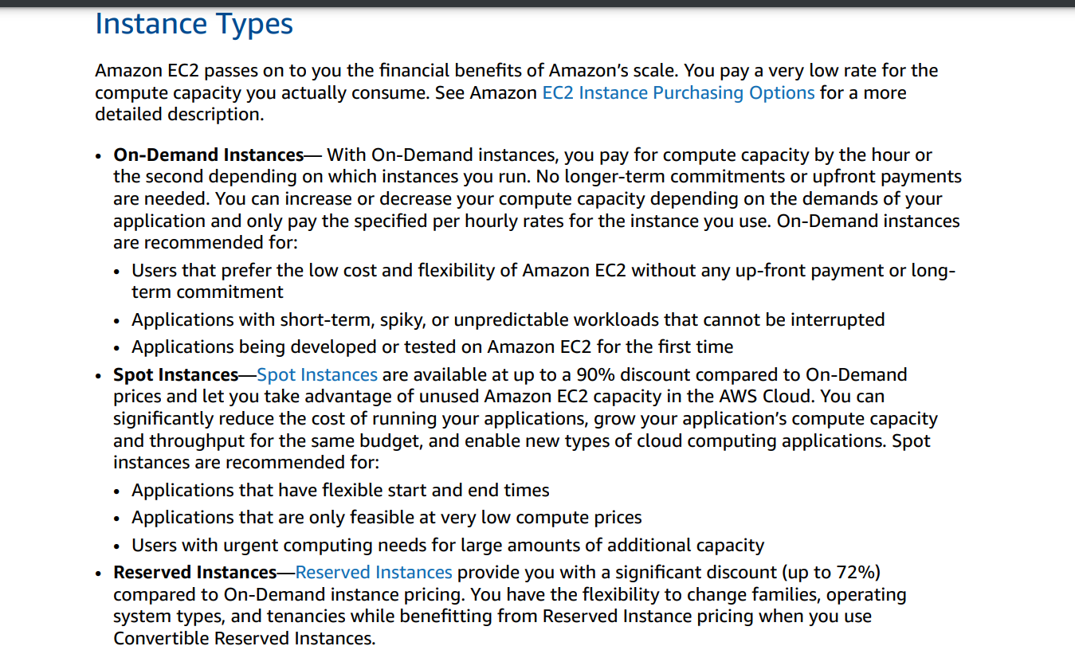

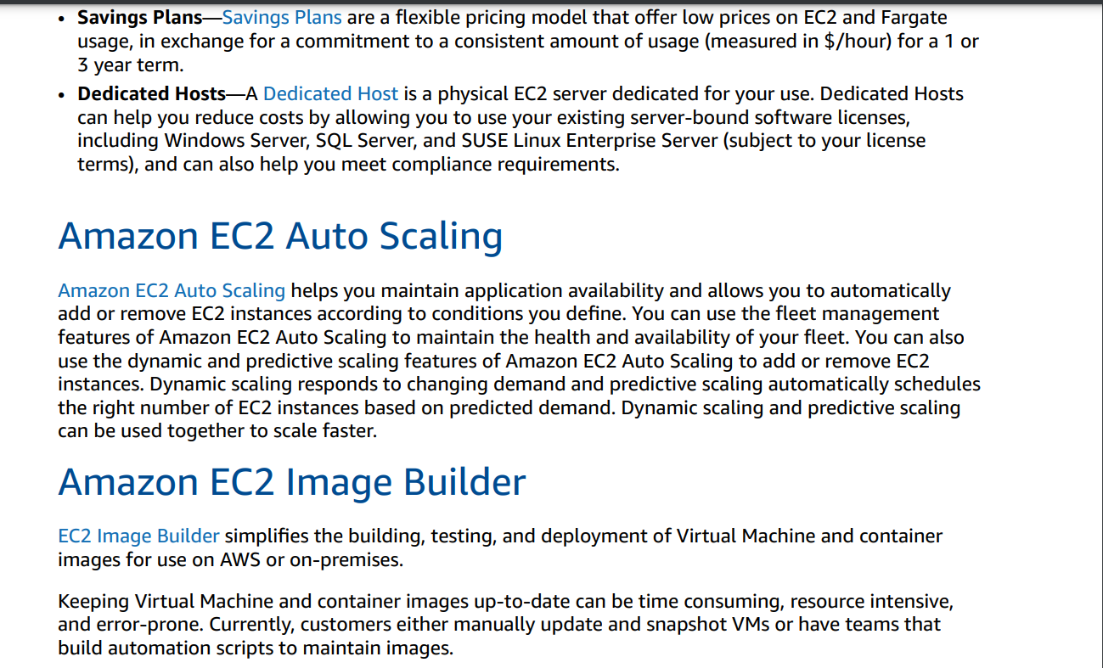

What AWS billing support resource is available to all support levels?

A. AWS Support concierge  
B. AWS Customer Service  
C. AWS technical account manager  
D. AWS Business Support

ANSWER: B

Which AWS services help to improve application performance by reducing latency while accessing content globally? (Choose two.)

A. Amazon CloudFront  
B. AWS VPN  
C. AWS Direct Connect  
D. AWS Global Accelerator  
E. Amazon S3 Glacier

ANSWER: A AND D

 Which AWS service provides the ability to quickly run one-time queries on data in Amazon S3?

A. Amazon EMR  
B. Amazon DynamoDB  
C. Amazon Redshift  
D. Amazon Athena

ANSWER: D

Which AWS service does AWS Snowball Edge natively support?

A. AWS Server Migration Service (AWS SMS)  
B. Amazon Aurora  
C. AWS Trusted Advisor  
D. Amazon EC2

ANSWER: D

 A company is building a new archiving system on AWS that will store terabytes of data. The company will NOT retrieve the data often. Which Amazon S3 storage class will MINIMIZE the cost of the system?

A. S3 Standard-Infrequent Access (S3 Standard-IA)  
B. S3 Glacier  
C. S3 Intelligent-Tiering  
D. S3 One Zone-Infrequent Access (S3 One Zone-IA)

ANSWER: B

 Which AWS service enables users to monitor for specific phrases, values, or patterns and set up alarms based on metrics?

A. AWS IQ  
B. Amazon Comprehend  
C. AWS CloudTrail  
D. Amazon CloudWatch Logs

ANSWER: D

 A company wants durable storage for static content and infinitely scalable data storage infrastructure at the lowest cost. Which AWS service should the company choose?

A. Amazon Elastic Block Store (Amazon EBS)  
B. Amazon S3  
C. AWS Storage Gateway  
D. Amazon Elastic File System (Amazon EFS)

ANSWER: B

Using AWS Identity and Access Management (IAM), what can be attached to an Amazon EC2 instance to make service requests?

A. Group  
B. Role  
C. Policy  
D. Access key

ANSWER: B

A security officer wants to enable IPsec communications to securely connect users from on-premises networks to AWS. Which AWS service or feature should the officer use?

A. Amazon VPC  
B. AWS VPN  
C. AWS Direct Connect  
D. Amazon Connect

ANSWER: B

 A company needs 24/7 phone, email, and chat access, with a response time of less than 1 hour if a production system has a service interruption. Which AWS Support plan meets these requirements at the LOWEST cost?

A. Basic  
B. Developer  
C. Business  
D. Enterprise

ANSWER: C

Which AWS service or feature provides information about ongoing or upcoming scheduled events that can affect an AWS account?

A. AWS Config  
B. AWS Systems Manager  
C. AWS Personal Health Dashboard  
D. AWS Trusted Advisor

ANSWER: C

 A bank needs to store recordings of calls made to its contact center for 6 years. The recordings must be accessible within 48 hours from the time they are requested. Which AWS service will provide a secure and cost-effective solution for retaining these files?

A. Amazon DynamoDB  
B. Amazon S3 Glacier  
C. Amazon Connect  
D. Amazon ElastiCache

ANSWER: B

 A media company wants to distribute video content to millions of users worldwide over the internet. The company wants to use the AWS global network backbone to distribute cached content with low latency and high data transfer speeds. Which AWS service will meet these requirements?

A. Amazon CloudFront  
B. AWS Global Accelerator  
C. AWS Direct Connect  
D. Amazon Connect

ANSWER: A

 The AWS global infrastructure consists of Regions, Availability Zones, and what else?

A. VPCs  
B. Data centers  
C. Dark fiber network links  
D. Edge locations

ANSWER: D

Which AWS Trusted Advisor feature is available exclusively to users with AWS Business Support or AWS Enterprise Support?

A. Notification setup  
B. Refresh checks  
C. AWS Support API  
D. Action links

ANSWER: C

 A company is required to store its data close to its primary users. Which benefit of the AWS Cloud supports this requirement?

A. Security  
B. High availability  
C. Elasticity  
D. Global footprint

ANSWER: B

Which of the following are ways to improve security on AWS? (Choose two.)

A. Using AWS Artifact  
B. Granting the broadest permissions to all IAM roles  
C. Running application code with AWS Cloud9  
D. Enabling multi-factor authentication (MFA) with Amazon Cognito  
E. Using AWS Trusted Advisor security checks

ANSWER: D AND E

Which of the following enables users to leverage the power of AWS services programmatically?

A. AWS Command Line Interface (AWS CLI)  
B. AWS Trusted Advisor  
C. AWS CodeDeploy  
D. AWS Management Console

ANSWER: A

Which security credentials are required to run commands by using the AWS Command Line Interface (AWS CLI)?

A. Access Key ID and Secret Access Key  
B. AWS root user email and password  
C. Amazon Elastic Compute Cloud (Amazon EC2) key pairs  
D. AWS Identity and Access Management (IAM) user name and password

ANSWER: A

Which are customer responsibilities when using Amazon EC2? (Choose two.)

A. Underlying hardware maintenance  
B. File-system-level encryption  
C. Guest operating system firewall configuration  
D. Hypervisor-level software patching  
E. Physical security at data center facilities

ANSWER: B AND C

A web developer has limited knowledge of AWS networking services such as Amazon VPC, Elastic Load Balancing, and Auto Scaling, but wants to host a highly available web application. Which AWS service would automatically handle the deployment and reduce the complexity for the developer?

A. AWS CodeDeploy  
B. AWS Resource Access Manager  
C. AWS Elastic Beanstalk  
D. AWS CloudFormation

ANS : C

. A company wants to route its traffic directly and privately to a VPC without going over the public internet. Which connectivity option provides this capability?

A. AWS VPN  
B. AWS Direct Connect  
C. VPC NAT gateway  
D. VPC internet gateway

ANS: B

A company wants to forecast its AWS Cloud costs for the upcoming year by analyzing its past AWS Cloud spending trends. Which AWS service should the company use to meet this requirement?

A. AWS Control Tower  
B. Cost Explorer  
C. AWS OpsWorks  
D. AWS CloudFormation

ANS: B

. Using Amazon Elastic Container Service (Amazon ECS) to break down a monolithic architecture into microservices is an example of:

A. a loosely coupled architecture.  
B. a tightly coupled architecture.  
C. a stateless architecture.  
D. a stateful architecture.

ANS: C

Which VPC component provides a layer of security at the subnet level?

A. Security groups  
B. Network ACLs  
C. NAT gateways  
D. Route tables

ANS: B

Which AWS service will help a company identify the user who deleted an Amazon EC2 instance yesterday?

A. Amazon CloudWatch  
B. AWS Trusted Advisor  
C. AWS CloudTrail  
D. Amazon Inspector

ANS: C