(https://btsamara.wixsite.com/games/post/video-short-pt-1)

Publish Date: 04/15/2020

Video Short (update #1)

Hello and welcome to my first blog post. In this blog, I will be discussing the process for some of my projects.

During the Fall semester of 2019, I was in a course called Motion Graphics. In it, we used the video editing program Adobe After Effects. Our final project was an open ended video assignment, aiming for between 1-3 minutes. After some brainstorming, I decided to make my project about the first few scenes of one of my absolute favorite games, The Legend of Zelda: Ocarina of Time. I soon came upon a stopping point for this project's scope, to stop the story when Link first leaves the Kokiri forest.

My initial idea was to have it look like an old NES or SNES game cinematics, looking specifically at Ninja Gaiden(https://www.youtube.com/watch?v=DtOxZiizL4E). Though, as I began working on it this idea changed, realizing I couldn't quite recreate these cinematics as I wanted. I still integrated some of the ideology with the the sizing of the text box and the sizing of the image. I also enjoyed the idea that in NES cinematics, simple 2-frame animations are the norm.
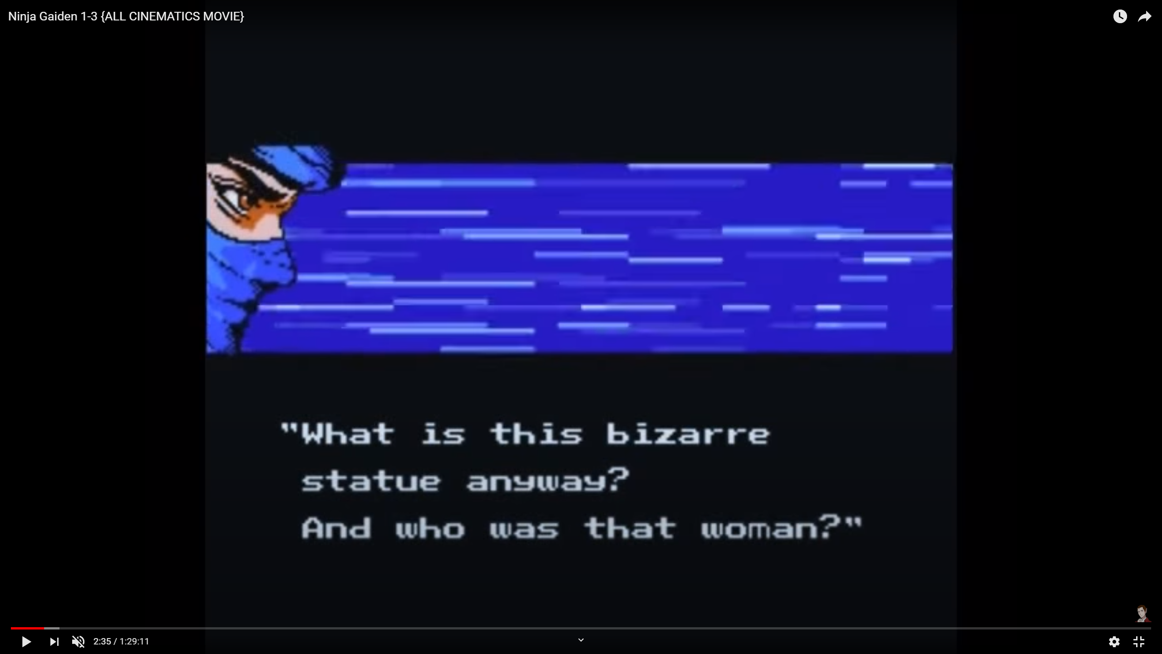
I reread the first view scenes in the LoZ: OoT manga (https://www.viz.com/read/manga/legend-of-zelda-volume-1/product/1890) and watched gameplay footage of the first scenes in the game itself (https://www.youtube.com/watch?v=FX8YkcOeOfQ), up to when Link leaves the forest. I noted the pivotal, plot-moving scenes - dreaming of Zelda, fighting Gohma, receiving the Kokiri Emerald, hearing the origin of the universe, etc. I identified which ones I wanted to use as reference, and began sketching. The research probably took between 1-2 hours. The sketches took maybe 5 hours all together, most of which I made fairly detailed to prepare for scanning. I had a little story boarding experience from a previous assignment in my game design course that helped.
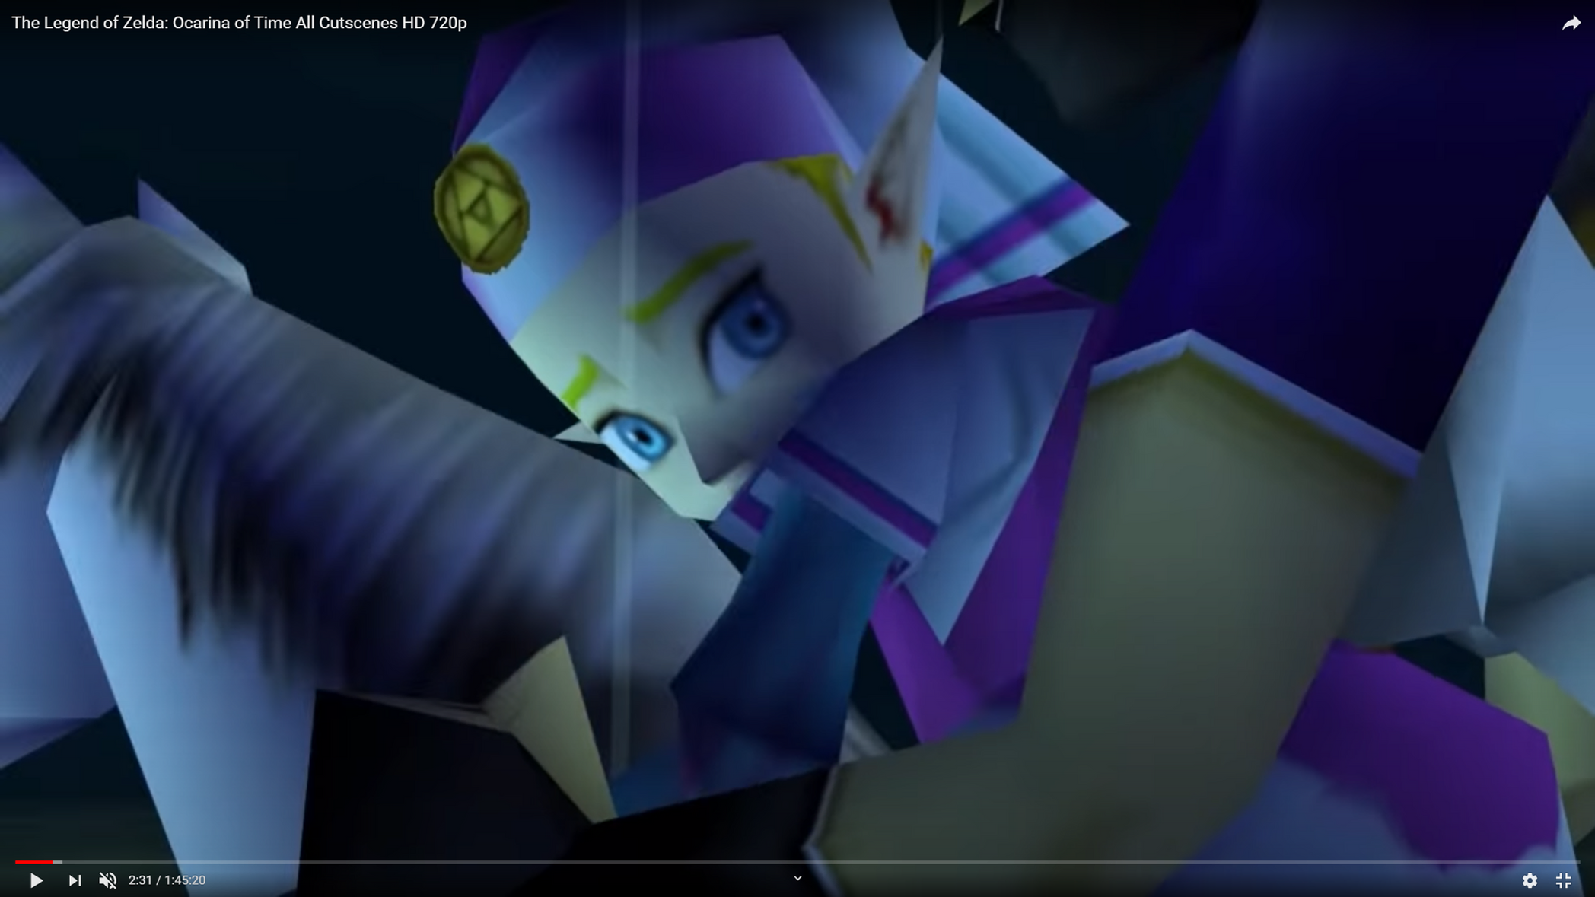
I've included some of my sketches below, in a slideshow format.
(See website)

I have images of my digitally traced images that I can include here in the future. I can also show how the editing looks in Adobe After Effects. Once I finish the animations I have planned, I'd plan to add sounds. Beyond that, one thing I'm considering is adding more of a background to each slide.
To be continued...

