Bronson Tharpe

Lab Assignment 5 – In-Lab

1. -bash: simple.sh: command not found

2. -bash: ./simple.sh: Permission denied

3. 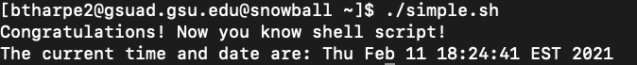

4. The -n option in the echo command makes it not output the trailing newline.

5. Yes, “Simple Script” is a comment.

6. No, “#!/bin/bash” is not a comment. It instructs the program loader to use /bin/bash.

7. There are 6 directories in the output.

8. There are no errors, and there is no need to put ./ before the file name because the working directory has been added to the PATH variable’s value and the PATH variable’s value is correct.

9. Yes. /home/btharpe2/bin

10. -bash: simple.sh: command not found. This is because the PATH variable’s value is incorrect.