**TransformData version 1 (4/10/2019)**

**Transformation Method/Steps**

1. Interpolation: gyro data was interpolated so rotational velocity data had same sample rate as accel data
   1. If example impact collected gyro data from -45 to 45 ms (at ~3133 Hz) and accel data from -15 to 45 ms (at ~4684 Hz), so gyro data was interpolated to increase sample rate to 4684 Hz for -15 to 45 ms
2. Filtering: accelerometer and gyroscope data were filtered with a four-pole Butterworth lowpass filter at -3 dB attenuation frequencies of 2000 Hz and 260 Hz, respectively
3. Zero offset: baseline offsets were applied to accelerometer and gyroscope data
4. Coordinate transformation: data was rotated from MP coordinate system to head CG coordinate system using device specific rotation matrices
5. Angular Acceleration Calculated: angular acceleration was calculated from rotated gyro data using a 5-pt stencil
6. Projection to CG: linear acceleration data was projected to the head CG using the rigid body transformation equation:

$${\overset{⃑}{a}}_{CG}={\overset{⃑}{a}}_{MG}+{\dot{\overset{⃑}{ω}}}_{MG}×\overset{⃑}{r}+{\overset{⃑}{ω}}_{MG}×({\overset{⃑}{ω}}_{MG}×\overset{⃑}{r})$$

where *aCG* is the linear acceleration of the head CG, *aMG* is the linear acceleration of the mouthpiece, ${\dot{ω}}_{MG}$ is the angular acceleration of the mouthpiece, *ω* is the angular velocity of the mouthpiece, and *r* is the vector from the mouthpiece to the head CG.

**Updates**

* Deleted ‘Use Estimated Board Orientation’ and ‘Use Estimated Projection Vector’ checkboxes from GUI
* New GUI has ‘Plot Data’ option:

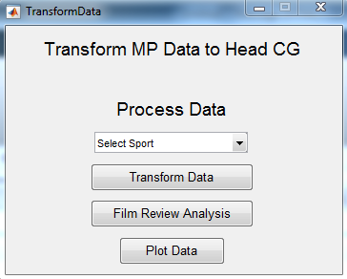

Changes to FormatInputData:

* Added function to determine number of meta data lines (‘determineFirmwareVersion’)
  + If numMetaDataLines = 1 (old version), accel and gyro data loaded using old functions (read_accel_and_gyro, etc.)
  + If numMetaDataLines = 2 (new version), accel and gyro data loaded using new functions (read_accel_and_gyro_variable, etc.)
* Save accel sample rate to impacts{1,k}.Info.AccelSampleRate
  + If numMetaDataLines = 1 (old version), sample rate = 4684
  + If numMetaDataLines = 2 (new version), sample rate = extracted from meta data
* Save transformation code version to impacts{1,k}.Info.TransformCodeVersion

Changes to GetTransformationInfo:

* Changed how ‘GetTransformationInfo’ searches for transformation file
  + looks for ***either*** ‘MPXXX_Transform.xls’ or ‘MPXXX_Transform.xlsx’
  + if neither exists, estimated/average rotation matrices and projection vectors are used
* Added ‘Source’ field to impacts{1,k}.Info.Transformation to document source of rotation matrices and projection vector
  + If loaded from MPXXX_Transform file, field displays filename
  + If estimated values used, field displays ‘estimated/average’

Changes to CalculateTransformedData:

* a_fs and g_fs defined as impacts{1,k}.Info.AccelSampleRate
* Offset linear acceleration using just 1st data point (instead of average of first 8 data points)
* Offset gyro data using 5th data point and set first 4 data points all equal to 0
* If impact is excluded from transformation due to gyro error (because length of gyro_x/y/z =1 after duplicates are removed, lines 44-45), that impact is deleted from impacts structure
  + Deleting these impacts because impacts with similar gyro error (consecutive 0 samples) are also deleted from impacts structure

Changes to CombineTransformedData:

* Removed functions ‘ExportImpactsToTable’ and ‘ExportPFN’ from the end of this function since those are dependent on film review and we want to be able to combine the transformed data even if film review hasn’t been completed
* If ‘00_transformedData.mat’ exists, load current file and find all impact dates in current impacts structure
  + extract impact dates from all input data folders
  + for each input data folder:
    - If impacts from date associated with current data folder already exist in impacts structure, do not add/change impacts structure
    - If no impacts exist for date associated with current data folder, add transformed data from current folder to combined impacts structure
* If ‘01_confirmedImpacts.mat’ exists, load current file and find all impact dates in current confirmedImpacts structure
  + extract impact dates from all input data folders
  + for each input data folder:
    - If impacts from date associated with current data folder already exist in confirmedImpacts structure, do not add/change confirmedImpacts structure
    - If no impacts exist for date associated with current data folder, add confirmed impact data from current folder to combined confirmedImpacts structure

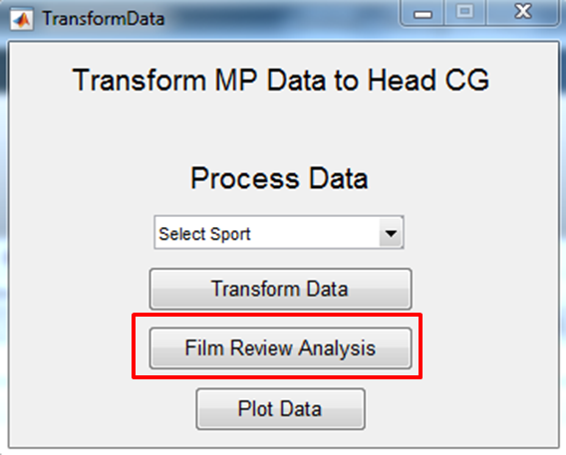

When ‘Film Review Analysis’ button is pressed:

* ReadFilmReview: loads film review info from Film_Review folders and saves to ‘FILM_REVIEW.mat’
* AddFilmReviewInfo: adds film review information (impact class, impact type, etc.) to impacts{1,k}.FilmReview
  + Existing ‘00_transformedData.mat’ is deleted at end of this function so that when ‘CombineTransformedData’ is run next, a new combined file is created that contains the FilmReview information
* ExtractConfirmedImpacts: extracts only confirmed impacts (TPs) from impacts MAT structures and saves as ‘01_confirmedImpacts.mat’ for each data folder
* CombineTransformedData: combines 00_transformedData MAT files (with new film review info) and saves new overall version; combines all ‘01_confirmedImpacts’ MAT files
* ExportImpactsToTable: exports table of impact info (‘impacts_2018XXXX.txt’) in each data folder
* CombinePFN: combines all PFN MAT files (‘01_PFN.mat’) to single MAT file containing values for all data folders

When ‘Plot Data’ button is pressed:

* If confirmed impacts have been extracted, confirmed impacts are plotted (ConfirmedImpacts_XX.XX.201X.pdf for each data folder and ConfirmedImpacts_All.pdf)
* If confirmed impacts ***have*** ***not*** been extracted, ***all*** impacts are plotted (TransformedData_XX.XX.201X.pdf for each data folder and TransformedData_All.pdf)