**1.Creating the Book class**

**2.Creating the abstract Media class**

- Media class

- Modify Book classes

+ Book class

**3.** **Creating the CompactDisc class**

- Disc Class

+ CompactDisc class

+ DigitalVideoDisc class

- Track class

**6.Create the Playable interface**

- Playable interface

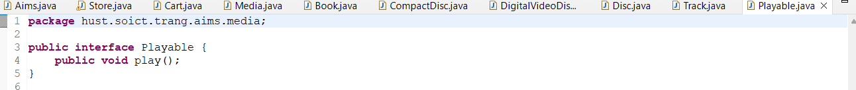

- DigitalVideoDisc

- Track

- CompactDisc

**5.** **Update the Cart class to work with Media**

**6. Update the Store class to work with Media**

**7. Constructors of whole classes and parent classes**

-Update ULM

- Which classes are aggregates of other classes? Checking all constructors of whole classes if they initialize for their parts? : Media class, Disc.

- Write constructors for parent and child classes. Remove redundant setter methods if any : trong code

**8. Unique item in a list**

- Media

- Track

**9. Polymorphism with toString() method**

- DigitalVideoDisc

- CompactDisc

- Book

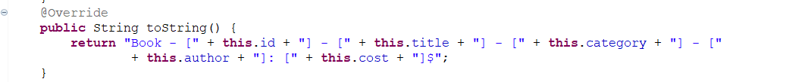

* Test in Cart.java

**10.Media sort in the cart**

**1. Use Comparator**

* **Sort by Cost then Title**

* **Sort by Title then Cost**

**2. Question**

Alternatively, to compare items in the cart, instead of using Comparator, we can use the Comparable interface and override the compareTo()method. You can refer to the Java docs to see the information of this interface.

Suppose we are taking this Comparable interface approach.

* **What class should implement the Comparable interface?** : Các lớp mà chỉ cần định nghĩa 1 quy tắc sắp xếp tại duy nhất 1 ngữ cảnh cho đối tượng vì sử dụng Comparable thì khi muốn đổi tiêu chí sắp xếp ví dụ như đang sắp xếp bằng title sang sắp xếp bằng cost thì phải sửa mã nguồn.
* **In those classes, how should you implement the compareTo()method be to reflect the ordering that we want?**: Viết theo thứ tự mong muốn phương thức ưu tiên 1 trước rồi đến phương thức ưu tiên 2 khi hai đối tượng có cùng mức ưu tiên ở phương thức 1. Lần lượt cho đến hết.

* **Can we have two ordering rules of the item (by title then cost and by cost then title) if we use this Comparable interface approach?**: Không thể vì Comparable chỉ cho phép một quy tắc mặc định sử dụng compareTo() để định nghĩa và khi muốn đổi sang quy tắc khác phải chỉnh compareTo().
* **Suppose the DVDs has a different ordering rule from the other media types, that is by title, then decreasing length, then cost. How would you modify your code to allow this?**

**11. Tạo console**

- main()

- initial()

* Chức năng View store

* See a media’s deatails

* Add a media to cart

* Play Media

* See current media bên dưới đã trình bày.
* Update Store

* See current cart

