6/16/2021

Cleared some space on the Raspberry Pi by uninstalling some un-needed programs (libreoffice, wolfram-engine, scratch)
Made MBED account to be able to program STM32
Use MBED studio for NUCLEO-F401RE development, works much better than the online compiler.
wait() has been nixed from the mbed.h so it was replaced with wait_ns() and wait_us(). I used wait_us() to replicate Felicia’s laser test script.
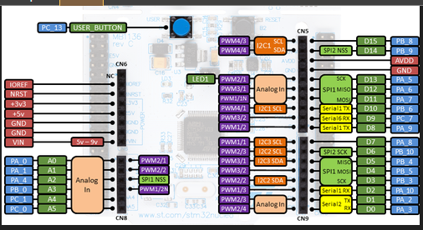
TODO: Figure out why relay will not switch

6/17/2021
Relay did not switch because I did not drag the bin file from my compiled program to the NULEO-F401RE…. As soon as I did that, everything worked as expected.
The Raspberry Pi 4 has a password of: raspberrypi
I plugged the control board into a power supply of one of the other computers here and there are no complaints on low voltage. Something is wrong with the tiny power supply where it will only provide about 4.8V instead of 5V and probably less under load.
Interesting thing to note, the CX430 power supply does end up having the raspberry pi complain about low voltage RARELY, like really rare. Should be fine though.
Worked on getting raspberry pi and nucleo ready for serial communication testing between the two. Having a weird issue where mbed studio will not see Serial as a data type. (Serial is no longer a data type, it is either BufferedSerial or UnbufferedSerial)

6/18/2021
BufferedSerial instead of just Serial…
Using BufferedSerial seems annoying, so I switched to UnbufferedSerial and I am trying to send 8 bits over serial from the raspberry pi to the nucleo… The raspberry pi is using /dev/serial0 for the port.
Cannot seem to get it to work. I’ll try again on Sunday….

6/21/2021
For some reason the NUCLEO was messed up! (LATER I found out that it is find) That was what was causing some of the problems.
Here is the final setup for UART communication between the raspberry pi and nucleo:
Raspberry Pi:
serial = serial.Serial(“/dev/ttyAMA0”, baudrate=9600, write_timeout=3.0, stopbits=1)
Python serial port is: /dev/ttyAMA0
Baudrate: 9600
write_timeout: 3.0
stopbits: 1

/boot/config.txt
enable_uart=1
dtoverlay=disable-bt
Must run the command once:
sudo systemctl disable hciuart

Nucleo:
static BufferedSerial raspi(D8, D2, 9600);
UART TX: D8
UART RX: D2
Baudrate: 9600

6/22/2021
I implemented the serial protocol that fl@c@ outlined here for powering the laser with a modification of not looking for a second packet_flag. Since refrencing the serial tutorial he did did not talk about having that.

6/23/2021
I did testing on the laser servo and the filter stepper motor and cuvette stepper motor and they worked. I will now try to daisy chain the serial connections together to get all three boards working and communicating.
I will just have them turning on and of LEDs based on messages to them.
I am changing the power supply to be from the power board instead of the computer, so I can not backfeed power
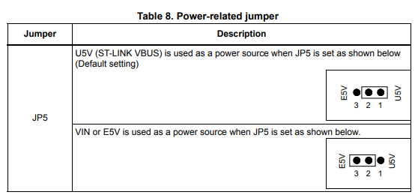

I was able to get communication between the raspberry pi and the 3 nucleo boards. I did this by having every board write whatever to serial it saw after it saw the packet start character. The boards were connected like so:

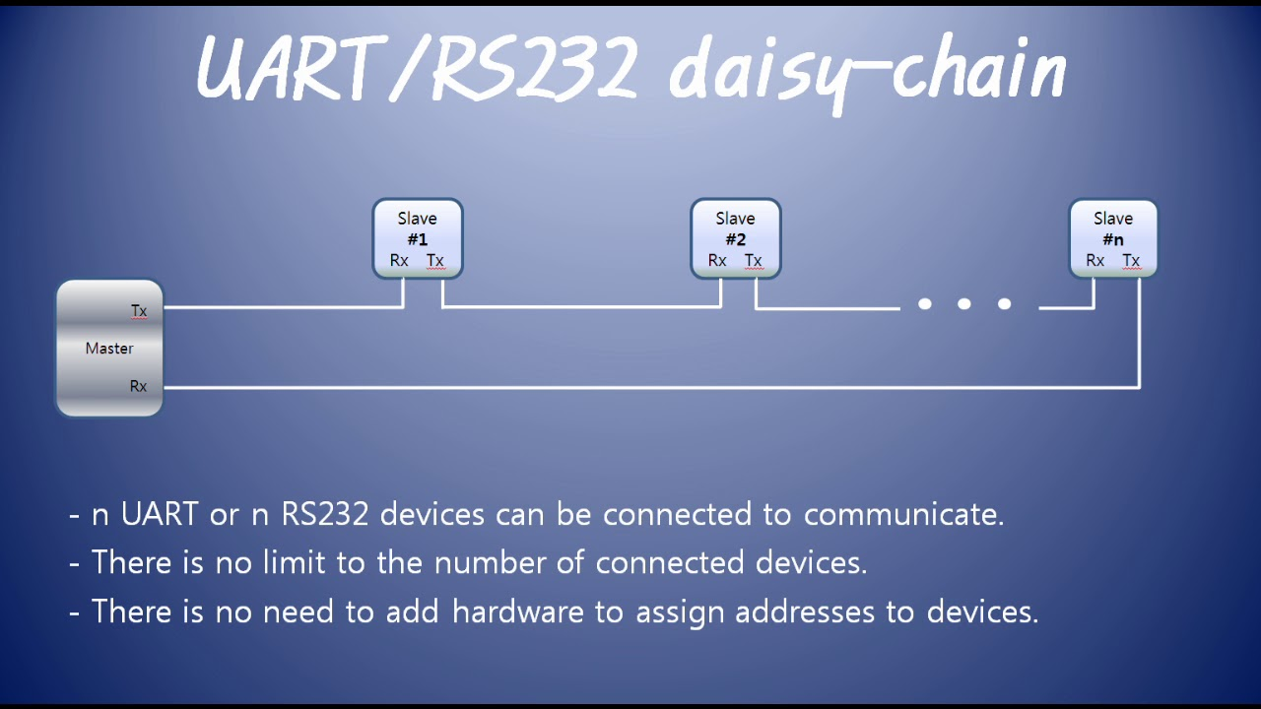
The current setup is:
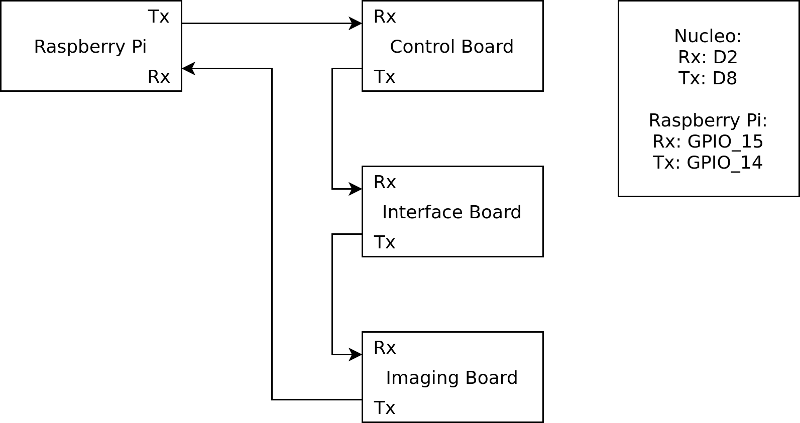

6/24/2021
Today I started work on the Imaging board using the code that fl@c@ has devised, while doing so I found out that you can use this:
FileHandle *mbed::mbed_override_console(int fd) {
return &raspi;
}
to redirect output to serial. With this I can use printf instead of raspi.write().
I am not able to get the debugger to work.

The system reports that it is out of memory…

6/25/2021
Here is the error:
++ MbedOS Error Info ++
Error Status: 0x80010132 Code: 306 Module: 1
Error Message: Thread: 0x0, System is out of memory
Location: 0x800A3E5
Error Value: 0x0
Current Thread: main Id: 0x200021A4 Entry: 0x80076F9 StackSize: 0x1000 StackMem: 0x200008D8 SP: 0x20017F2C
For more info, visit: https://mbed.com/s/error?error=0x80010132&tgt=NUCLEO_F401RE
-- MbedOS Error Info –
I fixed this error by uncommenting the line in printInfo() that has the uid.

printf() failed to print floats, the fix was to add a file called mbed_app.json and put this in it:
{
"target_overrides": {
"*": {
"target.printf_lib": "std"
}
}
}
The command GetSpectra was hanging because of accessing over the end of an array. I made sure to check to make sure we didn’t over shoot that and then it worked! I can take multiple images.

For next time, get PyQt4 and try to run spectraCide.py. You have to install it by downloading the tar.gz found here: https://riverbankcomputing.com/software/pyqt/download
It appears you also need this: https://riverbankcomputing.com/software/sip

6/28/2021
To be able to run PyQt4 which is what spectraCide.py is written in, I have to install sip:
https://gist.github.com/ZoomQuiet/1240c6202438c08e1f1d7134ca0189b2
and to do that I need a python virtual environment so:
https://github.com/pyenv/pyenv#installation
which lead me to the pyenv-installer:
https://github.com/pyenv/pyenv-installer

In installing SIP I made a virtual python envitonment called installSip with python version 2.7.16
To get PyQt4 installed I had to use:
sudo apt-get install qt4-dev-tools
After installing it all it still says no module named sip. After reboot, it says no such thing as PyQt4.
After using python3 and installing PyQt5 via:
sudo apt-get install python3-pyqt5
I fixed the print statements.
I installed a few missing modules and then installed chart_studio and plotly. chart_studio.plotly replaces plotly.plotly.
After changing QtGui to QtWidgets in the places where it said QtGui did not have that attribute. The spectraCide.py program worked with the GUI!! After clicking get spectra no COM62 port was found so I need to go through the program and adjust things so I can use them with the NUCLEOs.

6/29/2021
I added a combo box that holds all the detected serial ports, the user the can choose from these combo ports to then send the commands to. This is way better than the original hardcoded COM62 port.
I got some testing with the ccd in, and it works! The curve looks kind of flat though which is worrying. Fl@c@ was saying how his was very senstive, but I tried putting light on only one side and it was still fairly flat and close to the others. It definitely needs the cooling for the background noise that fl@c@ was talking about.
When redesigning some of the UI for the spectraCide.py I made the box to show the spectra a bit larger, this made it look all stretched and weird. So I followed this: https://stackoverflow.com/questions/13714454/specifying-and-saving-a-figure-with-exact-size-in-pixels with the dpi being 96.

6/30/2021
I got the temperture probes working a little bit. Sometimes they reported 999C and other times 24C which sounds right. So I thought that it might just need a little more time between temperature reads. Now only one thermometer shows up, and I do not know why. Trying again in the morning.

7/1/2021
HOLD THE RESET BUTTON on the nucleo… I don’t know why by sometimes it is finnicky and will not register two devices. Sometimes the temp on the thermometers shows -999.000C instead of the proper value… Maybe it is how quickly sampling is occuring?
It seems to do better if you hold the reset button and then wait a few seconds for things to initialize. I think the connections to the pcb for the temp probes are not good. Getting inconsistent readings.
The pcb seems to be fine, things are connected how they should be. I do not know why. Possibly a protocol issue?

7/2/2021
I noticed that R1 was a 47kΩ resistor instead of a 4.7kΩ resistor. So I replaced it and now it shows no devices found….

7/5/2021
Still shows no devices found, and now it is even worse. It gets stuck in the following loop only if there is a device plugged in:
while (oneWire.search(address)) // search for 1-wire device address
{
//pc.traceOut("Address = ");
for (int i = 0; i < ADDRESS_SIZE; i++)
{
//pc.traceOut("%x ", (int)address[i]);
devices[deviceCount][i] = address[i];
}
//pc.traceOut("\r\n");
deviceCount++;
}
Therefore for some reason oneWire.search(address) is not getting set to 0 to go back out of the loop… Was it because I measured the resistance of the resistor while the thing was powered on and now something is broken?

7/6/2021
Today I plugged in another NUCLEO-F401RE to the board and still had the same weird behavior where it gets stuck in the loop above when the CCD thermometer and cuvette thermometer are in place. When it is just the laser thermometer it initializes but say zero device count…
The CCD THERMOMETER is wired differently than the other two! THEY ARE NOT COMPATIBLE! I do not know if I broke the CCD thermometer.
I put back the old 47k resistor on and it still didn’t work. I then went back to the original program and rebuilt it just work without the modifications I made, and it did work! It still had the reading issue where it would read
-999C sometimes. I then replaced the 47k resistor with the 4.7k resistor again because it is the resistor that should be there, and it does not work… I will switch it back to the 47k resistor and just leave it be…
FINAL VERDICT:
DO NOT PUT ANYTHING BETWEEN THESE TWO LINES OF CODE:
wait_us(2000000);
device.initialize();
I had put a printf line in between and that is what was breaking it. However you MUST ALSO USE THE 47K RESISTOR, there is sstill the issue of inconsistent readings but you can just not count those.
INTERFACE BOARD
When looking at the interface board the wires are plugged in in the order of them on the ribbon with the white wire being on SD0/MISO on the LCD and at the one position on the interface board.

7/7/2021
Things the control board must be able to do for basic operation:
Turn on and off laser DONE
Laser shutter open/close DONE
Laser TTL
Change filters DONE (Rotary encoder not implemented!)
Open and close cuvette DONE
Temperature (cuvette and laser)
Control peltiers with H-Bridge
Things the imaging board must be able to do for basic operation:
Take the image (duh)
Keep track of the CCD temp

7/8/2021
The new plan is to use multiple threads, I can put opening and closing the cuvette and moving the filters on seperate threads so the control board can do other things while it takes more than 10 seconds to do those operations.
I will also be making classes for those objects, so it can hold onto current status of the object, whether it is closed or what filter it is on.

7/9/2021
Basic formatting for the filter, cuvette, and laser objects have been done. You can specify what pins they are on and get their current status.

7/14/2021
Started to make the SerialPacket class.
I experimented with threads. I am able to have a read thread and poll it multiple times. I can read and write in seperate threads and seperate times and get the data to go through. One thing that you need to watch out for is the buffer size. The buffer size for serial is 256 bytes if memory serves. Using an application buffer of 32 bytes you can get 32 byes at a time from the raspberry pi until the message is done. If the message receiving is larger that 256 bytes you have the possibility of losing bytes if you do not query quickly enough. Querying at 1000ms is a no go, but if you go at 100ms is reasonable, 10ms issss wayyy more than enough according to my testing.
I tried writing stuff to serial in the main looop while two other threads did reading and writing and it was chaos. DO NOT DO THIS! Make sure reading and writing are done in seperate threads!

7/19/2021
I determined that the best way to handle Serial communications is through a single class called SerialPort. Here is the class definition:
class SerialPort {
private:
BufferedSerial serial_port;

public:
SerialPort(PinName tx, PinName rx, int baud);
int writeSerialPacket(vector<char> tx_packet);
int readSerialPacket(vector<char> rx_packet);
};
The idea is that you declare the serial port and then you can use the writeSerialPacket() method to write it to the port by passing it a character vector which makes it easier to have different packet lengths. The return of -1 indicates there was a read or write error and 0 indicates success.
Currently a mind boggling issue is that when I do not loop the call to the write function it does not write anything to the serial port at all. Only when I put it in a while (true) loop does it actually start outputting. I’ll have to do more tests if I want to figure out why it does that. Even delaying the writing does not fix it and making two writes to it, it still does not output anything. At least on the raspberry pi.

8/16/2021
serial_port.writable() = 1 even if nothing is connected.
If you add a delay of at least 11ms after the end of the call to writeSerialPacket() then it will output correctly, problem solved.

8/17/2021
To start debugging first we need to start pyOCD:
pyocd gdbserver -t stm32f401re
To run the debugger type in the following:
arm-none-eabi-gdb PROGRAM.elf
The .elf file can be found within the BUILD folder of the project in BUILD/NUCLEO_F401RE/ARMC6. Once the gdb has started enter this command:
target remote localhost:3333
And you can then use gdb to debug the NUCLEO microcontroller. Congrats!

8/19/2021
A good way to encode packets in python is:
packet = b’\x48\x69\xa0\xf3’
serial.write(packet)
I need to see how to do it with the definitions that were given (so I don’t have to remember the command codes).

8/20/2021
The following is possible using the definitions:
packet_end = b’\xf3’
packet = b’\x48\x69\xa0’ + packet_end
So eventually packet would just be a list of appends.
All appends works
FIRST FULL PACKET!!
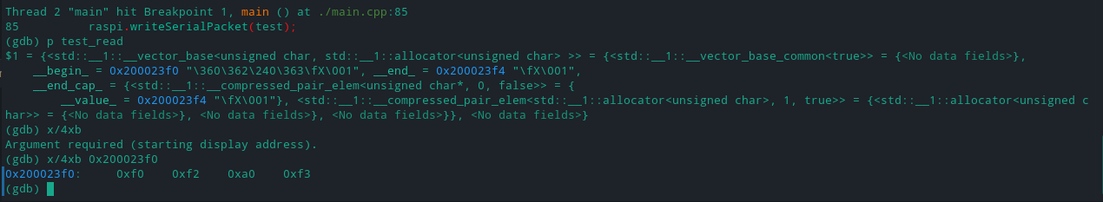
I MAY NEED TO FORGET ABOUT USING UNSIGNED 8 BIT INTEGERS! I WOULD NEED A WAY OF ENCODING NEGATIVE NUMBERS! Maybe just use signed integers? This is an issue I need to spend way more time on.
I HAVE DECIDED NOT TO DO DAISY CHAIN SERIAL.
The raspberry pi 4 has like 6 uart ports so why bother having all of them on one and possibly having issues?

8/23/2021
When casting a negative number to an unsigned 8 bit integer to send via serial, python receives the 2s complement of that number (which is to be expected). I am going to try having everything char casted and see how that effects the result.
For Pyton to read integers, floats, and doubles properly they need to be packed specially into the uint8_t type in C++ since they are multiple bytes long:
float test_convert = -11.0;
uint8_t* test_convert_array = (uint8_t *) &test_convert;

vector<uint8_t> test;
for (int i = 0; i < sizeof(float); i++) {
test.push_back(test_convert_array[i]);
}
test.push_back(0xF3);

Python will always read from serial as bytes in my case, to convert the bytes it reads into integers we need to do some conversions:
data = serial.read_until(b’\xf3’)
data = data[:-1] # cuts off final \xf3 value
int.from_bytes(data, “big”, signed=True)
To convert it into floats:
data = serial.read_until(b’\xf3’)
data = data[:-1] # cuts off final \xf3 value
struct.unpack(‘f’, data) # use ‘d’ if unpacking doubles
And there you have it, now we can send different data types from C++ to Python over Serial!!!
I tried adding code to work with arrays to convert them to a vector of uint8_t but so far it just failed, I’ll have to figure out why tomorrow.

8/24/2021
The code works correctly for floats and doubles outside of it and floats still works on the nucleo, however the double vector does not print. It was able to print after stepping throught the writeSerialPacket function with gdb. I am going to re-write that function with writing from a buffer instead.
WHEN WRITING FROM A BUFFER THERE HAS TO BE A THREAD DELAY FOR IT TO WORK PROPERLY!!! Idk why, but the longer the array the more the delay… I will have to remedy this somehow, I am not sure how at this point of time.

8/25/2021
Using
this→serial_port.sync();
ThisThread::sleep_for(1ms);
This allows all the data to be sent with only a 1ms delay, which is much better than the at least 11ms for small amounts of data!! Will do more testing.
You still have to have a longer delay for larger amounts of data, I do not like having to do that. I will have to figure out some sort of solution. While doing this testing pyocd now gives me a no cores found error while trying to flash… Copying it the normal way through usb failed but fixed the pyocd problem so flashing it that way works again.

11/9/2021

After having issues with the MakeFile, this is what resolved it:
https://github.com/ARMmbed/mbed-os/issues/9816

