Bachelor of Technology
Computer Science & Engineering Department

Lab Manual

CS – VTH SEM

PYTHON - CS 506



Submitted By: Submitted To:
Enrollment No. : - Asst. Prof. Khushboo Soni

Name of the Student:-

SHRI RAM GROUP OF INSTITUTIONS (SRGI), JABALPUR, 2025
LAB MANUAL
CS – Vth PYTHON(CS - 506)

INDEX

Sr.  No. | Title | Page No.
1 | To write a Python program to find GCD of two numbers without using built- in-function
2 | To write a Python program to find the exponentiation of a number without using built- in-function.
3 | To write a Python Program to find the maximum from a list of numbers without using built- in-function.
4 | Create a list and perform the following methods  1) insert() 2) remove() 3) append() 4) len() 5) pop() 6) clear()
5 | write a program to perform different arithmetic operations on numbers in python
6 | Write Python Programs to display the below patterns.  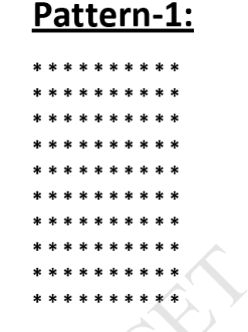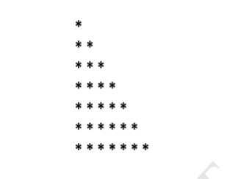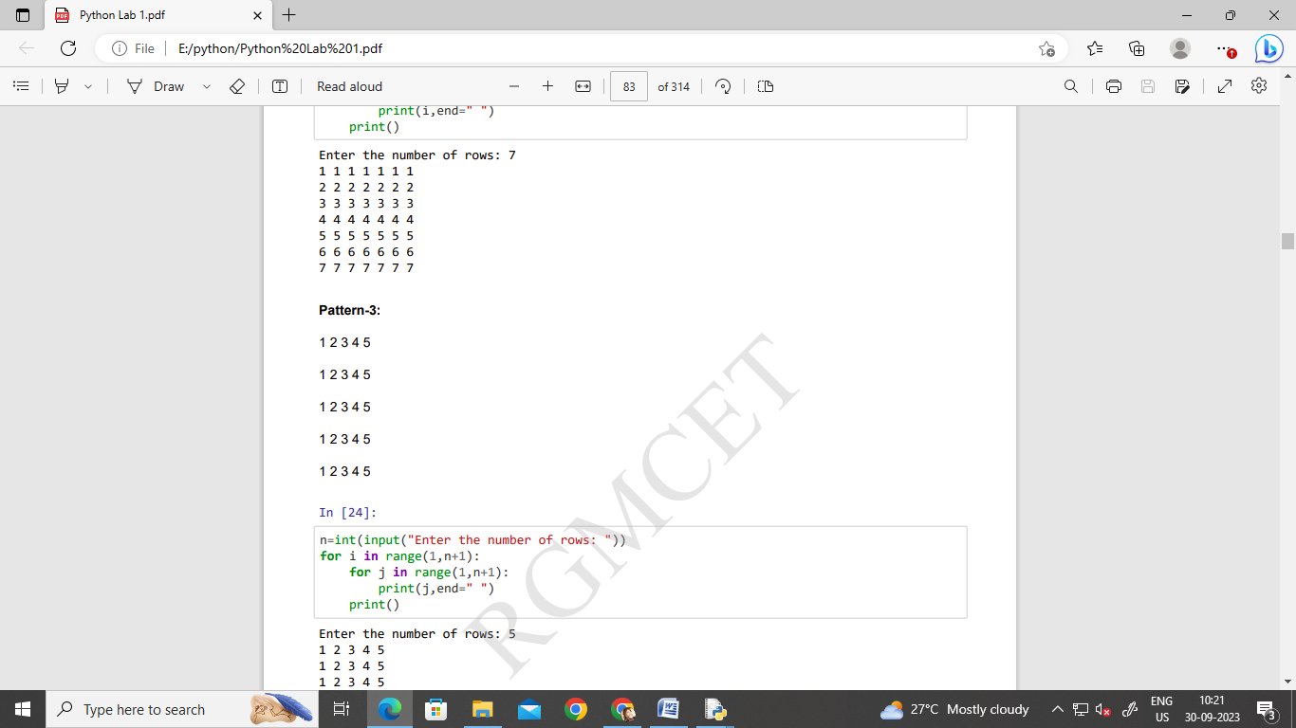
7 | To write a Python program to check whether number is prime or not.
8 | To write a Python program to find the square root of a number by using User defined function.
9 | Create a Dictionary and perform the following methods:-1.len() 2.copy() 3.get() 4.keys() 5.items() 6.values() 7.update() 8.pop() 9.clear()
10 | Create a Tuple and perform the following methods:- 1.len() 2) Check for item in tuple 3) Access Item
11 | Create a Set and perform the following methods:-1.len(set) 2.max(set) 3.min(set) 4.sum(set) 5.sorted(set) 6.add() 7.update() 8.discard() 9.union() 10.intersection() 11.difference()
12 | Implementation of Python Libraries for ML application such as NumPy,Pandas and Matplotlib.

PROGRAM NO. 1
AIM: - To write a Python program to find GCD of two numbers without using built- in-function

Program:
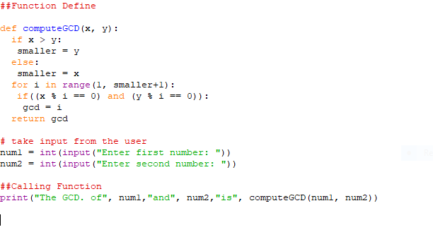 Output:

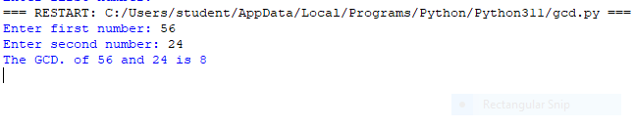
PROGRAM NO. 2
AIM: - - To write a Python program to find the exponentiation of a number without using built- in-function.

Program:
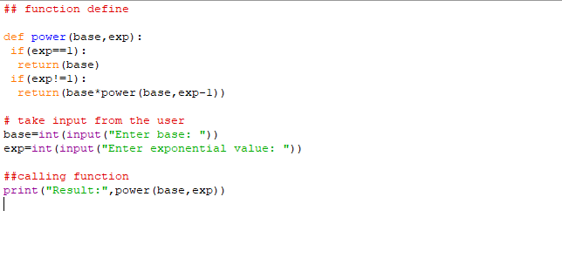 Output:

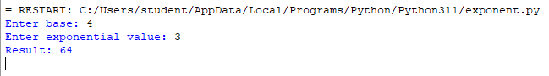

PROGRAM NO. 3
AIM: - To write a Python Program to find the maximum from a list of numbers without using built- in-function.

Program:
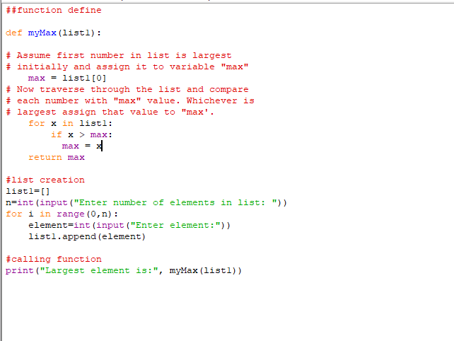
Output:

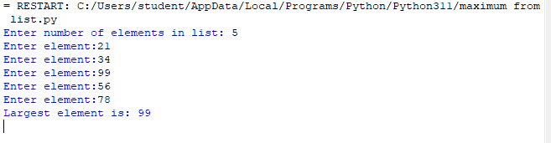

PROGRAM NO. 4
AIM: - Create a list and perform the following methods
- insert() 2) remove() 3) append() 4) len() 5) pop() 6) clear()

Program:
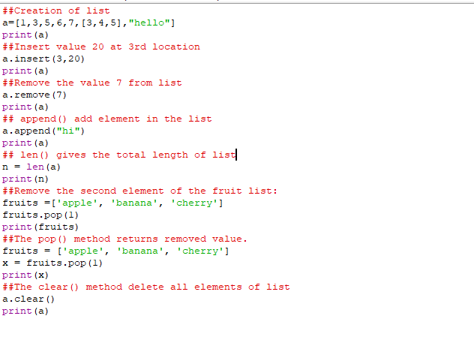 Output:

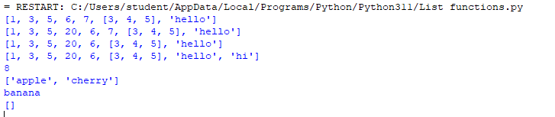

PROGRAM NO. 5
AIM:- write a program to perform different arithmetic operations on numbers in python

Program:
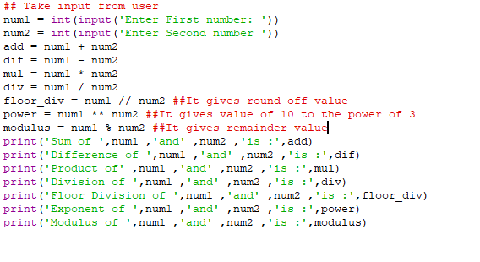 Output:

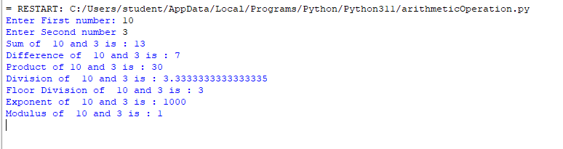

PROGRAM NO. 6
AIM:- Write Python Programs to display the below patterns.
Program:
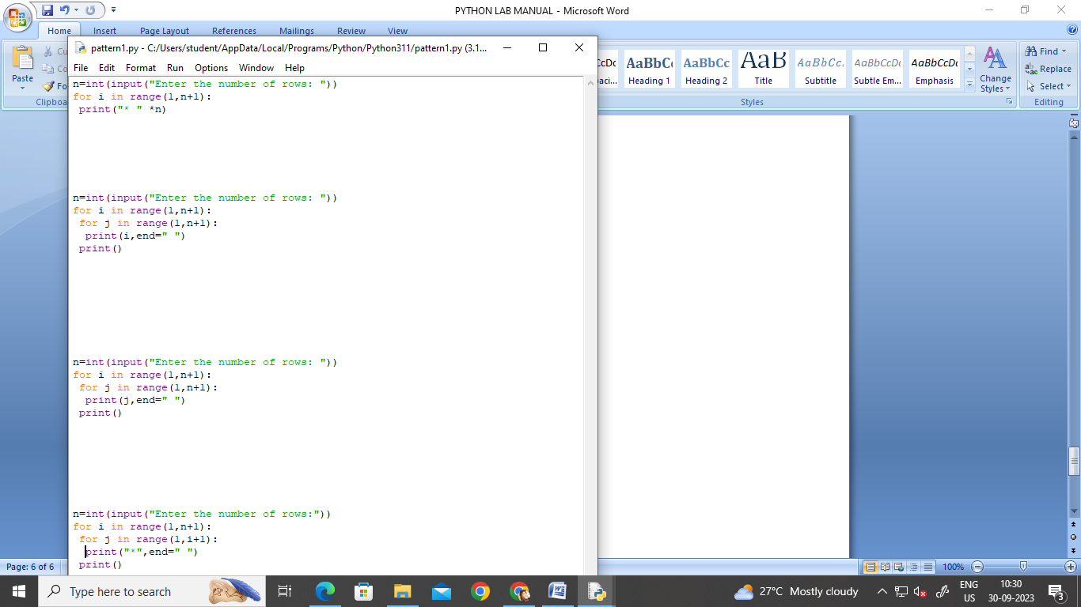
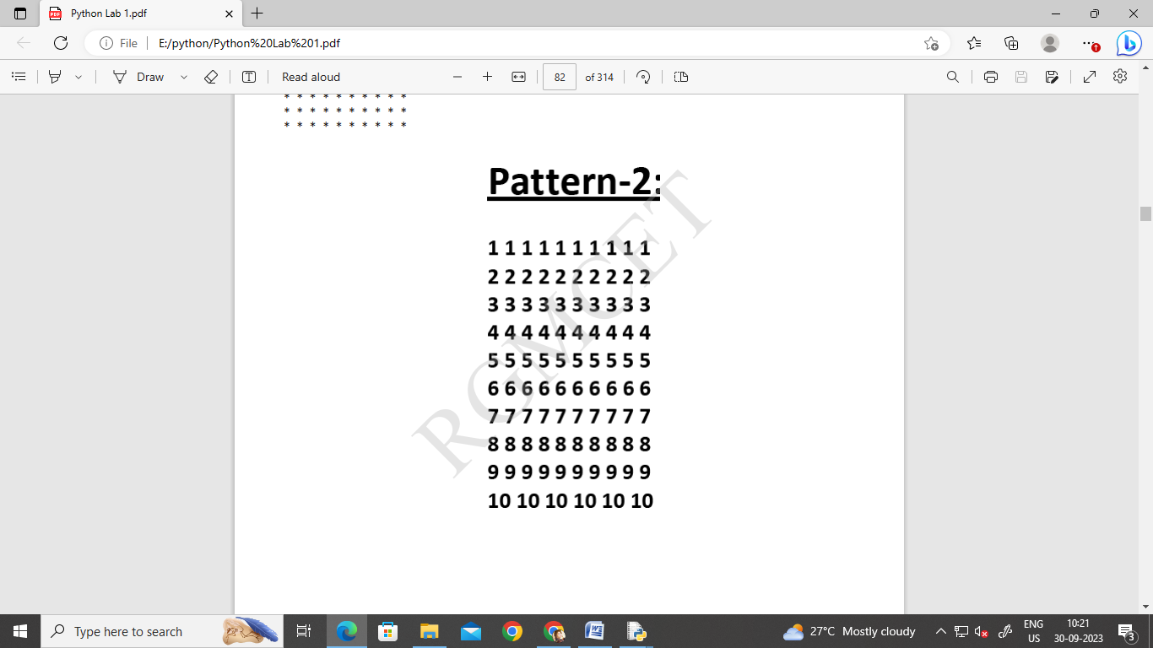
Program:

Program:

PATTERN – 4:
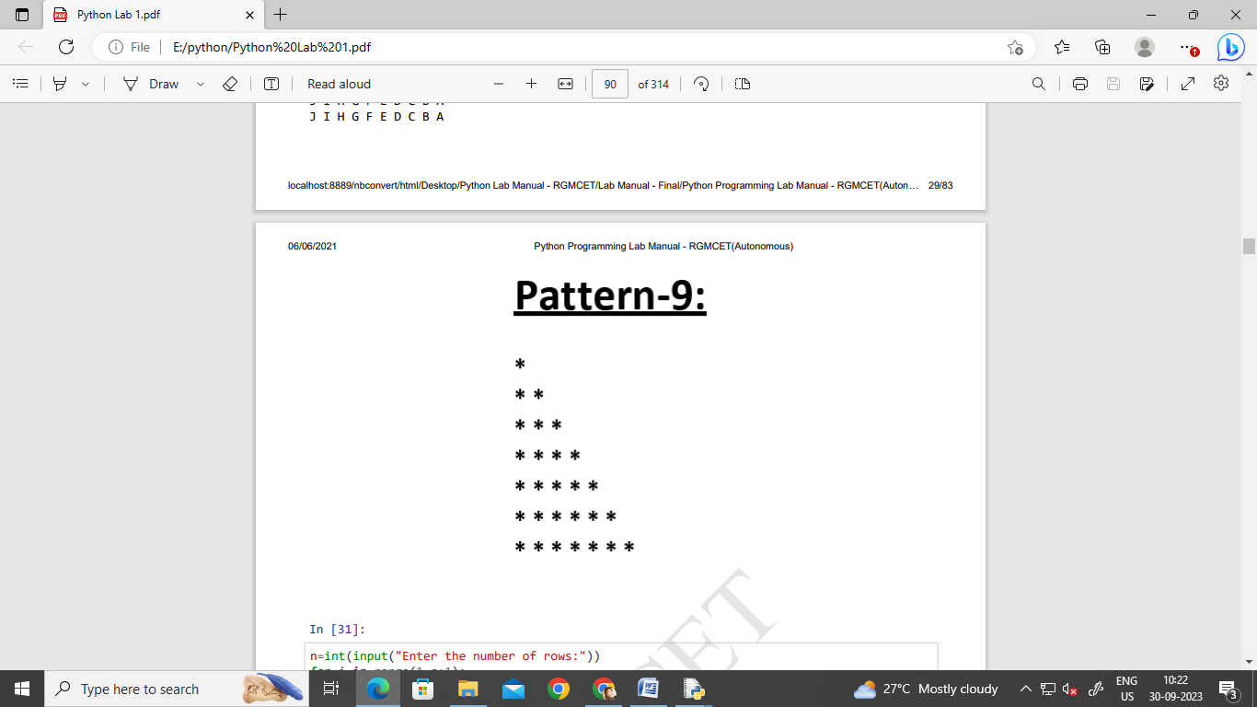
Program:

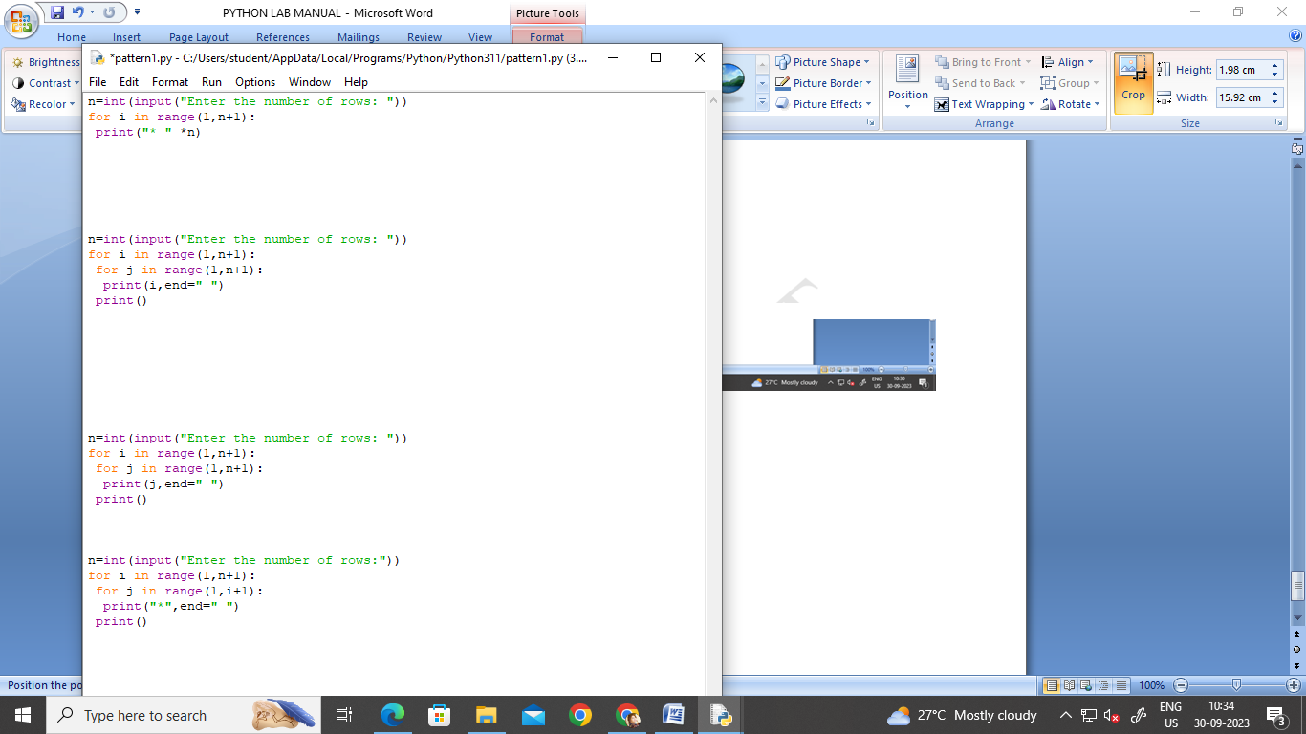
PATTERN – 5:
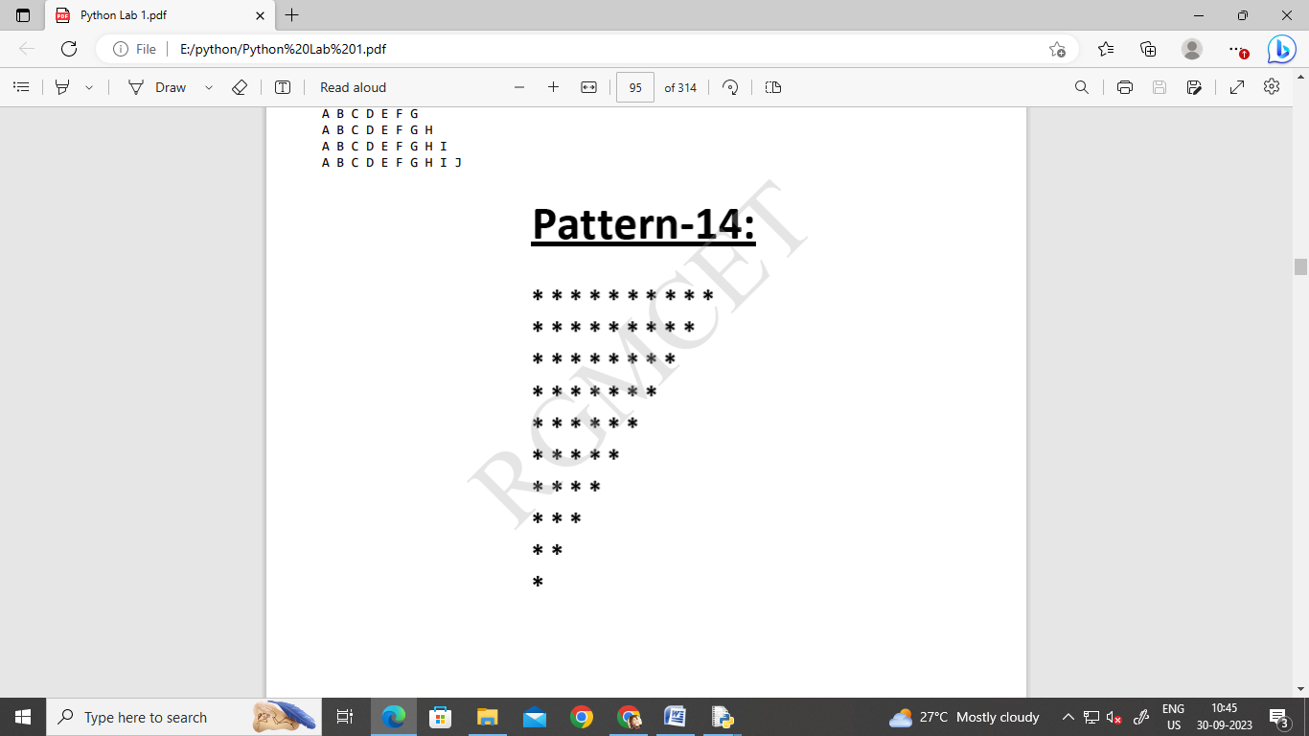
Program:
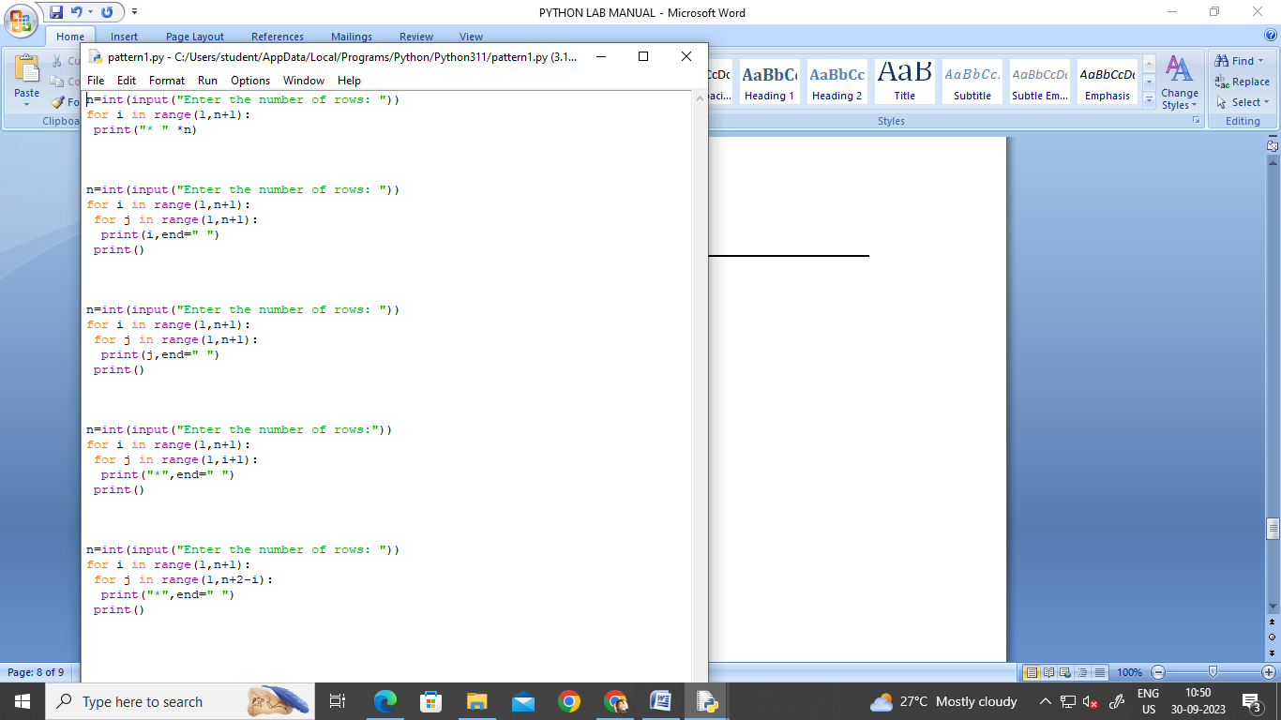

OUTPUT OF ALL PATTERNS :
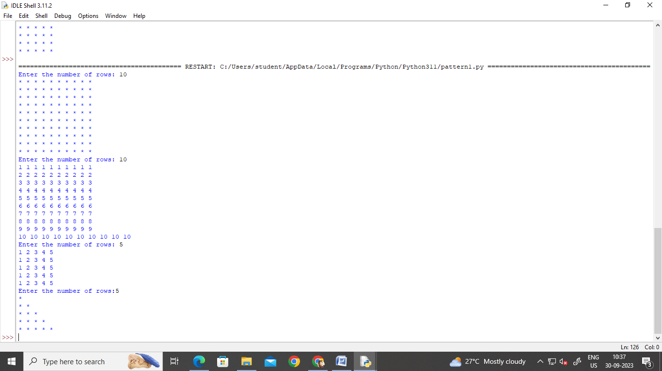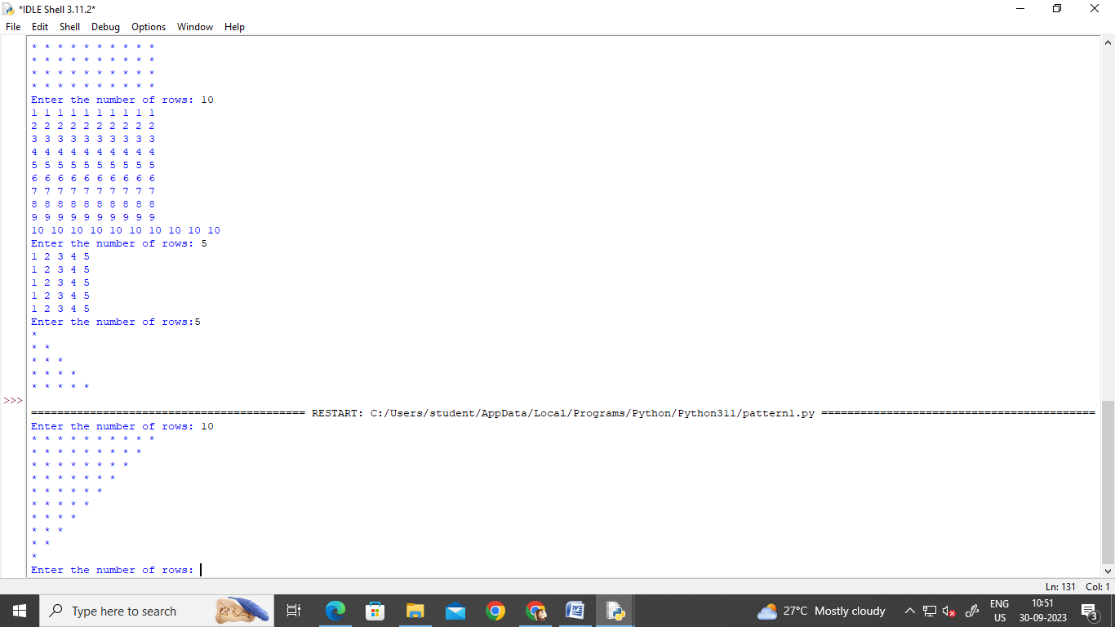
PROGRAM NO. 7
AIM:- To write a Python program to check whether number is prime or not.

Program:
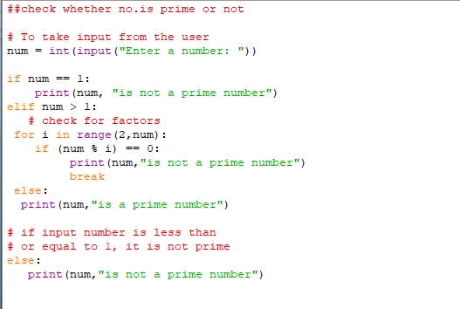

Output:

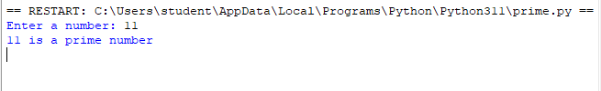

PROGRAM NO. 8
AIM:- To write a Python program to find the square root of a number by using User defined function.

Program: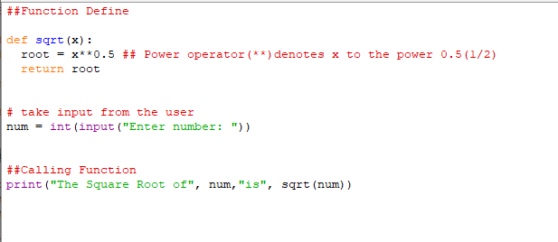
Output:

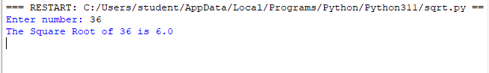
PROGRAM NO. 9
AIM:- Create a Dictionary and perform the following methods:-
- len()
- copy()
- get()
- keys()
- items()
- values()
- update()
- pop()
- clear()

Program:
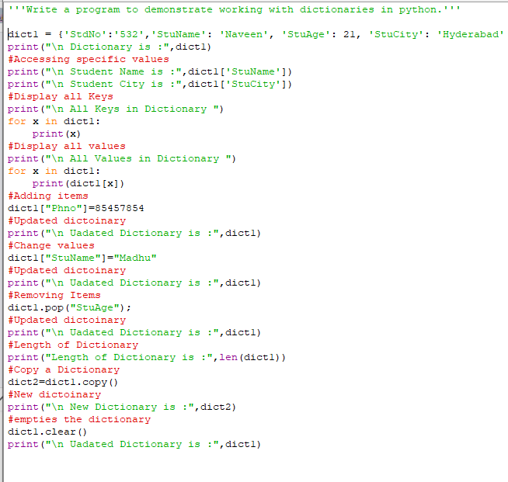
Output:

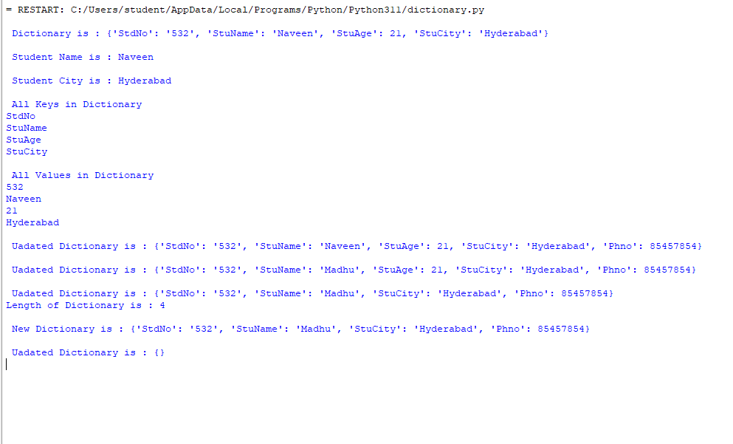
PROGRAM NO. 10
AIM:- Create a Tuple and perform the following methods:-
- len() 2) Check for item in tuple 3) Access Item

Program:
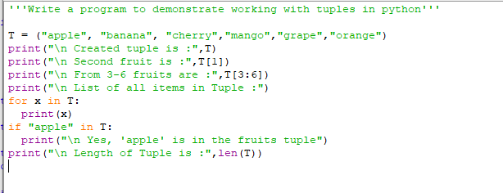
Output:

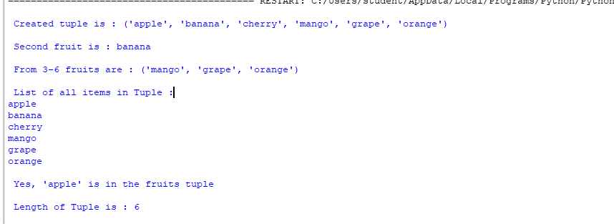
PROGRAM NO. 11
AIM:- Create a Set and perform the following methods:-
- len(set)
- max(set)
- min(set)
- sum(set)
- sorted(set)
- add()
- update()
- discard()
- union()
- intersection()
- difference()

Program:
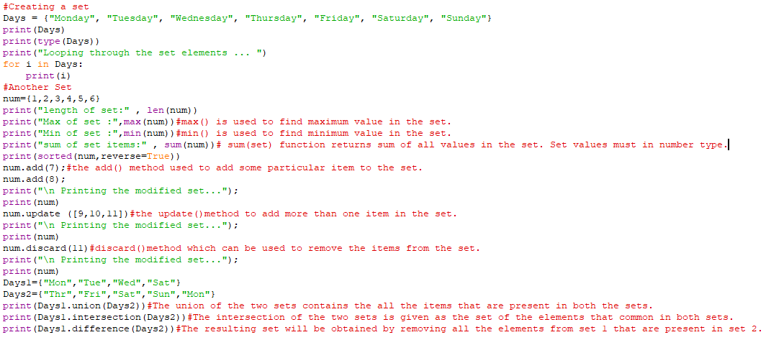
Output:

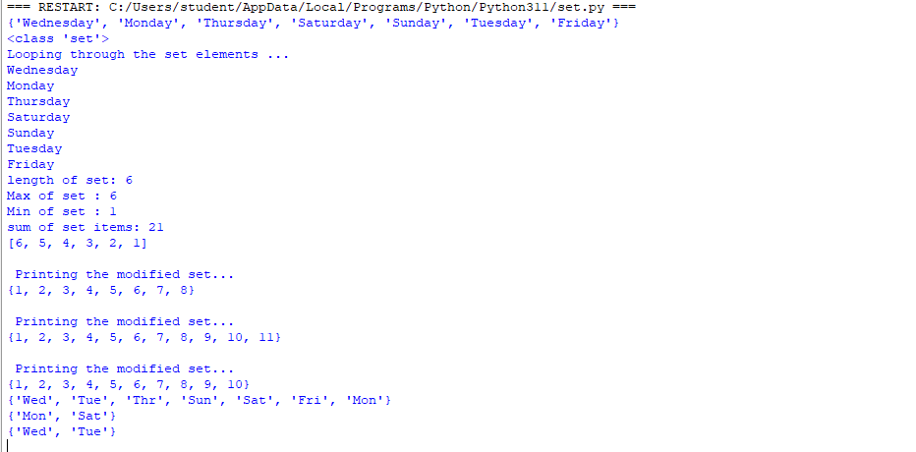

PROGRAM NO. 12
AIM: - Implementation of Python Libraries for ML application such as NumPy, Pandas and Matplotlib.

NUMPY LIBRARY

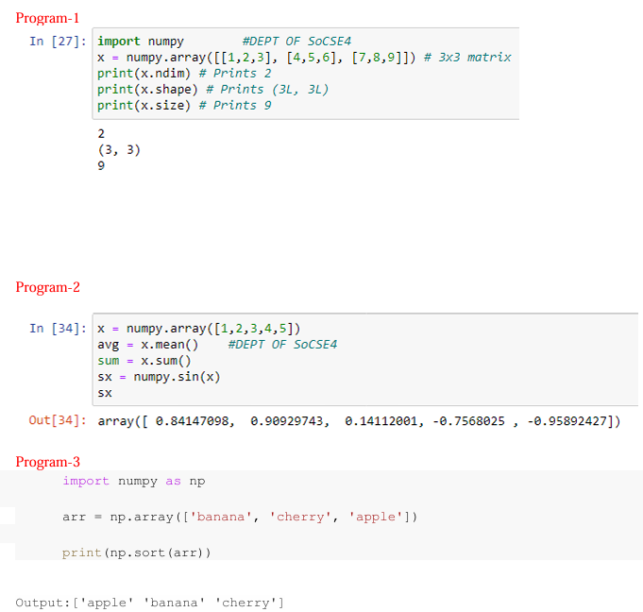

PANDAS LIBRARY

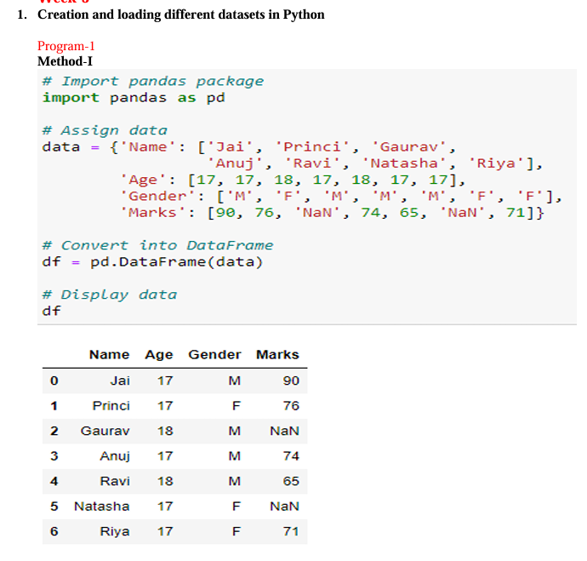
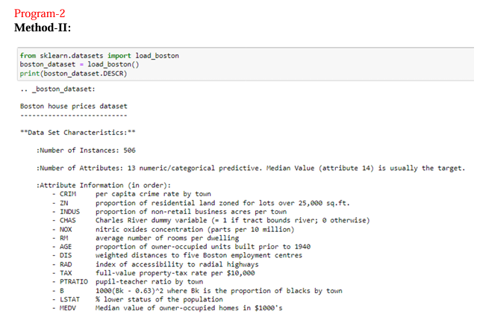

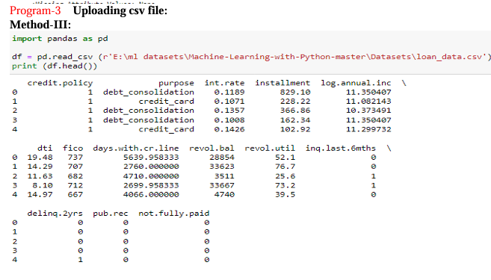

MATPLOT LIBRARY
