Financial Management Web Application

Raymond Lawson

CST-452 Capstone Project Requirements Document

Grand Canyon University

Instructor: Professor Bradley Mauger

Revision: 1.6

Date: 12/9/2023

**ABSTRACT**

This project attempts to address an issue surrounding financial management. Many individuals in todays times are not able to effectively manage their finances whether it is budgeting, saving for goals, or even just managing the month to month obligations. There are so many automatic drafts that keeping track and remembering everything is a difficult task. This application aims to alleviate the stress by being a central place to manage bills, income, saving for goals, and much more. This document is the Project Requirements Document for the Capstone Project. This document will describe the use cases/user stories, the system design, technical requirements, system logical model, screen definition and layouts, and any security issues currently identified.

|  |
| --- |
| History and Signoff Sheet |

**Change Record**

|  |  |  |
| --- | --- | --- |
| **Date** | **Author** | **Revision Notes** |
| 11/1/2023 | Raymond Lawson | Initial draft for review/discussion |
| 12/9/2023 | Raymond Lawson | Final review and submission. |
|  |  |  |

|  |
| --- |
| **Overall Instructor Feedback/Comments** |

|  |
| --- |
| **Overall Instructor Feedback/Comments** |

**Integrated Instructor Feedback into Project Documentation**

Yes  No

**TABLE OF CONTENTS**

Functional Requirements 4

Non-Functional Requirements 5

Technical Requirements 6

Logical System Design 7

User Interface Design 8

Reports Design 9

Functional Requirements

**Use Cases**

Describe the sequence of functional actions a project performs with either textual Use Cases, UML Use Case diagrams, or if using Scrum, provide a link to the User Stories (see template included in course materials).

NOTE: Once the functional requirements have been completed, there may be situations where Use Cases or User Stories may need to be taken out of scope, possibly due to technical challenges or timeline challenges. Any Use Cases or User Stories that are taken out of scope once the project development has started must be approved by the mentor and instructor with justification as to why the functionality is being removed from the project. The following must be updated if any Use Cases or User Stories are taken out of scope:

|  |  |  |
| --- | --- | --- |
| **Use Case or User Story** | **Approval Date** | **Justification** |
|  |  |  |

Link to Functional Requirements Document: <https://docs.google.com/spreadsheets/d/1CSfJYl4zfYlEIj4sN-k1eBc_spTjHg64/edit?usp=sharing&ouid=110853295913392877928&rtpof=true&sd=true>

Non-Functional Requirements

**Use Cases**

Describe the sequence of non-functional actions a project performs with either textual Use Cases, UML Use Case diagrams, or if using Scrum, provide a link to the User Stories (see template included in course materials).

NOTE: Once the non-functional requirements have been completed, there may be situations where Use Cases or User Stories may need to be taken out of scope, possibly due to technical challenges or timeline challenges. Any Use Cases or User Stories that are taken out of scope once the project development has started must be approved by the mentor and instructor with justification as to why the functionality is being removed from the project. The following must be updated if any Use Cases or User Stories are taken out of scope:

|  |  |  |
| --- | --- | --- |
| **Use Case or User Story** | **Approval Date** | **Justification** |
|  |  |  |

Link to Non-Functional Requirements Document: <https://docs.google.com/spreadsheets/d/1Me8EvWhggyRMn0a_7yQhUOBf5ekr8gvP/edit?usp=sharing&ouid=110853295913392877928&rtpof=true&sd=true>

Technical Requirements

**Use Cases**

Describe the tools and technologies used in the project.

NOTE: Once the technical requirements have been completed, there may be situations where technologies or tools may need to be taken out of scope or changed, possibly due to technical challenges or timeline challenges. Any technologies or tools that are taken out of scope or changed once the project development has started must be approved by the mentor and instructor with justification as to why the functionality is being removed from the project. The following must be updated if any technologies or tools are taken out of scope or changed:

|  |  |  |
| --- | --- | --- |
| **Technology or Tool** | **Approval Date** | **Justification** |
| **ASP.NET C#** |  | **Framework – This is the framework used to develop the application** |
| **HTML/CSS/Bootstrap/Razor** |  | **Front End – The front end is developed with these technologies.** |
| **MySQL** |  | **Back End – The database is a MySQL database. (relational database)** |
| **Model-View-Controller (MVC)** |  | **Design Pattern – The application utilizes the MVC design pattern.** |
| **Data Access Object (DAO)** |  | **Design Pattern – The application utilizes the DAO design pattern.** |
| **Visual Studio 2019** |  | **IDE – This is the development environment used to create the application.** |

Logical System Design

Provide a diagram of the logical architecture of the system.

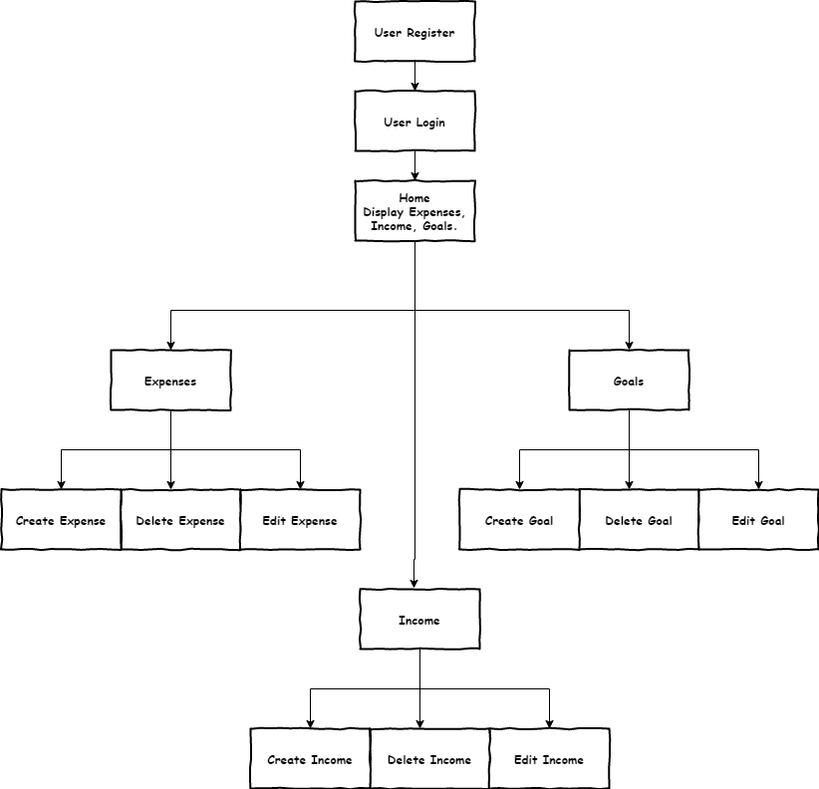

User Interface Design

Provide a sitemap and user interface design diagram for each user interface screen in the application, if not applicable, define the components of the project as described in the handbook.

Sitemap

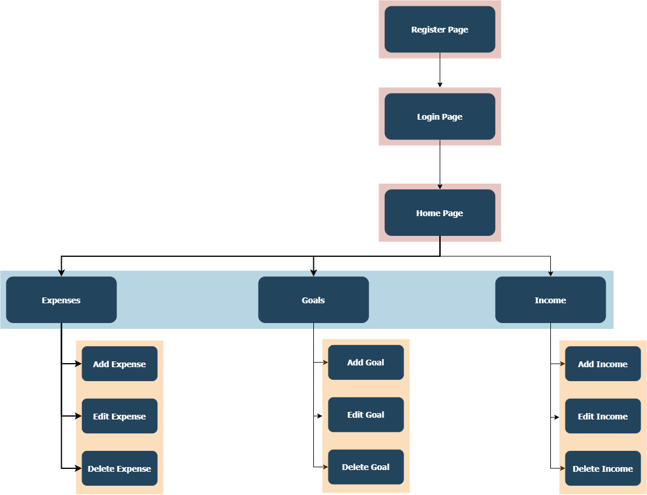

User Interface Design Drafts

Login Page

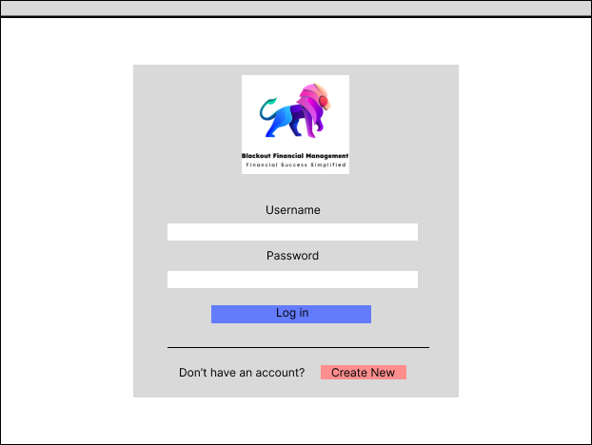

Register

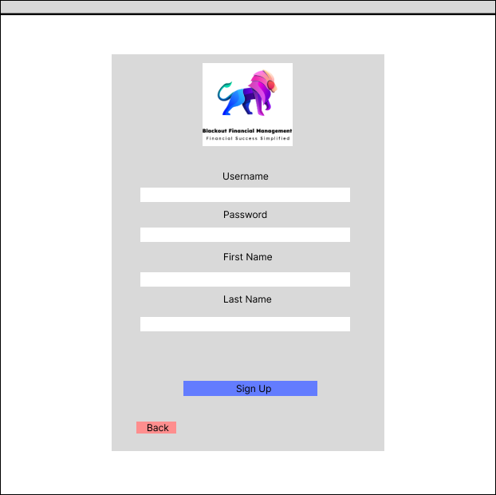

Home Page

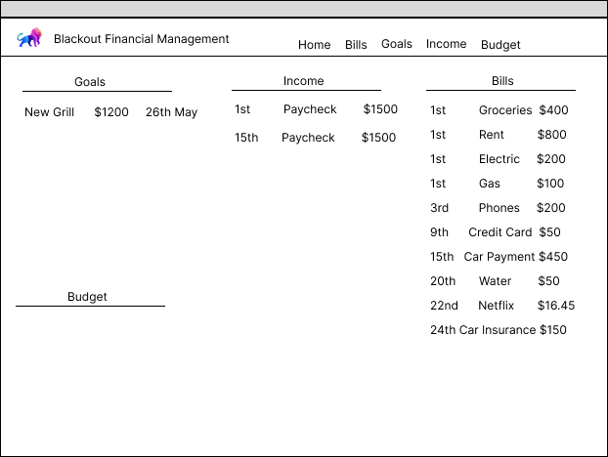

Bills Page

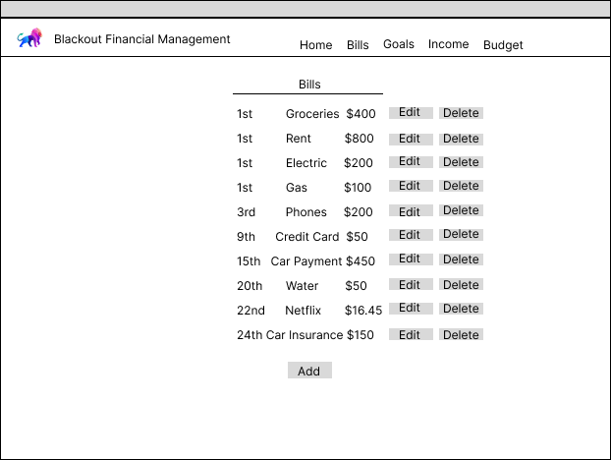

Goals Page

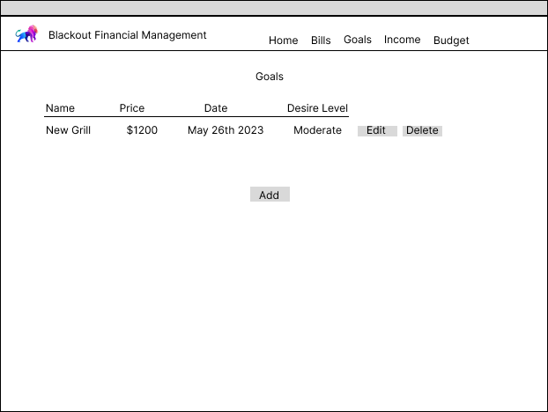

Income Page

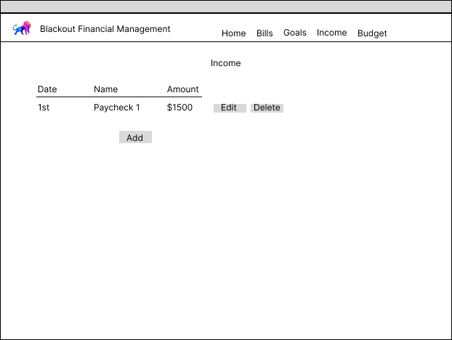

Budget Page

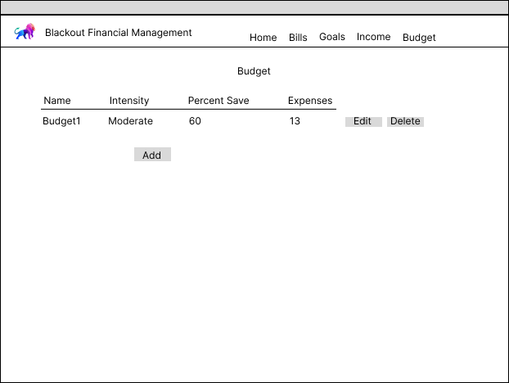

Reports Design

Provide a listing of the reports that the system will provide, if applicable. If not, state that the system does not produce any reports and provide additional documentation as described in the handbook.

The system does not produce any reports.