Financial Management Web Application

Raymond Lawson

CST-452 Capstone Project Proposal

Grand Canyon University

Instructor: Professor Bradley Mauger

Revision: 1.6

Date: 12/9/2023

**ABSTRACT**

Financial management is a crucial aspect of living a day-to-day life as an adult. This topic unfortunately has not been focused enough in classrooms. I remember being taught how to write a check and to manage a checkbook in high school which was the apex of my home economics class. This has been detrimental to several generations as they are ill-equipped to deal with real world financial issues and proper budget planning when going out into the workforce. The goal of this financial management tool is to remove the complexity of taking control of ones finances and offer a seamless and easy to understand platform to offer adults the best chance of success. This document is the Capstone Project Proposal that will identify the purpose and specifications regarding the project.

## **Capstone Project Proposal**

**General Information**

Project name: Financial Management Web Application

Author: Raymond Lawson

Project organization, if applicable: Raymond Lawson

Project manager, if applicable: Raymond Lawson

Date project proposal form is submitted: 10/22/2023

**Project Overview and Project Objectives**

**State the Problem**

**Background**

The problem is that for a long-time financial education was not prioritized by the United States school system. This has led to adults that cannot properly manage their personal finances. From a CivicScience study, the number of adults in the United States that claim they are not financially literate at all is 1-in-10 (Collins, 2023). There are currently applications on the market to help manage finances but a vast majority of them offer so many features they become crowded and intimidating to new users. The aim of this project is to develop a tool that the average person can use to take control of their financial situation and offer them the best chance for success.

**Christian Worldview**

Having a sound financial plan has a profound impact on anyone’s daily life. Financial chaos can incite depression, feelings of hopelessness or helplessness, and overall anxiety and stress. From a Christian perspective helping others be the best they can be is very important and in providing a tool such as this the average person has a better chance not to be overwhelmed with managing their money.

**Project Objectives**

The objectives to measure project success are:

1. The project allows users to sign up for an account and log in.
2. The project allows users to input and track their expenses.
3. The project allows users to add income information and shows which expenses fall within those paychecks.
4. The project allows users to add goals and goal information.
5. The project is not convoluted or too difficult for the average person to utilize.

**Challenges**

The challenges used to measure project success are:

1. The database layout is optimized.
2. Defensive programming and common security practices are used.
3. Income, Expenses, and Goals are automatically updated without need of user interference.

**Benefits and Opportunities**

The largest benefit from developing this application is to allow users to stay on top of their finances. This has an impact on every aspect of life. Poor financial decisions can be catastrophic and cause someone to lose everything they have worked for. In the world we live in most bills are automatic drafts that are meant for ease of use for the customer. However, a normal household can have so many of these that keeping track of all of them can be a daunting task. Even worse are those living in poverty, paycheck to paycheck and if they forget even one it could be detrimental and cause disastrous results.

**Project Scope**

This project is a web application so it will be all screen based and will store user account and financial information within a database. The data will have mathematical operations performed on it to show the user’s financial state. The scope of this project is to provide a tool that adequately allows the average person to manage their personal finances. The team will consist of a web developer (Raymond), backend developer (Raymond), and project manager (Raymond). The web developer will work 21 hours a week for 2 weeks. The backend developer will work 30 hours a week for 2 weeks. The project manager will work 15 hours a week for 4 weeks. There will be weekly milestone goals to reach. Outside of the scope of this project would be to add additional features that fall under “quality of life” improvements.

|  |  |  |
| --- | --- | --- |
| Stakeholder Name | Role(s) | Responsibilities |
| Raymond Lawson | Web developer, Backend developer, Project Manager. | Plan, analyze, design, and develop the application. Mange the project and ensure milestones are met and time is utilized efficiently. |
|  |  |  |

|  |  |  |  |  |  |  |  |  |  |  |
| --- | --- | --- | --- | --- | --- | --- | --- | --- | --- | --- |
| Work Breakdown Structure | | | | | | | | | | |
| ID | Task | Dependencies | Status | Effort Hours | Cost | Start Date | Planned Completion | Estimate to Completion | Actual Completion | Resource |
| 1 | Planning |  | Completed | 12 | $0 | 10/16/2023 | 10/22/2023 | 0 | 10/22/2023 |  |
| 2 | Requirement Analysis |  | Completed | 10 | $0 | 10/23/2023 | 10/29/2023 | 0 | 10/29/2023 |  |
| 3 | Final Architecture Plan |  | Completed | 15 | $0 | 10/30/2023 | 11/5/2023 | 0 | 11/5/2023 |  |
| 4 | Development Phase |  | Completed | 30 | $0 | 11/6/2023 | 11/13/2023 | 0 | 12/10/2023 |  |

**Project Completion**

|  |
| --- |
| Project Completion Criteria |
| 1 – Deadlines are met, and product is fully functional by the end of the last milestone. |
| 2 – The application is user friendly and does not deter new users with too many features. |
| 3 – Acceptable technology is utilized in developing the application. |

|  |  |  |  |  |  |
| --- | --- | --- | --- | --- | --- |
| Assumptions and Constraints | | | | | |
| ID | Description | Comments | Type | Status | Date Entered |
| 1 | Deadlines are met | It is assumed that the time given for each deadline is adequate and reachable. | Assumption |  | 10/18/2023 |
| 2 | Setbacks are allotted for in the overall time | It is assumed that the time allotted for the deadline has included an allowance for potential setbacks | Assumption |  | 10/18/2023 |

**Project Controls**

|  |  |  |  |  |
| --- | --- | --- | --- | --- |
| Risk Management | | | | |
|  | **Risk Probability** | **Risk Impact** |  |  |
| **Event Risk** | **(high, medium, low)** | **Risk Mitigation** | **Contingency Plan** |
| What is the risk? | What is the probability? | What is the impact if the risk occurs? | What can be done to minimize the risk? | What can be done to minimize the impact of the risk? |
| Computer malfunction during development | Low | Work on the project as a whole halts. | Ensure the machine is adequately maintained. | Ensure to have a backup machine. |
| Database Corruption | Low | User’s data could become corrupt or unavailable. | Ensure to have routine backups of the database. | Repair corrupted database. |
| Web server becomes unavailable | Low | Users cannot access web site. | Continuous monitoring of server logs to ensure no issues. | If necessary, offer a temporary alternate server such as from a cloud provider until the server is repaired. |
| Attacks from malicious actors | Medium | User data could become compromised | Put proper defensive programming and security practices in place. | Utilize most optimal recovery methods as efficiently and quickly as possible. |

|  |  |  |  |  |  |  |  |  |  |
| --- | --- | --- | --- | --- | --- | --- | --- | --- | --- |
| Change Control Log | | | | | | | | | |
| **ID** | **Change Description** | **Priority** | **Originator** | **Date Entered** | **Date Assigned** | **Evaluator** | **Status** | **Date of Decision** | **Included in Rev. #** |
| 1 |  |  |  |  |  |  |  |  |  |
| 2 |  |  |  |  |  |  |  |  |  |

|  |  |  |  |
| --- | --- | --- | --- |
| Roles and Responsibilities | | | |
| Name | Team | Project Role | Responsibility |
| Raymond Lawson | Development | Web designer, backend designer | Develop everything from the front end to back end for the application. |
| Raymond Lawson | Management | Project Manager | Ensure time is managed appropriately and all project milestones are met. Also meet with client to ensure no changes are required and if so, they are integrated as smoothly as possible. |

**Project Schedule**

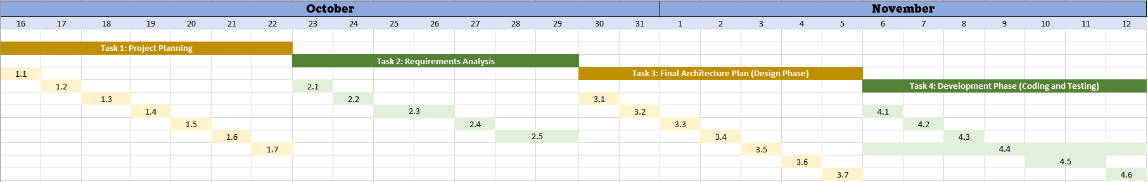

Below is the high-level design of the web application. I will utilize the Model-View-Control (MVC) pattern.

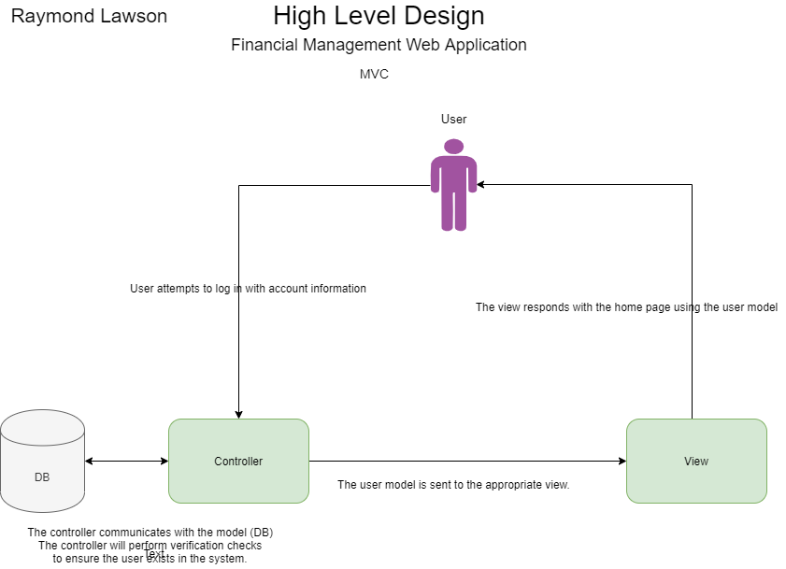

**Cost Estimate (if applicable)**

**Issue Log**

|  |  |  |  |  |  |  |  |  |
| --- | --- | --- | --- | --- | --- | --- | --- | --- |
| Issues Log | | | | | | | | |
| **ID** | **Issue Description** | **Project Impact** | **Action Plan/Resolution** | **Owner** | **Importance** | **Date Entered** | **Date to Review** | **Date Resolved** |
| 1 | What is the issue? | How will this impact scope, schedule & cost? | How do you intend to deal with this issue? | Who manages this issue? |  |  |  |  |
| 2 |  |  |  |  |  |  |  |  |
| 3 |  |  |  |  |  |  |  |  |

|  |
| --- |
| **Overall Instructor Feedback/Comments** |

**Integrated Instructor Feedback into Project Documentation**

Yes  No

**Project Approval**

Instructor <insert name and title>

References

Collins, J. (2023, April 26). *The State of Financial Literacy in the U.S.* Civic Science. Retrieved from <https://civicscience.com/the-state-of-financial-literacy-in-the-u-s/>