Create a complete label sheet with barcodes

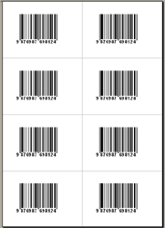
This is an example of how to create a complete label
page with barcodes on it using a macro. See the image on the right.

Run the macro “createlabels” from “Extras” -> “Macro” -> “Macros…”.

A new document (label page) will be created
and every label will get a barcode on it.

You can modify this macro using the VBA editor of word.
You can change the labels format, the barcode properties as
you want. Running serial numbers are easy to implement.

This demo is © Frank Horn, www.activebarcode.de

