QSketch: GPU-Aware Probabilistic Sketch Data Structures

Abstract—A fundamental problem in data analysis is determining the frequency distribution of items within a data set. A count-min sketch is a widely used data structure that can estimate such a distribution. General purpose computation with graphics processing units (GPUs) has become increasingly prevalent over the last decade or so. A GPU provides much higher instruction throughput and memory bandwidth than a typical CPU. However, achieving maximum throughput on GPUs for count-min sketch is challenging, especially for large, uniformly distributed data sets, because each operation needs several random memory accesses that are slow and inefficient on GPUs. In this paper, we propose a suite of novel count-min sketch structures called QSketch. QSketch structures need only one coalesced memory access on average. We also present methods and algorithms to improve the accuracy without decreasing the searching performance. We implemented the QSketch with CUDA 11 and evaluated its performance and accuracy on various GPU platforms.
- INTRODUCTION
A fundamental problem in data processing and analysis is determining the frequency distribution of items within some stream or over some set. Traditionally, this would be done with a lookup table of some kind to maintain the number of occurrences of each item. Hash tables and balanced binary trees are two typical ways of implementing such a lookup table. If the number of unique items is very large, however, these data structures may require a prohibitive amount of memory. Furthermore, in many situations, approximate answers are sufficient, leading to what are known as sketch data structures [1], [2]. Sketch data structures provide an approximate summary of some aspect of the data set, using a greatly reduced amount of memory.
In the hardware realm, graphic processing units (GPUs) have become increasingly powerful over the past decade or so, and, with the development of CUDA, have led to general purpose computing on GPUs. With their massive parallelism and memory bandwidth, GPUs have great potential for speeding up algorithms and data structures, but can be challenging to exploit due to their architecture.
One such sketch data structure is known as count-min sketch (CM sketch) [3]. A CM sketch estimates the frequency count of items, but may overcount, and thus provides a upper- bound. While CM sketch works well on a host CPU, a direct implementation on a GPU performs poorly. In this work, we present a suite of novel data structures for CM sketch on the GPU, which are named as QSketch. We firstly focus on improving the performance and show two algorithms. The first algorithm has some improvement compared to the original CM sketch. Our second algorithm achieve one memory access for
each operation, but suffers from lower accuracy. In order to improve the accuracy without losing performance, we then integrate two additional methods to improve the accuracy. The first method attains a higher accuracy than the previous sketches in this paper, but it is still limited by the GPU memory size. The second method can utilize the CPU memory to improve the accuracy. We implemented QSketch with CUDA 11 and evaluated its performance and accuracy on variable GPU platforms.
Specifically, we make the following contributions:
- We propose QSketch, a suite of novel, heterogeneous CM sketch data structures for GPUs, which have higher performance than the other sketches for a variety of distributions. They achieve one memory access per one operation, and has higher throughput than traditional sketches [4].
- We also develop methods and algorithms to improve the accuracy without decreasing the performance of inserting or querying.

- BACKGROUND & RELATED WORK

- GPU
A graphics processing unit (GPU) provides much higher instruction throughput and memory bandwidth than a CPU within a similar price and power envelope [5], [6]. Below we describe Nvidia’s GPUs using their terminology, though the concepts apply generally. Threads are grouped into blocks (1-, 2-, or 3-D) and blocks are organized into a grid (also 1-, 2-, or 3-D). A thread block may contain up to 1024 threads and the GPU schedules and executes threads of the same block in groups of 32 parallel threads, which are called warps. A warp of threads can only run in the same Streaming Multiprocessor (SM), and they must execute a common instruction in lockstep. Branches may cause warp divergence, which reduces performance [5].
Each SM has its own L1 cache (shared memory). The shared memory can only be accessed by the threads of the same block and is managed manually. The GPU also has a L2 cache which is accessible to all SMs and it caches accesses to global memory [5]. The global memory is the largest device memory and current GPUs usually have global memories of 4–16 GB. The device memories are weakly-ordered [5], thus the write order of one thread is not guaranteed to be same as the order observed by another thread.

2,500
Throughput (M operations/s)

2,000

1,500

1,000

500

10⁶ 10⁷ 10⁸
d == 1
d == 2
d == 3
Data Size
  - INSERT

6,000

4,000
Throughput (M operations/s)

2,000

10⁶ 10⁷ 10⁸
Data Size
  - QUERY
the count. They support three operations: INSERT, REMOVE, and QUERY. INSERT and REMOVE insert and remove items from the CM sketch, respectively; while QUERY retrieves an estimated count of the frequency of the given item. CM sketches have some relationship to Bloom Filters [13], but provide a frequency count rather than only set membership information.
A CM sketch uses d count arrays of fixed length w, each with an independent hash function, A key is inserted or removed by locating the value within each count array, and
d == 1
d == 2
d == 3
Fig. 1. Throughput for different d

- Throughput of Global Memory
One global memory transaction instruction can actually access a tile of data, which consists of 32 bytes for devices of compute capability 6.0 or higher [7]. When an instruction of a warp tries to access global memory, if addresses of different data are close enough, some transactions can actually access several addresses. These specific conditions allow global memory to have a high memory throughput when the threads of a warp can coalesce the adjacent memory accesses. For example, a warp can load a sequence of 32 4-byte integers in only 4 32-byte transactions. However, if the 32 integers are dispersed in a large memory area, they are unlikely to be close to each other and can not be coalesced, so the 32 accesses may need 32 memory transactions. Under this circumstance, each transaction still transfers 32 bytes data but only 4 bytes out of the 32 bytes are useful, which means that the throughput is divided by 8 [7]. So, global memory accesses should be coalesced whenever possible [5], especially for memory bound algorithms [8]–[12].
- Count-Min Sketch
incrementing or decrementing it, respectively. The count of a key is retrieved with QUERY by locating the value within each count array, and returning the minimum of all the values. If two different keys hash to the same value within a count array, the count will be an overestimate of the count for each of those keys.
In Algorithm 1, we show the original CM sketch algorithm, implemented for multiple threads. We assume that operations are called with an array of keys and each key is assigned to a separate thread within the parallel-for. We only show the INSERT operation because the REMOVE operation merely replaces atomicAdd() with atomicSub().
- Related Work
Some recent papers for sketch [14], [15] focus on improving accuracy rather than performance. The SF-sketch uses two CM sketches as its base. Although its accuracy is high compared to CM sketch, performance is not improved. Another drawback of the GPU SF-sketch is that it places the whole data structure in device memory, so they can not store a large data set due to limited GPU memory. We overcome those drawback in Section IV-B by using QSketch as the base data structure and placing the data separately on host and device.
The Topkapi-sketch [16] is focused on improving the
performance of skewed or power-law data by utilizing fast
Algorithm 1: Thread Sketch
1 table[w d] 0
× ←−
2 Function insert(keys)
3 parallel for each key in keys do
4 for i ← 0 to d do
5 id ← hashi(key)%w
6 atomic add(table[i × w + id], 1)
7 Function query(keys, counts)
8 parallel for each key in keys, count in counts do
9 count ← MAX INTEGER
10 for i ← 0 to d do
11 id ← hashi(key)%w
count ← min(count, table[i × w + id])

A count-min sketch (CM sketch, or just sketch, for brevity) [3] is a probabilistic data structure which estimates the frequency distribution of a set (or stream) of keys.
Sketches do not bound the data set size, regardless of the number of different keys; but may overestimate the count of a particular key, so thus provide an upper bound on
caches and reducing the atomic collisions. A similar strategy is used in another paper [17], which is fast for the Zipfian distribution. Neither of them is efficient for less skewed distributions, which is our focus.
Below, we will refer to any algorithms that have several count arrays and each key is processed by a single thread, such as Algorithm 1, as a thread sketch. This category includes [14]–[18].
- QSKETCH: IMPROVING GPU PERFORMANCE
A thread sketch has d count arrays and each array has w counter variables where w is much larger than d [3], [4]. An operation will access one random counter variable for each count array. The counter variables for a given key will be separated from each other in memory, due to the structure of a thread sketch and the accesses of them are unlikely to be coalesced into 32-byte global memory transactions [7]. This characteristic of sketch algorithms significantly reduce their performance, especially for the sketches on GPU. Figure 1 shows the throughput for d = 1, 2, and 3. The sketch with d = 1 is also called a count array [4], and its
performance is almost the same as the performance of GPU hash tables [19], [20], since they all need one global memory access for each operation. For large data sets, the INSERT and QUERY throughput is inversely proportional to d, indicating that memory accesses are not coalesced for most operations. To address this, we developed novel sketch algorithms which can coalesce the global memory accesses.
In this section, we focus on improving the throughput and show two variations. The first, which we term warp sketch, places all the counter variables for a given key near to each other, thus coalescing some memory accesses. The second, which we term sub warp sketch, places the counter variables closer than warp sketch. It achieves one global memory access for each operation.
- Warp Sketch

Algorithm 2: Warp Sketch

1 table[p w] 0
× ←−
2 hash mask table[H] generate hash mask(H)
←−
3 Function insert(keys)
4 parallel for each key in keys do
5 if thread index == 0 then
6 hv ← hash(key)
7 id ← hv%p
8 hash mask ← hash mask table[hv%H]

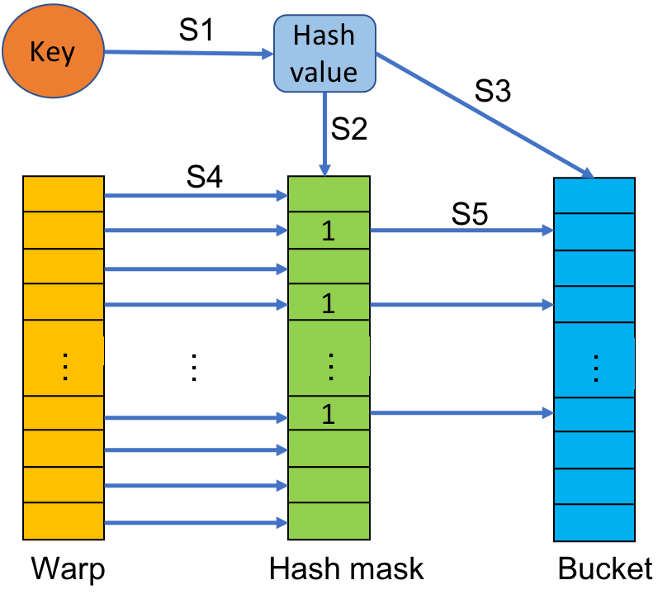

Fig. 2. INSERT of warp sketch.

grouped into batches and the order of items is arbitrary for the same batch. Meanwhile, an explicit synchronization such as cudaDeviceSynchronize() must be called between different batches if they have to run in order.
The warp sketch uses a two-level hashing scheme. First, the key is hashed to a bucket within the top-level array. Each bucket contains w counters. Then, a subset of the counters is
9 id ← broadcast(id)
10 for i ← thread index

to w
, step
warp size do

selected by using the initial raw hash value to index into the
11 if hash mask[i] then
12 atomic add(table[id × w + i], 1)

13 Function query(keys, counts)
14 parallel for each key in keys, count in counts, do
15 result MAX INTEGER
←
16 if thread index == 0 then
17 hv ← hash(key)
18 id ← hv%p
19 hash mask hash mask table[hv%H]
←
20 id broadcast(id)
←
21 for i thread index to w, step warp size do
←
22 if hash mask[i] then
23 result ← min(count, table[i × w + id]
24 result warp reduce min(result)
←
25 if thread index == 0 then
26 count ← result
table of pre-computed hash masks. As long as the size of H
is relatively prime to p, this effectively is computing another hash value. Each hash mask has been randomized to select d different variables from the bucket for any given key that hashes to that bucket.
The variable hash mask is a w-bit bitset, with d bits randomly set to 1 and the remainder set to 0. 1 indicates that the corresponding counter variable in the bucket is selected. The hash masks are stored in a table on device memory. Algorithm 2, first checks if there has already an available hash mask table, if not, it will generate H hash masks (e.g., H = 1024) and store them in the hash mask table. The different sketch objects share the same hash mask table. But they can also have their own hash mask table if it is needed. And the hash mask table is much smaller than the sketch. For example, a hash mask table that stores 1024 128-bits hash
masks will only need 16 KB memory and it is easy to be
cached in the L2 cache or other fast storage. So accesses of
A thread sketch has d count arrays and each table has w counter variables. However, the warp sketch has only one count array, split into many buckets, with each bucket containing a relatively small number of counter variables. We named it warp sketch because the threads of a warp execute synchronously to perform INSERT and QUERY operations. In Algorithm 2, p is the number of buckets, s is the size of each bucket in bytes, and w is the number of counter variables in a bucket. The variable thread index is the thread index of the warp (0–31). During initialization, all counter variables are set to 0. The items for INSERT and QUERY are
the hash mask table should incur global memory accesses for insertion, searching, or deletion operations.
For INSERT and REMOVE, each warp will be allocated a group of keys and it will handle them one by one. They are very similar, so here we only describe INSERT in Figure 2 and Algorithm 2. When performing the INSERT, the first thread of each warp will calculate the hash value of the key. Then it will select a random bucket and load a random hash mask by using the hash value. The hash mask is stored in shared memory so it can be accessed efficiently by all threads in the same block [5], [21]. But the bucket ID needs to be broadcast to the
Worst Case:

Best Case:

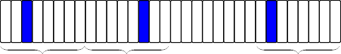
3 Global Memory Accesses(3×32-Byte)

1 Global Memory Access(1×32-Byte)

Algorithm 3: Sub-Warp (Quarter-Warp) Sketch
1 table[p w] 0
× ←−
2 hash mask table[H] generate hash mask(H)
←−
3 sid thread index/sub warp size
←−
4 tid thread index%sub warp size
←−
5 smask 0xff << (sid sub warp size)
←− ×
6 Function insert(keys)
7 parallel for each key[4] in keys do
8 if tid == 0 then
9 hv[sid] ← hash(key[sid])
10
Fig. 3. Worst And Best Cases For Warp Sketch (d = 3, w = 32)
11

warp. The broadcast() of Algorithm 2 and Algorithm 3 ¹²
13
is implemented by the warp shuffle functions [5], [22]. 14
Then all threads in this warp will increment or decrement
id ← hv[sid] % p
hash mask[sid] hash mask table[hv[sid]
←
%H]
id sub warp broadcast(smask, id)
←
if hash mask[sid][tid] then
atomic add(table[id × w + tid], 1)
the counter variables if the corresponding bits in the hash mask are 1 (S5 in Figure 2). The increment or decrement function must be atomic because different warps may access the same counter variable simultaneously, although they have different keys because of hash collision. Those memory accesses are guaranteed to access the variables in the same bucket, and the size of the bucket is relatively small so the memory addresses are close to each other. This causes more memory accesses to be coalesced, which will increase the insertion performance.
The QUERY operation will invoke similar functions but will not change the counter variables. The counter variables will be loaded if the corresponding bits in the hash mask are 1. The minimum of these is then written to the result array.
15 Function query(keys, counts)
16 parallel for each key[4] in keys, count in counts do
17 result MAX INTEGER
←
18 if tid == 0 then
19 hv[sid] ← hash(key[sid])
20 id ← hv[sid] % p
21 hash mask[sid] hash mask table[hv[sid]
←
%H]
22 id sub warp broadcast(smask, id)
←
23 if hash mask[sid][tid] then
24 result ← min(result, table[id × w + tid]]
25 result sub warp reduce min(result)
←
26 if tid == 0 then
27 count[sid] ← result
The minimum value is calculated by several warp shuffle
functions [5]. CUDA 11 introduces some new warp reduce functions, such as reduce_min_sync() [5], which may
improve search performance. Nevertheless, those functions are
only supported by devices of compute capability 8.x or higher, so we do not study their performance in this paper.
The size of the bucket w will influence both the throughput and accuracy. The smaller w will lead to higher performance because the memory accesses are more likely to be coalesced. If w is greater than the warp size, each warp must step through the bucket in a loop, which reduces the throughput. If w is equal to the warp size and the counter variables are 4-byte integers, the warp will need to access 32 4-byte integers, which will be coalesced into at most 4 32-byte memory accesses. So the number of actual memory accesses for each operation is the minimum of d and 4. For example, there can be only one 32-byte memory access if all bits of value 1 are concentrated in a quarter of the 32-bit hash mask, which is the best case in Figure 3. However, there will be min(d, 4) memory accesses for most operations, because all bits of a hash mask have equal possibility to be set and they should be discrete and appear in multiple quarters of a 32-bit hash mask. Figure 3 shows examples of worst case and best case.
- Sub-Warp Sketch
As mentioned in the previous section, the smaller w will lead to higher throughput because the memory accesses are more likely to be coalesced, but it still needs several 32-byte
global memory accesses for most operations even w equals
the warp size. If w is smaller than warp size, measurements show degraded performance. In order to continue to improve the throughput based on warp sketch, we developed sub warp sketch. Sub warp sketch divides a warp (32 threads) into several sub warps, and the threads of a sub warp will work together to accomplish INSERT and QUERY operations. In other words, a single warp will execute multiple operations simultaneously.
In order to achieve the best performance and balance the work load among sub warps, the size of the sub warp should be a factor of the warp size (32 threads) [5]. The w should be equal to the sub warp size. If w is greater than sub warp size, a larger sub warp size should be more efficient because an extra iteration is then unnecessary. The sub warp can be a half-warp or a quarter-warp if the counter variables are 4- byte integers. They are named as half warp sketch and quarter warp sketch. In this paper, sub warp sketch by default refers to quarter warp sketch. For half warp sketch, the 16 threads of the half-warp will operate on up to 16 4-byte adjacent integers, and they can be coalesced into one or two 32-byte memory transactions. When d = 3, ¹ operations need one memory transaction, And ³ operations need two memory transactions, so 1.75 memory transactions are needed for each operation on average. Fewer memory transactions are required compared to
4
4
warp sketch. Similarly, for quarter warp sketch, the 8 threads of the quarter-warp will operate on up to 8 4-byte integers but they are guaranteed to be coalesced into one 32-byte memory transaction.
The sub warp can not be smaller than a quarter-warp if the counter variables are 4-byte integers, because CUDA’s memory transactions for global memory are 32-byte, which can exactly load a bucket of 8 4-byte integers. And the two adjacent ¹ parts of one warp may not load the adjacent buckets since they have different keys. Both of them will need a 32- byte transaction to load their bucket and only half of the data is useful, which results in the overall performance halving.
8
Algorithm 3 shows the INSERT and QUERY operations for sub warp sketch, where each sub warp is a quarter warp and contains 8 threads. The sid is the sub warp index (0–3), and tid is the thread index of each sub warp (0– 8). The smask is a special mask that the bits are 1 for all the threads in the same sub warp, the bits are zero for the threads in the same warp but in different sub warps [5]. They are used in sub_warp_broadcast() and sub_warp_reduce_min(). For example, 0X000000FF, 0X0000FF00, 0X00FF0000, and 0XFF000000 are the masks of 4 sub warps, and all threads within the sub warp have the same mask.
For the INSERT and QUERY, the first threads of each sub warp (4 threads in total), will calculate 4 hash values, then load the 4 selected hash masks. The 4 hash masks are stored in the shared memory, and each sub warp will

1 Byte

4 Byte

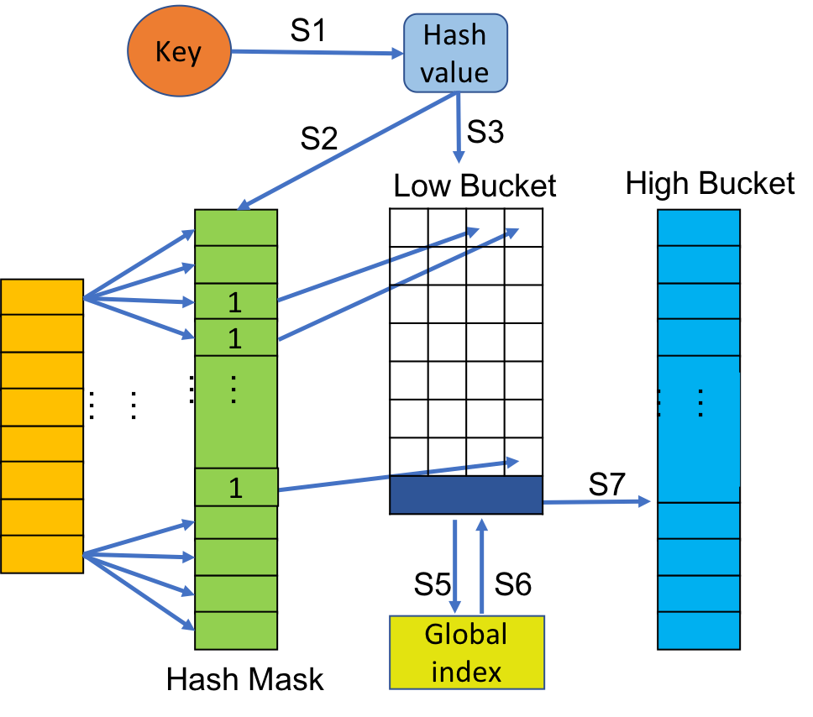
Fig. 4. INSERT of Multi-level Sub Warp Sketch

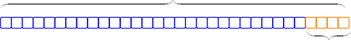
One Global Memory Access(32-Byte)

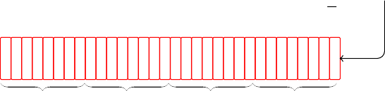
high frequency index
4 Global Memory Accesses(4×32-Byte)
operate on their own area. The sub_warp_broadcast() broadcasts the bucket id to other threads in the same sub warp, the 4 broadcasting functions are processed in one warp shuffle function ( shfl_sync()), with the help of smask. After the loading of hash masks, each sub warp will read or modify the counter variables if the corresponding bits of the hash masks are 1. The QUERY also needs to calculate the minimum values within the sub warp using sub_warp_reduce_min().
Those memory accesses are guaranteed to be coalesced into one 32-byte memory transaction because each bucket contains 8 4-byte integers (32 bytes in total) and all the buckets are at least 32-byte aligned.
- QSKETCH: IMPROVING THE ACCURACY
The warp sketch and sub warp sketch improve the INSERT and QUERY throughput as the size of bucket (w) shrinks. However, the smaller w also leads to lower accuracy. In this section, we integrate other methods to increase the accuracy without decreasing INSERT or QUERY throughput.
The accuracy of sketch is limited by the total size of the underlying count arrays. A larger count array usually leads to a more accurate sketch, because it can store more counter variables and each counter variable has a lower probability of accounting for multiple items (hash collision), which allows all counter variables of an item to be closer to the actual value [3], [17], [23]. Thus, the estimated frequency which is the minimum value of counter variables will be closer to the
Low Frequency Bucket: 32× 1-Byte Integer High Frequency Bucket: 32× 4-Byte Integer
Fig. 5. Buckets of Multi-level Sub Warp Sketch (MSWS)

real frequency of the item and the sketch can achieve a high QUERY accuracy.
In this section, we integrate two different methods into QSketch. The two methods can work with both warp sketch and sub warp sketch. We only show the details with sub warp sketch since it has higher throughput than warp sketch. The first, which we term multilevel warp sketch (MWS) uses two sketches. One sketch is capable of storing a large number of low frequency items and another one can store a small number of high frequency items. The second, which we term SF sub warp sketch or SFSWS, also uses two sketches. One sketch is stored in device memory (GPU memory) and it can achieve high throughput for QUERY. Another sketch is stored in host memory (CPU memory), which can store more items without the limit of device memory.
- Multi-level Sub Warp Sketch
Some sketches use an unsigned character (1-byte integer) as a counter variable instead of a 4-byte integer, allowing 4 times as many counter variables for the same memory size. This method is simple but useful for data with low frequencies,

Algorithm 4: Multi-level Sub Warp Sketch (MSWS)
1 table low[lp ∗ lw] ←− 0
2 table high[hp ∗ hw] ←− 0
3 mask table[H] ←− generate hash mask(H)
4 sid ←− thread index/sub warp size
5 tid ←− thread index%sub warp size
6 smask ←− 0xff << (sid × sub warp size)
7 global_{i}ndex global_{i}ndex start
←−
8 limit low bucket limit
←−
9 Function insert(keys)
10 parallel for each key[4] in keys do
11 if tid == 0 then
12 hv[sid] ← hash(key[sid])
13 id ← hv[sid] % lp
14 hash mask[sid]
←
hash mask table[hv[sid] %H]
15 id sub warp broadcast(smask, id)
←
16 low bucket
←
load bucket lock(table low, id)
17 if low bucket == NULL then
18 degenerate()
19 continue
20 cv, hi low bucket
←
21 if any sync(hi > hs) then
22 warp insert high()
23 inc merge(cv)
←
24 max low max(split(cv))
←
25 if inc = 0 and max low < limit then
/
26 sub warp insert low()
27 if max low >= limit then
28 id atomic allocate(low bucket)
←
29 warp insert high()

30 Function query(keys, counts)
31 parallel for each key[4] in keys do
32 if tid == 0 then
33 hv[sid] ← hash(key[sid])
34 id ← hv[sid] % lp
35 hash mask[sid]
←
hash mask table[hv[sid] %H]
36 id sub warp broadcast(smask, id)
←
37 low bucket load bucket(table low, id)
←
38 cv, hi low bucket
←
39 result low sub warp search low()
←
40 if any sync(hi > hs) then

41 result high ← warp search high()
42 min low warp reduce min(result low)
←
43 min high
←
warp reduce min(result high)

44 count ← min low + min high

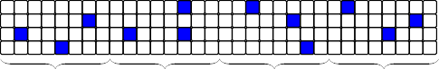
4 Global Memory Accesses For 4 Keys(4×32-Byte)
Fig. 6. Global Memory Accesses to Low Buckets For a Warp

especially for more uniformly distributed data. However, the maximum value of unsigned character is 255, and thus may overflow.
The multi-level sub warp sketch (MSWS) uses two tables to handle the 1-byte integer overflow problem, which can improve the accuracy without decreasing the throughput, especially when the majority of data is not too skewed. The first table is the high-frequency table and is the same as the table in warp sketch (w = 32). It uses 4-byte or 8-byte unsigned integers as its counter variables and is stored in global memory. But it is much smaller than a normal warp sketch and thus the accesses to the high frequency table are more likely to be cached in the L2 cache or other fast on- chip caches. A high frequency table that stores 1024 128- byte buckets (termed high buckets) will only need 128 KB memory and is smaller in size than the L2 cache size of current GPUs [5].
The second table is the low-frequency table, which is based on the sub warp sketch. It can store a large number of low frequency items with high accuracy and it will use 1- byte unsigned integer as its counter variable. In Algorithm 4 and Figure 4, we show the implementation where the low- frequency table is based on quarter warp sketch instead of half warp sketch, since the quarter warp sketch has higher throughput than half warp sketch. The low-frequency table contains many buckets (termed low buckets), and Figure 5 shows the connection between low bucket and high bucket. The size of each low bucket is 32-byte which can fit in one global memory access. It stores 28 1-byte counter variables and the last 4-byte (high bucket index) of low bucket can be used to store an index to the high frequency table. In Algorithm 4, hi is the short name of high bucket index, 0–1023 of high bucket index are reserved and 1024–(2³² 1) are valid indices. The 4-byte unsigned integer is enough for the size of current device memory, it can support about 2³² 128-byte high buckets and the high frequency table can use up to 512 GB global memory which is much bigger than the largest device memory. Although the low bucket needs to leave 4 bytes for preventing the overflow problem, it still can have 3.5 times counter variables than the buckets with 4-byte integers. Each hash mask is still 32-bit and the bits for the high bucket index are always zero, it will calculate a normal hash mask of 28-bit and pad 4-bit zero. Figure 6 shows the memory accesses of 4 sub warps, they access the first 28 counter variables randomly, but never the last 4 variables.
−
The INSERT of MSWS is similar as that of sub warp sketch. In Algorithm 4, the special processes start at Line 16. The sub warps will lock the low bucket and then load the contents of
each low bucket by single global memory access. Then sub warps will check the values of 4 high bucket indices via a warp vote function (any_sync()) [5], [22]. If there is at least one of them pointing to a valid high bucket, the 4 sub warps will first merge into a warp, and it will insert the keys into the high bucket for the valid high bucket indices. The warp then split into 4 sub warps, and the sub warps that have the valid high bucket indices are now idle.
The sub warps with invalid high bucket index will then insert the items to their own low buckets simultaneously. The sub warp will first load the low bucket and calculate the maximum value of the counter variables within a sub warp. If the maximum value is greater than the limit (e.g. 128) and the low bucket is going to overflow, the warp will request a new high bucket by atomicAllocate() and insert the element to the newly allocated bucket. If the maximum value is not greater than the limit, the sub warps will merge the 1- byte integers into 4-byte integers and insert them to the low frequency table.

Algorithm 5: Load Bucket Lock
1 Function load_bucket_lock(table low, id)
2 bucket ← table low + id × lw
sketch. They need 4 individual INSERT of warp sketch. The overhead of lock and degenerate() is non-trivial, and it will decrease the throughput by 5%–15%. If the majority of data are not highly skewed, the interference rarely happens in practice, and thus there is minimal performance loss. We tested MSWS more than 100,000 times and each test case has more than 1 million insertions. We do not observe any interference. Of course, some very skewed distributions may have different behaviors.
For QUERY, the sub warps will first load the counter variables from low bucket without need of lock and spilt them into 1-byte integers. If the low bucket is linked to any high bucket, it also needs to load the counter variables from high bucket. Then the sub warps will calculate two minimum values, the first is the estimated frequency for low frequency table, and the second is for high frequency table. The last step is to add them together to get the estimated frequency of the element.
Most operations do not need to access the high frequency table, and the high frequency table is usually small enough to be well cached. So, each INSERT or QUERY will still need one global memory access on average.
- SF Sub Warp Sketch
3 match ← have duplicate address(bucket)
4 if match then
5 return NULL
6 hi 1
←
7 lock bucket + w 1
← −
8 while hi == 1 do
9 hi= atomicExch(lock, 1)
10 threadfence block()
11 barrier()
12 return load(bucket)

The Algorithm 5 shows the details of
Algorithm 6: SF Sub Warp Sketch
1 device table[p w] 0
× ←−
2 host table[p w z] 0
× × ←−
3 device mask table[H] generate hash mask(H)
←−
4 host mask table[H] generate hash mask(H)
←−
5 Function insert(keys)
6 parallel for each key in keys do
7 hv hash(key)
←
8 id hv%p
←
9 sub bucket id[d]
←
conver to index(host mask table[hv%H])
10 for i ← 0 to d, step 1 do
11 sbi ← sub bucket id[i]
12 sub bucket ← host table[id][sbi]

load_bucket_lock(). If multiple sub warps of the same 13
←
or different warps, access the same block simultaneously. It 14
is possible that they all read the same old contents from the ¹⁵
j hash(key, i)%z
atomic add(sub bucket[j], 1) device update(sub bucket);
bucket and then they all insert items into low bucket. An
overflow may happen due to the race condition. A lock is
needed to prevent this race condition. The lock is implemented var atomicExch(), and stored into the high bucket index. It will use the reserved indices, so no extra memory is needed for the lock. The threads of a warp are in a lockstep and they will try to lock 4 buckets at the same time. After all sub warps get their locks and reach the barrier, they will load and return the contents of bucket. However, if two or more sub warps of the same warp try to lock the same bucket, there is at most one sub warp that will get the lock and others will fail. Then the sub warps will never get the needed locks. In order to prevent this, for sub warps of the same warp, we check if they try to lock the same bucket by comparing the addresses of buckets. If so, the INSERT of those 4 keys in the current warps will degenerate from sub warp sketch to warp
For some users, the QUERY throughput is much more important than the INSERT and REMOVE. And many clusters or servers also have a large unused host memory when running the sketches on GPU. We develop a new version of QSketch, which named as SF sub warp sketch or (SFSWS). The SFSWS can use the host memory to improve the accuracy without losing the QUERY throughput. It keeps the QUERY throughput the same as sub warp sketch, although it has to suffer a much lower INSERT performance. In this section, we only use the quarter warp sketch because it has higher throughput.
This idea was inspired by SF-Sketch [14], [23], which improves the accuracy by using two sketches. The SF-Sketch has two sketches, named as Slim Sketch and Fat Sketch, both of them are count-min sketch. The Slim Sketch is very small

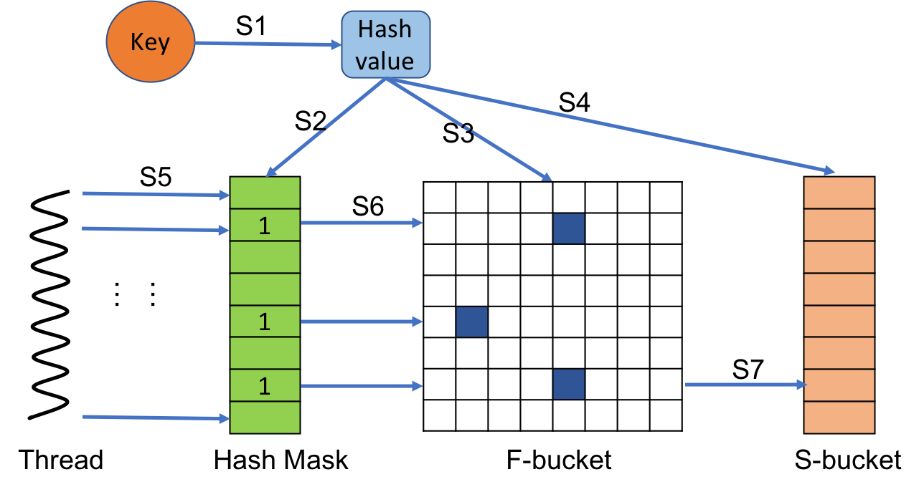

Fig. 7. INSERT of SF Sub Warp Sketch

and is stored in the fast cache, while the Fat Sketch is large and in the slow memory. They will make sure that each counter variable of Slim Sketch is always the maximum value of a corresponding group of Fat Sketch counter variables. The size of each group is z, and the Fat Sketch is z times larger than Slim Sketch. They also implemented it with CUDA and their performance is the same as count-min sketch and thread sketch, which is much slower than QSketch.
In Algorithm 6, the SFSWS also uses two sketches. The first sketch is the device table, and its data structure is sub warp sketch. It has p buckets and each bucket has w counter variables. The device table serves as Slim Sketch and is stored in the global memory. Another sketch is the host table. Its data structure is warp sketch. It has p buckets but each bucket has w sub bucket. Each sub bucket has z counter variables. The host table serves as Fat Sketch and is stored in the host memory. The host table is z times larger than the device table, and each counter variable in device table is always the maximum value of z counter variables of a sub bucket in the host table.
The SFSWS executes INSERT on host side. In Alogrithm 6 and Figure 7, the host thread first calculates a hash value then selects a bucket and the hash mask according to the hash value. It will update the random counter variables of the sub buckets if the bits in host hash mask are 1. After finishing the operation, the host thread also needs to update the device counter variable. The host thread copies z counter variables to the device memory. Then the device threads will calculate the maximum value of z variables and update its device counter variable.
The throughput of INSERT is limited by computing power and memory bandwidth of CPU, and it is much lower than the Sub warp sketch. The QUERY is exactly same as what the sub warp sketch does, so the QUERY performance is unchanged.
- RESULTS
We evaluated QSketch on both NVIDIA Tesla P100 and Nvidia GeForce RTX 2080 Ti since they have different global memories. The P100 has 12GB HBM2 memory (with ECC enabled) while The 2080ti has 11GB GDDR6 memory. We compiled the codes with CUDA 11 and run the program with a large range of grid size (1024–2²³) to get the peak
performance [7], [24]. We tested the QSketch for 10 batches and each batch ran the test code more than 50 times. We only recorded the best performance of each batch for P100 because the P100 was installed on cluster and the node may be shared by other users. The final results are the average of all best performances of each batch. We claim that the quarter warp sketch only needs a single coalesced atomic access on average for each INSERT or REMOVE. We only show the throughput of INSERT since REMOVE is similar as INSERT. And we also claim that quarter warp sketch requires only one global memory access for each QUERY on average.
We test the QSketch with uniform distributions of random keys. And we carefully choose the arguments of all the sketches so that they consume the same amount of device memory. The time usages of generating random keys and transferring data between host and device are not calculated in the performance. The random keys of uniform distribution are generated by curand [5] on device. The input keys are grouped into batches so they can fit in a device buffer. We also test different buffer sizes (2–128 MB) and we find the 64 MB buffer is enough for most situations. The number of input data is highly related to the throughput and accuracy. We test the QSketch for different Work Load Factor (WLF).
insertedkeys
WLF =
totalcountervariables
.
We compared the throughput of thread sketch, warp sketch, sub warp sketch, and MSWS; keeping d = 3 constant for all sketches. For warp sketch, we present its throughput at w = 32, which is its maximum performance. For sub warp sketch, we also show its maximum throughput, which is the performance of quarter warp sketch. The throughput of MSWS is slightly different from sub warp sketch, and we only show the throughput of lock-free version. The throughput of MSWS with lock is 5%–15% less than that of lock-free version. We do not graph the performance of SFSWS; its QUERY throughput is exactly same as sub warp sketch, but its INSERT throughput is much lower than other sketches, at about 20 Mops/s. This is expected, because INSERT is executed on the host.
And we compared the accuracy of thread sketch, warp sketch, sub warp sketch, MSWS and SFSWS. For SFSWS, we show two different results for z = 3 and z = 8. We use the relative error (RE) to quantify the accuracy of sketches. The relative error is e a /a, where e is the estimate value of frequency and a is the actual value.
| − |
- Throughput
Figure 8 shows the INSERT throughput of 4 sketches on 2080 Ti. For small data, INSERT throughput improves as the workload expands because if there are not enough insertion keys, some SMs will be idle and the overall performance will be low. The count arrays in sketches are also small because the workload factor is a constant number. Most of the counter variables are cached in the L2 cache, so we will have a higher L2 cache hit rate for the small input data set. The sketches are not limited with the memory throughput, and thread sketch,

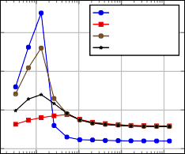
6,000
Thread Insert Warp Insert
Sub Warp Insert MSWS Insert
Throughput (M operations/s)

4,000

2,000
8,000

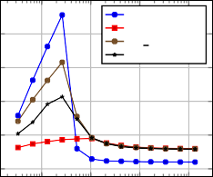
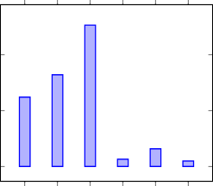
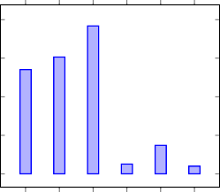
6,000
Thread Insert Warp Insert
Sub Warp Insert MSWS Insert
0.13
8.21 · 10−2
6.21 · 10−2
6.54 · 10−3 4.96 · 10−3
1.58 · 10−2
0.38
0.3
0.27
7.43 · 10−2
2.58 · 10−2 2.01 · 10−2
Throughput (M operations/s)
Average Relative Error
0.1
Average Relative Error
0 0.1 0.2 0.3 0.4

4,000
0 5 · 10⁻²

2,000

0
10⁵ 10⁶ 10⁷ 10⁸
Work Load

0
10⁵ 10⁶ 10⁷ 10⁸
Work Load
Thread
Warp
Sub Warp
MSWS
SFSWS-3
SFSWS-8
Thread
Warp
Sub Warp
MSWS
SFSWS-3
SFSWS-8
(a) 2080 TI, WLF = 0.5

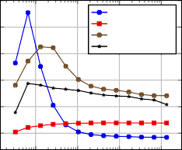
3,000
Thread Insert Warp Insert
Sub Warp Insert MSWS Insert
Throughput (M operations/s)

2,500

2,000

1,500
(b) 2080 Ti, WLF = 1.0

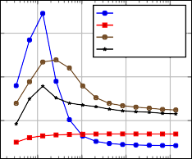
3,000
Thread Insert Warp Insert
Sub Warp Insert MSWS Insert
Throughput (M operations/s)

2,000

  - WLF = 0.5

Fig. 10. Accuracy

  - WLF = 1.0

1,000

500

10⁵

10⁶

10⁷

10⁸

1,000

10⁵

10⁶

10⁷

10⁸
The INSERT and QUERY throughput of sub warp sketch are close to the performance of example one random memory access algorithms, such as thread sketch (d = 1) and GPU
Work Load
(c) P100, WLF = 0.5
Work Load
(d) P100, WLF = 1.0
hash tables [19], [20]. But the sub warp sketch is still slightly slower than them because those algorithms only need to access

5,000
Throughput (M operations/s)

4,000

3,000

2,000

1,000
Fig. 8. INSERT Throughput

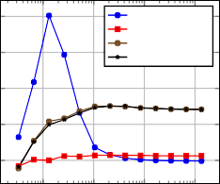
8,000
Thread Query Warp Query
Sub Warp Query MSWS Query
Throughput (M operations/s)

6,000

4,000

2,000

10⁵ 10⁶ 10⁷ 10⁸
Work Load

10⁵ 10⁶ 10⁷ 10⁸
Work Load
4 or 8 bytes of global memory for each operation, while the sub warp sketch needs to access 32 or more bytes for each operation.
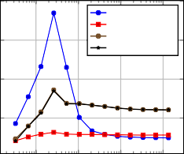
2080 Ti and P100 have different device memories, 2080 Ti has 11 GB GDDR6 memory while P100 has 12 GB HBM2. In addition, the memory bandwidth of P100 is 540GB/s which is 87.7% of the bandwidth of 2080 Ti, and the searching performance of P100 is also about 87.7% of 2080 Ti. These indicate that the searching performance is highly related to the global memory bandwidth.
Thread Query Warp Query
Sub Warp Query MSWS Query
(a) 2080 Ti, WLF = 0.5

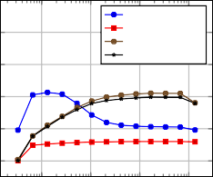
5,000
Thread Query Warp Query
Sub Warp Query MSWS Query
Throughput (M operations/s)

4,000

3,000

2,000

1,000

0

10⁵ 10⁶ 10⁷ 10⁸
Work Load
(c) P100, WLF = 0.5
(b) 2080 Ti, WLF = 1.0

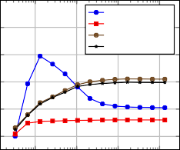
5,000
Thread Query Warp Query
Sub Warp Query MSWS Query
Throughput (M operations/s)

4,000

3,000

2,000

1,000

0

10⁵ 10⁶ 10⁷ 10⁸
Work Load
(d) P100, WLF = 1.0
- Accuracy
In Figure 10, the thread sketch, warp sketch, and sub warp sketch have an decreasing accuracy when the size of bucket
(w) is going smaller and the counter variables of an element in warp sketch and sub warp sketch will become much more concentrated than that of thread sketch.
The warp sketch and sub warp sketch can only select a random hash mask based on the hash mask table. The total number of hash masks is much smaller than the size of a normal hash table if the sketches want to have a high L2
Fig. 9. QUERY Throughput

warp sketch, sub warp sketch and MSWS have an increasing computational workload, which leads to decreasing INSERT throughput.
The INSERT throughput of thread sketch greatly decreases as the workload increases because it runs out of L2 cache and the L2 cache hit rate is low. The most memory accesses are not cached and the thread sketch is limited by the random access performance of global memory [25]. The INSERT throughput of sub warp sketch is approximately three times that of thread sketch, which means that sub warp sketch successfully coalesced three global memory accesses into one. Figure 9 shows the QUERY throughput of 4 sketches. The behaviors of QUERY is similar as INSERT.
cache hit rate and high performance. So the hash masks have a relatively high probability of collision. Even if different hash masks are selected, the counter variables within a bucket still have a high collision probability for the small size of bucket. MSWS outperforms thread sketch, warp sketch and sub warp sketch, because it can have more counter variables while using the same size of device memory. The SFSWS also has smaller RE than thread sketch, warp sketch and sub warp sketch. The accuracy of SFSWS increases with the increase of z. The larger z needs more host memory while the usage of device memory is unchanged.
- CONCLUSION
With the advent of streaming sources of large data, sketch algorithms are increasingly relevant. Often, only a sketch is needed. Written for CPUs, however, traditional sketch data
structures such as CM sketch do not perform well on GPUs. In this paper, we propose a suite of four novel sketch data structures on GPU, with varying performance characteristics. We show that, despite the challenge of the GPU memory architecture, we can achieve one memory access for each operation and obtain a much higher throughput than the CM sketch. We also develop and present methods to improve its accuracy, and we also utilize the host memory to improve accuracy while still have a high QUERY throughput.
REFERENCES
- V. Wei, N. Ivkin, V. Braverman, and A. S. Szalay, “Sketch and scale geo-distributed tsne and umap,” in 2020 IEEE International Conference on Big Data (Big Data), 2020, pp. 996–1003.
- A. Mandal, H. Jiang, A. Shrivastava, and V. Sarkar, “Topkapi: parallel and fast sketches for finding top-k frequent elements,” Advances in Neural Information Processing Systems, vol. 31, pp. 10 898–10 908, 2018.
- G. Cormode and S. Muthukrishnan, “An improved data stream summary: the count-min sketch and its applications,” Journal of Algorithms, vol. 55, no. 1, pp. 58–75, 2005. [Online]. Available: https://www.sciencedirect.com/science/article/pii/S0196677403001913
- O. Alipourfard, M. Moshref, Y. Zhou, T. Yang, and M. Yu, “A comparison of performance and accuracy of measurement algorithms in software,” in Proceedings of the Symposium on SDN Research, ser. SOSR ’18. New York, NY, USA: Association for Computing Machinery, 2018. [Online]. Available: https://doi.org/10.1145/3185467.3185475
- NVIDIA Corporation, “CUDA C++ Programming Guide,” 2021, version 11.4.
- S. Memeti, L. Li, S. Pllana, J. Kołodziej, and C. Kessler, “Benchmarking opencl, openacc, openmp, and cuda: Programming productivity, performance, and energy consumption,” in Proceedings of the 2017 Workshop on Adaptive Resource Management and Scheduling for Cloud Computing, ser. ARMS-CC ’17. New York, NY, USA: Association for Computing Machinery, 2017, p. 1–6. [Online].
Available: https://doi.org/10.1145/3110355.3110356
- NVIDIA Corporation, “CUDA C++ Best Practices Guide,” 2021, version 11.4.
- P. Chen, M. Wahib, S. Takizawa, R. Takano, and S. Matsuoka, “A versatile software systolic execution model for gpu memory-bound kernels,” in Proceedings of the International Conference for High Performance Computing, Networking, Storage and Analysis, ser. SC ’19. New York, NY, USA: Association for Computing Machinery, 2019. [Online]. Available: https://doi.org/10.1145/3295500.3356162
- Y. Hu, P. Kumar, G. Swope, and H. H. Huang, “Trix: Triangle counting at extreme scale,” in 2017 IEEE High Performance Extreme Computing Conference (HPEC), 2017, pp. 1–7.
- Y. Hu, H. Liu, and H. H. Huang, “Tricore: Parallel triangle counting on gpus,” in SC18: International Conference for High Performance Computing, Networking, Storage and Analysis, 2018, pp. 171–182.
- H. Wang, L. Geng, R. Lee, K. Hou, Y. Zhang, and X. Zhang, “Sep- graph: Finding shortest execution paths for graph processing under a hybrid framework on gpu,” in Proceedings of the 24th Symposium on Principles and Practice of Parallel Programming, ser. PPoPP ’19. New York, NY, USA: Association for Computing Machinery, 2019, p. 38–52. [Online]. Available: https://doi.org/10.1145/3293883.3295733
- S. Beamer, K. Asanovic, and D. Patterson, “Direction-optimizing breadth-first search,” in SC ’12: Proceedings of the International Conference on High Performance Computing, Networking, Storage and Analysis, 2012, pp. 1–10.
- B. H. Bloom, “Space/time trade-offs in hash coding with allowable errors,” Commun. ACM, vol. 13, no. 7, p. 422–426, Jul. 1970. [Online].
Available: https://doi.org/10.1145/362686.362692
- L. Liu, Y. Shen, Y. Yan, T. Yang, M. Shahzad, B. Cui, and G. Xie, “Sf-sketch: A two-stage sketch for data streams,” IEEE Transactions on Parallel & Distributed Systems, vol. 31, no. 10, pp. 2263–2276, oct 2020.
- C.-Y. Hsu, P. Indyk, D. Katabi, and A. Vakilian, “Learning-based frequency estimation algorithms.” in International Conference on Learning Representations, 2019.
- A. Mandal, “Enabling parallelism and optimizations in data mining algorithms for power-law data,” Ph.D. dissertation, Georgia Institute of Technology, 2020.
- F. Tas¸yaran, K. Yıldırır, M. K. Tas¸, and K. Kaya, “One table to count them all: Parallel frequency estimation on single-board computers,” in European Conference on Parallel Processing. Springer, 2019, pp. 405– 418.
- T. Yang, J. Jiang, P. Liu, Q. Huang, J. Gong, Y. Zhou, R. Miao, X. Li, and
S. Uhlig, “Adaptive measurements using one elastic sketch,” IEEE/ACM Transactions on Networking, vol. 27, no. 6, pp. 2236–2251, 2019.
- S. Ashkiani, M. Farach-Colton, and J. D. Owens, “A dynamic hash table for the gpu,” in 2018 IEEE International Parallel and Distributed Processing Symposium (IPDPS). Los Alamitos, CA, USA: IEEE Computer Society, may 2018, pp. 419–429. [Online]. Available: https://doi.ieeecomputersociety.org/10.1109/IPDPS.2018.00052
- Y. Li, Q. Zhu, Z. Lyu, Z. Huang, and J. Sun, “Dycuckoo: Dynamic hash tables on gpus,” in 2021 IEEE 37th International Conference on Data Engineering (ICDE). Los Alamitos, CA, USA: IEEE Computer Society, apr 2021, pp. 744–755. [Online]. Available: https://doi.ieeecomputersociety.org/10.1109/ICDE51399.2021.00070
- J. Chen, N. Xiong, X. Liang, D. Tao, S. Li, K. Ouyang, K. Zhao,
N. DeBardeleben, Q. Guan, and Z. Chen, “Tsm2: Optimizing tall- and-skinny matrix-matrix multiplication on gpus,” in Proceedings of the ACM International Conference on Supercomputing, ser. ICS ’19. New York, NY, USA: Association for Computing Machinery, 2019, p. 106–116. [Online]. Available: https://doi.org/10.1145/3330345.3330355
- A. Li, W. Liu, L. Wang, K. Barker, and S. L. Song, “Warp- consolidation: A novel execution model for gpus,” in Proceedings of the 2018 International Conference on Supercomputing, ser. ICS ’18. New York, NY, USA: Association for Computing Machinery, 2018, p. 53–64. [Online]. Available: https://doi.org/10.1145/3205289.3205294
- L. Liu, Y. Shen, Y. Yan, T. Yang, M. Shahzad, B. Cui, and G. Xie, “Sf-sketch: A two-stage sketch for data streams,” IEEE Transactions on Parallel and Distributed Systems, vol. 31, no. 10, pp. 2263–2276, 2020.
- V. Volkov, “Understanding latency hiding on gpus,” Ph.D. dissertation, University of California, Berkeley, 2016. [Online]. Available: http://proxy.binghamton.edu/login?url=https://www.proquest.com/dissertations- theses/understanding-latency-hiding-on-gpus/docview/1873487227/se- 2?accountid=14168
- H. Zhou, S. Bateni, and C. Liu, “Gru: Exploring computation and data redundancy via partial gpu computing result reuse,” in Proceedings of the 2018 International Conference on Supercomputing, ser. ICS ’18. New York, NY, USA: Association for Computing Machinery, 2018, p. 43–52. [Online]. Available: https://doi.org/10.1145/3205289.3205318

