**Web Programming Languages**

**Programming Project**

**Team:**

**Sourik Dhua(sxd170830)**

**Vinay Gujar(vpg170030)**

**Arunabha Chakraborty(axc175630)**

**Architecture Diagram:**

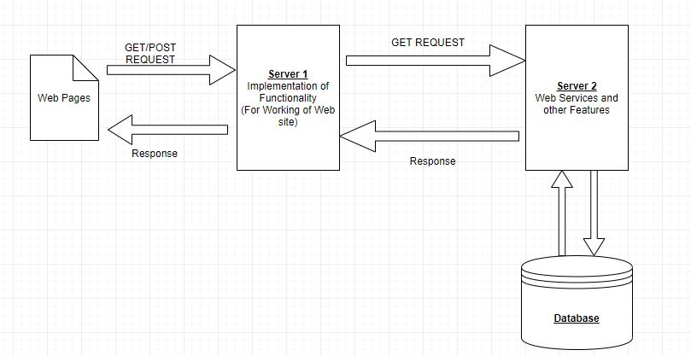

***Modules:***

**Website:**

This is the front end and user point of contact to the webservices, the website implemented here has the functionality for the user to input the required data and make the required changes in the database, as well as log in as admin and set the number of bids to be allowed on a particular day and time. This platform gives user the ability to make bids as well as post the bids in their name for others to bid on. We have used bootstrap as our base to the website home page and developed other webpages around it.

**Server 1 for Functionality:**

Server 1 is the second point of contact from the website, it receives data from the user and if any data need to be relayed to database it uses other HTTP protocol to communicate with the Server 2 and contact database. All the communications from website to the server 1 are through HTTP protocols. The main functionality of Server 1 is manipulation of data with accordance to the desired output for example the table data from the database need to be molded in the form of table to show the user in user-friendly manner and same goes to when data needs to be sent to the database. The calculation of time slots and displaying available time slot is processed here.

**Server 2 for Web Services and other Features:**

The implementation of Webservices and microservices is done here the functionality of authentication and rightful user is implemented here, this server also acts a relay and only way of communication between database and other entities, the interaction between two servers is done using HTTP protocol and RESTful services

**Database:**

Database is mainly used for storing and retrieving data for the functionality implementation, database used in this project is SQL as it’s a relational database the ease of operation is needed, we us the database to keep a tab whether the data is being updated in the table and inspect for updates when the user post any information.

***Description:***

**LOGIN/LOGOUT:**  The Login functionality is being implement with the help of HTTP GET request and response. The query is checked from the database to authenticate the user to the website and logout to make the user redirect to the home page of the website.

**User Profile Information:** This functionality is helpful for user to edit his profile information and display the information that has being entered by him on the website.

**Forgot Password:** The tab under the login information is helpful when a user forgets his/her password this tab redirect him to a different page where depending upon the answer to the given question the ability to reset his/her password is activated.

**Ability to Post**: The ability to put in items to be bid and post items description, its initial bidding price and minimum bidding price and choose the date and time slot for the bidding process also ability to upload a pic for the item.

**Ability to Delete:** The ability to delete the user posted data about the item is provided to the user.

**Ability to Bid:** The user has been granted the ability to bid for items posted by others and receive bids posted by him.

**Auction Schedule:** There is a tab present where the user can view the full table of the items available for auction.

**Sorting:** The table used to display the items available for bidding is in the sortable format where it can be sorted in column format or search the item in the list by specifying the name of the item he is looking for.

**Unresponsive Page:** The page when not available the user is redirected to other page where its displayed 404 error.

**Admin Login:** This is a special login available for privileged user who can set the number of items that can be made available to bid and set the date and time between which this items can be auctioned.

***WEBSERVICES and FEATURES:***

**Server:** The calculation of time slots with the help of inputs taken from admin are calculate and posted for other users to select their time slots.

**Cache:** A web cache its an information technology for the temporary storage of web documents, such as HTML pages and images, to reduce server lag.

**SSL/TLS:** We tried to implement secure connection by implementing the following protocol by deploying it to between all the connections in the server.

**Database table:** The output tables need to be called from database and format it in user format to help user process of bidding.

***PROBLEMS ENCOUNTERED:***

1. Connection of the front end to the server, initially, the message from front end was not being sent to server. We are trying to do a post request and the data should get into the database. We researched for it on the internet and found the correct way to implement both sides and got it working.

2. We were stuck at the design of the slot calculation and how to show it to the front end. But through thorough brainstorming, we came up with a design. The logic has been described in the admin login part of the report.

3. First server was not getting connected to the second one. The second server was made to be a http server similar to the first one. GET request was working but POST was not. The data was not getting transmitted in the post part.

4. The front-end design of the bidding page was also an issue although it was solved quickly. So, we decide on displaying the table with bidding items to the user and the let the user bid on each item as the bidding slot gets activated.