# 杨智茹个人第五次作业

MARTE

A Standard for Modeling and Analysis of Real-Time and Embedded Systems including its software and hardware aspects.

* The Proposals will define a metamodel and its underlying UML profile.
* It shall be possible to use independently software and hardware parts of the profile.

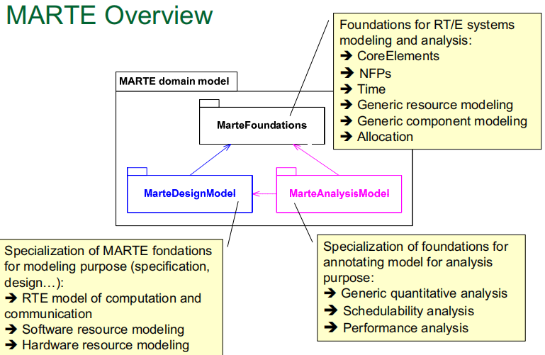

图一 MARTE Overview

GRM

* Provides basic concepts for modeling a general (high-level) platform for processing RTE applications
* Includes the features for modeling processing platforms at different level of details.
* Build in a bottom-up process to abstract finer-level platforms

A UML profile for modeling APIs of RT/E sw execution supports

BUT it is NOT a new API standard dedicated to the RT/E domain!

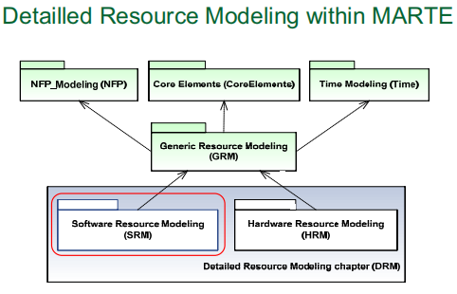

图二 MARTE/DRM

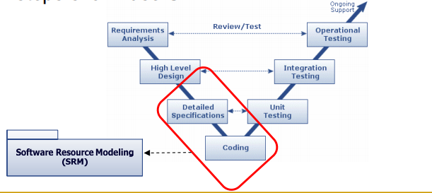

图三 MARTE/SRM

HRM is a detailed HW architecture design language

Level of details depends on the description accuracy

* Ex1: Functional simulator of a processor only requires its instruction set family
* Ex2: Performance simulation need a fine description of processors micro-architecture.

目标元模型

（元模型说明）

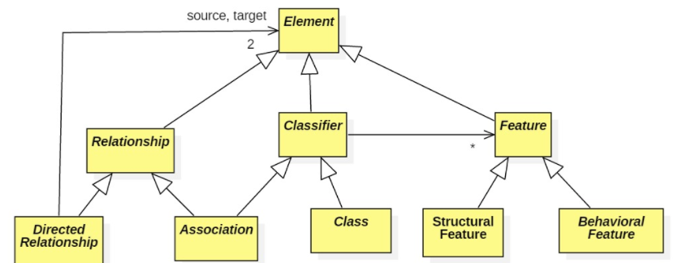

图四 参考uml元模型

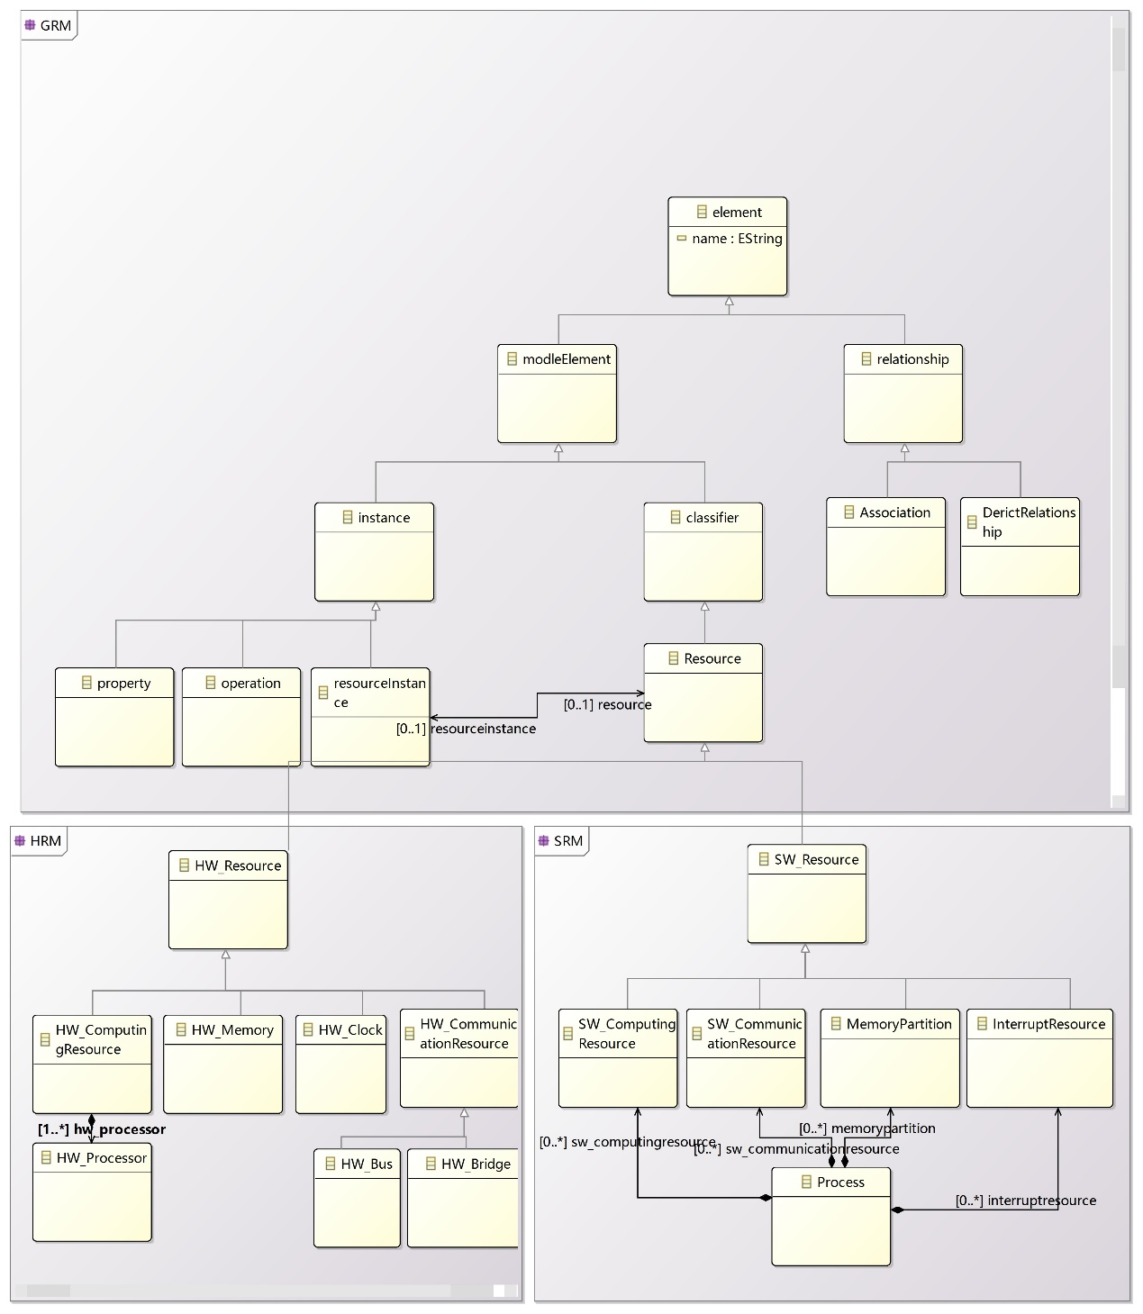

图五 目标原模型

目标元模型简介：

MARTE是UML的一个变种，其中GRM专注于资源管理，HRM/SRM都是GRM的特化。画GRM的元模型离不开UML，所以前半部分和UML的基础元模型很像，最重要的Resource元素。HRM/SRM分别继承了Resource。HW_Resource又由几个重要的部分组成，计算资源包括一个或多个核，还有内存，始终，通信设施等资源。SW_Resource包括计算资源，通信资源，内存分区和中断等。SW_Resource又可以统一于进程概念，进程占有这些资源。

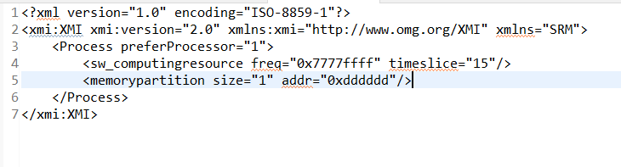

图六 目标模型

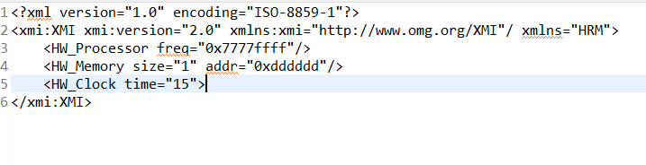

图七 输出模型

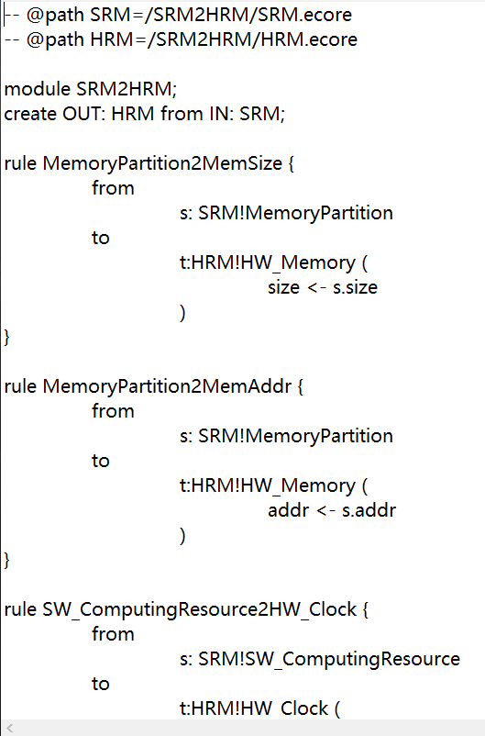

图八 转换规则部分截图

模型转换简介：

输入元模型：SRM，输出元模型：HRM。

转换的目标是将统一于进程概念的软件资源投射到硬件上