MAVEN2 学习笔记 （一步步搭建ssi项目）

IDE工具为 idea 10.5.1

首先配置maven环境，不配置也行，只要将maven包下载解压缩，然后在idea中设置 file-setting maven home directory为你的maven文件夹地址就可以了
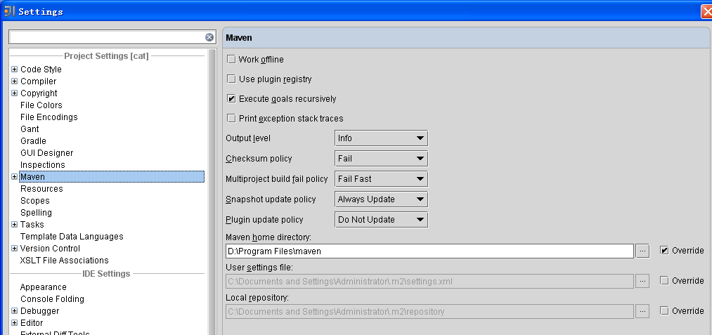

1. 用Maven2 搭建struts2.18项目
IDE工具为 idea 10.5.1
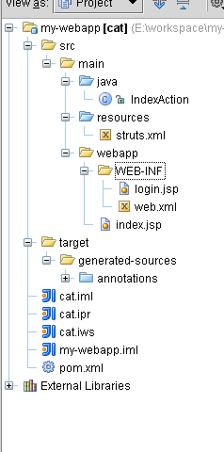
先创建项目骨架部分
mvn archetype:create -DgroupId=com.mycompany.app -DartifactId=my-webapp -DarchetypeArtifactId=maven-archetype-webapp
命令说明：
archetype
groupId 项目的java包结构：com
artifactId 项目的名称：certusSimple
archetypeArtifactId（ 项目骨架的类型 ）：
* maven-archetype-archetype
* maven-archetype-j2ee-simple
* maven-archetype-mojo
* maven-archetype-portlet
* maven-archetype-profiles (currently under development)
* maven-archetype-quickstart
* maven-archetype-simple (currently under development)
* maven-archetype-site
* maven-archetype-site-simple, and
* maven-archetype-webapp

Pom.xml文件

<?xml version="1.0" encoding="UTF-8"?>
<project xmlns="http://maven.apache.org/POM/4.0.0" xmlns:xsi="http://www.w3.org/2001/XMLSchema-instance"
xsi:schemaLocation="http://maven.apache.org/POM/4.0.0 http://maven.apache.org/maven-v4_0_0.xsd">
<modelVersion>4.0.0</modelVersion>
<!-- 项目或者组织的唯一标志，并且配置时生成的路径也是由此生成 -->
<groupId>my.web</groupId>
<!--项目的通用名称-->
<artifactId>cat</artifactId>
<!--打包的机制，如pom, jar, maven-plugin, ejb, war, ear, rar, par-->
<packaging>war</packaging>
<!-- 项目的版本 -->
<version>1.0</version>
<!-- 项目除了artifactId外，可以定义别名 -->
<name>web</name>
<!-- 开发者 -->
<developers>
<developer>
<id>mars</id>
<name>Ryan</name>
<roles>
<role>开发</role>
<role>测试</role>
</roles>
<email>993985246@qq.com</email>
<timezone>+8</timezone>
</developer>
<developer>
<id>mars</id>
<name>whjzuiai</name>
<roles>
<role>开发</role>
</roles>
<email>76513716@qq.com</email>
<timezone>+8</timezone>
</developer>
</developers>
<dependencies>
<!-- 依赖 -->
<dependency>
<groupId>junit</groupId>
<artifactId>junit</artifactId>
<version>3.8.1</version>
<scope>test</scope>
</dependency>

<!--这里下面的两个dependency, servlet-api与jsp-api所需-->
<dependency>
<groupId>javax.servlet</groupId>
<artifactId>servlet-api</artifactId>
<version>2.4</version>
<scope>provided</scope>
</dependency>
<dependency>
<groupId>javax.servlet</groupId>
<artifactId>jsp-api</artifactId>
<version>2.0</version>
<scope>provided</scope>
</dependency>
<dependency>
<groupId>org.apache.struts</groupId>
<artifactId>struts2-core</artifactId>
<version>2.1.8.1</version>
</dependency>
<dependency>
<groupId>org.apache.struts</groupId>
<artifactId>struts2-tiles-plugin</artifactId>
<version>2.1.8.1</version>
</dependency>
<dependency>
<groupId>org.apache.tiles</groupId>
<artifactId>tiles-jsp</artifactId>
<version>2.0.4</version>
</dependency>
<dependency>
<groupId>javax.servlet</groupId>
<artifactId>jstl</artifactId>
<version>1.1.0</version>
</dependency>
</dependencies>
<!--主要用于编译设置，包括两个主要的元素，build和reporting -->
<build>
<plugins>
<plugin>
<groupId>org.apache.maven.plugins</groupId>
<artifactId>maven-eclipse-plugin</artifactId>
<configuration>
<wtpmanifest>true</wtpmanifest>
<wtpapplicationxml>true</wtpapplicationxml>
<wtpversion>2.0</wtpversion>
</configuration>
</plugin>
<plugin>
<groupId>org.codehaus.mojo</groupId>
<artifactId>tomcat-maven-plugin</artifactId>
</plugin>
<plugin>
<artifactId>maven-javadoc-plugin</artifactId>
<configuration>
<links>
<link>http://gceclub.sun.com.cn/Java_Docs/jdk6/html/zh_CN/api</link>
</links>
<aggregate>true</aggregate>
</configuration>
</plugin>
<plugin>
<artifactId>maven-site-plugin</artifactId>
<configuration>
<locales>zh_CN</locales>
<outputEncoding>UTF-8</outputEncoding>
</configuration>
</plugin>
<plugin>
<groupId>org.mortbay.jetty</groupId>
<artifactId>maven-jetty-plugin</artifactId>
<version>6.1.6</version>
</plugin>
<plugin>
<artifactId>maven-compiler-plugin</artifactId>
<configuration>
<source>1.6</source>
<target>1.6</target>
<encoding>UTF-8</encoding>
</configuration>
</plugin>
</plugins>
</build>
<reporting>
<plugins>
<plugin>
<groupId>org.codehaus.mojo</groupId>
<artifactId>surefire-report-maven-plugin</artifactId>
</plugin>
<plugin>
<artifactId>maven-javadoc-plugin</artifactId>
<configuration>
<links>
<link>http://gceclub.sun.com.cn/Java_Docs/jdk6/html/zh_CN/api</link>
</links>
<aggregate>true</aggregate>
<charset>UTF-8</charset>
<docencoding>UTF-8</docencoding>
<encoding>UTF-8</encoding>
</configuration>
</plugin>
</plugins>
</reporting>

</project>

Web.xml文件
<?xml version="1.0" encoding="UTF-8"?>
<web-app xmlns:xsi="http://www.w3.org/2001/XMLSchema-instance"
xmlns="http://java.sun.com/xml/ns/javaee" xmlns:web="http://java.sun.com/xml/ns/javaee/web-app_2_5.xsd"
xsi:schemaLocation="http://java.sun.com/xml/ns/javaee http://java.sun.com/xml/ns/javaee/web-app_2_5.xsd"
id="WebApp_ID" version="2.5">
<display-name>SSH_proto</display-name>

<filter>
<filter-name>struts2</filter-name>
<filter-class>org.apache.struts2.dispatcher.FilterDispatcher</filter-class>
</filter>
<filter-mapping>
<filter-name>struts2</filter-name>
<url-pattern>/*</url-pattern>
</filter-mapping>

</web-app>

Login.jsp文件

<html>
<body>
<h2>Hello World!1112</h2>
</body>
</html>

struts.xml文件
<?xml version="1.0" encoding="UTF-8" ?>

<!DOCTYPE struts PUBLIC
"-//Apache Software Foundation//DTD Struts Configuration 2.0//EN"
"http://struts.apache.org/dtds/struts-2.0.dtd">

<struts>

<include file="struts-default.xml" />
<package name="My" namespace="/" extends="struts-default">
<action name="sss" class="IndexAction" method="index">
<result name="success">WEB-INF/login.jsp</result>
</action>
</package>
</struts>

运行使用jetty插件run
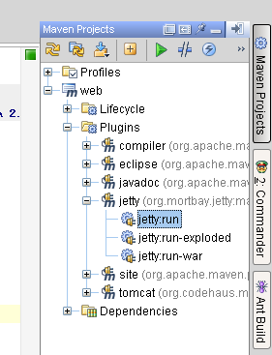

启动成功
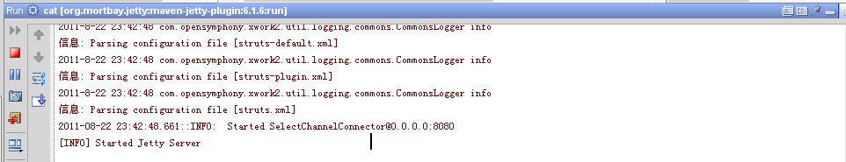
访问地址 成功
