**Does Technology Create a Divide between the More and Less Fortunate?**

A teacher assigns a research paper that requires students to read several articles on the web. A school requires that all students type papers on a computer and submit the papers using email. While these may be valid ways to integrate technology in a curriculum or to help instructors manage their classroom they assume all students have ample access to technology outside of school. School districts that assume all students have computers at home place less fortunate students at a further disadvantage. These students may have to stay after school to use a computer or study at the local library to access the Internet. Students at school districts in disadvantaged areas may fall further behind if the school is unable to provide access to the technology taken for granted at other schools, including interactive whiteboards and dedicated technology specialists. These discrepancies are known collectively as the digital divide, a term used to illustrate the gap between those with and without access to technology. With the recent widespread growth on mobile device users, some aspects of the digital divide are closing. Students can email and do research on Internet-capable mobile devices, as well as access education-related apps. Mobile device capabilities, however, are limited. You cannot use a mobile device to write a research paper, prepare a resume, or submit a college application. Some companies and organizations are trying to provide better access. One cable company provides low-cost Internet access to families who receive free or reduced school lunches. Schools can apply for technology grants to purchase classroom computers. These grants may be able to provide access to students, but if no one can teach the students or their teachers how to use the technology, it may not solve the problem. Is it the school's responsibility to provide an even playing field regarding technology access? Why or why not? Should schools be allowed to require students to use technology? Why or why not? What steps can society take to narrow the digital divide?

**Government**

Most government offices have websites to provide citizens with up-to-date information. People in the United States access government websites to view census data, file taxes, apply for permits and licenses, pay parking tickets, buy stamps, report crimes, apply for financial-aid, and renew vehicle registrations and driver's licenses. Employees of government agencies use computers as part of their daily routine. North American 911 call centers use computers to dispatch calls for fire, police, and medical assistance. Military and other agency officials use the U.S. Department of Homeland Security’s network of information about domestic security threats to help protect against terrorist attacks. Law enforcement officers have online access to the FBI's National Crime Information Center (NCIC) through in-vehicle laptops, fingerprint readers, and mobile devices (Figure 1-33). The NCIC contains more than 15 million missing persons and criminal records, including names, fingerprints, parole/probation records, mugshots, and other information.

**Finance**

Many people and companies use online banking or finance software to pay bills, track personal income and expenses, manage investments, and evaluate financial plans. The difference between using a financial institutions' website versus finance software on your computer is that all your account information is stored on the bank's computer instead of your computer. The advantage is you can access your financial records from anywhere in the world. Investors often use online investing to buy and sell stocks and bonds — without using a broker. With online investing, the transaction fee for each trade usually is much less than when trading through a broker.

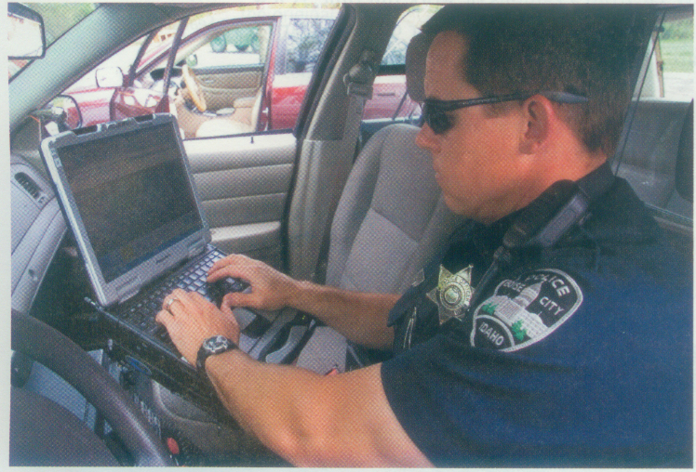

Figure 1-33 Law enforcement officials have in-vehicle computers and mobile devices to access emergency, missing person, and criminal records in computer networks in local, state, and federal agencies. David R. Frazier Photolibrary, Inc. / Alamy