PENGAJUAN INSENTIF – PROFIT STORE LEADER

Lampiran : 1 (satu) lembar
Dari : Store Leader
Kepada : Finance Manager
Tembusan :
- CEO Madinah Group Indonesia
- Coorporate Strategy
- HR Manager

Bismillahirrahmaanirrahiim
Assalaamu’alaikum Warahmatullaahi Wabarakaatuh
Sehubungan dengan telah berakhirnya bulan Juni 2026, maka dengan ini saya mengajukan Insentif Bulanan senilai Rp 3.179.000 sesuai dengan TAP CEO yang berlaku.
Adapun Detail Pencapaian sebagai berikut :

PENGAJUAN INSENTIF STORE LEADER
Cabang |  | Omset  (After Diskon) | Gross Profit | Prepaid  Expanses | Net Profit | %  Net Profit | Insentif Net  Profit | % Pengali  Insentif | Top Up  Insentif | Insentif  Sales Hijau | Insentif  Masuk Shift | Total  Insentif
Cabang Asal | Klender | 325,147,800 | 130,186,396 | 3,960 | 35,643 | 0.0% | 0 |  | 1,640,000 | 0 | 500,000 | 2,140,000
Cabang Tujuan | Jatibening | 287,760,200 | 120,924,915 | 996,305 | 11,457,506 | 4.0% | 0 |  | 0 | 0 | 0 | 0
Cabang |  | Omset  (After Diskon) | Gross Profit | Prepaid  Expanses | Net Profit | %  Net Profit | Insentif Net  Profit | % Pengali  Insentif | Insentif Fix | Insentif  Sales Hijau | Insentif  Masuk Shift | Total  Insentif
Cabang Asal | Warbong | 470,697,357 | 109,918,921 | 299,270 | 3,441,610 | 0.7% | 0 | 40% | 0 | 0 | 0 | 0
Cabang Tujuan | Condet | 543,444,404 | 163,847,558 | 3,331,730 | 38,314,894 | 7.1% | 1,700,000 | 80% | 1,360,000 | 0 | 0 | 1,360,000
 |  |  |  |  |  |  |  | Pengurang atas Pencapaian Goal Gross Profit |  |  | 10% | 214,000
Pencapaian Goal : |  |  |  |  |  |  |  | Pengurang atas Pencapaian Goal Lain |  |  | 5% | 107,000
Gross Profit Klender |  | 84.83% |  |  |  |  | TOTAL INSENTIF YANG DIDAPAT |  |  |  |  | 3,17G,000
Tingkat Kepuasan Pelanggan |  | 110.67%
Omset Aksesoris |  | 62.85%
 | Klender - Jatibening | Isi Bulannya -> | 7 | 8 | G | 10 | 11 | 12 | 1 | 2 | 3 | 4
 |  |  | H | H+1 | H+2 | H+3 | H+4 | H+5 | H+6 | H+7 | H+8 | H+9
 |  | Status Rotasi
 | Warbong - Condet | Isi Bulannya -> | 4 | 5 | 6 | 7 | 8 | G | 10 | 11 | 12 | 1
 |  |  | H | H+1 | H+2 | H+3 | H+4 | H+5 | H+6 | H+7 | H+8 | H+9
 |  | Status Rotasi | Done | Done | Done

Demikian yang dapat disampaikan, atas perhatian dan kerjasamanya kami ucapkan terima kasih.

Jakarta, 6 Agustus 2026 Diajukan oleh,

Vicky Faldhy Agita
Store Leader

Diperiksa oleh,

Budiarja Ibrahim
Store Area Manager

Diperiksa oleh,

Zaskanul Tibalky
CEO MFlash

Disetujui oleh,

Galih Permana
Chief Finance Officer









PENGAJUAN BIAYA


Ruko Madinah Office, Blok C4, Jl. Pd. Kelapa Raya No.1B, Malaka Jaya, Kec. Duren Sawit, Kota Jakarta Timur,
Validasi FA
Tanggal penyerahan dokumen :
Bank / atas nama :
No Rekening Tujuan :
Keterangan
DKI Jakarta 13460

Nama : Vicky Faldhy Agita
Jabatan : Store Leader MFlash Klender
Jenis Keperluan : Pengajuan Biaya

TANGGAL | DESKRIPSI / DETAIL | KUANTITAS | HARGA / PCS | TOTAL
6-Aug-26 | Top Up Insentif Klender - Juni 2026 | 1 | Rp 1,640,000 | Rp 1,640,000  Rp -  Rp -  Rp -  Rp -  Rp -  Rp -  Rp -
Grand Total |  | 1 | Rp 1,640,000 | Rp 1,640,000

Mengajukan,
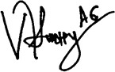

( Vicky Faldhy Agita )
Jakarta, 6 Agustus 2026

Menyetujui,

( )


Mengetahui,

( )



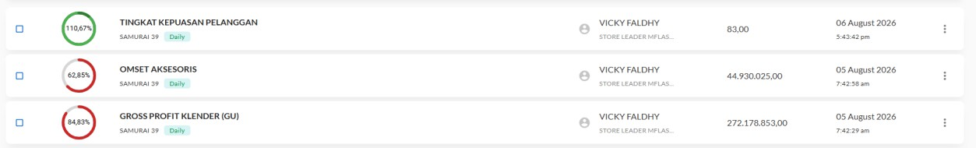

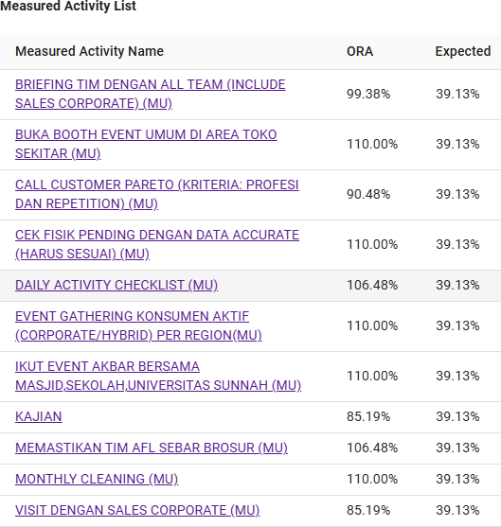





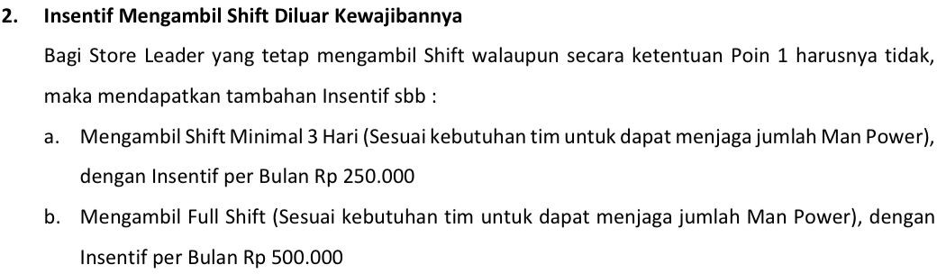

NAMA |  | VICKY FALDHY AGITA
NIK
JABATAN |  | STORE LEADER
LOKASI KERJA |  | KLENDER
DARI TANGGAL |  | 24-May-26
HINGGA TANGGAL |  | 23-Jun-26
NO | Hari | Tanggal | IN | Keterangan Scann Masuk | OUT | Keterangan Scann Keluar | CATATAN
1 | Ahad | 5/24/2026 | OFF
2 | Senin | 5/25/2026 | 10:23:02 | Success | 17:15:38 | Success
3 | Selasa | 5/26/2026 | 11:08:49 | Success | 20:16:03 | Success
4 | Rabu | 5/27/2026 | OFF |  |  |  | Idul Adha
5 | Kamis | 5/28/2026 | 8:50:41 | Success | 17:23:56 | Success
6 | Jumat | 5/29/2026 | 8:00 | Failed | 17:00 | Failed
7 | Sabtu | 5/30/2026 | 9:08:14 | Success | 13:26:05 | Success
8 | Ahad | 5/31/2026 | OFF
9 | Senin | 6/1/2026 | OFF |  |  |  | Public Holiday
10 | Selasa | 6/2/2026 | 10:37:40 | Success | 20:00 | Failed
11 | Rabu | 6/3/2026 | 20:06:21 | Success | 20:06:43 | Success
12 | Kamis | 6/4/2026 | 11:10:24 | Success | 20:00 | Failed
13 | Jumat | 6/5/2026 | 23:51:53 | Success | 23:52:10 | Success
14 | Sabtu | 6/6/2026 | 12:10:55 | Success | 16:42:15 | Success
15 | Ahad | 6/7/2026 | OFF
16 | Senin | 6/8/2026 | 8:08:20 | Success | 17:06:54 | Success
17 | Selasa | 6/9/2026 | 9:00 | Failed | 18:00 | Failed
18 | Rabu | 6/10/2026 | 8:29:36 | Success | 17:30 | Failed
19 | Kamis | 6/11/2026 | 7:53:20 | Success | 18:32:19 | Success
20 | Jumat | 6/12/2026 | 8:57:33 | Success | 20:08:11 | Success
21 | Sabtu | 6/13/2026 | 10:42:55 | Success | 17:40:03 | Success
22 | Ahad | 6/14/2026 | OFF
23 | Senin | 6/15/2026 | 8:48:14 | Success | 17:16:28 | Success
24 | Selasa | 6/16/2026 | OFF |  |  |  | Public Holiday
25 | Rabu | 6/17/2026 | 8:00:24 | Success | 17:23:52 | Success
26 | Kamis | 6/18/2026 | 9:03:14 | Success | 17:40:14 | Success
27 | Jumat | 6/19/2026 | 11:11:18 | Success | 20:36:08 | Success
28 | Sabtu | 6/20/2026 | 9:20:27 | Success | 17:27:34 | Success
29 | Ahad | 6/21/2026 | OFF
30 | Senin | 6/22/2026 |  |  |  |  | Cuti Tahunan
31 | Selasa | 6/23/2026 |  |  |  |  | Cuti Tahunan



