Install required tool chain first: All latest tool chain 2026

1. ARM GNU Toolchain
- Purpose: Compile firmware for RP2040 (Pico/Pico W).
- Recommended version for Pico SDK 2.2.0: arm-gnu-toolchain-14.2.rel1-mingw-w64-i686-arm-none-eabi.exe
- Install notes: Add the bin folder to your PATH if needed (or CMake will detect automatically in Developer Command Prompt).
2. CMake
- Purpose: Generate build files (Ninja or MSVC).
- Recommended: Latest stable (>=3.13).
- Install notes: Add to PATH (default in Windows installer).
cmake –version
3. Ninja
- Purpose: Fast, cross-platform build system used by Pico SDK.
- Install command:
winget install Ninja-build.Ninja
- Verify:
ninja --version
4. Git
- Purpose: Clone SDK and PicoTool repositories.
- Install notes: Use Git for Windows, add git to PATH.
git --version
5. Visual Studio Community (Windows)
- Purpose: Build host tools (picotool.exe, pioasm.exe) using MSVC.
- Workload required:
  - Desktop development with C++
  - Optional: CMake support included
- Why: Pico W projects require some host tools (C++ executables) compiled for Windows.
6. Pico SDK
- Purpose: Core libraries and headers for RP2040 / Pico W projects.
- Clone repo:
git clone -b master https://github.com/raspberrypi/pico-sdk.git C:\Users\soume\Documents\Pico\pico-sdk
- Set environment variable
setx PICO_SDK_PATH "C:\Users\soume\Documents\Pico\pico-sdk"
- Verify:
echo %PICO_SDK_PATH%
7. PicoTool
- Purpose: Convert .elf to .uf2 and other post-processing of binaries.
- Options:
  - Download pre-built release from GitHub
    - PicoTool Releases
  - Build from source using MSVC + Ninja + CMake (required if you need USB support or latest version).
- Build from source:
cd C:\Users\soume\Documents\Pico\picotool
mkdir build && cd build
cmake -G Ninja -DPICO_SDK_PATH=C:\Users\soume\Documents\Pico\pico-sdk ..
ninja

✅ Summary Workflow
- Install ARM GCC toolchain
- Install CMake
- Install Ninja
- Install Git
- Install Visual Studio Community + C++ workload
- Clone Pico SDK and set PICO_SDK_PATH
- Clone or download PicoTool
- Create project folder with CMakeLists.txt and main.c
- Build project (Developer Command Prompt recommended for Pico W):
cmake -G Ninja -DPICO_BOARD=pico_w ..
ninja
- Convert .elf → .uf2 using picotool if you skipped pico_add_extra_outputs()

1) 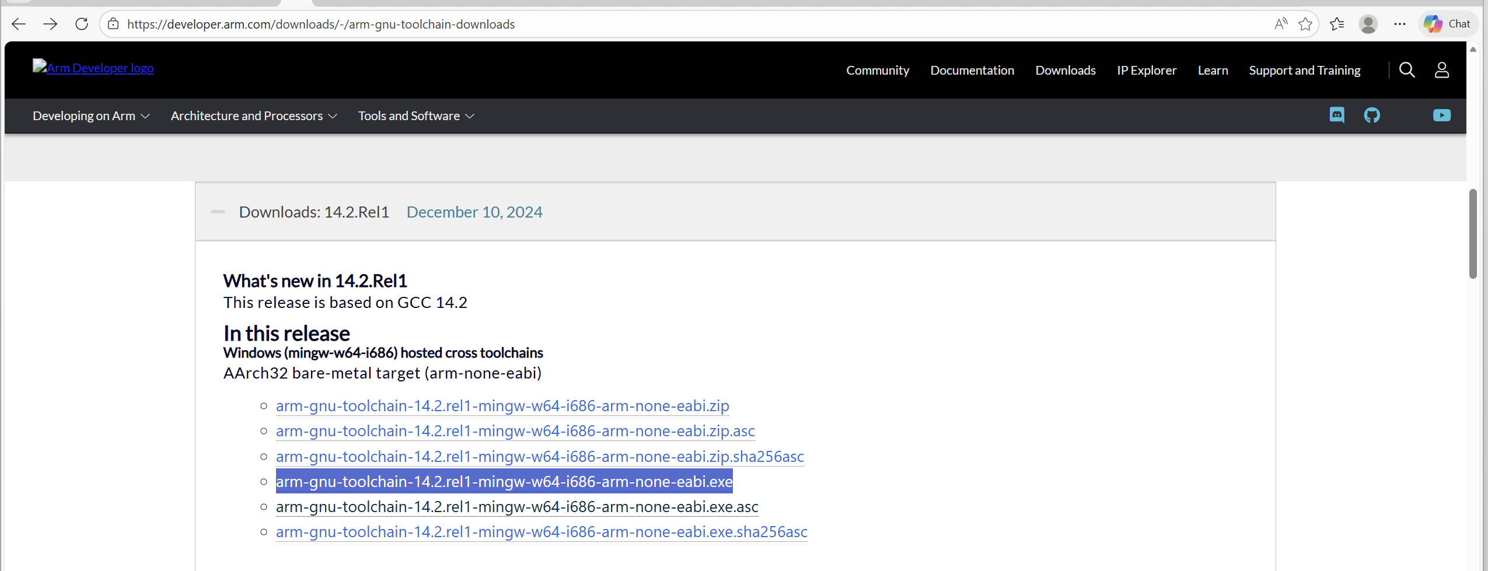
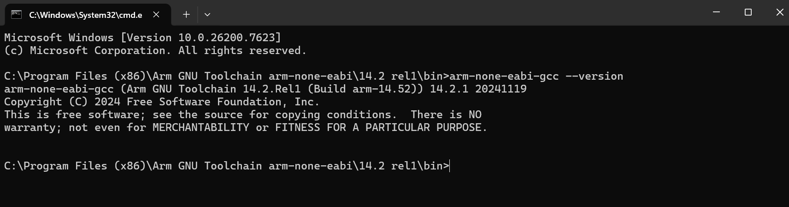

2) 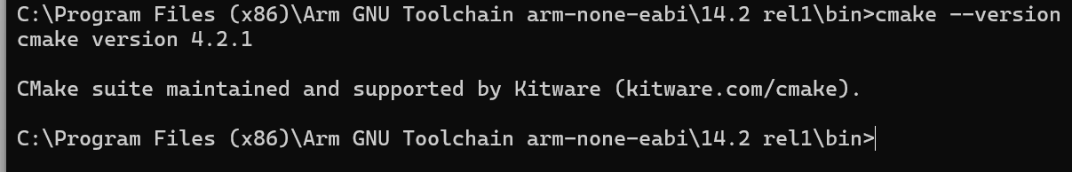
3) 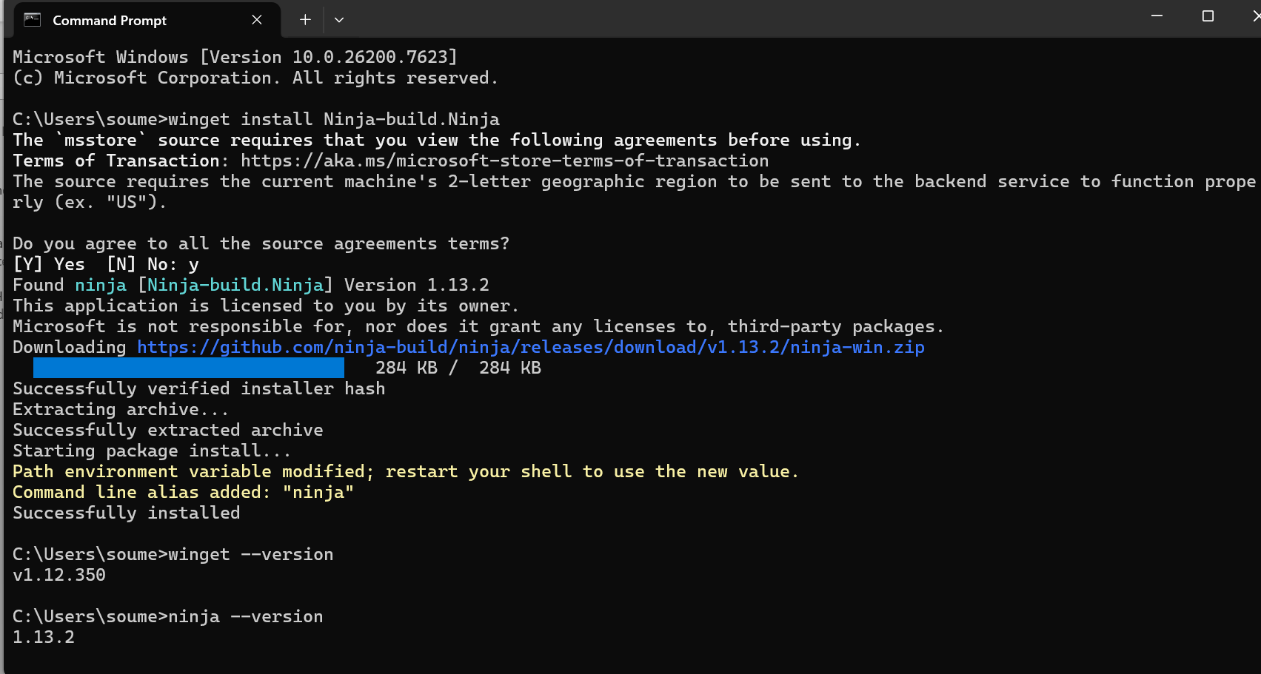
4) 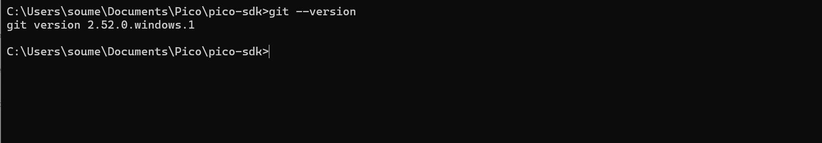
5) 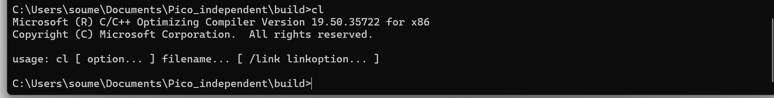
6) 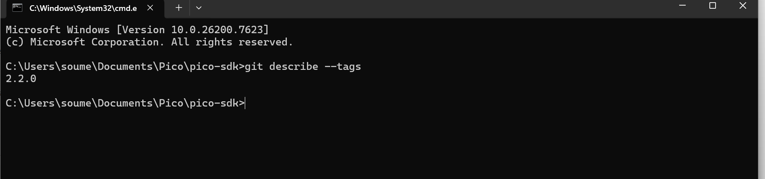
7) download latest tag version pico tools from github, Release 2.2.0-a4 · raspberrypi/picotool dowload . or clone it then buils using msvc tool chain, this not build using arm toll chain and not nomal cmd , only builf from developer command prompts
