**PROJECT DOCUMENTATION**

**FOUNDATIONS OF AI APPLICATION LAB**

**ENCRYPTION AND DECRYPTION TOOL**

* **SURYAVEER YADAV**

**INTRODUCTION**

Data security is a major issue which we are facing today in this digital world of communication. As we know that today hackers are almost at every corner in search of our user data which can be hacked by them for their different purposes. Even the risk gets doubled when comes to the data of any country's government. So. a system or terminology is must require to make that data safe forever by any means during communication.

Data protection can be accomplished by changing the original data by any means to some other to use data so that if someone gets that data then also it must remain in unuseful bits. This process can be achieved by Encrypting that data by some means of algorithms which are known to the sender and the similar Decryption algorithms to be known to only the desired receiver so that it can avert that encrypted data back to the use understandable farm. Today as it is a need to develop such kind of applications which performs the specified task but along with it should be very much user friendly so that no special skills need to be required to learn in order to use that application or project

In the application, the user has to select either want to send something by encrypting or want to receive by decrypting. If it wants to send then it has to select the source file previously designed or type some message which is to Encrypt and then transfer. Whereas on the receiver side again the receiver has to select the file which is to be received from the sender along with a decryption key to decrypt that manage. The decryption key can be selected either manually if told by the sender a selecting key sent by the sender along with the encrypted data to avoid further delay in processing the message.

|  |
| --- |
| Encryption & Decryption Tool  **PROJECT IMPLEMENTATION**  **TECH STACK**   * Python 3 * Tkinter for GUI * pycryptodomex for Cryptodome * AES Encryption * pyinstaller to make .exe   External Dependencies pycryptodomex for AES encryption. pip install pycryptodomex pyinstaller to build executable.  pip install pyinstaller  To Build Executable  STEP 1. Install the Pyinstaller Package  In the Windows Command Prompt, type the pip install pyinstaller command and press Enter  Step 2. Create the Executable using Pyinstaller  Now you’ll be able to create the executable from the Python script using pyinstaller. Simply go to the Command Prompt, and then type:  **cd** followed by the location where your Python script (KrypApp.py) is stored |
| example cd C:\Users\yadav\Documents\ProjectAI |
|  |

|  |
| --- |
| Encryption & Decryption Tool  Next, use the following template to create the executable: |
| pyinstaller --onefile pythonScriptName.py |
| Since in our example, the *pythonScriptName* is ‘**KrypApp**‘, then the command to create the executable is: |
| pyinstaller --onefile KrypApp.py |
| Step 3. To Run Executable  our executable should now get created at the location that you specified.  In my case, I went back to the location where I originally stored the ‘KrypApp’ script (C:\Users\yadav\Documents\ProjectAI).  Few additional files got created at that location. To find the executable file, open the **dist** folder:  Now you’ll see the executable file: |

# Encryption & Decryption Tool

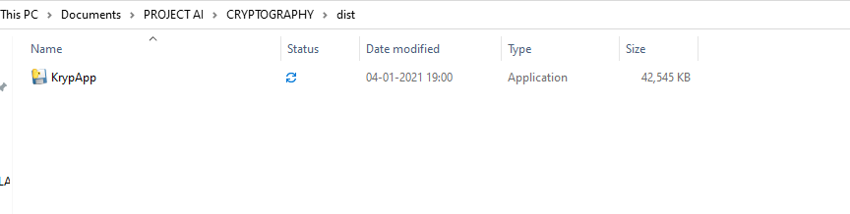

Once you click on the file, you should be able to launch your program (if you get an error message, you may need to install [Visual C++ Redistributable](https://support.microsoft.com/en-ca/help/2977003/the-latest-supported-visual-c-downloads)).

Once you click on the ‘KrypApp’ executable, you’ll see the following display

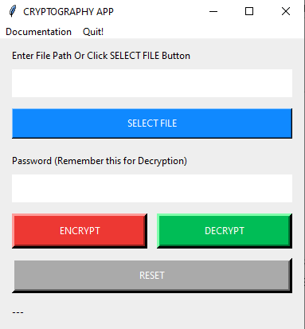

# Encryption & Decryption Tool

**HOW TO USE THIS PROGRAM**

## How to encrypt and decrypt-

1. Open the App and Click SELECT FILE Button and select your file e.g. "abc.jpg".
2. Enter your Secret Key (This can be any alphanumeric letters). Remember this so you can Decrypt the file later.
3. Click ENCRYPT Button to encrypt. A new encrypted file with ".sss" extention e.g. "abc.jpg.sss" will be created in the same directory where the "abc.jpg" is.
4. When you want to Decrypt a file you, will select the file with the ".sss" extention and Enter your Secret Key which you chose at the time of Encryption. Click DECRYPT Button to decrypt. The decrypted file will be of the same name as before with the suffix "**decrypted**" e.g. "abc dekrypted .jpg".
5. Click RESET Button to reset the input fields and status bar.
6. You can also Click CANCEL Button during Encryption/Decryption to stop the process.