Lesson 23: Parabolas
Math 2412 Precalculus · Unit 4: Analytic Trigonometry, Conics & Discrete Topics · Student Guided Notes
Name: ______________________________ Date: ______________

Lesson objective
Students will define a parabola by its focus and directrix, write and graph parabolas with vertex at the origin or at (h, k), find the focus, directrix, and latus rectum, and solve problems about parabolic reflectors.

Before class
Complete these short tasks before the lesson. They review skills this lesson builds on.
- Complete the square: $x^{2}−8x$ and $y^{2}+4y$ (Lesson 7).
- Find the distance from (3, 4) to the line $y=−1$ and to the point (3, 1).
- Give the vertex and axis of symmetry of $y={(x−2)}^{2}+5$ (Lesson 7).

Skill 23.1: Parabolas with Vertex at the Origin

Key ideas
- A parabola is the set of all points that are the same distance from a fixed point, the ______________ (1), and a fixed line, the ______________ (2). It is the conic you get when the plane is parallel to the edge of the cone.
- The vertex is halfway between the focus and the directrix. The directed distance from the vertex to the focus is p.
- The latus rectum is the segment through the focus, perpendicular to the axis, with endpoints on the parabola. Its length is ______________ (3).
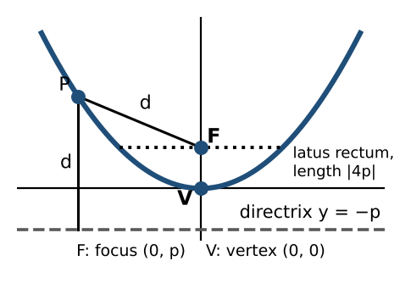
Opens | Equation | Focus | Directrix | Latus rectum endpoints
right (p > 0) or left (p < 0) | $y^{2}=4px$ | (p, 0) | ________ (4) | (p, ±2p)
up (p > 0) or down (p < 0) | $x^{2}=4py$ | ________ (5) | $y=−p$ | (±2p, p)

Example: identify and graph
- $y^{2}=24x$: $4p=24$, $p=6$. Opens right; focus (6, 0), directrix $x=−6$, latus rectum endpoints (6, ±12), length 24.
- $x^{2}=6y$: $4p=6$, $p=\frac{3}{2}$. Opens up; focus (0, 3/2), directrix $y=−\frac{3}{2}$, latus rectum endpoints (±3, 3/2), length 6.
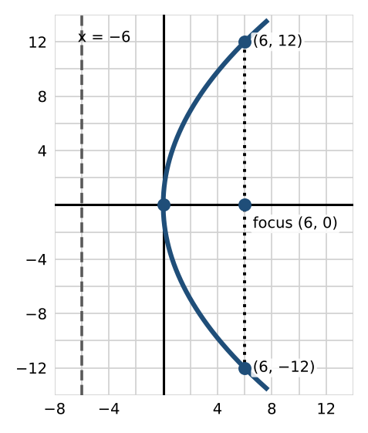 | 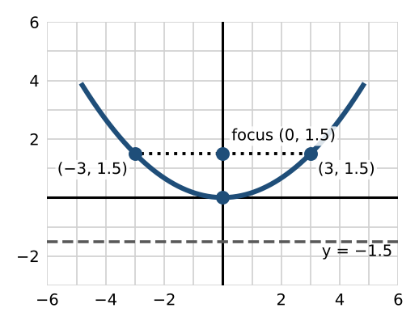

Practice
a. Find the focus, directrix, and latus rectum endpoints of $y^{2}=−8x$, and graph it.
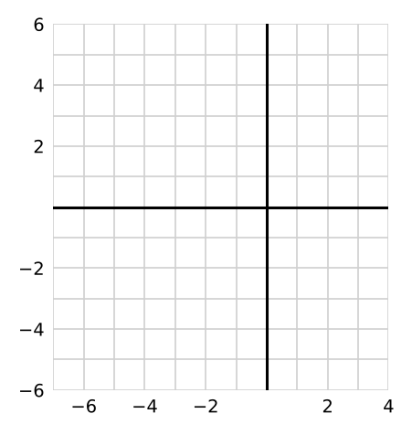

Skill 23.2: Equation from the Focus and Directrix

Steps
- The vertex is halfway between the focus and the directrix.
- A vertical directrix ($x=…$) means the parabola opens left or right: use ______________ (6). A horizontal directrix means it opens up or down: use $x^{2}=4py$.
- Find p, the signed distance from the vertex to the focus, and substitute.

Example
- Focus (−1/2, 0), directrix $x=\frac{1}{2}$: vertex (0, 0), $p=−\frac{1}{2}$, so $y^{2}=4(−\frac{1}{2})x$, that is, $y^{2}=−2x$.
- Focus (0, 7/2), directrix $y=−\frac{7}{2}$: vertex (0, 0), $p=\frac{7}{2}$, so the equation is ______________ (7).

Practice
a. Write the equation of the parabola with focus (0, −3) and directrix $y=3$.

Skill 23.3: Parabolas with Vertex (h, k)

Key ideas
Opens | Equation | Focus | Directrix | Latus rectum endpoints
right or left | ${(y−k)}^{2}=4p(x−h)$ | (h + p, k) | ________ (8) | (h + p, k ± 2p)
up or down | ${(x−h)}^{2}=4p(y−k)$ | ________ (9) | $y=k−p$ | (h ± 2p, k + p)

If the equation is in general form, complete the square on the squared variable to reach standard form.

Example 1: ${(y−1)}^{2}=−16(x+3)$
Vertex (−3, 1); $4p=−16$, so $p=−4$ and it opens left. Focus (−7, 1), directrix $x=1$, latus rectum endpoints (−7, 9) and (−7, −7).
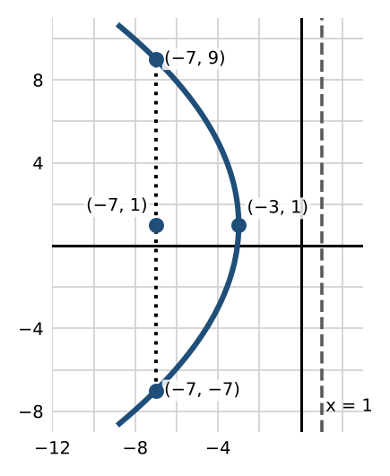

Example 2: $x^{2}−8x−28y−208=0$
- Group the x terms: $x^{2}−8x=28y+208$. Add 16 to both sides: ${(x−4)}^{2}=28y+224=28(y+8)$.
- Vertex (4, −8); $4p=28$, so $p=7$, opening up. Focus (4, −1), directrix ______________ (10), latus rectum endpoints (−10, −1) and (18, −1).
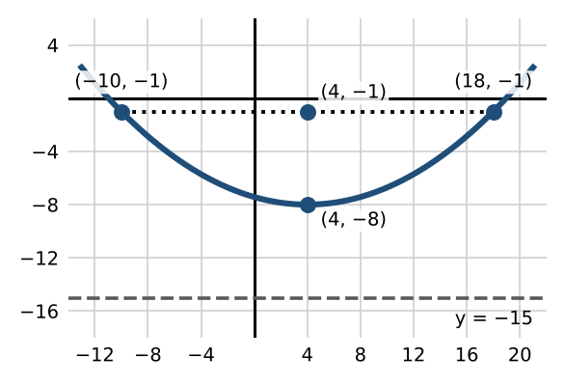

Practice
a. Find the vertex, focus, directrix, and latus rectum endpoints of ${(x+1)}^{2}=4(y−8)$, and graph it.  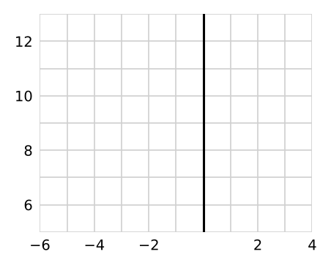 | b. Write $y^{2}+4y−8x+28=0$ in standard form. Give the vertex, focus, and directrix.

Skill 23.4: Parabolic Reflectors

Key ideas
Rays parallel to the axis of a parabolic mirror reflect through the ______________ (11), and a source at the focus sends rays out parallel to the axis. Satellite dishes, flashlights, and solar cookers use this.

Example: a solar fire starter
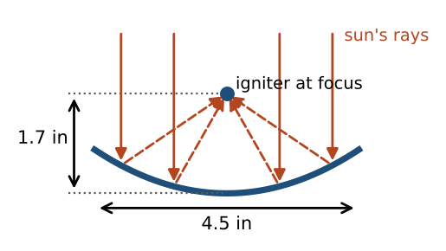
The mirror is 4.5 inches across, and the igniter sits at the focus, 1.7 inches above the vertex. Put the vertex at the origin.
- Equation: $p=1.7$, so $x^{2}=4(1.7)y=6.8y$.
- Depth: the rim is at $x=2.25$, so $y={2.25}^{2}/6.8≈0.74$ inch.

Practice
a. A satellite dish is 24 inches across and 4 inches deep. How far from the vertex should the receiver be placed?

Exit check
1. Find the focus and directrix of $x^{2}=−20y$.

2. Write the parabola with focus (4, 0) and directrix $x=−4$.

3. Give the vertex of ${(y+3)}^{2}=12(x−2)$.

