Lesson 6: Function Operations & Inverses
Math 2412 Precalculus · Unit 1: Algebra Foundations & Functions · Student Guided Notes
Name: ______________________________ Date: ______________

Lesson objective
Students will combine functions, form and decompose compositions and find their domains, and find, verify, and graph inverse functions.

Before class
Complete these short tasks before the lesson. They review skills this lesson builds on.
- For $f(x)=x^{2}−3$, find $f(x+1)$ (Lesson 4).
- Find the domain of $\frac{1}{x−3}$ and of $\sqrt{x+2}$ (Lesson 4).
- Simplify the complex fraction $\frac{1+\frac{1}{x}}{1−\frac{1}{x}}$ (Lesson 1).
- Solve $y=\frac{2x+1}{x−3}$ for x.

Skill 6.1: Combining Functions

Key ideas
Operation | Definition | Note
Sum | $(f+g)(x)=f(x)+g(x)$
Difference | $(f−g)(x)=f(x)−g(x)$
Product | $(fg)(x)=f(x)·g(x)$
Quotient | $(\frac{f}{g})(x)=\frac{f(x)}{g(x)}$ | requires $g(x)≠0$

- The domain of $f+g$, $f−g$, and $fg$ is every x in the domain of ______________ (1) f and g.
- The domain of $\frac{f}{g}$ also leaves out every x where ______________ (2).
- Find the domain before simplifying. Cancelling can hide a restriction.

Example: $f(x)=x^{2}−4$ and $g(x)=x+2$
- $(f+g)(x)=x^{2}+x−2$ and $(f−g)(x)=x^{2}−x−6$, both with domain (−∞, ∞).
- $(fg)(x)=(x^{2}−4)(x+2)=x^{3}+2x^{2}−4x−8$, domain (−∞, ∞).
- $(\frac{f}{g})(x)=\frac{x^{2}−4}{x+2}=x−2$, but the domain is (−∞, −2) ∪ (−2, ∞) because $g(−2)=0$.
- Evaluate: $(f+g)(2)=f(2)+g(2)=0+4=4$.

Practice
a. For $f(x)=\sqrt{x}$ and $g(x)=x−1$, find $(\frac{f}{g})(x)$ and its domain. | b. For $f(x)=x^{2}$ and $g(x)=2x+1$, find $(fg)(−3)$.
c. Use the table: at $x=−2,0,2$, f is 3, −1, 5 and g is 4, 2, −3. Find $(f+g)(0)$, $(f−g)(2)$, and $(fg)(−2)$.

Skill 6.2: Composition of Functions

Key ideas
- The composition $f∘g$ ("f composed with g") is $(f∘g)(x)=f(g(x))$. Apply g first, then f.
- In general, $f∘g$ and $g∘f$ are ______________ (3) functions.
- The domain of $f∘g$: every x in the domain of ______________ (4) for which $g(x)$ is in the domain of f.
- Decomposing means writing a function as a composition of simpler functions, an inside function and an outside function.

Steps: find a composition and its domain
- Identify the inside function and find its restrictions.
- Form the composition by substituting the inside function into the outside function. Simplify.
- Find any restrictions of the simplified expression.
- The domain must satisfy the restrictions from both step 1 and step 3.

Example 1: $f(x)=\sqrt{x+3}$ and $g(x)=x^{2}−2$
$(f∘g)(x)=\sqrt{(x^{2}−2)+3}=\sqrt{x^{2}+1}$. g has no restrictions, and $x^{2}+1$ is always positive, so the domain is (−∞, ∞).
$(g∘f)(x)={(\sqrt{x+3})}^{2}−2=x+1$. But the inside function √(x + 3) needs $x≥−3$, so the domain is [−3, ∞), even though $x+1$ alone has no restriction.

Example 2: three functions
For $f(x)=\frac{x}{x+1}$, $g(x)=x^{10}$, and $h(x)=x+3$: $(f∘g∘h)(x)=f(g(h(x)))=\frac{{(x+3)}^{10}}{{(x+3)}^{10}+1}$.

Example 3: decompose $H(x)={(2x−1)}^{5}$
Inside: $g(x)=2x−1$. Outside: $f(x)=x^{5}$. Then $H=f∘g$.

Practice
a. For $f(x)=x^{2}+3$ and $g(x)=2x−1$, find $(f∘g)(x)$ and $(g∘f)(x)$. | b. For $f(x)=\frac{1}{x−2}$ and $g(x)=\sqrt{x}$, find $(f∘g)(x)$ and its domain.
c. For $f(x)=x^{2}$ and $g(x)=x−5$, find $(f∘g)(2)$. | d. Decompose $H(x)=\sqrt{x^{2}+7}$ into $f∘g$.

Skill 6.3: One-to-One Functions

Key ideas
- A function is ______________ (5) if different inputs always give different outputs: if $x₁≠x₂$, then $f(x₁)≠f(x₂)$.
- ______________ (6): if every horizontal line crosses the graph at most once, the function is one-to-one.
- Only one-to-one functions have inverse functions.

Examples
- $f(x)=x^{2}$ is not one-to-one: $f(2)=f(−2)=4$. The line $y=4$ crosses the graph twice.
- $f(x)=x^{3}$ is one-to-one: every horizontal line crosses its graph exactly once.
- $f(x)=x^{2}$ with $x≥0$ is one-to-one. Restricting the domain to the right half removes the repeats.

Practice
Is each function one-to-one? Explain.
a. $f(x)=2x+5$ | b. $f(x)=\left|x\right|$
c. $f(x)=\sqrt{x}$ | d. $f(x)=x^{2}−1$

Skill 6.4: Inverse Functions

Key ideas
- If f is one-to-one, its inverse $f⁻¹$ undoes f: $f⁻¹(f(x))=x$ and $f(f⁻¹(x))=x$.
- The domain of $f⁻¹$ is the ______________ (7) of f, and the range of $f⁻¹$ is the ______________ (8) of f.
- If (a, b) is on the graph of f, then ______________ (9) is on the graph of $f⁻¹$. The graphs are reflections across the line ______________ (10).
- $f⁻¹(x)$ does not mean $\frac{1}{f}(x)$.

Steps: find an inverse function
- Replace $f(x)$ with y.
- Swap x and y.
- Solve for y.
- Replace y with $f⁻¹(x)$.
- State the domain of $f⁻¹$: the range of f.

Example 1: $f(x)=1+3x$
$y=1+3x$. Swap: $x=1+3y$. Solve: $y=\frac{x−1}{3}$. So $f⁻¹(x)=\frac{x−1}{3}$.
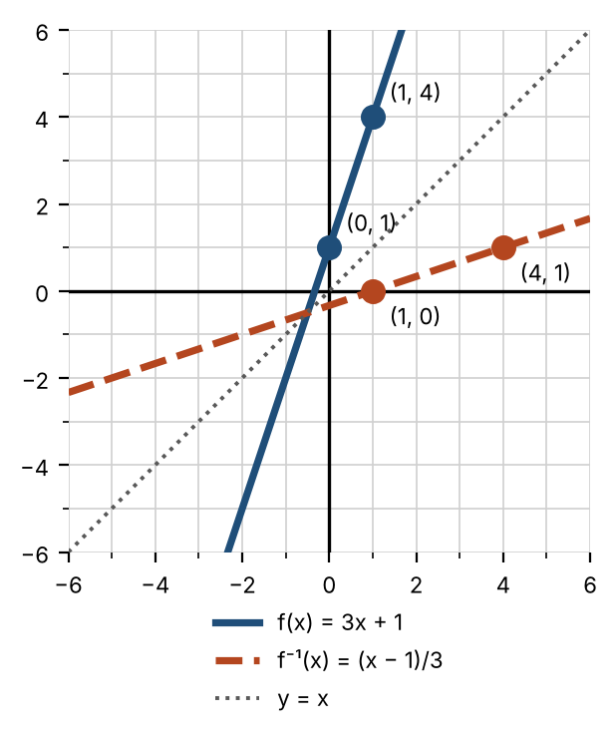

Example 2: $f(x)=x^{2}+9$ with $x≥0$
Swap: $x=y^{2}+9$. Solve: $y^{2}=x−9$, so $y=\sqrt{x−9}$ (positive, because the original domain was $x≥0$).
$f⁻¹(x)=\sqrt{x−9}$ with domain [9, ∞), the range of f.

Example 3: verify that $f(x)=\frac{3−x}{4}$ and $g(x)=3−4x$ are inverses
$f(g(x))=\frac{3−(3−4x)}{4}=\frac{4x}{4}=x$ ✓ and $g(f(x))=3−4·\frac{3−x}{4}=3−(3−x)=x$ ✓.

Practice
a. Show that $f(x)=\frac{x+2}{x−2}$ and $g(x)=\frac{2x+2}{x−1}$ are inverses. | b. Find the inverse of $f(x)=2x^{3}−5$.
c. Find the inverse of $f(x)=\frac{2x+1}{x−3}$. | d. The graph of f passes through (−2, −3), (0, 1), (1, 3), and (3, 4). Sketch $f⁻¹$.  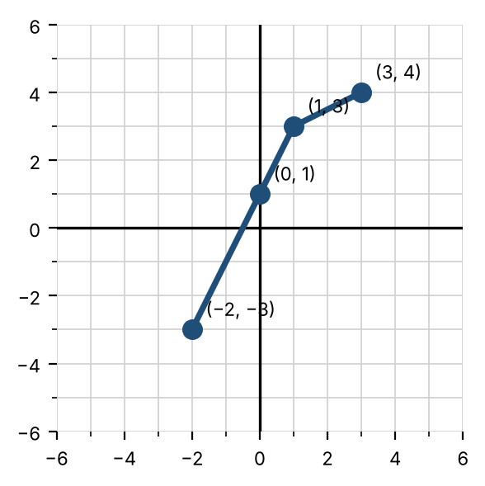  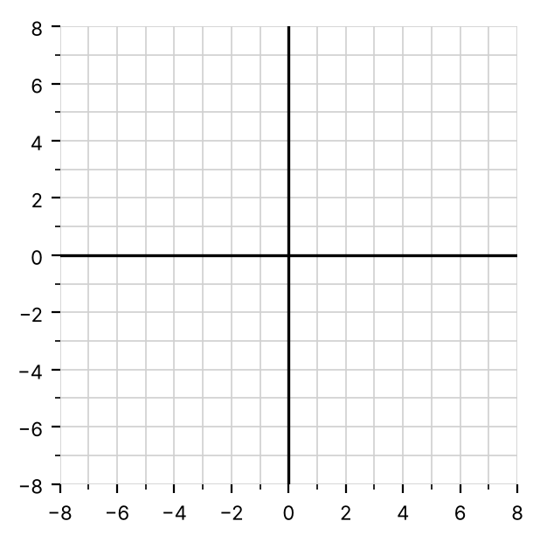

Exit check
1. For $f(x)=x+4$ and $g(x)=x^{2}$, find $(f∘g)(3)$ and $(g∘f)(3)$.

2. Find the inverse of $f(x)=5x−2$.

3. Is $f(x)=x^{2}−1$ one-to-one? Explain.

