Lesson 10: Exponential & Logarithmic Functions
Math 2412 Precalculus · Unit 2: Polynomial, Rational, Exponential & Logarithmic Functions · Student Guided Notes
Name: ______________________________ Date: ______________

Lesson objective
Students will graph exponential functions and their transformations, use the natural base e, convert between exponential and logarithmic form, evaluate logarithms, and graph logarithmic functions and find their domains.

Before class
Complete these short tasks before the lesson. They review skills this lesson builds on.
- Evaluate $2^{−3}$, $9^{\frac{1}{2}}$, and $8^{\frac{2}{3}}$ (Lesson 1).
- Find the inverse of $f(x)=2x+1$. How are the graphs of f and $f^{−1}$ related? (Lesson 6)
- Describe how $y=−{(x+1)}^{2}+3$ is transformed from $y=x^{2}$ (Lesson 5).

Skill 10.1: Exponential Functions

Key ideas
- An exponential function has the form $f(x)=C·a^{x}$, where $a>0$ and $a≠1$. C is the ______________ (1) and a is the ______________ (2).
- The variable is in the exponent. Compare $x^{2}$ (a power function) with $2^{x}$ (an exponential function).
x | −2 | −1 | 0 | 1 | 2
$2^{x}$ | ________ (3) | ________ (4) | 1 | 2 | ________ (5)
$3^{x}$ | ________ (6) | ________ (7) | 1 | 3 | ________ (8)

Properties of $f(x)=a^{x}$
- Domain ______________ (9); range ______________ (10).
- Horizontal asymptote ______________ (11) (the x-axis).
- Passes through (0, 1) and (1, a). Key points: (−1, 1/a), (0, 1), (1, a).
- If $a>1$, the function increases (growth). If $0<a<1$, it decreases (decay).
- ${(\frac{1}{a})}^{x}=a^{−x}$, so the graph of ${(\frac{1}{2})}^{x}$ is the reflection of $2^{x}$ across the y-axis.
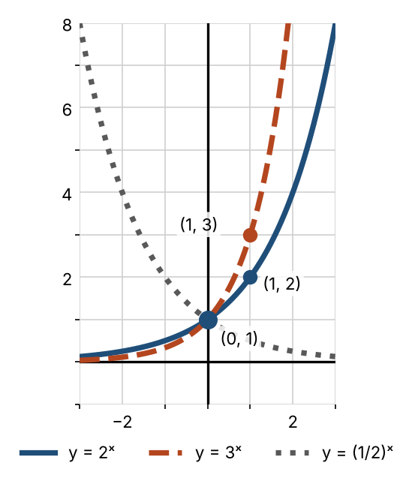

Practice
a. Evaluate $f(x)=3·2^{x}$ at $x=−1$, 0, and 3. | b. Growth or decay? $y={0.8}^{x}$, $y={(\frac{5}{4})}^{x}$, $y=3^{−x}$
c. Sketch $r(x)={(\frac{1}{5})}^{x}$. Label three key points and the asymptote.  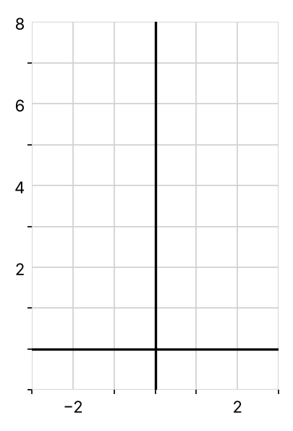 | d. Find $f(x)=C·a^{x}$ if the graph passes through (0, 4) and (2, 36).

Skill 10.2: Transformations & the Natural Base e

Key ideas
- Transform exponential graphs with the Lesson 5 rules. Move the key points (−1, 1/a), (0, 1), (1, a), and move the asymptote.
- A vertical shift k moves the horizontal asymptote to ______________ (12), and the range changes with it.
- The natural base is $e≈2.71828$. The graph of $y=e^{x}$ lies between $y=2^{x}$ and $y=3^{x}$, with key points (−1, 1/e), (0, 1), and (1, e).

Example: $f(x)=3+2^{x+1}$
Shift $y=2^{x}$ left 1 and up 3: $(x,y)→(x−1,y+3)$. Asymptote $y=3$; range (3, ∞).
 | 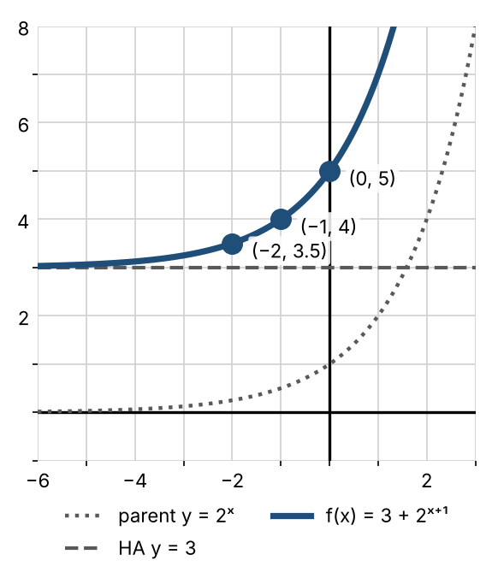
  Parent point | New point
  (−1, 1/2) | (−2, 3.5)
  (0, 1) | (−1, 4)
  (1, 2) | (0, 5)

Practice
Move the key points, then sketch. State the asymptote and the range.
a. $f(x)=2^{x−2}−3$  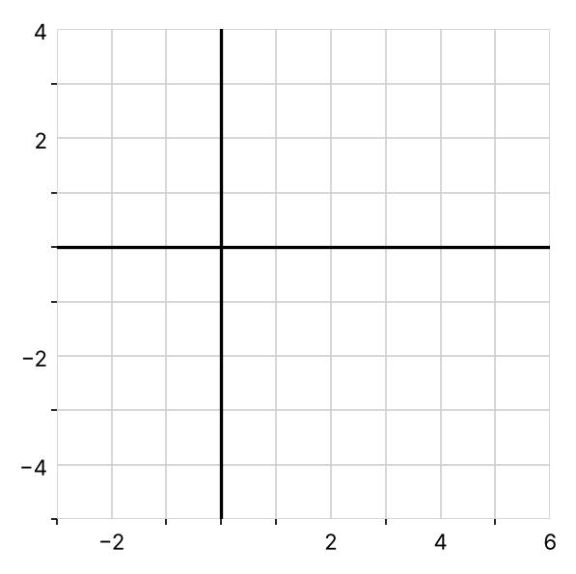 | b. $f(x)=2+e^{x+3}$  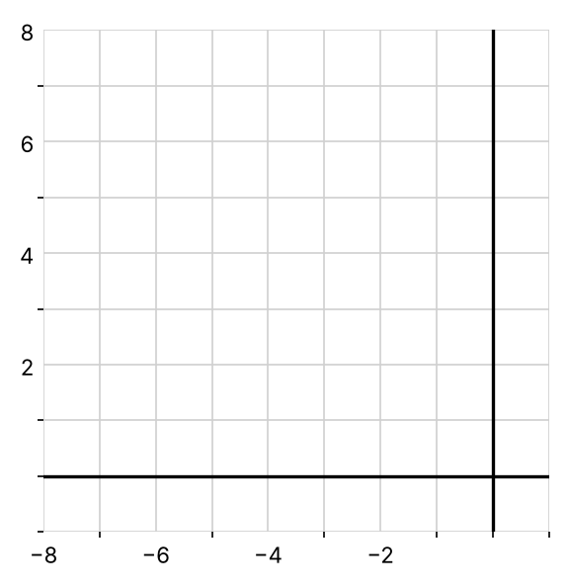 | c. $f(x)=−2^{x}$  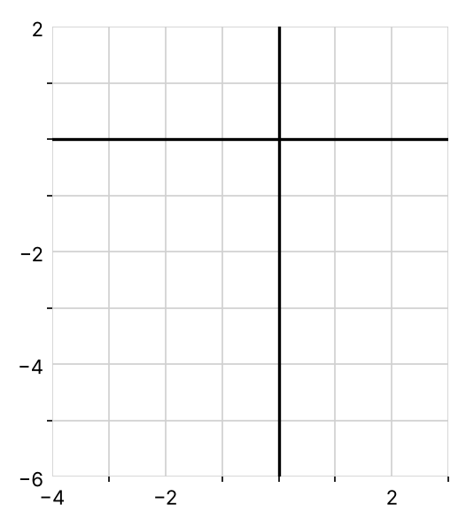
  Parent point | New point
  (−1, 1/2)
  (0, 1)
  (1, 2)
  Parent point | New point
  (−1, 1/e)
  (0, 1)
  (1, e)
  Parent point | New point
  (−1, 1/2)
  (0, 1)
  (1, 2)

Skill 10.3: Logarithms

Key ideas
Definition: for $a>0$, $a≠1$, and $x>0$: $\log_{a} x=y$ means $a^{y}=x$. A logarithm is an ______________ (13).
- The common logarithm is $log x=\log_{10} x$. The natural logarithm is $ln x=\log_{e} x$.
- Read $\log_{2} 8$ as "the exponent on 2 that gives 8." So $\log_{2} 8=3$.
- You cannot take the logarithm of 0 or of a negative number.

Example 1: logarithmic form to exponential form
Logarithmic form | Exponential form
$\log_{2} 8=3$ | $2^{3}=8$
$\log_{3} 81=4$ | ________ (14)
$\log_{5}(\frac{1}{25})=−2$ | ________ (15)

Example 2: exponential form to logarithmic form
Exponential form | Logarithmic form
$2^{4}=16$ | $\log_{2} 16=4$
${(\frac{2}{3})}^{3}=\frac{8}{27}$ | ________ (16)
$4^{−2}=\frac{1}{16}$ | ________ (17)

Basic properties
Property | Why | Natural log version
$\log_{b} 1=0$ | $b^{0}=1$ | $ln 1=0$
$\log_{b} b=1$ | $b^{1}=b$ | $ln e=1$
$\log_{b} b^{u}=u$ | the exponent on b is u | $ln e^{u}=u$
$b^{\log_{b} u}=u$ | $\log_{b}$ and $b^{x}$ undo each other | $e^{ln u}=u$

Example 3: simplify
$\log_{2} 1=0$; $\log_{5} 5=1$; ${10}^{log 15}=15$; $5^{\log_{5} 3}=3$; $ln e^{4}=4$; $log {10}^{5}=5$.

Example 4: evaluate
$\log_{2} 32=5$; $\log_{9} 3=\frac{1}{2}$ (since $9^{\frac{1}{2}}=3$); $log 0.001=−3$; $\log_{4} 8=\frac{3}{2}$ (since $4^{y}=8$ means $2^{2y}=2^{3}$).

Practice
a. Write $6^{2}=36$ in logarithmic form. | b. Write $\log_{7}(\frac{1}{49})=−2$ in exponential form.
c. Evaluate $\log_{3} 27$, $log 1000$, $\log_{2}(\frac{1}{8})$, and $ln \sqrt{e}$. | d. Simplify $7^{\log_{7} 12}$ and $\log_{6} 6^{9}$.

Skill 10.4: Logarithmic Functions & Graphs

Key ideas
- $y=\log_{a} x$ is the ______________ (18) of $y=a^{x}$. Its graph is the reflection of $y=a^{x}$ across the line $y=x$.
- Domain ______________ (19); range ______________ (20). The domain of the log function is the range of the exponential, and the reverse.
- Vertical asymptote ______________ (21). Key points: (1/a, −1), (1, 0), (a, 1).
- To find the domain of a log function, set the argument greater than 0 and solve.
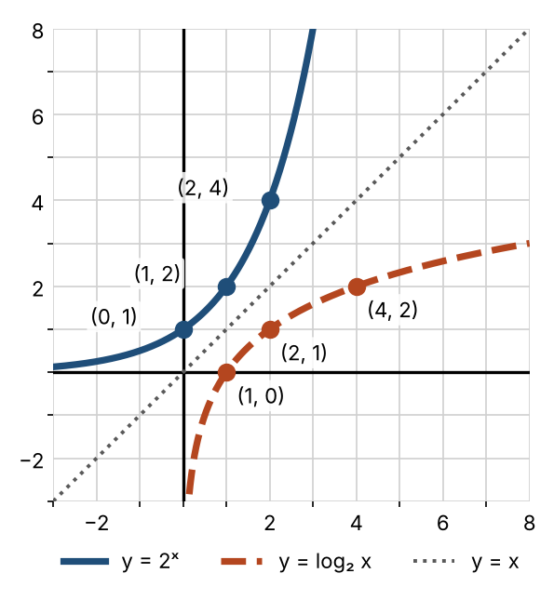

Example 1: domains
- $f(x)=\log_{3}(x−2)$: $x−2>0$, so the domain is (2, ∞).
- $f(x)=log(x^{2}−4)$: $x^{2}−4>0$, so the domain is (−∞, −2) ∪ (2, ∞) (Lesson 3).

Example 2: $f(x)=3+\log_{5}(x−2)$
Shift $y=\log_{5} x$ right 2 and up 3. Vertical asymptote $x=2$; domain (2, ∞).
 | 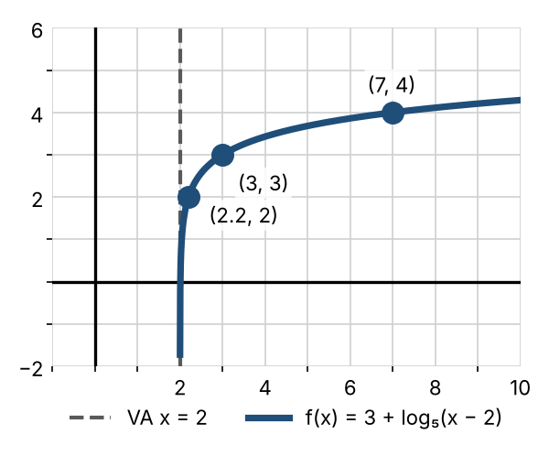
  Parent point | New point
  (1/5, −1) | (2.2, 2)
  (1, 0) | (3, 3)
  (5, 1) | (7, 4)

Practice
a. Find the domain of $f(x)=ln(5−x)$. | b. Find the domain of $g(x)=log(3x+6)$.
c. Sketch $f(x)=−2+ln(x−3)$. State the asymptote and domain.  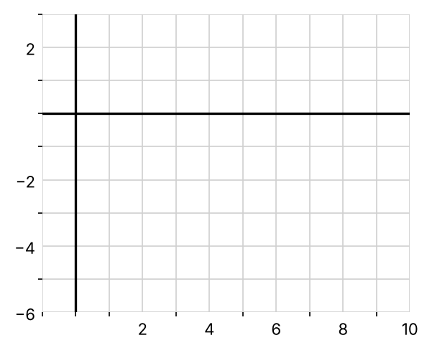 | d. Sketch $y=\log_{2}(x+4)$. State the asymptote and domain.  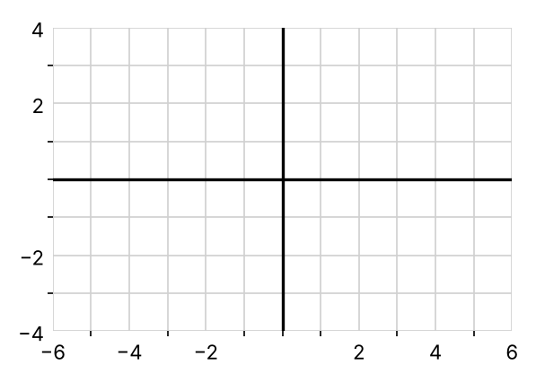
  Parent point | New point
  (1/e, −1)
  (1, 0)
  (e, 1)
  Parent point | New point
  (1/2, −1)
  (1, 0)
  (2, 1)
  (4, 2)

Exit check
1. Write $\log_{4} 64=3$ in exponential form.

2. Evaluate $\log_{2}(\frac{1}{16})$.

3. State the domain, range, and asymptote of $f(x)=2^{x−1}+3$.

