Lesson 15: The Unit Circle & the Six Trig Functions
Math 2412 Precalculus · Unit 3: Trigonometric Functions & Triangles · Student Guided Notes
Name: ______________________________ Date: ______________

Lesson objective
Students will define sine and cosine as coordinates on the unit circle, find exact values of all six trigonometric functions at any multiple of π/6 or π/4 using reference angles, use the Pythagorean, reciprocal, and quotient identities to find values and simplify expressions, and evaluate trig functions with a calculator.

Before class
Complete these short tasks before the lesson. They review skills this lesson builds on.
- Find the reference angle of 225° and of $5π/6$ (Lesson 13).
- Give $sin 30°$, $cos 45°$, and $tan 60°$ exactly (Lesson 14).
- Simplify $\sqrt{1−\frac{9}{49}}$.

Skill 15.1: The Unit Circle

Key ideas
- The ______________ (1) has center (0, 0) and radius 1. An angle t in standard position cuts off an arc of length t.
- If the terminal side of t meets the unit circle at (x, y), then ______________ (2) and ______________ (3).
- Because $x^{2}+y^{2}=1$, the Pythagorean identity is ______________ (4) for every t.
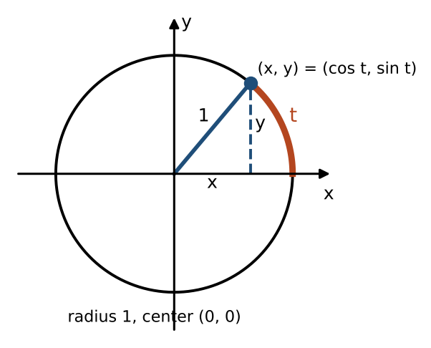

Example 1: missing coordinates
- (1/2, y) is on the unit circle: $y^{2}=1−\frac{1}{4}=\frac{3}{4}$, so $y=±\sqrt{3}/2$.
- (x, √2/2) is on the unit circle: $x^{2}=1−\frac{1}{2}=\frac{1}{2}$, so $x=±\sqrt{2}/2$.

Example 2: use the quadrant to choose the sign
If $sin t=\frac{3}{7}$ and t is in quadrant II, find $cos t$.
- Identity: $\cos^{2}t=1−\frac{9}{49}=\frac{40}{49}$, so $cos t=±\sqrt{40}/7=±2\sqrt{10}/7$. In quadrant II, x is negative: $cos t=−2\sqrt{10}/7$.
- Reference triangle: opposite 3, hypotenuse 7, adjacent $\sqrt{49−9}=2\sqrt{10}$, drawn to the left of the y-axis.
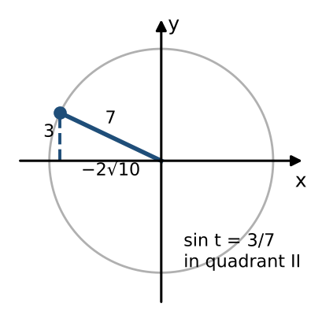

Practice
a. Find y if (−3/5, y) is on the unit circle in quadrant III. | b. If $cos t=−\frac{24}{25}$ and t is in quadrant II, find $sin t$. | c. Can $sin t=0.8$ and $cos t=0.5$ for the same t? Explain.

Skill 15.2: Exact Values with Reference Angles

Key ideas
- An angle and its reference angle have the same sine and cosine values, except possibly for the ______________ (5).
- The quadrant gives the sign. A memory aid: All Students Take Calculus (QI all, QII sine, QIII tangent, QIV cosine).
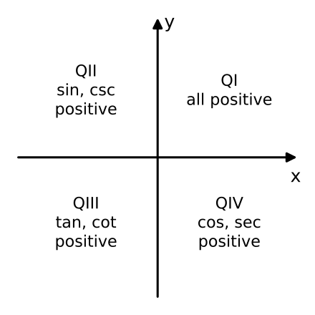
- Find the reference angle (and a coterminal angle between 0 and 2π if needed).
- Find the value of the function at the reference angle.
- Attach the sign for the quadrant.
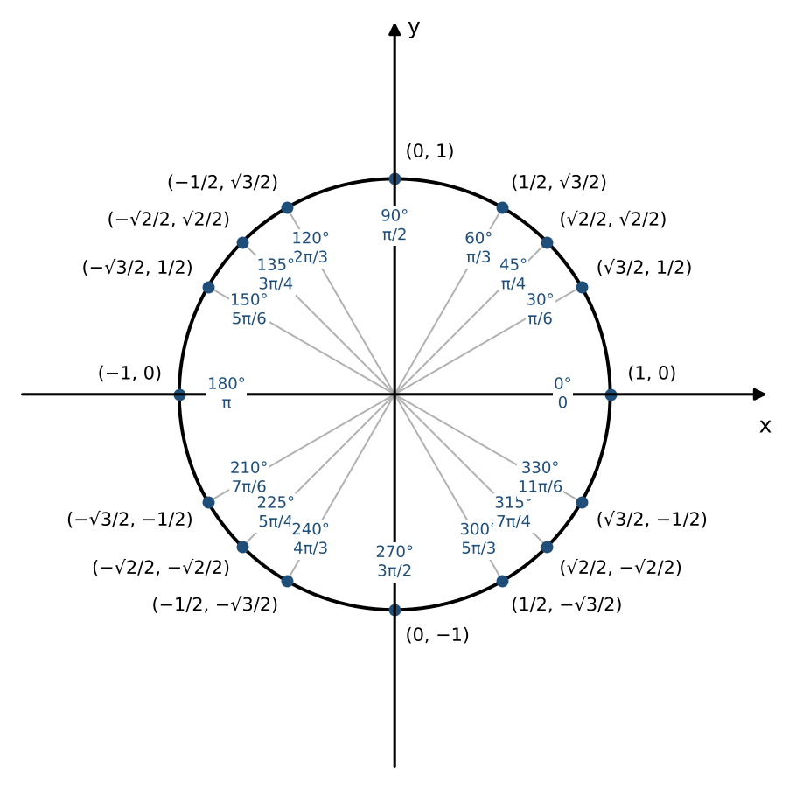

Example: use reference angles
Value | Reference angle and quadrant | Answer
$cos 315°$ | 45°, quadrant IV (cos +) | $\sqrt{2}/2$
$sin(−2π/3)$ | coterminal $4π/3$: $π/3$, quadrant III (sin −) | ________ (6)
$tan 240°$ | 60°, quadrant III (tan +) | ________ (7)
$sec(3π/4)$ | $π/4$, quadrant II (cos −) | ________ (8)
$cot 120°$ | 60°, quadrant II (tan −) | ________ (9)
$csc(5π/6)$ | $π/6$, quadrant II (sin +) | ________ (10)

Practice
a. Find $sin 210°$ and $cos 210°$. | b. Find $tan(5π/3)$.
c. Find $cos(−5π/4)$. | d. Find $sin(3π/2)$ and $cos π$.

Skill 15.3: The Six Trigonometric Functions

Key ideas
If the terminal side of t meets the unit circle at (x, y):
Uses y | Uses x | Uses both
$sin t=y$ | $cos t=x$ | $tan t$ = ________ (11), $x≠0$
$csc t$ = ________ (12), $y≠0$ | $sec t$ = ________ (13), $x≠0$ | $cot t$ = ________ (14), $y≠0$

- Even and odd: cosine and secant are ______________ (15): $cos(−t)=cos t$. Sine, cosecant, tangent, and cotangent are ______________ (16): $sin(−t)=−sin t$.

Example 1: all six values from a point
- (−√3/2, 1/2): $sin t=\frac{1}{2}$, $cos t=−\sqrt{3}/2$, $tan t=−1/\sqrt{3}=−\sqrt{3}/3$, $csc t=2$, $sec t=−2/\sqrt{3}=−2\sqrt{3}/3$, $cot t=−\sqrt{3}$.
- (√2/2, −√2/2): $sin t=−\sqrt{2}/2$, $cos t=\sqrt{2}/2$, $tan t=−1$, $csc t=−\sqrt{2}$, $sec t=\sqrt{2}$, $cot t=−1$.

Example 2: all six values at $t=−5π/6$
Coterminal angle $7π/6$, reference angle $π/6$, quadrant III, point (−√3/2, −1/2). So $sin =−\frac{1}{2}$, $cos =−\sqrt{3}/2$, $tan =\sqrt{3}/3$, $csc =−2$, $sec =−2\sqrt{3}/3$, $cot =\sqrt{3}$.

Practice
a. Find all six values at $t=π/3$. | b. Find all six values at $t=π/6$. | c. Use even and odd properties: if $sin t=0.4$ and $cos t=0.92$, find $sin(−t)$ and $cos(−t)$.

Skill 15.4: Identities & the Calculator

Key ideas
- Reciprocal identities: $csc t=\frac{1}{sin t}$, $sec t=\frac{1}{cos t}$, $cot t=\frac{1}{tan t}$.
- Quotient identities: $tan t$ = ______________ (17) and $cot t$ = ______________ (18).
- Pythagorean identities: $\sin^{2}t+\cos^{2}t=1$, $1+\tan^{2}t$ = ______________ (19), and $1+\cot^{2}t$ = ______________ (20).

Example 1: simplify
- $\frac{sec t}{tan t}=(\frac{1}{cos t})·(\frac{cos t}{sin t})=\frac{1}{sin t}=csc t$
- $tan t·cos t=(\frac{sin t}{cos t})·cos t=sin t$

Example 2: all six values from one
If $cos t=\frac{12}{13}$ and t is in quadrant IV: $sin t=−\sqrt{1−\frac{144}{169}}=−\frac{5}{13}$. Then $tan t=−\frac{5}{12}$, $csc t=−\frac{13}{5}$, $sec t=\frac{13}{12}$, $cot t=−\frac{12}{5}$.
If $sec t=−\frac{17}{8}$ and $0<t<π$: $cos t=−\frac{8}{17}$, so t is in quadrant II and $sin t=\frac{15}{17}$. Then $tan t=−\frac{15}{8}$, $csc t=\frac{17}{15}$, $cot t=−\frac{8}{15}$.

Calculator skills
- Set the mode to ______________ (21) for angles without a degree symbol.
- Calculators have no csc, sec, or cot keys. Use the reciprocals: $csc(5π/7)=\frac{1}{sin(5π/7)}≈1.2790$ and $cot(−π/8)=\frac{1}{tan(−π/8)}≈−2.4142$.

Practice
a. Simplify $sin t·csc t$ and $\frac{1−\cos^{2}t}{sin t}$. | b. If $tan t=\frac{3}{4}$ and t is in quadrant III, find $sin t$ and $cos t$.
c. If $csc t=3$ and $cos t<0$, find $sin t$, $cos t$, and $tan t$. | d. Use a calculator: $sec 2.5$ and $cot 40°$, to four decimal places.

Exit check
1. Find $cos(4π/3)$ exactly.

2. Find $sec 135°$ exactly.

3. If $sin t=−\frac{8}{17}$ and t is in quadrant IV, find $cos t$ and $tan t$.

