Lesson 5: Transformations & Symmetry
Math 2412 Precalculus · Unit 1: Algebra Foundations & Functions · Student Guided Notes
Name: ______________________________ Date: ______________

Lesson objective
Students will graph functions by applying shifts, stretches, compressions, and reflections to parent functions, and will classify functions as even, odd, or neither.

Before class
Complete these short tasks before the lesson. They review skills this lesson builds on.
- Make a table of values for y = x² (use x = −2, −1, 0, 1, 2) and for y = √x (use x = 0, 1, 4).
- Find f(−x) for f(x) = x³ − x. Simplify your answer.
- Review Lesson 4: read the domain and range from two graphs.

Skill 5.1: Parent Functions

Key ideas
A ______________ (1) is the simplest function in a family. Every other function in the family is a transformation of it.
Key points are a few exact points on the parent graph. We move the key points, then draw the shape through them.
Fill in the domain and range of each parent function. The first row is done for you.
Name | Equation | Key points | Domain | Range
Linear | f(x) = x | (−1, −1), (0, 0), (1, 1) | (−∞, ∞) | (−∞, ∞)
Quadratic | f(x) = x² | (−2, 4), (−1, 1), (0, 0), (1, 1), (2, 4) | ________ (2) | ________ (3)
Square root | f(x) = √x | (0, 0), (1, 1), (4, 2) | ________ (4) | ________ (5)
Absolute value | f(x) = |x| | (−1, 1), (0, 0), (1, 1) | ________ (6) | ________ (7)
Cubic | f(x) = x³ | (−1, −1), (0, 0), (1, 1) | ________ (8) | ________ (9)
Cube root | f(x) = ∛x | (−8, −2), (−1, −1), (0, 0), (1, 1), (8, 2) | ________ (10) | ________ (11)
Greatest integer (step) | f(x) = ⟦x⟧ | (−1, −1), (0, 0), (1, 1), (2, 2); closed dot on the left of each step, open dot on the right | ________ (12) | ________ (13)
Reciprocal | f(x) = 1/x | (−2, −½), (−1, −1), (−½, −2), (½, 2), (1, 1), (2, ½); asymptotes x = 0 and y = 0 | ________ (14) | ________ (15)
Reciprocal squared | f(x) = 1/x² | (±2, ¼), (±1, 1), (±½, 4); asymptotes x = 0 and y = 0 | ________ (16) | ________ (17)

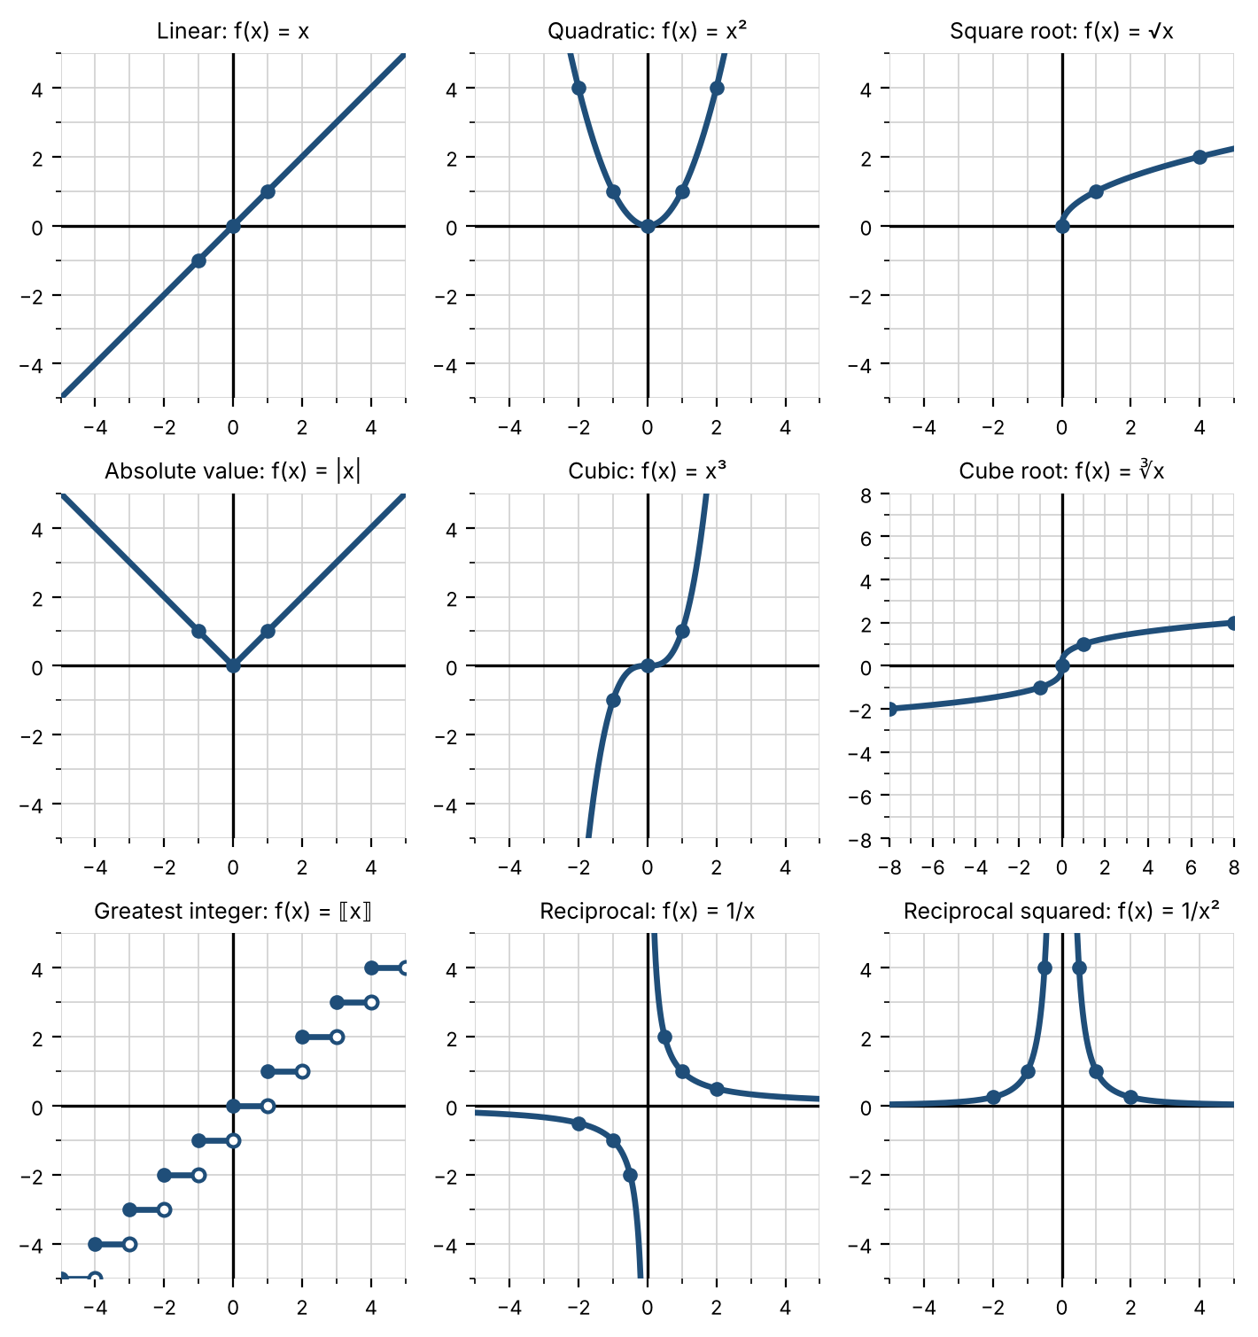

Practice
a. Name the parent function of g(x) = −2(x + 1)³ + 4. | b. Name the parent function of h(x) = √(x − 5) + 1. | c. Name the parent function of k(x) = 4|3x| − 7.

Skill 5.2: Shifting Graphs

Key ideas
A ______________ (18) changes the position, size, or direction of a parent graph. A shift moves the graph without changing its shape.
Shift | Equation | What happens | Point rule
Vertical | y = f(x) + k | k > 0: moves ________ (19) k units. k < 0: moves ________ (20) |k| units. | (x, y) → (x, y + k)
Horizontal | y = f(x − h) | h > 0: moves ________ (21) h units. h < 0: moves ________ (22) |h| units. | (x, y) → (x + h, y)

Changes outside the function act on y and move the way the sign suggests. Changes inside the function act on x and move the ______________ (23) way. For example, f(x + 3) moves the graph 3 units left.

Steps: graph a shifted function
- Identify the parent function and list its key points.
- Find k, the number added outside the function.
- Find h by writing the inside as x − h. For example, x + 3 = x − (−3), so h = −3.
- Apply (x, y) → (x + h, y + k) to every key point.
- Plot the new points and connect them in the shape of the parent graph.

Example: graph h(x) = (x − 2)² + 4
Step 1. Parent: y = x². Key points (−2, 4), (−1, 1), (0, 0), (1, 1), (2, 4).
Steps 2–3. k = 4 (up 4). Inside is x − 2, so h = 2 (right 2).
Step 4. Apply (x, y) → (x + 2, y + 4):
Step 5. The vertex moves from (0, 0) to (2, 4). The shape does not change. | 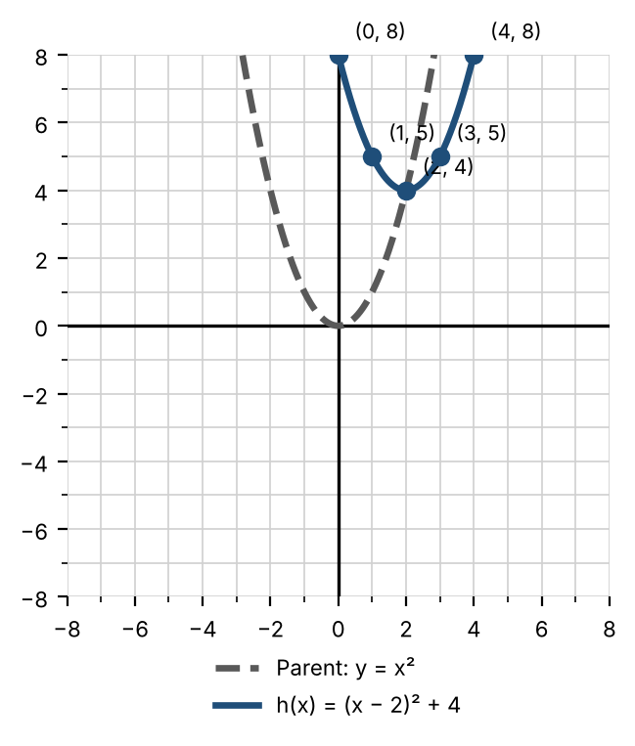
  Parent point | New point
  (−2, 4) | (0, 8)
  (−1, 1) | (1, 5)
  (0, 0) | (2, 4)
  (1, 1) | (3, 5)
  (2, 4) | (4, 8)

Practice
For each function, name the parent, describe the shift, complete the table, and sketch the graph.
a. g(x) = √(x + 1)  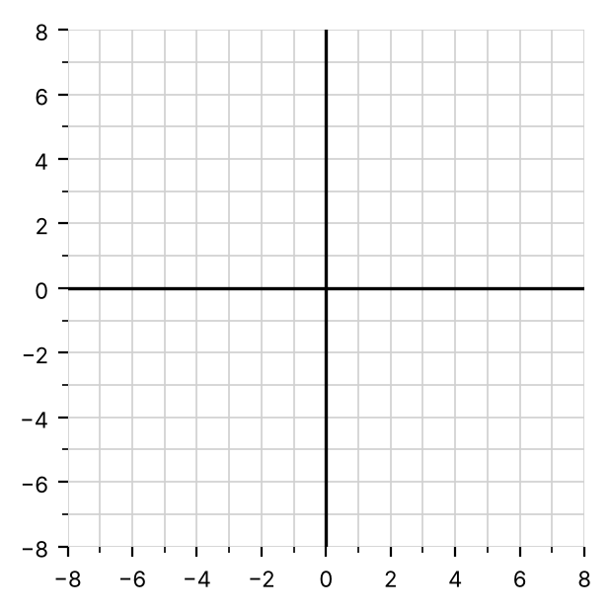 | b. g(x) = |x| − 3
  Parent point | New point
  (0, 0)
  (1, 1)
  (4, 2)
  Parent point | New point
  (−1, 1)
  (0, 0)
  (1, 1)
c. g(x) = (x + 1)³ − 2
Parent point | New point
(−1, −1)
(0, 0)
(1, 1)

Skill 5.3: Stretching, Compressing & Reflecting

Key ideas
Vertical changes: y = a·f(x). Multiply every y-coordinate by a. Point rule: (x, y) → (x, a·y).
- |a| > 1: vertical ______________ (24). The graph gets taller.
- 0 < |a| < 1: vertical ______________ (25). The graph gets flatter.
- a < 0: reflection across the ______________ (26).
Horizontal changes: y = f(b·x). Divide every x-coordinate by b. Point rule: (x, y) → (x ÷ b, y).
- |b| > 1: horizontal ______________ (27) by a factor of 1/|b|. The graph gets narrower.
- 0 < |b| < 1: horizontal ______________ (28). The graph gets wider.
- b < 0: reflection across the ______________ (29).
The inside rule shows up again. Multiplying x by 4 inside the function makes the graph 4 times ______________ (30), not wider.

Steps: graph a stretched, compressed, or reflected function
- Identify the parent function and list its key points.
- Decide where the number is. Outside, multiplying the whole function, is a. Inside, multiplying x, is b.
- For a, multiply each y-coordinate by a. For b, divide each x-coordinate by b.
- Plot the new points and connect them in the shape of the parent graph.

Example 1: graph g(x) = −2√x
Parent √x. The −2 is outside, so a = −2: vertical stretch by 2 and reflection across the x-axis. Rule: (x, y) → (x, −2y).
 | 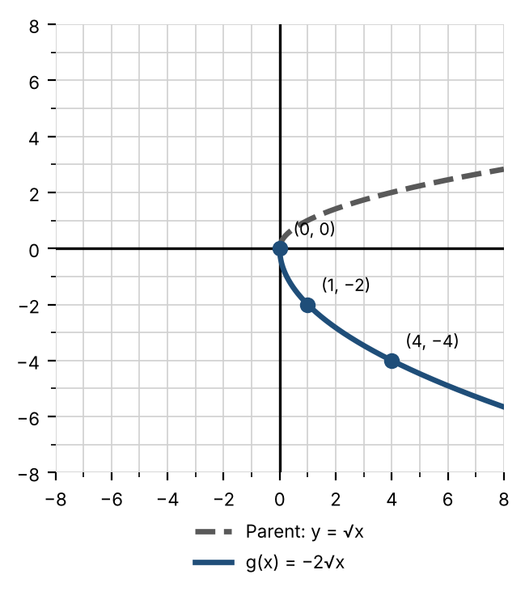
  Parent point | New point
  (0, 0) | (0, 0)
  (1, 1) | (1, −2)
  (4, 2) | (4, −4)

Example 2: graph h(x) = √(4x)
Parent √x. The 4 is inside, so b = 4: horizontal compression by a factor of 1/4. Rule: (x, y) → (x ÷ 4, y).
 | 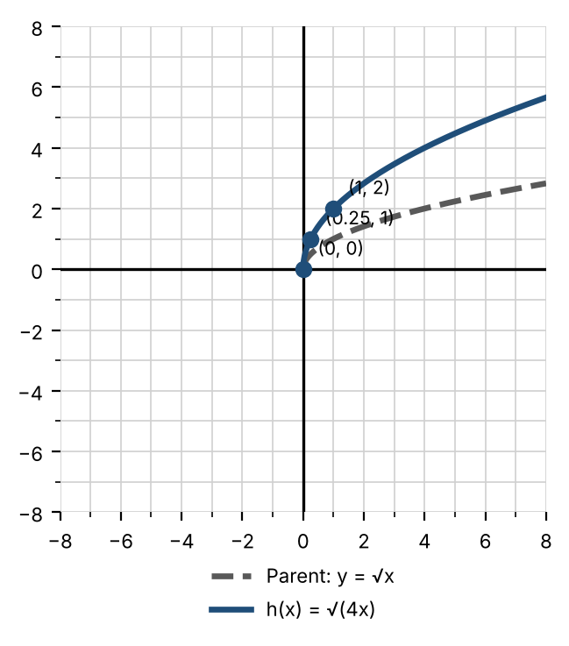
  Parent point | New point
  (0, 0) | (0, 0)
  (1, 1) | (0.25, 1)
  (4, 2) | (1, 2)

Notice: √(4x) = √4 · √x = 2√x. A horizontal compression of √x looks exactly like a vertical stretch.

Practice
For each function, describe the transformation, complete the table, and sketch the graph.
a. g(x) = ½x² | b. g(x) = √(−x)
  Parent point | New point
  (−2, 4)
  (−1, 1)
  (0, 0)
  (1, 1)
  (2, 4)
  Parent point | New point
  (0, 0)
  (1, 1)
  (4, 2)
c. g(x) = −3|x|
Parent point | New point
(−1, 1)
(0, 0)
(1, 1)

Skill 5.4: Combining Transformations

Key ideas
The general form of a transformed function is y = a·f(b(x − h)) + k.
Mapping rule: (x, y) → (x ÷ b + h, a·y + k)
- The ______________ (31) numbers, b and h, change the x-coordinates.
- The ______________ (32) numbers, a and k, change the y-coordinates.
- Order matters. Divide by b ______________ (33) adding h. Multiply by a before adding k.

Steps: graph with more than one transformation
- Rewrite the function in the form a·f(b(x − h)) + k. If needed, factor b out of the inside: √(2x − 6) = √(2(x − 3)).
- Identify the basic shape (the parent) and list its key points.
- Identify a, b, h, and k.
- Write the mapping rule.
- Apply the rule to each key point in a table.
- Plot the new points and connect them in the shape of the parent graph.

Example 1: graph f(x) = −2(x − 1)² + 5
Steps 1–3. Already in form. Parent x². a = −2, b = 1, h = 1, k = 5.
Step 4. Rule: (x, y) → (x + 1, −2y + 5).
Step 6. The parabola opens down, is narrower than the parent, and has its vertex at (1, 5). | 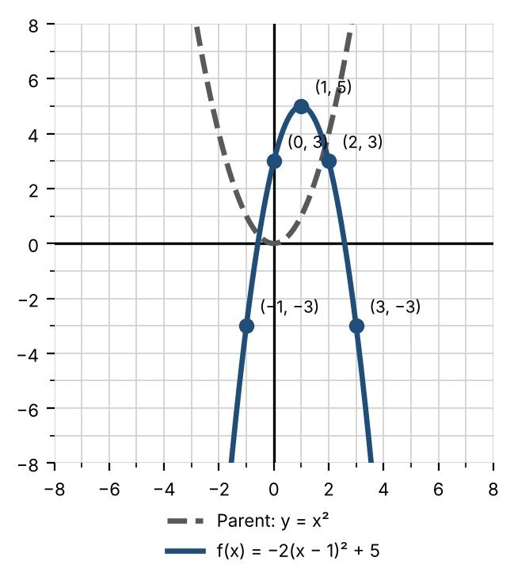
  Parent point | New point
  (−2, 4) | (−1, −3)
  (−1, 1) | (0, 3)
  (0, 0) | (1, 5)
  (1, 1) | (2, 3)
  (2, 4) | (3, −3)

Example 2: graph f(x) = √(2x − 6) + 1
Step 1. Factor 2 out of the inside: f(x) = √(2(x − 3)) + 1.
Steps 2–3. Parent √x. a = 1, b = 2, h = 3, k = 1.
Step 4. Rule: (x, y) → (x ÷ 2 + 3, y + 1).
 | 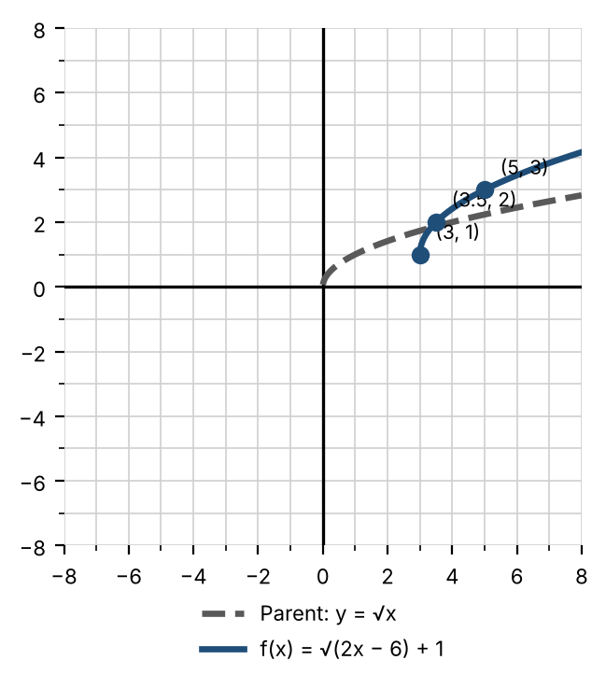
  Parent point | New point
  (0, 0) | (3, 1)
  (1, 1) | (3.5, 2)
  (4, 2) | (5, 3)

Check: The graph starts where the inside equals zero. 2x − 6 = 0 gives x = 3, not x = 6.

Practice
For a–c, identify a, b, h, and k, write the mapping rule, complete the table, and sketch the graph.
a. f(x) = 3|x + 2| − 4 | b. f(x) = −√(x − 4) + 2
  Parent point | New point
  (−1, 1)
  (0, 0)
  (1, 1)
  Parent point | New point
  (0, 0)
  (1, 1)
  (4, 2)
c. f(x) = √(−x + 2) | d. Write an equation for the graph shown. Its parent is y = |x|.  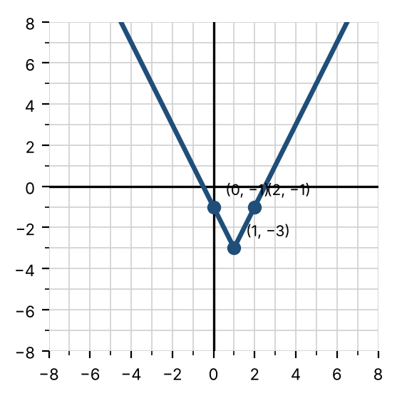
  Parent point | New point
  (0, 0)
  (1, 1)
  (4, 2)

Skill 5.5: Even & Odd Functions

Key ideas
- A function is ______________ (34) if f(−x) = ______________ (35) for every x in the domain. Its graph is symmetric about the ______________ (36).
- A function is ______________ (37) if f(−x) = ______________ (38) for every x in the domain. Its graph is symmetric about the ______________ (39): rotating it 180° leaves it unchanged.
- Most functions are ______________ (40) even nor odd.
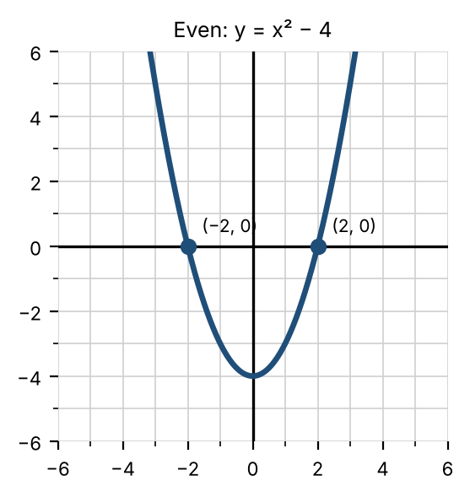 | 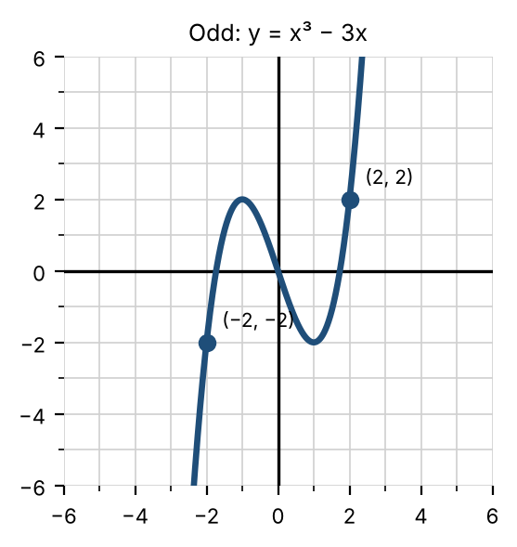

Steps: test a function algebraically
- Replace every x with (−x) to find f(−x).
- Simplify f(−x).
- If f(−x) is the same as f(x), the function is even.
- If not, find −f(x) by changing the sign of every term in f(x). If f(−x) is the same as −f(x), the function is odd.
- If neither matches, the function is neither.

Example 1: f(x) = x³ − x
f(−x) = (−x)³ − (−x) = −x³ + x. This is not f(x).
−f(x) = −x³ + x. This matches f(−x), so f is odd.

Example 2: h(x) = x² + x
h(−x) = (−x)² + (−x) = x² − x. This is not h(x) = x² + x, and it is not −h(x) = −x² − x. So h is neither.
Pattern for polynomials: if every power of x is even (a constant counts as x⁰), the function is even. If every power is odd, the function is odd.

Practice
Determine algebraically whether each function is even, odd, or neither.
a. f(x) = 2x⁴ − x² | b. g(x) = x⁵ + 3x | c. h(x) = x³ + 1
d. k(x) = |x| + 5 | e. m(x) = 1/x | f. n(x) = 1/x²

Use symmetry to decide whether each graph is even, odd, or neither.
a. Graph A  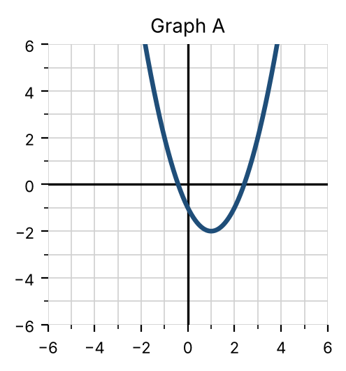 | b. Graph B  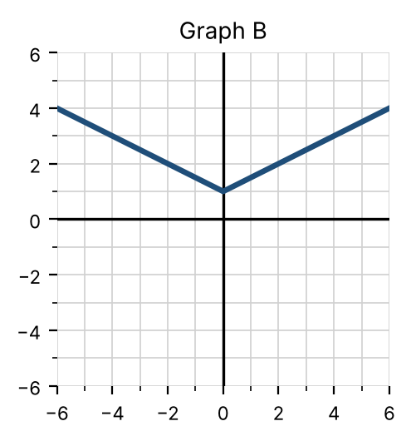 | c. Graph C  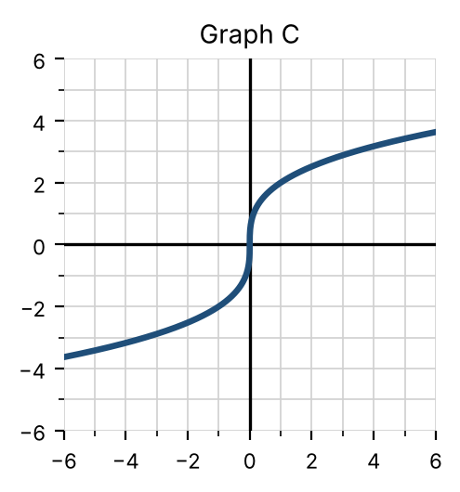

Exit check
1. Describe in words how g(x) = −(x + 4)² − 1 transforms y = x².

2. The point (2, 3) is on the graph of f. What point must be on the graph of y = 2f(x − 1) + 4?

3. Is f(x) = x² − 3x even, odd, or neither?

