Lesson 19: Oblique Triangles
Math 2412 Precalculus · Unit 3: Trigonometric Functions & Triangles · Student Guided Notes
Name: ______________________________ Date: ______________

Lesson objective
Students will solve oblique triangles with the Law of Sines (including the ambiguous SSA case) and the Law of Cosines, find the area of a triangle from two sides and an angle or from three sides (Heron's formula), and apply these tools to navigation and measurement problems.

Before class
Complete these short tasks before the lesson. They review skills this lesson builds on.
- Solve $\frac{8}{sin 40°}=\frac{x}{sin 65°}$ for x, to two decimal places.
- Find both angles between 0° and 180° with $sin θ=0.6$ (Lessons 15 and 18).
- Find $\cos^{−1}(−0.25)$ in degrees (Lesson 18).

Skill 19.1: Law of Sines (AAS and ASA)

Key ideas
- An oblique triangle has no right angle. Label the angles α, β, γ and the sides across from them a, b, c.
- To solve a triangle is to find all three sides and all three angles.
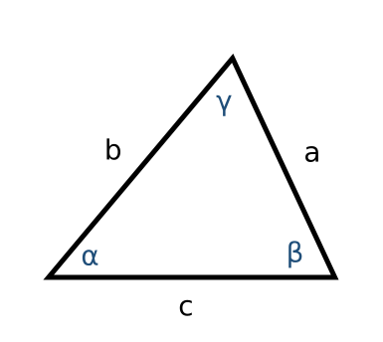
Law of Sines: ______________ (1), or flipped, $\frac{a}{sin α}=\frac{b}{sin β}=\frac{c}{sin γ}$.
Use it when you know two angles and a side (AAS or ASA). Find the third angle first: the angles add to ______________ (2).

Example: solve each triangle
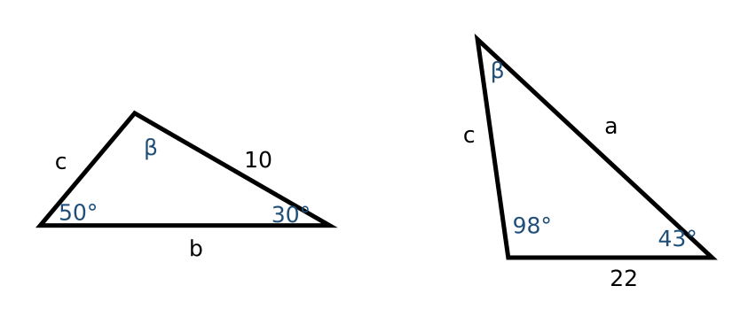
- Left ($α=50°$, $γ=30°$, $a=10$): $β=180°−50°−30°=100°$. $b=10sin 100°/(sin 50°)≈12.86$ and $c=10sin 30°/(sin 50°)≈6.53$.
- Right ($α=98°$, $γ=43°$, $b=22$): $β=39°$. $a=22sin 98°/(sin 39°)≈34.62$ and $c=22sin 43°/(sin 39°)≈23.84$.

Practice
a. Solve the triangle with $α=40°$, $β=72°$, and $c=15$.

Skill 19.2: The Ambiguous Case (SSA)

Key ideas
With two sides and an angle opposite one of them (SSA), the given information may describe no triangle, one triangle, or ______________ (3) triangles. Picture side a swinging from the end of side b; let $h=b·sin α$ be the height.
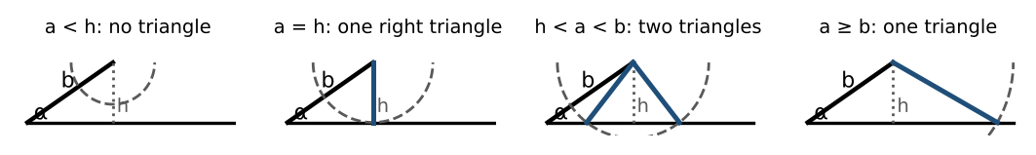
- Use the Law of Sines to find $sin β$. If $sin β>1$, there is ______________ (4) triangle.
- Otherwise $β₁=\sin^{−1}(…)$, and a second candidate is $β₂=180°−β₁$.
- Keep $β₂$ only if $α+β₂<180°$. Then finish each triangle.

Example: $α=35°$, $a=6$, $b=8$
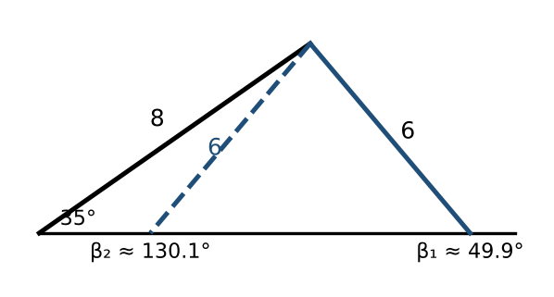
- $sin β=8sin 35°/6≈0.7648$, so $β₁≈49.89°$ and $β₂≈130.11°$. Both work, because $35°+130.11°<180°$.
- Triangle 1: $γ₁≈95.11°$, $c_{1}=6sin 95.11°/(sin 35°)≈10.42$.
- Triangle 2: $γ₂≈14.89°$, $c_{2}=6sin 14.89°/(sin 35°)≈2.69$.

Practice
a. How many triangles have $α=40°$, $a=3$, $b=7$? | b. Solve the triangle with $α=60°$, $a=10$, $b=8$.

Skill 19.3: Law of Cosines (SAS and SSS)

Key ideas
Law of Cosines: $a^{2}=b^{2}+c^{2}−2bccos α$, $b^{2}=a^{2}+c^{2}−2accos β$, ______________ (5).
- Use it for SAS (two sides and the angle between them) and SSS (three sides).
- For SSS, solve for an angle: $cos α=\frac{b^{2}+c^{2}−a^{2}}{2bc}$. Find the largest angle first; it is across from the longest side.
- If $γ=90°$, the law becomes the ______________ (6).

Example 1: solve each triangle (SSS)
- $a=20$, $b=25$, $c=18$: $cos α=\frac{625+324−400}{900}=0.61$, so $α≈52.41°$. $cos β=\frac{400+324−625}{720}=0.1375$, so $β≈82.10°$. $γ≈45.49°$.
- $a=5$, $b=7$, $c=10$: $cos γ=\frac{25+49−100}{70}≈−0.3714$, so $γ≈111.80°$. $cos α=\frac{49+100−25}{140}$, so $α≈27.66°$. $β≈40.54°$.

Example 2: a boat (SAS)
A boat leaves port, travels 10 miles, turns 20°, and travels 8 more miles. How far is it from port? The angle between the two legs is $180°−20°=160°$.
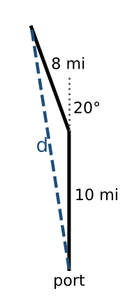
$d^{2}={10}^{2}+8^{2}−2(10)(8)cos 160°≈314.35$, so $d≈17.73$ miles.

Example 3: locating a cell phone (SSS)
Two towers are 6000 feet apart on an east-west highway. A phone north of the highway is 5050 feet from tower 1 and 2420 feet from tower 2.
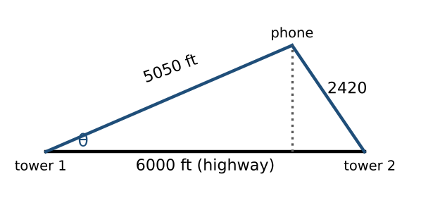
- $cos θ=\frac{{6000}^{2}+{5050}^{2}−{2420}^{2}}{2·6000·5050}≈0.9183$, so $θ≈23.33°$.
- East of tower 1: $5050cos θ≈4637$ feet. North of the highway: $5050sin θ≈2000$ feet.

Practice
a. Two sides of a triangle are 12 and 9, with a 52° angle between them. Find the third side.

Skill 19.4: Area and Applications

Key ideas
- Two sides and the included angle: $Area=(\frac{1}{2})absin γ$ (any two sides and the angle between them).
- Three sides (Heron's formula): with $s=\frac{a+b+c}{2}$, ______________ (7).

Example 1: area
- $a=90$, $b=52$, included angle 102°: $Area=(\frac{1}{2})(90)(52)sin 102°≈2288.87$ square units.
- Sides 10, 15, 7: $s=16$; $Area=\sqrt{16·6·1·9}=\sqrt{864}≈29.39$ square units.
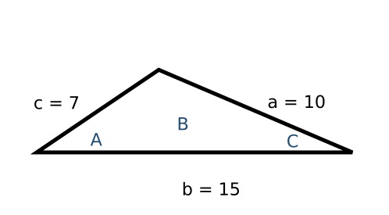

Example 2: radar stations
Two radar stations 20 miles apart detect an aircraft between them, at angles of elevation 35° and 15°. Find its altitude.
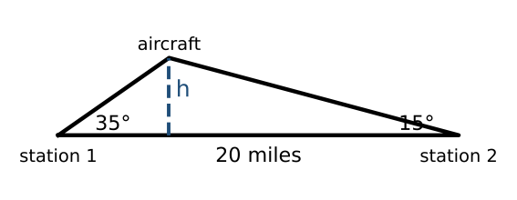
- The angle at the aircraft is $180°−35°−15°=130°$.
- Distance from station 1: $20sin 15°/(sin 130°)≈6.757$ miles.
- Altitude: $h=6.757sin 35°≈3.88$ miles.

Practice
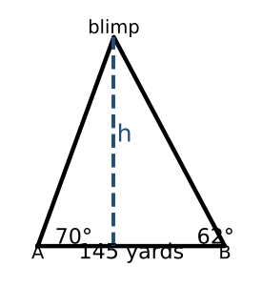
a. The angles of elevation to a blimp from the two end zones A and B of a stadium are 70° and 62°, and A and B are 145 yards apart. Find the height of the blimp. | b. Find the area of a triangle with sides 9, 10, and 13.

Exit check
1. Which law would you use first to solve a triangle with $a=7$, $b=9$, $γ=48°$?

2. Find the area of a triangle with sides 8 and 11 and an included angle of 40°.

3. How many triangles have $α=30°$, $a=5$, $b=8$?

