Lesson 20: Fundamental Identities & Verification
Math 2412 Precalculus · Unit 4: Analytic Trigonometry, Conics & Discrete Topics · Student Guided Notes
Name: ______________________________ Date: ______________

Lesson objective
Students will state the reciprocal, quotient, Pythagorean, and even-odd identities, use algebra (factoring, common denominators, conjugates) on trigonometric expressions, and verify identities.

Before class
Complete these short tasks before the lesson. They review skills this lesson builds on.
- Factor $a^{2}−b^{2}$ and $x^{2}−x−2$ (Lesson 1).
- Add $\frac{a}{b}+\frac{b}{a}$ as a single fraction (Lesson 1).
- Give the six trig functions of θ in terms of x, y, and r for a point on its terminal side (Lesson 15).

Skill 20.1: The Fundamental Identities

Key ideas
- An identity is an equation that is true for ______________ (1) value of the variable where both sides are defined.
- On the unit circle the point at angle θ is (cos θ, sin θ), and the right triangle it makes gives $\cos^{2}θ+\sin^{2}θ=1$.
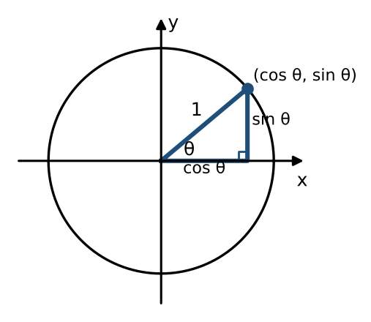
Family | Identities | More identities
Reciprocal | $csc θ=\frac{1}{sin θ}$, $sec θ=\frac{1}{cos θ}$ | $cot θ=\frac{1}{tan θ}$
Quotient | $tan θ=\frac{sin θ}{cos θ}$ | ________ (2)
Pythagorean | $\sin^{2}θ+\cos^{2}θ=1$ | $1+\tan^{2}θ=\sec^{2}θ$, ________ (3)
Even-odd | $cos(−θ)=cos θ$, $sec(−θ)=sec θ$ (even) | $sin(−θ)$ = ________ (4); tan, csc, cot are also odd

Example 1: where the other Pythagorean identities come from
- Divide $\sin^{2}θ+\cos^{2}θ=1$ by $\cos^{2}θ$: $\tan^{2}θ+1=\sec^{2}θ$.
- Divide by $\sin^{2}θ$ instead: $1+\cot^{2}θ=\csc^{2}θ$.

Example 2: simplify
- $sin θcot θ=sin θ·\frac{cos θ}{sin θ}=cos θ$.
- $(1−\sin^{2}θ)sec θ$ simplifies to ______________ (5), because $1−\sin^{2}θ=\cos^{2}θ$ and $sec θ=\frac{1}{cos θ}$.
- $tan(−θ)cos θ=−\frac{sin θ}{cos θ}·cos θ=−sin θ$.

Practice
a. Simplify $cos θtan θcsc θ$. | b. Simplify $(\sec^{2}θ−1)cot θ$.

Skill 20.2: Algebra with Trig Expressions

Key ideas
- Treat $sin θ$ and $cos θ$ like the variables a and b: factor, find common denominators, and multiply by ______________ (6) the same way.
- After the algebra, look for a Pythagorean identity to finish.

Example 1: factor
- $\sin^{2}θ−\cos^{2}θ=(sin θ−cos θ)(sin θ+cos θ)$, a difference of squares.
- $\cos^{2}θ−cos θ−2$ factors as ______________ (7), like $x^{2}−x−2$.

Example 2: add fractions
- $\frac{sin θ}{cos θ}+\frac{cos θ}{sin θ}=\frac{\sin^{2}θ+\cos^{2}θ}{sin θcos θ}=\frac{1}{sin θcos θ}=sec θcsc θ$.
- $tan θ+\frac{1}{tan θ}=\frac{\tan^{2}θ+1}{tan θ}=\frac{\sec^{2}θ}{tan θ}$, which simplifies to $sec θcsc θ$ as well.

Example 3: multiply by the conjugate
$\frac{1}{cos θ−sin θ}·\frac{cos θ+sin θ}{cos θ+sin θ}=\frac{cos θ+sin θ}{\cos^{2}θ−\sin^{2}θ}$. The bottom becomes $\cos^{2}θ−\sin^{2}θ$, a difference of squares; this is the same move as rationalizing $\frac{1}{\sqrt{3}−\sqrt{2}}$. (In Lesson 21, $\cos^{2}θ−\sin^{2}θ$ becomes $cos(2θ)$.)

Practice
a. Factor $\tan^{2}θ−9$. | b. Write $\frac{1}{1+cos θ}+\frac{1}{1−cos θ}$ as one term. | c. Multiply $\frac{sin θ}{1−cos θ}$ by the conjugate of its bottom and simplify.

Skill 20.3: Verifying Identities

Strategies
- Work on ______________ (8) only, usually the more complicated side, until it matches the other side. Do not move terms across the equal sign.
- Rewrite in terms of sine and cosine.
- Use algebra: factor, combine fractions, or multiply by a conjugate.
- Look for a Pythagorean identity, and keep the other side in view as your target.

Example 1: change to sine and cosine
- $tan θcos θ=\frac{sin θ}{cos θ}·cos θ=sin θ$ ✓
- $csc θcos θtan θ=\frac{1}{sin θ}·cos θ·\frac{sin θ}{cos θ}=1$ ✓
- $\frac{cot θ}{csc θ}=(\frac{cos θ}{sin θ})·(sin θ)=cos θ$ ✓

Example 2: use a Pythagorean identity
- $\frac{\sec^{2}θ−1}{\sec^{2}θ}=\frac{\tan^{2}θ}{\sec^{2}θ}=\frac{\sin^{2}θ}{\cos^{2}θ}·\cos^{2}θ=\sin^{2}θ$ ✓
- $(1−\cos^{2}θ)(1+\cot^{2}θ)=\sin^{2}θ·\csc^{2}θ=\sin^{2}θ·\frac{1}{\sin^{2}θ}=1$ ✓

Example 3: multiply by a conjugate
Verify $\frac{cos θ}{1+sin θ}=\frac{1−sin θ}{cos θ}$. Start on the left and multiply by $\frac{1−sin θ}{1−sin θ}$:
$\frac{cos θ(1−sin θ)}{1−\sin^{2}θ}=\frac{cos θ(1−sin θ)}{\cos^{2}θ}=\frac{1−sin θ}{cos θ}$ ✓

Practice
a. Verify $sec θ−cos θ=sin θtan θ$. | b. Verify $\frac{1+\tan^{2}θ}{\csc^{2}θ}=\tan^{2}θ$. | c. Verify $\frac{sin θ}{1−cos θ}=\frac{1+cos θ}{sin θ}$.

Exit check
1. Simplify $sin θsec θ$.

2. Write $1−\sin^{2}θ$ using one function.

3. Verify $cot θsin θ=cos θ$.

