**Titanic data analysis**

* **Flume**

Command to run flume:

flume-ng agent -n TitanicAgent -c conf -f /usr/local/flume/conf/titanic_flume.conf

Copy the data file spooldir mentioned in conf file:

cp /home/acadgild/nikidir/TitanicData.txt /home/acadgild/nikidir/spooldir

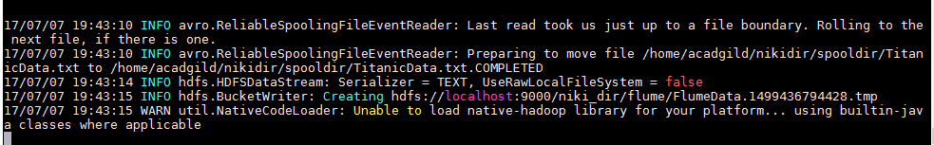

Check the file in hdfs:

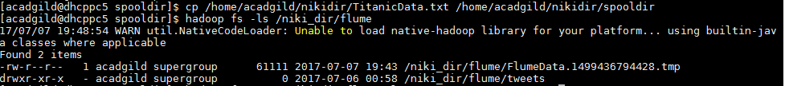

Check the content:

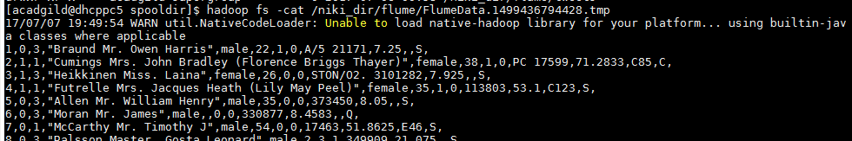

* **Hive:**

Creating table:

create table titanic_data

(

passenger_Id int,

is_survived int,

pclass int,

name string,

sex string,

age int,

sib_sp int,

parch int,

ticket string,

fare float,

cabin string,

embarked char(1))

row format delimited

fields terminated by ',';

Inserting data:

LOAD DATA INPATH 'hdfs://localhost:9000/niki_dir/flume' OVERWRITE INTO TABLE titanic_data;

1. In this problem statement, we will find the average fare of each class.

select AVG(fare),pclass from titanic_data group by pclass;

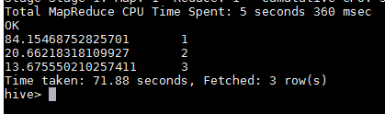

1. In this problem statement, we will find the number of people alive in each class and embarked at Southampton.

select count(*), pclass from titanic_data where embarked='S' and is_survived=1 group by pclass;

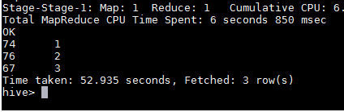

1. In this problem statement, we will find out number of males and females who died in each class.

select pclass, sex, count(*) from titanic_data where is_survived=0 group by pclass,sex;

