1. Write a program to read a text file and print the number of rows of data in the document.

Val first= sc.textFile(“/home/acadgild/niki/Test.txt”)

Println(“lines in text file: ”+first.count)

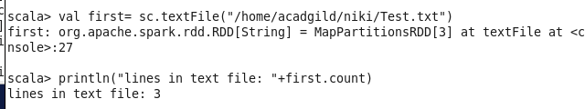

1. Write a program to read a text file and print the number of words in the document.

flatmap.collect()

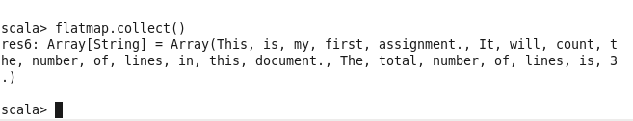

3. We have a document where the word separator is -, instead of space. Write a spark

code, to obtain the count of the total number of words present in the document.

Val flatmap =first.flatMap(line=>line.split(“-”))

Println(flatmap.count)

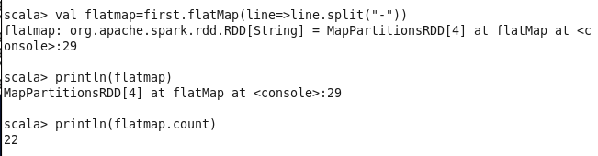

**To find unique word count:**

Val counts= flatmap.map(word=>word,1).reduceByKey(_+_)

Val res=counts.collect

Res.length

