File created in local FS

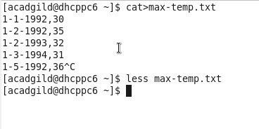

File copied to hadoop directory in hdfs

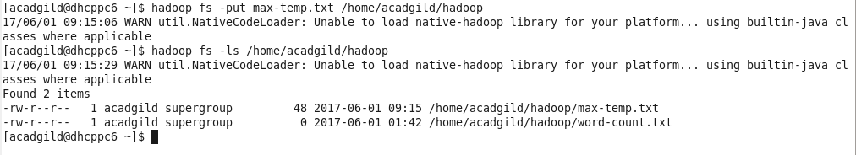

Changing the permission of the file

