1. Pwd: print the name of the working directory.



4. mkdir: allows the user to make a new directory.

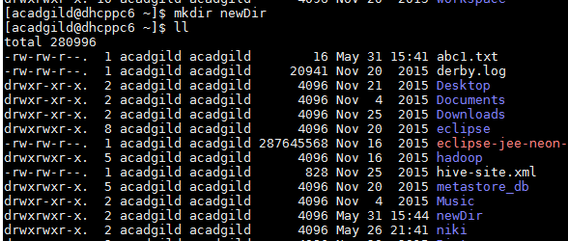

5.rm: removes a file or directory. Use –r for recursively removing all the files inside a directory



6. ls : The ls command lists files and directories within the current working directory, allowing admins to see when configuration files were last edited.

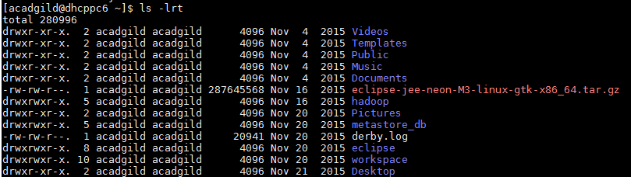

7. echo :

Echo allows a user to repeat, or "echo," a string variable to standard output.

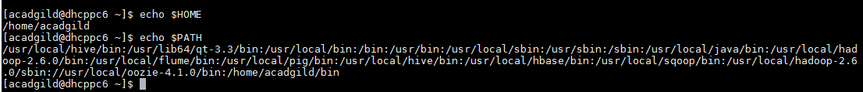

8. cat (short for concatenate): **cat** command allows us to create single or multiple files, view contain of file, concatenate files and redirect output in terminal or files.

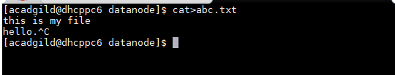



9. who : Displays who is [logged on](https://www.computerhope.com/jargon/s/signon.htm) to the [system](https://www.computerhope.com/jargon/s/system.htm).

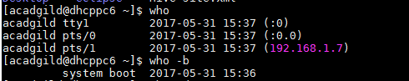

10. cd: change directory - will allow the user to change between file directories.

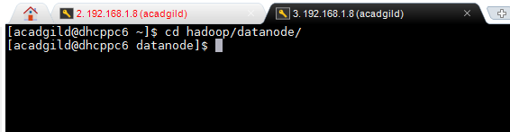

11. date : Date sets a system's date and time. This is also a useful way to output/print current information when working in a script file.

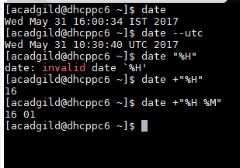

12. cal : to display calendar

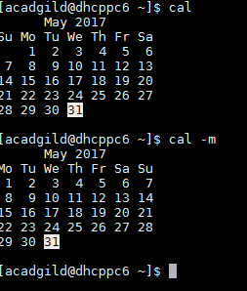

13. mv: allows a user to move a file to another folder or directory.

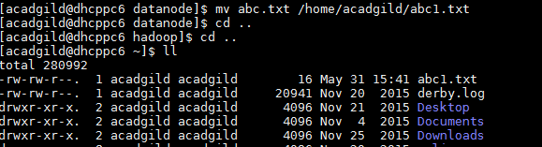

14. cp : The cp command copies files and directories

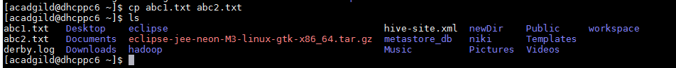

15. which :

all programs should run from the /usr/bin folder but in reality, this is not the case. The sure fire way of finding out where a program is located is by using the which command.

