(a) Top 5 employees (employee id and employee name) with highest rating.

(In case two employees have same rating, employee with name coming first in dictionary should get preference)

emp= load 'employee_details.txt' USING PigStorage(',') as (emp_id:int,emp_name:chararray,emp_salary:int,emp_rating:int);

o= ORDER emp by emp_rating desc,emp_name asc;

l= limit o 5;

dump l;

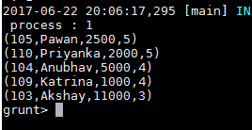

(b) Top 3 employees (employee id and employee name) with highest salary, whose employee id is an odd number.

(In case two employees have same salary, employee with name coming first in dictionary should get preference)

SPLIT emp into odd if emp_id%2==1, even if emp_id%2==0;

o= order odd by emp_salary desc;

result= limit o 3;

final= foreach result generate emp_id,emp_name;

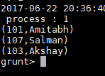

(c) Employee (employee id and employee name) with maximum expense

(In case two employees have same expense, employee with name coming first in dictionary should get preference)

emp= load 'employee_details.txt' USING PigStorage(',') as (emp_id:int,emp_name:chararray,emp_salary:int,emp_rating:int);

emp_exp= load 'employee_expenses.txt' as (emp_id:int,emp_exp:int);

joined_emp_exp= join emp by emp_id, emp_exp by emp_id;

max_emp= order joined_emp_exp by emp_exp desc, emp_name asc;

top= limit max_emp 3;

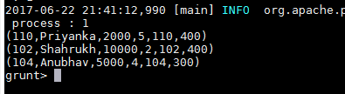

(d) List of employees (employee id and employee name) having entries in employee_expenses file.

emp= load 'employee_details.txt' USING PigStorage(',') as (emp_id:int,emp_name:chararray,emp_salary:int,emp_rating:int);

emp_exp= load 'employee_expenses.txt' as (emp_id:int,emp_exp:int);

left_outer_joined_data = join emp by emp_id left outer, emp_exp by emp_id;

withexp= filter left_outer_joined_data by emp_exp::emp_id is not null;

withexpresult= foreach withexp generate emp::emp_id, emp::emp_name;

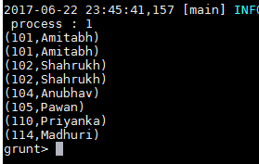

(e) List of employees (employee id and employee name) having no entry in employee_expenses file.

emp= load 'employee_details.txt' USING PigStorage(',') as (emp_id:int,emp_name:chararray,emp_salary:int,emp_rating:int);

emp_exp= load 'employee_expenses.txt' as (emp_id:int,emp_exp:int);

left_outer_joined_data = join emp by emp_id left outer, emp_exp by emp_id;

withoutexp= filter left_outer_joined_data by emp_exp::emp_id is null;

withoutexpresult= foreach withoutexp generate emp::emp_id, emp::emp_name;

