Q. Find out the most viewed page – MR mode.

1. register /usr/local/pig/contrib/piggybank/java/piggybank.jar
2. logs = LOAD '/niki/s7/sample_log.txt' USING org.apache.pig.piggybank.storage.apachelog.CombinedLogLoader()

AS (addr: chararray, logname: chararray, user: chararray, time: chararray,

method: chararray, uri: chararray, proto: chararray,

status: int, bytes: int, referer: chararray, userAgent: chararray);

1. refers = GROUP logs BY referer;

refers: {group: chararray,logs: {(addr: chararray,logname: chararray,user: chararray,time: chararray,method: chararray,uri: chararray,proto: chararray,status: int,bytes: int,referer: chararray,userAgent: chararray)}}

1. refer_counts = FOREACH refers GENERATE flatten($0), COUNT($1) as count;

refer_counts: {group: chararray,count: long}

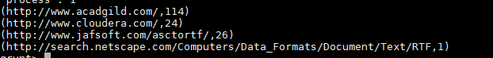

1. sorted_refer_counts = ORDER refer_counts BY count DESC;

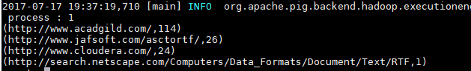

1. top1_refers = LIMIT sorted_refer_counts 1;

