players = load 'baseball' as (name:chararray, team:chararray, position:bag{t:(p:chararray)}, bat:map[]);

1. **Concat :**

B= foreach players generate CONCAT(name,team);

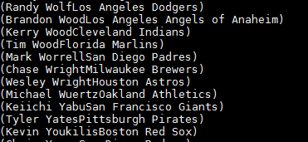

1. **Tokenize**

A = load 'wordcount.txt' as (line:chararray);

B = foreach A generate TOKENIZE(line) as tokens;



1. Sum

B= group emp all;



C= foreach B generate (emp.emp_name), SUM(emp.emp_salary);



1. Min

C= foreach B generate (emp.emp_name), MIN(emp.emp_salary);

1. Max

C= foreach B generate (emp.emp_name), MAX(emp.emp_salary);

1. Limit

B= Limit emp 3;

1. Store

store emp into 'abc.txt'

1. Distinct : find unique ratings

* grp= group emp all;
* A_unique = FOREACH grp {

rating= emp.emp_rating;

unique_rating= DISTINCT rating;

generate group, unique_rating;};

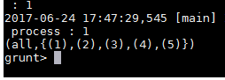

1. Flatten

On above output:

B= foreach A_unique generate flatten(unique_rating) as rating;

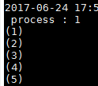

1. IsEmpty

emp_co= cogroup emp by emp_id, emp_exp by emp_id;

emp_empty= filter emp_co by IsEmpty(emp_detail);

