Perform and explain the code flow and the associated result for the below tasks. Candidates should

create and use their own employee dataset for the same. Share the screenshot of the commands used

and its associated result.

* Transfer data between Mysql and HDFS (Import and Export) using Sqoop.

1. Create table employee:

create table employee(

name varchar(30),

skill varchar(30),

rating int,

location varchar(30)

);

1. Grant permission

grant all on *.* to 'root'@'localhost' with grant option;

1. Export command

sqoop export --connect jdbc:mysql://localhost/mydb --username root -P --table employee --export-dir /niki/emp_details.txt

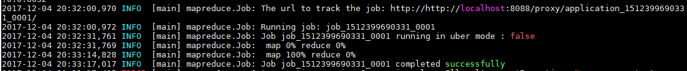

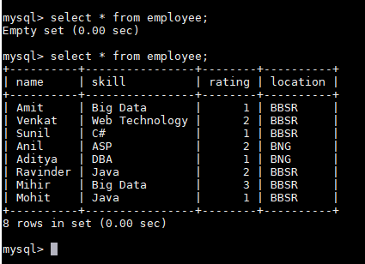

1. Import command

sqoop import --connect jdbc:mysql://localhost/mydb --username root -P --table employee --target-dir niki/emp_improt.txt -m 1

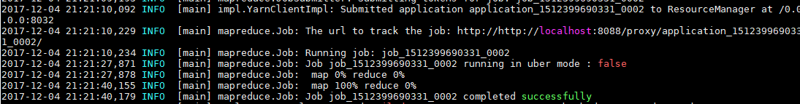

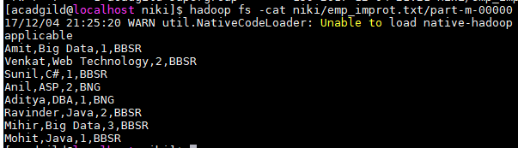

* Transfer data between Mysql and Hive (Import and Export only selected columns) using Sqoop.