Acadgild spark vm import

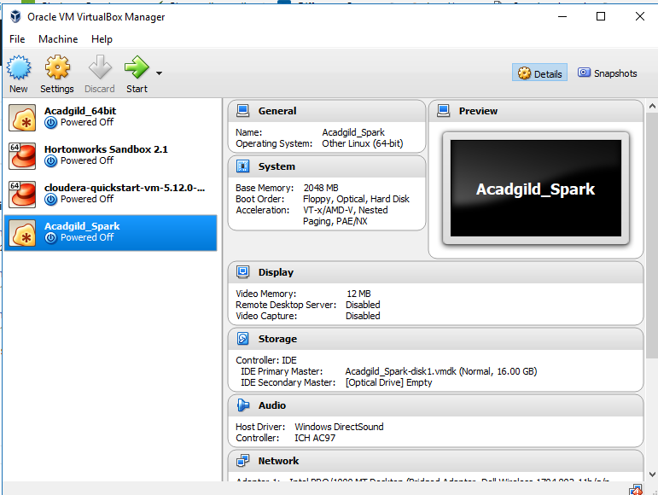

1. Starting name node:

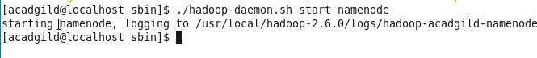

1. Starting datanode:



1. Starting resourcemanager:

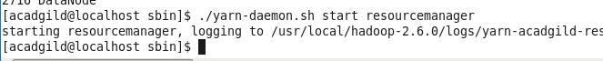

1. Starting nodemanager:



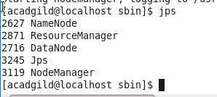

1. Start spark:

