A Fibonacci series (starting from 1) written in order without any spaces in between, thus

producing a sequence of digits.

Write a Scala application to find the Nth digit in the sequence.

○ Write the function using standard for loop

**object** Fibo

{

**def** main(args:Array[*String*])

{

println("Enter value of n")

**val** n =scala.io.StdIn.readLine().toInt

**val** str=loop(n)

println("The series is : "+str)

println(s"The $n th digit in sequence is: "+ str.charAt(n-1))

}

**def** loop( n : Int ) : *String* =

{

**var** a = 0

**var** b = 1

**var** i = 0

**var** str="01"

**while**( i < n-2 )

{

**val** c = a + b

a = b

b = c

str=str+c

i = i + 1

}

str

}

}

O/p:

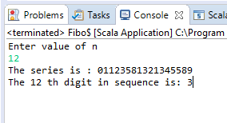

○ Write the function using recursion

**object** Fibo

{

**def** main(args:Array[*String*])

{

**val** series = from(0,1)

println("Enter value of n")

**val** n =scala.io.StdIn.readLine().toInt

**val** str=series.take(n).mkString("")

println("The series is : "+str)

println(s"The $n th digit in sequence is: "+ str.charAt(n-1))

}

**def** from(a: Int, b: Int): *Stream*[Int] =

Stream.cons(a, from(b,a+b))

}

O/p:

