1.Write a simple program to show inheritance in scala.

**object** MyClass

{

**def** main(args :Array[*String*])

{

**val** d1=**new** GolderRetriever("Rockey")

**val** d2= **new** bullDog("Sam")

println(d1)

println(d2)

}

}

**abstract** **class** Animal(n : *String*)

{

**def** sound: *String*

**def** legs: scala.Int

**val** name=n

**def** color:*String*

**override** **def** toString = "Name is " + n+", Its color is "+color+" and it has "+legs+" legs. it sounds "+sound;

}

**abstract** **class** Dog(n:*String*) **extends** Animal(n)

{

**def** sound: *String* = "Bow Bow"

**def** legs: Int = 4

}

**class** bullDog(n:*String*) **extends** Dog(n)

{

**def** color: *String* ="brown"

}

**class** GolderRetriever(n:*String*) **extends** Dog(n)

{

**def** color: *String* ="golden"

}

o/p:

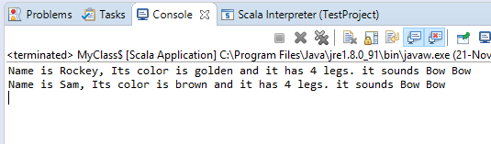

2.Write a simple program to show multiple inheritance in scala.

**object** MyClass

{

**def** main(args :Array[*String*])

{

**val** d1=**new** GolderRetriever("Rockey")

println(d1)

println(d1.isDomestic)

}

}

**abstract** **class** Animal(n : *String*)

{

**def** sound: *String*

**def** legs: scala.Int

**val** name=n

**def** color:*String*

**override** **def** toString = "Name is " + n+", Its color is "+color+" and it has "+legs+" legs. it sounds "+sound;

}

**trait** domestic

{

**def** isDomestic:*String* ="I am domestic"

}

**abstract** **class** Dog(n:*String*) **extends** Animal(n) **with** domestic

{

**def** sound: *String* = "Bow Bow"

**def** legs: Int = 4

}

**class** GolderRetriever(n:*String*) **extends** Dog(n)

{

**def** color: *String* ="golden"

}

o/p:

