1. Pwd: print the name of the working directory.



1. Vi

The default editor that comes with the UNIX operating system is called vi (visual editor).

The UNIX vi editor is a full screen editor and has two modes of operation:

* Command mode commands which cause action to be taken on the file, and
* Insert mode in which entered text is inserted into the file.

In the command mode, every character typed is a command that does something to the text file being edited; a character typed in the command mode may even cause the vi editor to enter the insert mode. In the insert mode, every character typed is added to the text in the file; pressing the <Esc> (Escape) key turns off the Insert mod.

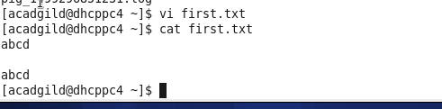

3.. Touch

The touch command updates the access and [modification](https://www.computerhope.com/jargon/m/modify.htm) times of each FILE to the current system time. If you specify a FILE that does not already exist, touch creates an empty file with that name.

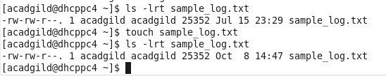

4. mkdir: allows the user to make a new directory.

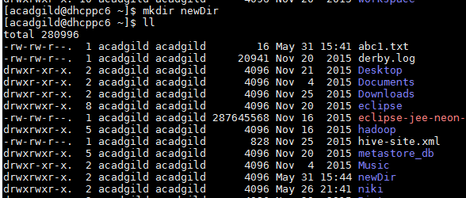

5.rm: removes a file or directory. Use –r for recursively removing all the files inside a directory



6. ls : The ls command lists files and directories within the current working directory, allowing admins to see when configuration files were last edited.

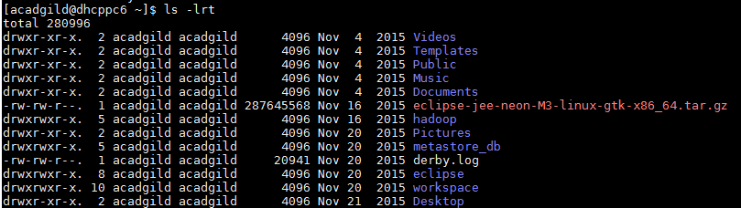

7. echo :

Echo allows a user to repeat, or "echo," a string variable to standard output.

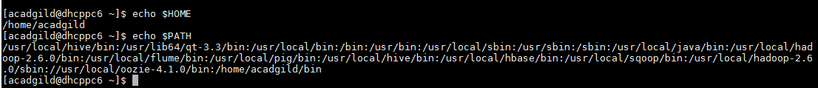

8. cat (short for concatenate): **cat** command allows us to create single or multiple files, view contain of file, concatenate files and redirect output in terminal or files.

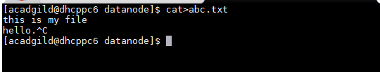



9. who : Displays who is [logged on](https://www.computerhope.com/jargon/s/signon.htm) to the [system](https://www.computerhope.com/jargon/s/system.htm).

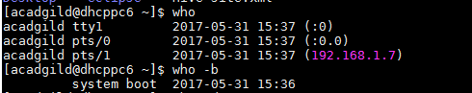

10. cd: change directory - will allow the user to change between file directories.

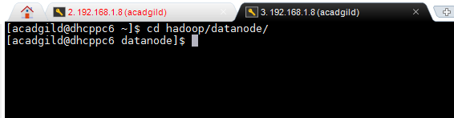

11. date : Date sets a system's date and time. This is also a useful way to output/print current information when working in a script file.

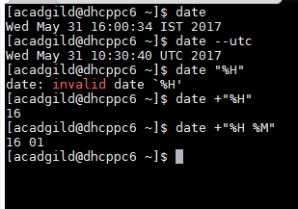

12. cal : to display calendar

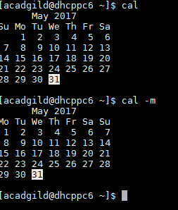

13. mv: allows a user to move a file to another folder or directory.

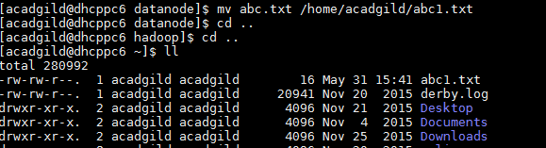

14. cp : The cp command copies files and directories

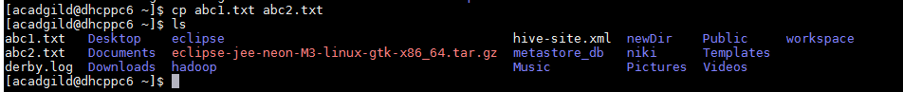

15. which :

all programs should run from the /usr/bin folder but in reality, this is not the case. The sure fire way of finding out where a program is located is by using the which command.

