1. Create file in local.

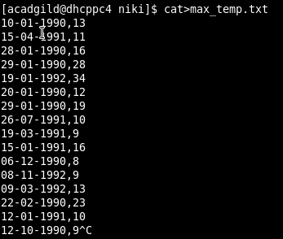

1. Put file in hdfs

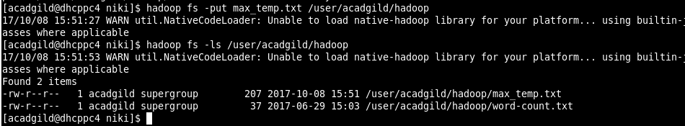

1. Change permission to have owner and group full control

